**Math 10 Foundations/Pre-Calculus Textbook**

**Please do NOT write in this textbook (other than on this page!). If this textbook is lost you will be charged a fee for it.**

|  |  |  |
| --- | --- | --- |
| **Name** | **Teacher’s Name** | **Semester/year** |
|  |  |  |
|  |  |  |
|  |  |  |
|  |  |  |
|  |  |  |

**Table of Contents**

|  |  |  |  |
| --- | --- | --- | --- |
| **Outcome** | | **Questions** | **Answers** |
| 1A | Prime factorization, GCF, LCM, square and cube roots | 5 | 8 |
| 2A | Radicals | 9 | 12 |
| 2B | Powers | 14 | 21 |
| 3A | Metric and imperial conversion | 25 | 28 |
| 3B | Surface area and volume | 29 | 31 |
| 4 | Trigonometry | 32 | 40 |
| 5A | Polynomial multiplication | 42 | 46 |
| 5B | Factoring | 48 | 52 |
| 6 | Relations and functions | 55 | 61 |
| 7 | Slope | 64 | 71 |
| 8A | Linear functions | 74 | 84 |
| 8B | Graphing linear relations | 87 | 89 |
| 9 | Writing equations | 94 | 103 |
| 10 | Systems of linear equations | 107 | 111 |

|  |  |
| --- | --- |
| **OUTCOMES** | **ASSESSMENT RUBRICS** |
| **FP. 10.1 Demonstrate understanding of factors of whole numbers by determining the: prime factors, greatest common factor, least common multiple, principal square root, cube root** | |

|  |  |  |  |  |
| --- | --- | --- | --- | --- |
| **Level**  **Criteria** | **Intervention 1**  **Spend some extra time with the criteria and ask for help.** | **Instructional 2**  **Good start. You are beginning to make sense of this on your own. You are consistent with the basic learning goals for this outcome.** | **Independence 3**  **You did it and you did it on your own. You are able to complete the processes for this outcome. Your work is thorough and consistently accurate.** | **Mastery 4**  **Great work! This is going extra well for you. You have understood the outcome, are able to explain your strategies and apply these to situations. Your work is always accurate.** |
| **Outcome 1:** Students will demonstrate understanding of factors of whole numbers by determining the prime factors, greatest common factor and least common factor | I need more help with becoming consistent with the criteria. | I can consistently determine the prime factors of a whole number, GCF and LCM of whole numbers | I can find the principal square root and cube root of whole numbers using the factors of the number. I am able to explain the strategy I use for finding prime factors, GCF or LCM, square root and cube roots. | I can report about the numbers 0 and 1 with respect to factors and multiples. I can perform error analysis. I am able to solve situational problems involving GCf, LCM, square roots and cube roots. |

**Practice #1 – Prime Factorization**

Level 2

1. List the prime factors of each number.

a) 40 b) 75 c) 81

d) 120 e) 140 f) 192

2. List the first 6 multiples of each number

a) 6 b) 13 c) 22

3. Determine the greatest common factor of each pair of numbers.

a) 46, 84 b) 64, 120

c) 81, 216 d) 220, 860

4. Determine the greatest common factor of each set of numbers.

a) 150, 275, 420 b) 126, 210, 546, 714

5. Determine the least common multiple of each pair of numbers

a) 12, 14 b) 21, 45

c) 45, 60 d) 32, 45

6. Determine the least common multiple of each set of numbers

a) 20, 36, 38 b) 12, 18, 25, 30

**Practice #2 – Prime Factorization**

Level 4

1. Two marching bands are to be arranged in rectangular arrays with the same number of columns. One band has 42 members, the other has 36 members. What is the greatest number of columns in the array?
2. a) What are the dimensions of the smallest square that could be tiled using an 18 cm by 24 cm tile? Assume the tiles cannot be cut.

b) Could the tiles in part a) be used to cover a floor with dimensions 648 cm by 1512 cm? Explain.

Level 4

1. How can you use the prime factorization of a number to determine all the factors of that number?

4. Explain why the numbers 0 and 1 have no prime factors.

5. Do all whole numbers have at least one prime factor? Explain.

6. Marcia says that she knows that 61 is a prime number because she tried dividing 61 by all the natural numbers up to and including 7, and none of them was a factor. Do you agree with Marcia? Explain.

**Practice #3 – Prime Factorization**

Level 3

1. Determine the square root of each number without a calculator. Explain the process used.

a) 196 b) 3600 c) 441

2. Determine the cube root of each number without a calculator. Explain the process used.

a) 216 b) 512 c) 3375

3. Use factoring to determine whether each number is a perfect square, a perfect cube, or neither. Do NOT use a calculator. Explain how you know whether it is any of the above.

a) 225 b) 729 c) 1944

d) 324 e) 4096 f) 13 824

4. What strategies might you use to determine if a number is a perfect square or a perfect cube?

1. What strategy could you use to determine that a number is not a perfect square? Not a perfect cube?

Level 4

6. Connor needs to replace the edging on a square rug. If the rug has an area of 25 m2, what length of edging does he need?

7. A recycling depot compresses cardboard into cubic bales. If each bale has a volume of 46 656 in.3, what are its edge lengths?

8. Is it possible to construct a cube with 2000 interlocking cubes? Justify your answer.

9. Meteorologists use the formula D3 = 684t2 to describe violent storms, such as tornadoes and hurricanes. D is the diameter of the storm, in kilometers, and t is the number of hours it will last.

a) If a storm lasts for 4 h, what is its diameter?

b) If the diameter of a hurricane is 30 km, how long will it last?

**Answers**

**Practice #1**

1a) 2 x 2 x 2 x 5 b) 5 x 5 x 3 c) 3 x 3 x 3 x 3

d) 2 x 2 x 2 x 3 x 5 e) 2 x 2 x 5 x 7 f) 2 x 2 x 2 x 2 x 2 x 2 x 3

2a) 6, 12, 18, 24, 30, 36 b) 13, 26, 39, 52, 65, 78

c) 22, 44, 66, 88, 110, 132

3a) 2 b) 8

c) 27 d) 20

4a) 5 b) 42

5a) 84 b) 315

c) 180 d) 1440

6a) 3420 b) 900

**Practice #2**

1) 6; use GCF

2a) 72 x 72; use LCM b) Yes, Discussion

3) Discussion

4) Discussion

5) Discussion

6) Discussion

**Practice #3**

1a) 14 b) 60 c) 21

2a) 6 b) 8 c) 15

3a) perfect square; 15 b) perfect cube; 9; perfect square; 27

c) neither

d) perfect square; 38

e) perfect square; 64; perfect cube; 16

f) perfect cube; 24

4) Discussion

5) Discussion

6) 5m per side, so 20m in total

7) 36 inches

8) No; not a perfect cube

9) a)22.2 km

b) Approximately 6.3 hours

|  |  |
| --- | --- |
| **OUTCOMES** | **ASSESSMENT RUBRICS** |
| **FP10.2 Demonstrate understanding of irrational numbers in both radical (including mixed radical) and exponent forms through: representing; identifying; simplifying; ordering; relating to rational numbers; applying exponent laws** | |

|  |  |  |  |  |
| --- | --- | --- | --- | --- |
| **Level**  **Criteria** | **Intervention 1**  **Spend some extra time with the criteria and ask for help.** | **Instructional 2**  **Good start. You are beginning to make sense of this on your own. You are consistent with the basic learning goals for this outcome.** | **Independence 3**  **You did it and you did it on your own. You are able to complete the processes for this outcome. Your work is thorough and consistently accurate.** | **Mastery 4**  **Great work! This is going extra well for you. You have understood the outcome, are able to explain your strategies and apply these to situations. Your work is always accurate.** |
| **Outcome 2A:** Students will demonstrate understanding of irrational numbers by determining if a number is an irrational number, ordering rational numbers, and knowing where they may be used. | I need more help with becoming consistent with the criteria. | I am consistently able to change an entire radical to a mixed radical and a mixed radical to an entire radical for simple numbers (ie. Not a lot of factors) I am consistently able to order real numbers including rational and irrational. | I am able to change all radical numbers from mixed to entire and vice versa. I am able to consistently determine and justify if a number is irrational in radical form (by simplifying) | I am able to answers questions involving irrational numbers and explain how they are used in the question. I am able to perform error analysis |

**Practice #1 – Radicals**

1. Tell whether each number is rational or irrational. Explain how you know.

a)  b)  c) 

d)  e)  f) 1.25

Level 2

2. Order each set of numbers from least to greatest. Then, identify the irrational numbers.

a)    

b)    

3. Plot each set of numbers on a number line. Which of the numbers in each set is irrational?

a)    

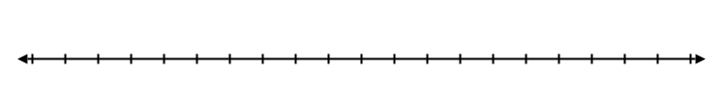

b)    

**Practice #2 – Radicals**

Level 2/3

1. Write each radical in simplest form, if possible. Tell whether each number is rational or irrational.

a)  b)  c) 

d)  e)  f) 

g)  h)  i) 

j)  k)  l) 

Level 4

2. A student simplified  as shown:



Identify the errors the student made, then write a correct solution.

**Practice #3 – Radicals**

Level 2

1. Write each mixed radical as an entire radical.

a)  b)  c) 

d)  e)  f) 

g)  h)  i) 

Level 4

2. Can every mixed radical be expressed as an entire radical? Explain.

3. Can every entire radical be expressed as a mixed radical? Explain.

**Practice #4 – Radicals**

Level 4

1. Create a decimal form of an irrational number.

2. The Rubik’s Cube is a mechanical puzzle. Calculate the edge length of a Rubik’s Cube with a volume of 38.44 cm3, to three decimal places.

3. Police can estimate the speed of a car by the length of the skid marks made when the driver braked. The formula is . In this formula, v is the speed, in miles per hour, d is the length of the skid marks, in feet, and f is the coefficient of friction. What was the speed of a vehicle if the skid marks were 75 feet long and the coefficient of friction was 0.7?

4. The amount of current, I, in amperes, that an application used can be calculated by the formula , where P is the power, in watts, and R is the resistance, in ohms. How much current does an appliance use if P = 120W and R = 3 ohms? Express your answer to one decimal place.

5. How do you determine whether a radical represents a rational or an irrational number? Use examples to explain.

6. How can you determine whether the decimal form of a radical represents its exact value?

7. Draw a diagram that represents the relationship of the following: Real numbers, natural numbers, whole numbers, integers, rational numbers and irrational numbers.

**Answers**

**Practice #1**

1a) 3.464101615; irrational because 12 is not perfect square

b) 2; rational because 16 has a fourth root of 2

c) -4.641588834; irrational because -100 is not a perfect cube

d)  = 0.66666; rational because is a perfect square

e) 1.118033989; irrational because 1.25 is not a perfect square f) 1.25; rational

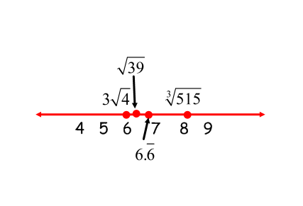2a)  ;  is irrational

b)  ;  is irrational

3a)  and  are irrational

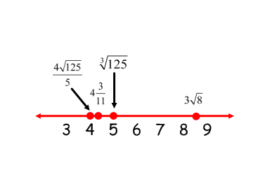

b)  is irrational

**Practice #2**

1a)  irrational b)  irrational c) 40 rational

d) irrational e)  irrational f)  irrational

g) 7 rational h)  irrational i)  irrational

j)  irrational k)  rational l)  irrational

2) 96≠4 x 48 and ; should be 

**Practice #3**

1a)  b)  c) 

d)  e)  f) 

g)  h)  i) 

2) Discussion

3) Discussion

**Practice #4**

1) Various answers

2) 3.375 cm

3) 39.69 m/h

4) 6.3 amperes

5) Discussion

6) Discussion

7) Discussion

|  |  |
| --- | --- |
| **OUTCOMES** | **ASSESSMENT RUBRICS** |
| **FP10.2 Demonstrate understanding of irrational numbers in both radical (including mixed radical) and exponent forms through: representing; identifying; simplifying; ordering; relating to rational numbers; applying exponent laws** | |

|  |  |  |  |  |
| --- | --- | --- | --- | --- |
| **Level**  **Criteria** | **Intervention 1**  **Spend some extra time with the criteria and ask for help.** | **Instructional 2**  **Good start. You are beginning to make sense of this on your own. You are consistent with the basic learning goals for this outcome.** | **Independence 3**  **You did it and you did it on your own. You are able to complete the processes for this outcome. Your work is thorough and consistently accurate.** | **Mastery 4**  **Great work! This is going extra well for you. You have understood the outcome, are able to explain your strategies and apply these to situations. Your work is always accurate.** |
| **Outcome 2B:** Students will demonstrate understanding of irrational numbers in exponent form | I need more help with becoming consistent with the criteria | I am consistently able to evaluate and simplify expressions using all exponent laws including a negative or rational exponent (numerical and variable bases) where there is one step | I am consistently able to simplify expressions by applying the exponent laws (numerical and variable bases) involving more than one step, including negative and rational exponents | I am able to perform error analysis. I am able to determine which value is larger/smaller in a set of numbers. I am able to answer situational questions. I am able to explain my strategies. |

**Practice #1 - Powers**

Level 2

1. Write as a single power.

a)  b)  c)  d)  e)  f) 

g)  h) i) 

j)  k)  l) 

m)  n)  o) 

p) 

1. Write as a single power.

a)  b)  c) 

d)  e)  f) 

g)  h)  i) 

j)  k)  l) 

m)  n)  o) 

p)  q)  r) 

s)  t) 

Level 3

3. Write as a single power.

a)  b)

**Practice #2 - Powers**

Level 2

1. Write each power with a positive exponent

a)  b)  c) 

d)  e)  f) 

g)  h) 

1. Write each power with a positive exponent and then evaluate

a)  b)  c) 

d)  e)  f) 

g)  h)  i) 

j)  k)  l) 

m)  n)  o) 

p)  q)  r) 

Level 4

1. Identify the errors in each simplification. Write the correct solution.





1. Which is greater, 2-5 or 5-2? Verify your answer

5. When you save money in a bank, the bank pays you interest. This interest is added to your investment and the resulting amount also earns interest. We say the interest compounds. Suppose you want an amount of $3000 in 5 years. The interest rate for the saving account is 2.5% compounded annually. The money, P dollars, you must invest now is given by the formula: P = 3000(1.025)-5. How much money must you invest now to have $3000 in 5 years?

6. Use a pattern of your choice. Describe the relationship between a negative exponent and its equivalent form with a positive exponent.

**Practice #3 – Roots and Powers**

Level 2

1. Write each power as a radical.

a)  b)  c) 

d)  e)  f) 

g)  h) 

2. Write each radical as a power

a)  b)  c) 

d)  e)  f) 

g)  h) 

3. Evaluate each power without using a calculator

a)  b)  c) 

d)  e)  f) 

g)  h) 

4. Evaluate

a)  b)  c) 

d) 

5. Evaluate

a)  b)  c) 

d)  e)  f) 

g)  h) 

Level 2/3

6. Simplify. Write your answers with positive exponents

a)  b)  c) 

d)  e)  f) 

g)  h)  i) 

**Practice #4 – Powers**

Level 2

1. Write each power as a radical.

a)  b)  c) 

d)  e)  f) 

g)  h)  i) 

j)  k)  l) 

2. Write each radical as a power.

a)  b)  c) 

d)  e)  f) 

g)  h)  i) 

j)  k)  l) 

3. Evaluate each power without using a calculator.

a)  b)  c) 

d)  e)  f) 

g)  h) 

4. Evaluate.

a)  b)  c) 

d) 

5. Evaluate.

a)  b)  c) 

d)  e)  f) 

g)  h) 

**Practice #5 - Powers**

Level 4

1. The height, h metres, of a certain species of fir tree can be estimated from the formula , where d metres is the diameter at the base. Use the formula to determine the approximate height of a fir tree with base diameter 3.2 m.

2. Under certain conditions, the temperature, T, in degrees Celsius, of a cooling object can be modeled using the formula  In this formula, t is time, in minutes. What is the temperature:

a) after 10 min? b) after 0.25 h?

3. Here is an expression for the percent of caffeine that remains in your body n hours after you drink a caffeine beverage: 

a) What is the percent of caffeine that remains after h.

1. Use the expression to determine the percent of caffeine that remains after 1.5 h.

c) After how many hours does 50% of the caffeine remain? Explain how you know.

4. Here is a student’s solution for evaluating a power.





Identify the errors the student made. Write a correct solution.

**Practice #6 - Powers**

Level 3

1. Simplify. Write your answers with positive exponents

a)  b)  c) 

d)  e)  f) 

g)  h)  i) 

j)  k) 

Level 4

2. Identify the errors in each simplification. Write the correct solution.

a)  b)  

 



**Answers**

**Practice #1**

1a) $x^{7}$ b) $a^{-3}$ c) $b^{-2}$

d) m e) x f)

g) h) 1 i) x2

j) k) l) n

m) n) x10 o) 1

p)

2a) n6 b) c) n12

d) e) f)

g) h) i) a2b2

j) n6m3 k) c-12d-8 l) x3y-3

m) x3y6 n) a4b-4 o) m35n-5

p) x6y-15 q) a5b5 r) a-3b-5

s) mn t) a-5b2

3a) a-10b15 a) a16b-7 c3

**Practice #2**

1a) b) c)

d) e) f) x4

g) w5 h) z2

2a)  b)  c) 

d)  e)  f) 

g)  h) -  i) 

j)  k)  l) 

m)  n)  o) 

p)  q)  r) 

3) Error is in first step, did not follow order of operations, should have done power of a power for numerator and denominator first

Correct answer should be

4) 5-2

5) $2651.56

6) Discussion

**Practice #3**

1a)  b)  c) 

d)  e)  f) 

g)  h) 

2a)  b)  c) 

d)  e)  f) 

g)  h) 

3a) 4 b) 6 c) 4

d) 2 e) -3 f) -10

g)  h) 

4a) 6 b) 3 c) 

d) 

5a) 2 b) 3 c) -4

d)  e)  f) 0.2

g) -0.3 h) -10

6a) b) m2 c) m2

d) e) f)

g) h) i) $xy^{\frac{4}{3}}$

**Practice #4**

1a)  b)  c) 

d)  e)  f) 

g)  h)  i) 

j)  k)  l) 

2a)  b)  c) 

d)  e)  f) 

g)  h)  i) 

j)  k)  l) 

3a) 64 b) 7776 c) 16

d) 8 e) -243 f) -10000000

g)  h) 

4a) 216 b) 27 c) 

d) 

5a) 8 b) 9 c) -1024

d)  e)  f) 0.008

g) -0.00243 h) 100

**Practice #5**

1) 76 m

2a) 4oC b) 1.3oC

3a) 93.3% b) 81.2% c) 5 hours

4) first step; should be ; final answer is 2.744

**Practice #6**

1a) 4x2 b) c)

d) e) f)

g) h) i)

j) k)

2a) -5-2 is not equal to 10. The answer should be $\frac{b}{25a^{4}}$

b) In step 1 the exponents are not added together. The answer should be $\frac{r^{\frac{1}{2}}}{s^{\frac{5}{4}}}$

|  |  |
| --- | --- |
| **OUTCOMES** | **ASSESSMENT RUBRICS** |
| **FP10.3 Demonstrate understanding of SI and imperial units of measurement including: linear measurement; surface area of spheres, right cones, cylinders, prisms and pyramids; volume of spheres, right cones, cylinders, prisms, and pyramids; relationships between and within measurement systems** | |

|  |  |  |  |  |
| --- | --- | --- | --- | --- |
| **Level**  **Criteria** | **Intervention 1**  **Spend some extra time with the criteria and ask for help.** | **Instructional 2**  **Good start. You are beginning to make sense of this on your own. You are consistent with the basic learning goals for this outcome.** | **Independence 3**  **You did it and you did it on your own. You are able to complete the processes for this outcome. Your work is thorough and consistently accurate.** | **Mastery 4**  **Great work! This is going extra well for you. You have understood the outcome, are able to explain your strategies and apply these to situations. Your work is always accurate.** |
| **Outcome 3A:** Demonstrate understanding of SI and imperial units of measurements including linear measurement and relationships between and within measurement systems | I need more help with becoming consistent with the criteria. | I can use referents to estimate linear lengths.  I can convert when there is a single step involved in the conversion. | I can consistently convert between systems of measurements.  I can consistently measure linear lengths using appropriate measurement tools. | I can solve situational questions involving measurements and conversions.  I understand the difference between comparable measures between systems (ie. yards to metres)  I can verify my conversions. |

**Practice #1 – Measurement**

Level 2

1. Convert
2. 8040 cm to meters b) 8040 mm to cm c) 8040 cm to mm

d) 8040 m to km e) 8040 m to cm f) 8040 km to m

**Practice #2 – Measurement**

Level 2

1. Which imperial unit is the most appropriate unit to measure each item? Justify your choice.
2. The height of your desk
3. The thickness of a mattress
4. The width of a car
5. The length of a flat panel TV
6. The distance from school to your home
7. Convert:
8. 3 ft. to inches
9. 63 yd. to feet
10. 48 in. to feet
11. 2 mi. to feet

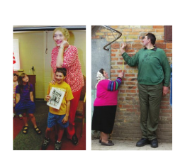Level 3

3. a) 574 in. to yards, feet, and inches

b) 7390 ft. to miles, yards, and feet

Level 4

4. In 2008, Sandy Allen and Leonid Stadnyk were the world’s tallest living woman and man. Their respective heights are 7 ft. 7 in. and 8 ft. 5 in. How many inches shorter is Sandy than Leonid?

5. Carolyn is building a pen for her dog. The perimeter of the pen is 52 ft.

1. Convert the perimeter to yards and feet.
2. The fencing material is sold by the yard. It costs $10.99/yd. What is the cost of the material before taxes?

**Practice #3 – Measurement**

Level 3

1. Convert each measurement. Answer to the nearest tenth.
2. 16 in. to cm
3. 4 ft. to m
4. 5 yd. to m
5. 1650 yd. to km
6. 6 mi. to km
7. 2 in. to mm
8. Convert each measurement.
9. 25 mm to the nearest inch
10. 2.5 m to the nearest foot
11. 10 m to the nearest yard
12. 150 km to the nearest mile
13. Convert each measurement. Answer to the nearest tenth.
14. 1 ft. 10 in. to cm
15. 2 yd. 2 ft. 5 in. to cm
16. 10 yd. 1 ft. 7 in. to m

Level 4

1. The Fraser River is approximately 1375 km long. The Tennessee River is approximately 886 mi. long. Which river is longer? Justify your answer.
2. A retail fabric store advertises a storewide sale. It lists a certain material for $0.89/yd. A fabric warehouse is selling the same material for $0.93/m. Which store has the better price? Justify your answer.

**Answers**

**Practice #1**

1a) 80.4 m b) 804 cm c) 80400 mm

d) 8.04 km e) 804000 cm f) 8040000 m

**Practice #2**

1) Answers may vary. For example:

a) foot

b) inch

c) foot

d) inch

e) mile

2a) 36 in. b) 189 ft. c) 4 ft. d) 10560ft.

3a) 15 yd. 2 ft. 10 in. b) 1 mi. 703 yd. 1 ft.

4) 10 in.

5a) 17 yd. 1 ft. b) $197.82

**Practice #3**

1a) 40.6 cm b) 1.2 m c) 4.6 m

d) 1.5 km e) 9.7 km f) 50.8 mm

2a) 1 in. b) 8 ft. c) 11 yd. d) 93 mi.

3a) 55.9 cm b) 256.5 cm c) 9.6 m

4) Tennessee River

5) The warehouse

|  |  |
| --- | --- |
| **OUTCOMES** | **ASSESSMENT RUBRICS** |
| **FP10.3 Demonstrate understanding of SI and imperial units of measurement including: linear measurement; surface area of spheres, right cones, cylinders, prisms and pyramids; volume of spheres, right cones, cylinders, prisms, and pyramids; relationships between and within measurement systems** | |

|  |  |  |  |  |
| --- | --- | --- | --- | --- |
| **Level**  **Criteria** | **Intervention 1**  **Spend some extra time with the criteria and ask for help.** | **Instructional 2**  **Good start. You are beginning to make sense of this on your own. You are consistent with the basic learning goals for this outcome.** | **Independence 3**  **You did it and you did it on your own. You are able to complete the processes for this outcome. Your work is thorough and consistently accurate.** | **Mastery 4**  **Great work! This is going extra well for you. You have understood the outcome, are able to explain your strategies and apply these to situations. Your work is always accurate.** |
| **Outcome 3B:** Demonstrate understanding of surface area and volume | I need more help with becoming consistent with the criteria. | I can consistently find the surface area and volume when the necessary dimensions are given. | I can consistently find the surface area and volume of right pyramids, right cones, right prisms, cylinders and spheres | I can accurately determine an unknown measurement given the surface area/volume and some measurements.  I can solve situational questions involving surface area/volume.  I can find the surface area/volume of composite objects |

**Practice #1 – Surface Area and Volume**

Level 2

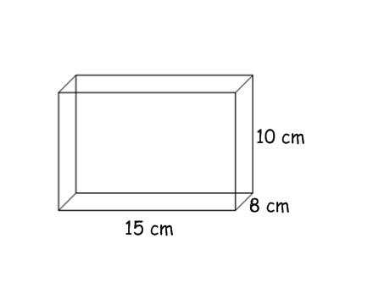

1. Find the surface area of the following rectangular prism:

2. Find the surface area of the following cylinder

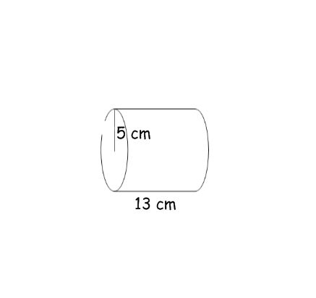

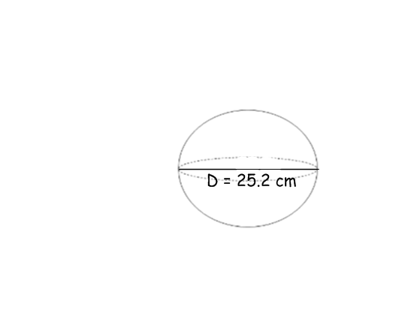3. Find the surface area of the following sphere

4. Find the surface area of the following cone

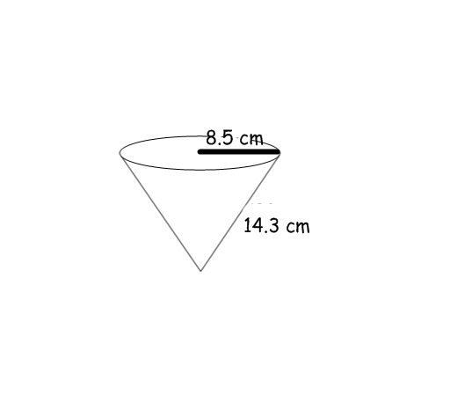

5. Find the surface area of the following pyramid

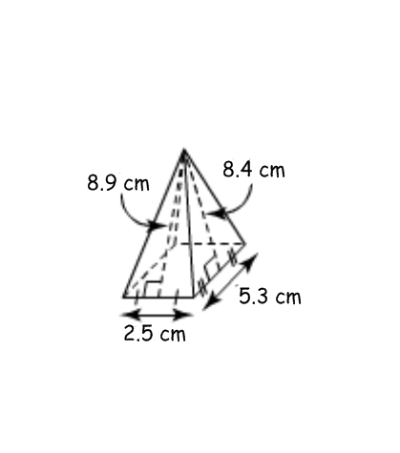

**Practice #2 – Surface Area and Volume**

Level 2

Find the volume of each object in Practice #1.

**Answers**

**Practice #1**

1. 700 cm2
2. 565.2 cm2
3. 1994.0256 cm2

4) 608.532 cm2

5) 80.02 cm2

**Practice #2**

1. 1200 cm3
2. 1020.5 cm3
3. 8374.90752 cm3

4) 869.65 cm3

5) 36.66 cm3 or 37.54 cm3 (diagram not to scale)

|  |  |
| --- | --- |
| **OUTCOMES** | **ASSESSMENT RUBRICS** |
| **FP10.4 Develop and apply the primary trigonometric ratios (sine, cosine, tangent) to solve problems that involve right triangles.** | |

|  |  |  |  |  |
| --- | --- | --- | --- | --- |
| **Level**  **Criteria** | **Intervention 1**  **Spend some extra time with the criteria and ask for help.** | **Instructional 2**  **Good start. You are beginning to make sense of this on your own. You are consistent with the basic learning goals for this outcome.** | **Independence 3**  **You did it and you did it on your own. You are able to complete the processes for this outcome. Your work is thorough and consistently accurate.** | **Mastery 4**  **Great work! This is going extra well for you. You have understood the outcome, are able to explain your strategies and apply these to situations. Your work is always accurate.** |
| **Outcome 4:** Demonstrate understanding of how to develop and apply the primary trigonometric ratios (sine, cosine, tangent) to solve problems that involve right triangles. | I need more help with becoming consistent with the criteria. | I can apply relationships between the ratios of side lengths and angle sizes in similar right triangles.  I can demonstrate how to identify the hypotenuse of a right triangle and the adjacent and opposite sides to an acute angle in that right triangle.  I can set up the trig ratios correctly.  I can use my calculator to find trig ratio values and measures of angles. | I am able to consistently solve problems for a missing value involving one right triangle by applying the primary trigonometric ratios and/or the Pythagorean Theorem | I am able to consistently solve right triangles.  I am able to create and solve problems that involve indirect and direct linear measurements by using the primary trigonometric ratios, the Pythagorean Theorem, and measurement instruments.  I am able to explain and analyze problems involving right triangles.  I can solve problems involving more than one right triangle. |

**Practice #1 - Trigonometry**

Level 2

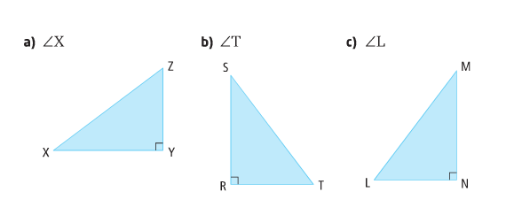1. Identify the hypotenuse, opposite, and adjacent sides associated with each specified angle.

2. Determine each tangent ratio to four decimal places using a calculator

a) tan 74o b) c)

d) tan 45o e) tan 60o f)

g) tan 89o h) i) tan 37o

j) k) tan 18o l)

1. Write each trigonometric ratio in lowest terms

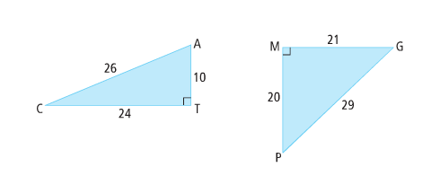

a) sin A b) tan C c)sin C

d)tan P e) cos C f)cos G

g)tan G h) sin P i) cos P

Level 3

4. Determine the length of XY to the nearest tenth of a centimeter.

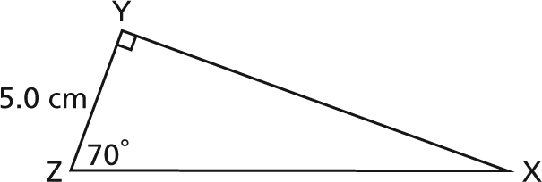

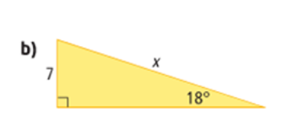5. Determine each length of x. Express your answer to the nearest tenth of a unit.

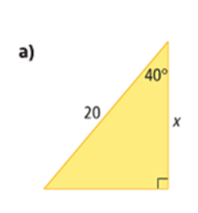

6. Determine the length of VX to the nearest tenth of a centimeter.

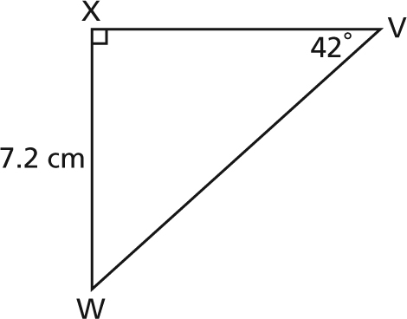

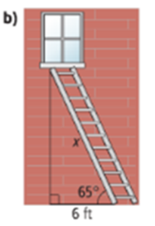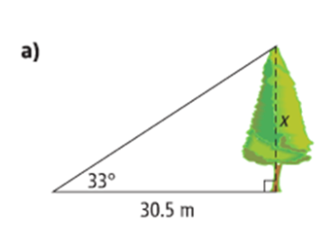7. Determine the value of each variable. Express your answer to the nearest tenth of a unit.

Level 4

1. Oil rigs are found throughout Alberta. They play a crucial role in the search for crude oil and natural gas products. Determine the height of a rig if a 52m long guy wire is attached to the top of the rig and forms an angle of 50o with the ground. Express your answer to the nearest tenth of a metre.

9. At Wapiti Valley Ski Area in Saskatchewan, the beginner slope is inclined at an angle of 11.6o from the horizontal and the advanced slope at an angle of 26.9o from the horizontal.

a) Suppose Francis skis 1200 m down the advanced slope while Barbara skis the same distance down the beginner slope. Predict who will cover a greater horizontal distance. Justify your prediction.

b) Calculate the difference between the horizontal distances for the two skiers, to the nearest tenth of a metre.

**Practice #2 – Trigonometry**

Level 2

1. Calculate the measure of each angle, to the nearest degree.

a) cos A = 0.4621 b) tan A = 0.7 c) cos B = 0.6779

d) $tanθ=1.75$ e) sin A = 0.5543 f) $tanB=0.5543$

g) sin C = 1.232 h)  i) 

Level 3

2. Determine the measures of <K and <N to the nearest degree.

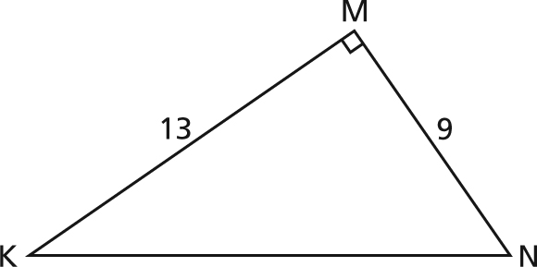

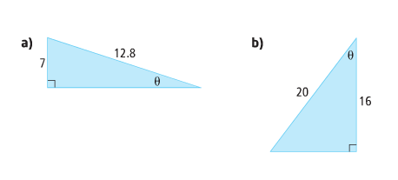3. Determine the measure of each angle . Express your answer to the nearest tenth of a degree.



4. Determine the value of each variable. Express each answer to the nearest tenth of a unit.

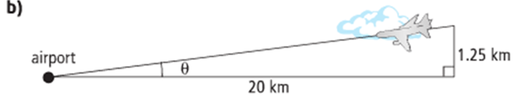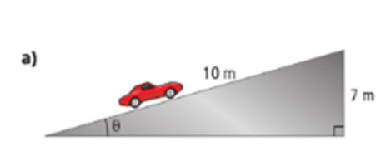

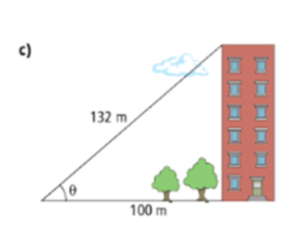

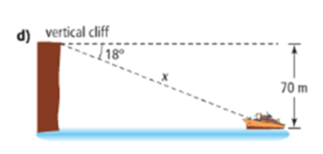

Level 4

5. A support cable is anchored to the ground 5 m from the base of a telephone pole.   
The cable is 19 m long. It is attached near the top of the pole. What angle, to the nearest degree, does the cable make with the ground?

1. The Idaa Trail is a traditional route of the Dogrib, an Athapaskan-speaking group of Dene. It stretches from Great Bear Lake to Great Slave Lake, in the Northwest Territories. Suppose a hill of the trail climbs 148 ft vertically over a horizontal distance of 214 ft.

a) Calculate the angle of steepness of the hill.

b) How far would you have to climb to get to the top of the hill?

7. An observer is sitting on a dock watching a float plane in Vancouver harbour. At a certain time, the plane is 300 m above the water and 430 m from the observer. Determine the angle of elevation of the plane measured from the observer, to the nearest degree.

8. When can you use the sine ratio to determine the measure of an acute angle in a right triangle? When can you use the cosine ratio?

9. Explain when you might use the sine or cosine ratio instead of the tangent ratio to determine the length of a side in a right triangle. Include examples.

**Practice #3 – Trigonometry**

Level 4

1. A surveyor needs to determine the height of a large grain silo. He positions his transit 65m from the silo and records an angle of elevation of 52o. If the height of the transit is 1.7m, determine the height of the silo, to the nearest metre.

2. A balloonist decides to use an empty football field for his landing area. When the balloon is directly over the goal post, he measures the angle of depression to the base of the other goal post to be 53.8o. Given that the distance between goal posts in a Canadian football field is 110 yd, determine the height of the balloon.

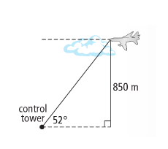

3. An airplane is observed by an air traffic controller at an angle of elevation of 52o. The airplane is 850 m above the observation deck of the tower. What is the distance from the airplane to the tower? Express your answer to the nearest metre.

4. Cape Beale Lighthouse, BC, is on a cliff that is 51 m above sea level. The lighthouse is there to warn boats of the danger of shallow waters and the possibility of rocks close to the shore. The safe distance for boats from this cliff is 75 m. If the lighthouse keeper is 10 m above ground and observes a boat at an angle of depression of 50o, is the boat a safe distance from the cliff? Justify your conclusion.

5. At night, it is possible to make precise measurements of cloud height using a search light. An alidade is set 720 ft away from the search light. It measures the angle of elevation to the place where the light strikes the cloud to be 35o. What is the altitude of the cloud? Express your answer to the nearest foot.

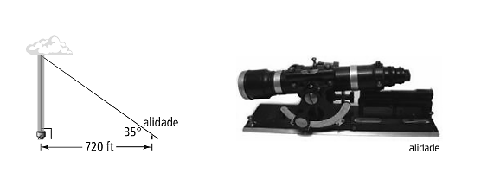

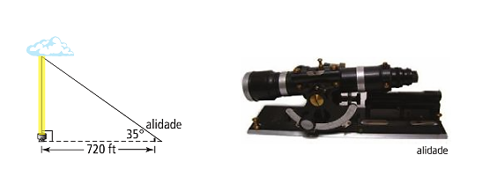

**Practice #4 – Trigonometry**

Level 3

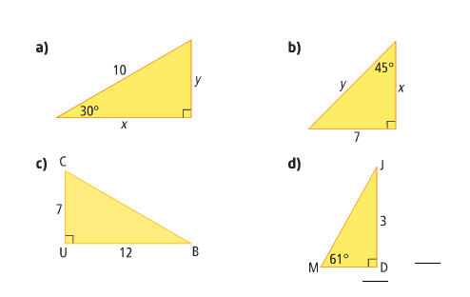1. Solve each triangle, to the nearest tenth of a unit.



Level 4

2. Calculate the length of BC, to the nearest tenth of a centimetre

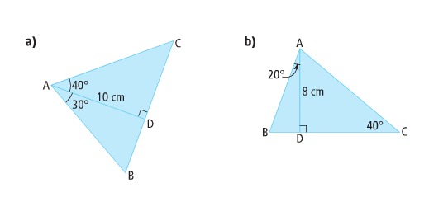

3. Determine the measure of <CAB to the nearest degree.

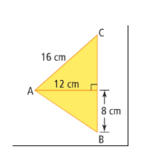

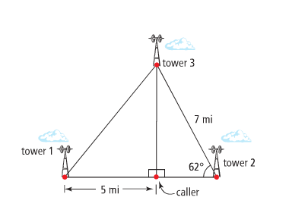4. A cell phone can be used to send music, but as your location changes, you move in and out of range from one cell to the next. Three or more cellular towers may pick up a cell phone’s signal. A cell phone signal has been located 5 mi from tower 1.

1. What is the distance from the caller to tower 3?
2. How far is tower 1 from tower 3?

5. When we solve a right triangle, sometimes we determine the measure of an unknown angle before we determine the length of an unknown side and sometimes we reverse these calculations. How would you decide which measure to calculate first?

6. Can we solve a right triangle is we are given only the measures of the two acute angles? Explain.

7. How does the information you are given about a right triangle determine the steps you take to solve the triangle? Include examples with your explanation.

**Answers**

**Practice #1**

1a) hypotenuse – XZ; opposite – YZ; adjacent - XY

b) hypotenuse – ST; opposite – RS; adjacent - RT

c) hypotenuse – LM; opposite – MN; adjacent - LN

2a) 3.4874 b) 0.8290 c) 0.3355

d) 1 e) 1.7321 f) 0.5534

g) 57.2900 h) 0.8902 i) 0.75355

j) 0.1736 k) 0.3249 l) 1

3a) $\frac{12}{13}$ b) $\frac{5}{12}$ c) $\frac{5}{13}$ d) e) f)

g) h) i)

4) XY=13.7

5) a) 15.3 b) 22.7

6) 8.0

7a) 19.8 b) 14.2

8) 39.8

9a) Barbara b) 105.3 m

**Practice #2**

1a) 62 b) 35 c) 47 d) 60 e) 34 f) 29

g) undefined h)30 i)41

2.

3. a) 33.2 b) 36.9

4a) 44.4 b) 3.6 c) 40.7 d) 226.5

5. 74.7

6a) 34.7 b) 260.0 m

7) 44

8) Discussion

9) Discussion

**Practice #3**

1) 85m

2) 150 yd.

3) 1079 m

4) No, because it is approx. 51.2 m from the cliff

5) 504 ft.

**Practice #4**

1a) missing angle – 60; y = 5; x = 8.7

b) missing angle – 45; y = 9.9; x = 7

c) <C = 59.7; <B = 30.3; CB = 13.9

d) <J = 29; MD = 1.7; JM = 3.4

2a) 14.2 cm b) 12.4 cm

3) 75

4a) 6.2 mi b) 7.9

5) Discussion

6) Discussion

7) Discussion

8) Discussion

|  |  |
| --- | --- |
| **OUTCOMES** | **ASSESSMENT RUBRICS** |
| **FP10.5 Demonstrate understanding of the multiplication and factoring of polynomial expressions (concretely, pictorially, and symbolically) including: multiplying of monomials, binomials, and trinomials; common factors; trinomial factoring; relating multiplication and factoring of polynomials** | |

|  |  |  |  |  |
| --- | --- | --- | --- | --- |
| **Level**  **Criteria** | **Intervention 1**  **Spend some extra time with the criteria and ask for help.** | **Instructional 2**  **Good start. you are beginning to make sense of this on your own. You are consistent with the basic learning goals for this outcome.** | **Independence 3**  **You did it and you did it on your own. You are able to complete the processes for this outcome. Your work is thorough and consistently accurate.** | **Mastery 4**  **Great work! This is going extra well for you. You have understood the outcome, are able to explain your strategies and apply these to situations. Your work is always accurate.** |
| **Outcome 5A:** Students will demonstrate an understanding of the multiplication of monomials, binomials, and trinomials concretely, pictorially and symbolically. | I need more help with becoming consistent with the criteria. | I am consistent with multiplying monomials by polynomials  I am consistent with the process of how to multiply binomials by binomials, but  I make consistent mistakes, maybe with signs | I am consistent with multiplying binomials by binomials | I am able to simplify, model and explain multiplying polynomials. Some ways I might show this are:  I am able to multiply all types of polynomials accurately.  I am able to perform error analysis on multiplication of polynomials.  I am able to show multiplication pictorially, concretely and symbolically.  I can explain the relationship of binomial multiplication to two digit number multiplication. |

**Practice #1 - Multiplying Polynomials**

Level 2

1. Simplify

a) 5(x + 3) b) 2(m + 5) c) -3(n + 1)

d) 6(x – 5) e) 3(m – 2) f) -2(c – 3)

g) 5(x + y + 3) h) 2(m + n + 5) i) -3(c + d + 2)

j) 4(e – f – 3) k) 2(m – n + 2) l) -5(x + y – 4)

m) 3(3x + 4) n) 2(4m – 6) o) -5(2x – 3)

p) 5(2x – 3y + 2) q) 6(3x + 2y – 5) r) -2(4m – n + 3)

**Practice #2 - Multiplying Polynomials**

Level 2

1. Simplify

a) 2x(x + 5) b) 3m(m – 2) c) 4y(y + 2)

d) 3x(2x + 4) e) 5c(2c – 3) f) 3x(5x – 2)

g) -2n(4n – 5) h) -3m(2m + 5) i) -5x(3x – 2)

j) -3x(-2x + 5) k) 4x(-2x – 3) l) -6n(4n + 6)

m) 3b(4b + 5c – 2) n) 2h(3h – 5j + 7) o) 7x(-2x + 5y – 7)

p) 5xy(3x + 2y – 7) q) -2mn(3m – 5n + 7) r) 3gh(-5h + 2g – 5)

s) 3x2y3(2x + 5y) t) 4m2n7(3m2 + 5n2) u) -3h2j7(3hj2+2h–4j6)

v) -2a3b6c2(4ab + 4b2c5 – 2a7c2)

**Practice #3 - Multiplying Polynomials**

Level 3

1. Multiply.

a) (x – 2)(x + 3) b) (x – 5)(x – 2) c) (x + 4)(x + 7)

d) (3x – 4)(2x – 1) e) (2x – 5)(x – 3) f) (x + 1)(x – 2)

g) (x – 3)(x – 4) h) (x + 4)(x – 3) i) (2v + 3)(v + 2)

j) (3r + 1)(r + 4) k) (2g + 3)(3g + 2) l) (3t + 4)(3t + 4)

m) (2g – 5)(3g – 3) n) (12 + h)(7 – h) o) (11 – j)(2 – j)

p) (3 + m)(5 – m) q) (-4 – 2h)(-2 – 4h) r) (-m + 5)(4m – 1)

s) ( 5- r)(6 + r) t) (-y + 1)(-3y – 1)

Level 4

2. Model the following (use algebra tiles or area model).

a) (x + 2)(x + 3) b) (2x + 5)(3x + 1)

3. Find and correct the errors in each expansion.

a) (r – 13)(r + 4) = r2 + 4r – 13r + 52

= r2 + 9r + 52

b) (s – 15)(s – 5) = s2 – 15s + 15s + 75

= s2 + 75

c) (p + 3)(p + 7) = p2 + 7p + 3p + 21

= p2 + 10p + 21

= 11p2 + 21

4. Explain the relationship between the multiplication of two binomial expressions and the area of a rectangular region.

**Practice #4 - Multiplying Polynomials**

Level 3/4

1. Simplify

a) (c + 1)(c2 + 3c + 2) b) (2y + 11)(j2 + 3j + 1)

c) (2x – 3)(3x2 + 7x + 2) d) (5 – 4r)(6 + 3r – 2r2)

e) (4m – p)2 f) (3g – 4h)(2g + 3h)

g) (y – 2z)(y + z – 2) h) (x – 3)(6x2 – 4x – 12)

i) (2y2 + 3y – 1)(y2 + 4y + 5) j) (4s2 + s)(3s2 – 2s + 6)

2. The product of 45 and 34 can be thought of as (40 + 5)(30 + 4). You can represent 40 + 5 as 4t + 5 where t represents 10.

a) What expression could represent 30 + 4?

b) Use binomial multiplication of the algebraic expression. Substitute to find the product of 45 and 34.

3. Rachel’s solution to the multiplication of a binomial and a trinomial is shown below.

(4x – 1)(2x2 + 11x – 7) = 8x3 + 44x – 24x – 2x2 – 11x + 6

= 6x2 – 9x + 6

a) Check Rachel’s solution for x = 2

b) Does Rachel have a correct solution? If not, identify her error and provide the correct product in simplified form.

**Practice #5 - Multiplying Polynomials**

Level 3/4

1. Expand and simplify

a) (3x + 5)(2x + 2) + (3x + 7)(x + 6) b) (2x + 3)(5x + 4) + (x – 4)(3x – 7)

c) (4y – 5)(3y + 2) – (3y + 2)(4y – 5) d) (3x – 2)2 – (2x + 6)(3x – 1)

e) 2a(2a – 1)(3a + 2) f) -3r(r – 1)(2r + 1)

g) 5x2(2x – 1)(4x – 3) h) -xy(2x + 5)(4x – 5)

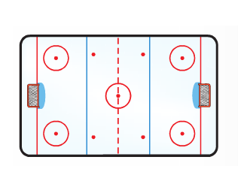2. The length of the ice surface of a hockey rink is represented by 5x + 25. The width is represented by 2x + 10. What expression represents the area of the ice surface?

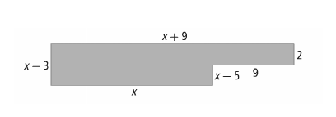

3. Write an expression to represent the area of the figure. Simplify.

**Answers**

**Practice #1**

1a) 5x + 15 b) 2m + 10 c) -3n – 3

d) 6x – 30 e) 3m – 6 f) -2c + 6

g) 5x + 5y + 15 h) 2m + 2n + 10 i) -3c – 3d – 6

j) 4e – 4f – 12 k) 2m – 2n + 4 l) -5x – 5y + 20

m) 9x + 12 n) 8m – 12 o) -10 + 15

p) 10x – 15y + 10 q) 18x + 12y – 30 r) -8m + 2n – 6

**Practice #2**  
1a) 2x2 + 10x b) 3m2 – 6m c) 4y2 + 8y

d) 6x2 + 12x e) 10c2 – 15c f) 15x2 – 6x

g) -8n2 + 10n h) -6m2 – 15m i) -15x2 + 10x

j) 6x2 – 15x k) -8x2 – 12x l) -24n2 – 36n

m) 12b2 + 15bc – 6b n) 6h2 – 10hj + 14h o) -14x2 + 35xy – 49x

p) 15x2y + 10xy2 – 35xy q) -6m2n + 10mn2 – 14mn r) -15gh2 + 6g2h – 15gh

s) 6x3y3 + 15x2y4 t) 12m4n7 + 20m2n9 u) -9h3j9 – 6h3j7 + 12h2j13

v) -8a4b7c2 – 8a3b8c7 + 4a10b6c4

**Practice #3**

1a) x2 + x – 6 b) x2 – 7x + 10 c) x2 + 11x + 28

d) 6x2 – 11x + 4 e) 2x2 – 11x + 15 f) x2 – x – 2

g) x2 – 7x + 12 h) x2 + x – 12 i) 2v2 + 7v + 6

j) 3r2 + 13r + 4 k) 6g2 + 13g + 6 l) 9t2 + 24t + 16

m) 6g2 – 21g + 15 n) 84 – 5h – h2 o) 22 – 13j + j2

p) 15 + 2m – m2 q) 8 + 20h + 8h2 r) -4m2 + 21m – 5

s) 30 – r – r2 t) 3y2 – 2y – 1

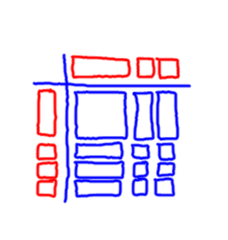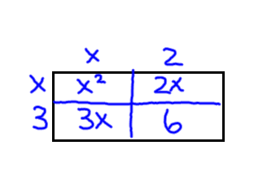2a) or (x + 2)(x + 3) = x2 + 5x + 6

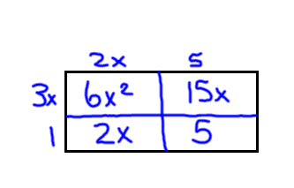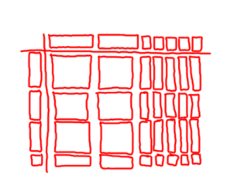b) or (2x + 5)(3x + 1) = 6x2 + 17x + 5

3a) first step, 52 should be -52;

second step, 4r – 13r is not 9r, it is -9r;

final answer should be r2 – 9r – 52

b) first step should be s2 – 15s – 5s + 75;

final step should be s2 – 20s + 75

c) answer is the second step;

third step is eliminated

4) various answers

**Practice #4**

1a) c3 + 4c2 + 5c + 2 b) 2j2y + 6jy + 2y + 11j2 + 33j + 11

c) 6x3 + 5x2 – 17x – 6 d) 8r3 – 22r2 – 9r + 30

e) 16m2 – 8mp + p2 f) 6g2 + gh – 12h2

g) y2 – yz – 2y – 2z2 + 4z h) 6x3 – 22x2 +36

i) 2y4 + 11y3 + 21y2 + 11y – 5 j) 12s4 – 5s3 + 22s2 + 6s

2a) 3t + 4 b) 1530

3a) 161 12 b) 4x(11x) = 44x2 not 44x;

4x(-7) = -28x not -24x;

(-1)(-7) = 7 not 6

Correct: 8x3 + 42x2 – 39x + 7

**Practice #5**

1a) 9x2 + 41x + 52 b) 13x2 + 4x + 40

c) 0 d) 3x2 – 28x + 10

e) 12a3 + 2a2 – 4a f) -6r3 + 3r2 + 3r

g) 40x4 – 50x3 + 15x2 h) -8x3y – 10x2y + 25xy

2) 10x2 + 100x + 250

3) x(x – 3) + 2(9); x2 – 3x + 18

|  |  |
| --- | --- |
| **OUTCOMES** | **ASSESSMENT RUBRICS** |
| **FP10.5 Demonstrate understanding of the multiplication and factoring of polynomial expressions (concretely, pictorially, and symbolically) including: multiplying of monomials, binomials, and trinomials; common factors; trinomial factoring; relating multiplication and factoring of polynomials** | |

|  |  |  |  |  |
| --- | --- | --- | --- | --- |
| **Level**  **Criteria** | **Intervention 1**  **Spend some extra time with the criteria and ask for help.** | **Instructional 2**  **Good start. You are beginning to make sense of this on your own. You are consistent with the basic learning goals for this outcome.** | **Independence 3**  **You did it and you did it on your own. You are able to complete the processes for this outcome. Your work is thorough and consistently accurate.** | **Mastery 4**  **Great work! This is going extra well for you. You have understood the outcome, are able to explain your strategies and apply these to situations. Your work is always accurate.** |
| **Outcome 5B:** Students will demonstrate an understanding of factoring concretely, pictorially and symbolically. | I need more help with becoming consistent with the criteria. | I am consistent with factoring 2 of the 3 types of polynomial factoring (GCF, trinomials, difference of squares) where there is only one method to the question (ie. I only have to do GCF or box method ONCE in the question) | I am consistent with factoring polynomials where there is only one method to the question.  I am able to perform the first step in a multiple strategy question (ie. where you have to do GCF and then factor a trinomial, or where you have to continue difference of squares more than once) | I am consistent with factoring polynomials of all types and any number of steps.  I am able to perform error analysis.  I am able to explain the relationship between multiplying and factoring polynomials |

**Practice #1 - Factoring Polynomials**

Level 2/3

1. Factor the following. You may use algebra tiles to assist you if necessary.

a) v2 + 2v + 1 b) v2 + 4v + 4 c) x2 + 6x + 9

d) x2 + 8x + 16 e) m2 + 13m + 40 f) y2 + 12y + 27

2. Factor the following.

a) x2 + 19x – 20 b) x2 + 15x – 54 c) x2 + 12x – 28

d) n2 – 5n – 24 e) a2 – a – 20 f) y2 – 2y – 48

g) a2 + a – 20 h) y2 + 2y – 48 i) m2 – 15m + 50

j) a2 – 12a + 36 k) 12 + 13k + k2 l) -16 – 6g + g2

m) 60 + 17y + y2 n) -72 – z + z2 o) m2 – 7m – 60

p) w2 – 14w + 45 q) b2 + 9b – 36 r) h2 – 10h – 24

Level 4

3. Can you find a pattern that would lead to a more efficient/quicker way to factor these?

4. Factor and then verify.

a) q2 + 6q + 8 b) n2 – 4n – 45 c) k2 – 9k - 90

**Practice #2 - Factoring Polynomials**

Level 2/3

1. Factor the following

a) 3m2 + 4m + 1 b) 2n2 + 13n + 6 c) 2y2 + 5y + 2

d) 2a2 + 11a + 12 e) 2m2 – 11m + 12 f) 5a2 – 7a – 6

g) 5s2 + 19s – 4 h) 14c2 – 19c – 3 i) 8a2 + 18a – 5

j) 8r2 – 14r + 3 k) 6d2 + d – 5 l) 15e2 – 7e – 2

m) 14y2 – 13y + 3 n) 10p2 – 17p – 6 o) 10r2 – 33r – 7

Level 4

2. Find and correct the errors in each factorization

a) 6u2 + 17u – 14 = (2u – 7)(3u + 2)

b) 3k2 – k – 30 = (3k – 3)(k + 10)

c) 4v2 – 21v + 20 = (4v – 4)(v + 5)

3. a) Evaluate 12x2 – 17x – 5 when x = 3

b) Factor 12x2 – 17x – 5

c) If we evaluate the factored form of 12x2 – 17x – 5 when x = 3, what do you think the answer will be? Explain why and prove your answer.

**Practice #3 - Factoring Polynomials**

Level 2/3

1. Factor

a) 81m2 – 49 b) 25m2 – 36 c) t2 – 25

d) x2 – 49 e) q2 – 1 f) c2 – 36

g) b2 – 121 h) 9d2 – 16f2 i) 144a2 – 9b2

j) 81k2 – 49m2  k) v2 – 36t2 l) 4j2 – 225h2

m) 100y2 – 81z2 n) 121m2 – n2 o) 25m2 – 64n2

Level 4

2. Do you see any patterns that would lead you to a more efficient/quicker method for factoring these types?

3. Factor and verify

a) 16v2 – 49 b) x2 – 9

4. Explain how difference of squares can be factored using trinomial factoring strategies.

**Practice #4 - Factoring Polynomials**

Level 2/3

1. Factor the following. You can use the box method or a more efficient method if you recognize the polynomial.

a) 4k2 – 7k + 3 b) 4b2 – 5b – 6 c) 4b2 – 81

d) 9g2 – 16h2 e) f2 + 17f + 16 f) c2 – 13c + 22

g) g2 + 6gh + 9h2 h) 16j2 – 24jk + 9k2 i) 6x2 – 13x – 5

j) m2 – 14m + 49 k) n2 + 10m + 25 l) 6a2 – 31a + 5

m) x2 + 4x + 1 n) 4k2 – 7k + 3 o) f2 + 17f + 16

p) 6x2 – 17xy + 5y2 q) h2 – 25j2 r) 16r2 + 8rt + t2

2. Factor and verify

a) m2 – 14m + 49 b) 4p2 + 12p + 9

Level 4

3. Critique the statement “any trinomial can be factored into two binomial factors”.

**Practice #5 - Factoring Polynomials**

Level 2/3

1. Factor the following:

a) 15n – 6 b) 5y + 10 c) 9k + 6

d) 6 + 12x2 e) 4m2 + 14m f) 3h + 7h2

g) 9m2 – 12m3 h) 48x2 – 24 i) -a2 – a3

j) 3x2 + 6x4 k) 8y3 – 12y l) -7d – 14d4

m) 3x2 + 12x – 6 n) 4 – 6y – 8y2 o) -7m – 7m2 – 14

p) 10n – 6 – 12n2 q) 6v4 + 7v – 8v3 r) 24x + 30x3– 2x4

s) 25xy + 15x2 – 30x2y2 t) 9a4b2 – 6a3b5 + 12a2b6

u) 10a3b2 + 12a5b3 – 5a2b2 v) 7r3s2 + 14r2s2 – 21rs2

Level 4

2. Here are a student’s solutions for factoring polynomials. Identify the errors in each solution. Write a correct solution.

a) Factor: 3m2 + 9m3 – 3m

Solution: 3m(m + 3m2)

b) Factor: -16 + 8n – 4n3

Solution: -4(4 + 2n + n2)

3. Factor the following:

a) 32 + 20 b) 48 + 36 c) 18 + 45

4. Can every binomial be factored? Explain.

**Practice #6 - Factoring Polynomials**

Level 4

1. Factor completely

a) 15a2 – 65a + 20 b) 18h2 + 15h – 18 c) 12m2 –52m – 40

d) 24g2 – 2g – 70 e) 4x2 + 4x – 48 f) -5n2 + 40n – 35

g) -3m2 – 18m – 24 h) 10x2 + 80x + 120 i) 7x2 – 35x + 42

j) 18m2 – 2n2 k) 16x4 – m8 l) x8 – y8

m) 16m8 – 81 n) 2m4 – 8n8

2. Explain why it is important to look for common factors first when factoring a trinomial.

**Practice #7 – Factoring Polynomials**

Level 3/4

1. Factor fully. Use the strategy that you prefer.

a) 9k + 6 b) 3x2 – 6x4 c) -3c2 – 13c4–12c3

d) x2 + 12x – 28 e) y2 – 2y – 48 f) 8a2 + 18a – 5

g) 15a2 – 65a + 20 h) s2 + 11s + 30 i) 2x2 + 14x + 6

j) 3x2 + 15x – 42 k) 15a3 – 3a2b – 6ab2 l) w2 + 10w – 24

m) 3c2d – 10cd – 2d n) f2 + 17f + 16 o) 4t2 + 9t – 28

p) h2 – 25j2 q) 6x2 – 17xy + 5y2 r) 28a2 – 7a3

s) 25t2 + 20tu + 4u2 t) 3x2 – 3x – 60 u) 18m2 – 2n2

2. Factor and verify

a) c2 – 13c + 22 b) 4t2 + 9t – 28 c) h2 – 25j2

Level 4

3. Explain, using examples, how the processes of factoring and multiplication are related.

4. Which strategies can you use to factor a trinomial? Give an example of when you might use each strategy to factor a trinomial.

**Answers**

**Practice #1**

1a) (v + 1)2 b) (v + 2)2 c) (v + 3)2

d) (x + 4)2 e) (m + 8)(m + 5) f) (y + 9)(y + 3)

2a) (x + 20)(x – 1) b) (x + 18)(x – 3) c) (x + 14)(x – 2)

d) (n – 8)(n + 3) e) (a – 5)(a + 4) f) (y – 8)(y + 6)

g) (a + 5)(a – 4) h) (y + 8)(y – 6) i) (m – 10)(m – 5)

j) (a – 6)2 k) (12 + k)(1 + k) or (k + 12)(k + 1) l) (-8 + g)(2 + g) or (g- 8)(g+2)

m) (12 + y)(5 + y) or (y + 12)(y + 5) n) (-9 + z)(8 + z) or (z – 9)(z + 8) o) (m – 12)(m + 5)

p) (w – 9)(w – 5) q) (b + 12)(b – 3) r) (h – 12)(h + 2)

3) Discussion

4a) (q + 4)(q + 2) b) (n – 9)(n + 5) c) (k – 15)(k + 6)

Verify: q2 + 2q + 4q + 8 Verify: n2 + 5n – 9n – 45 Verify: k2 + 6k – 15k–90

q2 + 6q + 8 n2 – 4n – 45 k2 – 9k – 90

**Practice #2**

1a) (3m + 1)(m + 1) b) (2n + 1)(n + 6) c) (2y + 1)(y + 2)

d) (2a + 3)(a + 4) e) (2m – 3)(m – 4) f) (5a + 3)(a – 2)

g) (5s – 1)(s + 4) h) (7c + 1)(2c – 3) i) (4a – 1)(2a + 5)

j) (4r – 1)(2r – 3) k) (6d – 5)(d + 1) l) (5e + 1)(3e – 2)

m) (7y – 3)(2y – 1) n) (10p + 3)(p – 2) o) (5r + 1)(2r – 7)

2a) signs are mixed, should be (2u + 7)(3u – 2)

b) numbers are mixed, should be (3k – 10)(k + 3)

c) numbers and signs are mixed, should be (4v – 5)(v – 4)

3a) 52 b) (3x – 5)(4x + 1) c) Discussion

**Practice #3**

1a) (9m – 7)(9m + 7) b) (5m – 6)(5m + 6) c) (t – 5)(t + 5)

d) (x – 7)(x + 7) e) (q – 1)(q + 1) f) (c – 6)(c + 6)

g) (b – 11)(b + 11) h) (3d – 4f)(3d + 4f) i) (12a – 3b)(12a + 3b)

j) (9k – 7m)(9k + 7m) k) (v – 6t)(v + 6t) l) (2j – 15h)(2j + 15h)

m) (10y – 9z)(10y + 9z) n) (11m – n)(11m + n) o) (5m – 8n)(5m + 8n)

2) Discussion

3a) (4v – 7)(4v + 7) b) (x – 3)(x + 3)

Verify: 16v2 + 28v – 28v – 49 Verify: x2 + 3x – 3x – 9

16v2 – 49 x2 – 9

4) Discussion

**Practice #4**

1a) (4k – 3)(k – 1) b) (4b + 3)(b – 2) c) (2b – 9)(2b + 9)

d) (3g – 4h)(3g + 4h) e) (f + 16)(f + 1) f) (c – 11)(c – 2)

g) (g + 3h)2 h) (4j – 3k)2 i) (3x + 1)(2x – 5)

j) (m – 7)2 k) (n + 5)2 l) (6a – 1)(a – 5)

m) prime n) (4k – 3)(k – 1) o) (f + 16)(f + 1)

p) (3x – y)(2x – 5y) q) (h – 5j)(h + 5j) r) (4r + t)2

2a) (m – 7)2 b) (2p + 3)2

Verify: (m – 7)(m – 7) Verify: (2p + 3)(2p + 3)

m2 – 7m – 7m + 49 4p2 + 6p + 6p + 9

m2 – 14m + 49 4p2 + 12p + 9

3) Discussion

**Practice #5**

1a) 3(5n – 2) b) 5(y + 2) c) 3(3k + 2)

d) 6(1 + 2x2) e) 2m(2m + 7) f) h(3 + 7h)

g) 3m2(3 – 4m) h) 24(2x2 – 1) i) -a2(1 + a)

j) 3x2(1 + 2x2) k) 4y(2y2 – 3) l) -7d(1 + 2d3)

m) 3(x2 + 4x – 2) n) 2(2 – 3y – 4y2) o) -7(m + m2 + 2)

p) 2(5n – 3 – 6n2) q) v(6v3 + 7 – 8v2) r) 6x(4 + 5x2 – 2x3)

s) 5xy(5 + 3x – 6xy) t) 3a2b2(3a2 – 2ab3 + 4b4)

u) a2b2(10a + 12a3b – 5) v) 7rs2(r2 + 2r – 3)

2a) They forgot the 1 as the third term in the bracket; should be 3m(m + 3m2 – 1)

b) They forgot to change the sign on the second term: should be -4(4 – 2n + n2)

3a) 4(8 + 5) b) 12(4 + 3) c) 9(2 + 5)

4) Discussion

**Practice #6**

1a) 5(a – 4)(3a – 1) b) 3(2h + 3)(3h – 2) c) 4(3m + 2)(m – 5)

d) 2(3g + 5)(4g – 7) e) 4(x + 4)(x – 3) f) -5(n – 7)(n – 1)

g) -3(m + 4)(m + 2) h) 10(x + 6)(x + 2) i) 7(x – 3)(x – 2)

j) 2(3m – n)(3m + n) k) 2x – m2)(2x + m2)(4x2 + m4) l) (x – y)(x+ y)(x2+y2)(x4+y4)

m) (2m2 – 3)(2m2 + 3)(4m4 + 9) n) 2(m2 – 2n4)(m2 + 2n4)

2) Discussion

**Practice #7**

1a) 3(3K + 2) b) 3x2(1 – 2x2) c) -c2(3 + 13c2 + 12c)

d) (x + 14)(x – 2) e) (y – 8)(y + 6) f) (4a – 1)(2a + 5)

g) 5(3a – 1)(a – 4) h) (s + 5)(s + 6) i) 2(x2 + 7x + 3)

j) 3(x + 7)(x – 2) k) 3a(5a2 – ab – 2b2) l) (w + 12)(w – 2)

m) d(3c2 – 10c – 2) n) (f + 16)(f + 1) o) (4t – 7)(t + 4)

p) (h – 5j)(h + 5j) q) (3x – y)(2x – 5y) r) 7a2(4 – a)

s) (5t + 2u)2 t) 3(x – 5)(x + 4) u) 2(3m – n)(3m + n)

2a) (c – 11)(c – 2) b) (4t – 7)(t + 4) c) (h – 5j)(h + 5j)

V: c2 – 2c – 11c + 22 V: 4t2 + 16t – 7t – 28 V: h2 + 5hj – 5hj – 25j2

c2 – 13c + 22 4t2 + 9t – 28 h2 – 25j2

3) Discussion

4) Discussion

|  |  |
| --- | --- |
| **OUTCOMES** | **ASSESSMENT RUBRICS** |
| **FP10.6 Expand and apply understanding of relations and functions including: 1) relating data, graphs, and situations 2) analyzing and interpreting 3) distinguishing between relations and functions** | |

|  |  |  |  |  |
| --- | --- | --- | --- | --- |
| **Level**  **Criteria** | **Intervention 1**  **Spend some extra time with the criteria and ask for help.** | **Instructional 2**  **Good start. You are beginning to make sense of this on your own. You are consistent with the basic learning goals for this outcome.** | **Independence 3**  **You did it and you did it on your own. You are able to complete the processes for this outcome. Your work is thorough and consistently accurate.** | **Mastery 4**  **Great work! This is going extra well for you. You have understood the outcome, are able to explain your strategies and apply these to situations. Your work is always accurate.** |
| **Outcome 6:** Students will demonstrate understanding of relations and functions | I need more help with becoming consistent with the criteria. | I am able to consistently determine if a relation is a function. I can determine the domain and range of relations of discrete data (points) | I can determine the domain and range of any type of relation(from all types, graphs, pairs, table of values). I can determine and explain any restrictions on the domain and range of a relation. I am able to match a graph to its given situation. | I am able to analyze graphs of relations to determine the situation that it could represent. I can draw a graph given a situation. I am able to explain the difference between relations and functions. |

**Practice #1 – Relations and Functions**

Level 2

1. Determine whether each relation is a function or is not a function. Give a reason for your answer.

a) {(-1,2), (0,1), (1,2), (2,5)} b) {(3,12), (4,12), (5,14), (6,14)}

c) {(1,2), (2,3), (3,4), (4,5), (5,6)}

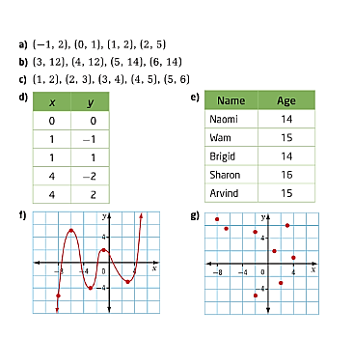

Level 3

2. For each table below:

i) Describe the relation in words

ii) Represent the relation:

* as a set of ordered pairs
* 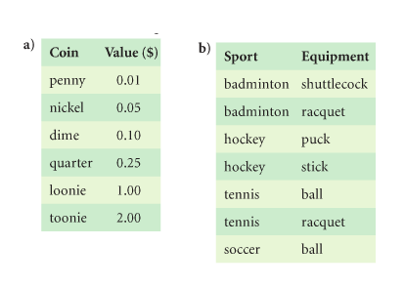as an arrow diagram

Level 4

3. Why is the order of the elements in an ordered pair important? Give an example.

4. Create a relation that you can describe in words. Show two different ways to represent your relation.

5. Which statement is true? Give an example to justify your choice.

a) All functions are relations, but not all relations are functions.

b) All relations are functions, but not all functions are relations.

6. Critique the statement “Relations and Functions are the same thing.”

**Practice #2 – Relations and Functions**

Level 2

1. List the domain and range of the graph of each function

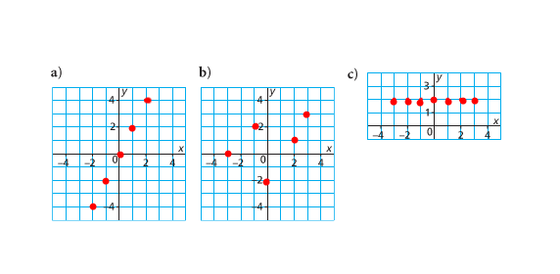

2. List the domain and range for each function

a) b) { (0, 10), (2, 14), (4, 18), (6, 22), (7, 26)}

|  |  |
| --- | --- |
| X | Y |
| 1 | 1 |
| 2 | 4 |
| 3 | 9 |
| 4 | 16 |

Level 3

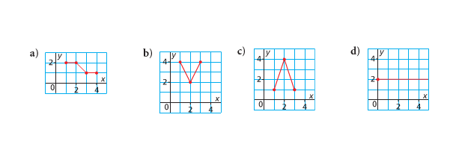3. Match the graph of each function to its domain and range listed below

i) domain: ; range 

ii) domain: ; range 

iii) domain: ; range 

iv) domain: ; range 

4. Determine the domain and range of the graph of each function.

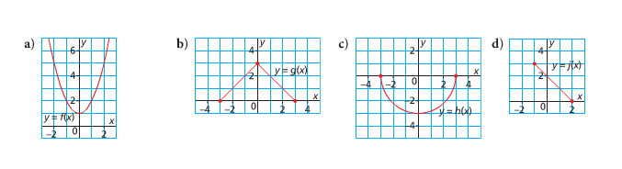

5. Give the domain and range of each group. Use words, a number line, interval notation, and set notation.

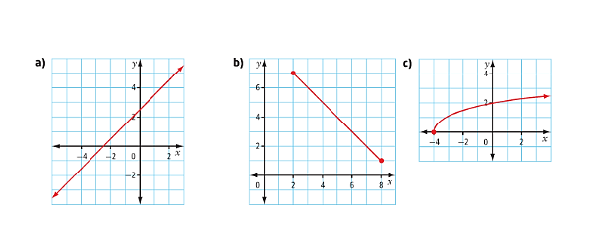

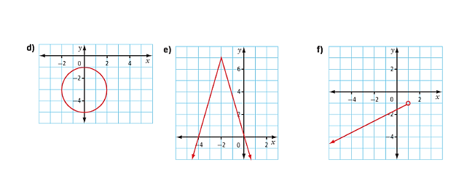

6. This set of ordered pairs associates a number with a polygon that has that number of sides: {(3, isosceles triangle), (3, equilateral triangle), (3, right triangle), (3, scalene triangle), (4, square), (4, rectangle), (4, rhombus), (4, trapezoid), (4, parallelogram), (5, pentagon), (6, hexagon)}

a) Does the set of ordered pairs represent a function? Explain.

b) Identify the domain and range

c) Suppose the elements in the ordered pairs were reversed. Use the association “has this number of sides”. Would the new relation be a function? Explain.

d) Identify the domain and range of the relation in part c

**Practice #3 – Relations and Functions**

Level 3

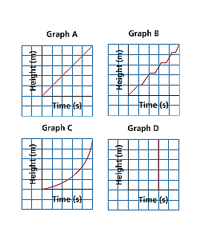1. To raise a flag, Sarah pulls the rope steadily with both hands for a short time, then moves both hands up the rope and pulls again. She does this until the flag has been raised. Which graph best represents the height of the flag? Give reasons for your choice.



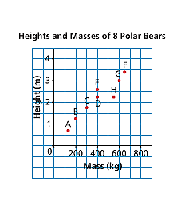Level 4

2. Each point on the graph represents a polar bear. Explain the answer to each question below.

a) Which bear has the greatest mass? What is this mass?

b) Which bear is the shortest? What is its height?

c) Which two bears have the same mass? What is this mass?

d) Which two bears have the same height? What is this height?

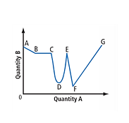

3. The graph shows how quantity B is changing relative to quantity A. Describe each section of the graph as representing a constant increase, a constant decrease, an increase that is not constant, a decrease that is not constant, or no change. Explain your answers.

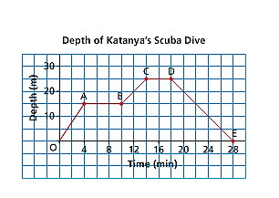

4. Kara went scuba diving in Egypt. This graph shows her depth below sea level as a function of time on one of her dives. Write all that you know about the dive from the graph.

5. This graph shows the number of cars, n, in the school parking lot as a function of time, t.

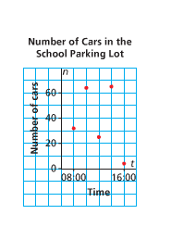

a) Why are the points on the graph not connected?

c) Estimate the domain and range of the graph. Are there any restrictions on the domain and range? Explain.

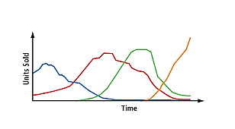6. Formats for distributing recorded music have changed through the years. Study the multi-line graph. Predict which line represents each format: vinyl albums, cassette tapes, compact discs, and digital downloads. Explain your choices.

7. An oven is turned on at a room temperature of 20oC and it takes 10 min to reach a temperature of 190oC. A tray of cookies is placed in the oven to bake for 10 min. The oven is then turned off and returns to room temperature after 15 min. Sketch a graph of temperature as a function of time. Label each section of the graph and explain what it represents.

8. The two graphs below have the same shape, but different vertical axes. Copy each graph and include numbers and units on both axes. Write and justify a possible situation that it represents.

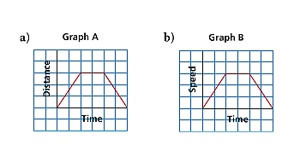

**Answers**

**Practice #1**

1 a) yes b) yes c) yes d) no e) yes f) yes g) no

2a) i) this coin has the value of

ii) {(penny, 0.01), (nickel, 0.05), (dime, 0.10), (quarter, 0.25), (loonie, 1.00), (toonie, 2.00)}

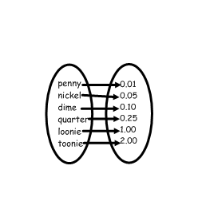

b) i) this sport uses the following equipment

ii) {(badminton, shuttlecock), (badminton, racquet), (hockey, puck), (hockey, stick), (tennis, ball),

(tennis, racquet), (soccer, ball)}

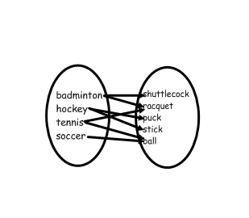

3) Discussion

1. Various
2. a) “All functions are relations, but not all relations are functions.” Is true. Some relations can have elements in the domain that go to more than one element in the range, therefore they would not be functions but are still relations.
3. Discussion – similar to explanation for #5

**Practice #2**

1 a) D: {-2, -1, 0, 1, 2} R: {-4, -2, 0, 2, 4}

b) D: {-3, -1, 0, 2, 3} R: {-2, 0, 1, 2, 3}

c) D: {-3, -2, -1, 0, 1, 2, 3} R: {2}

2) a) D:{1, 2, 3, 4} R:{1, 4, 9, 16}

b) D:{0, 2, 3, 6, 7} R:{10, 14, 18, 22, 26}

3) a) iv) b) i) c) ii) d) iii)

4) There is more than one way to write the answers

a) D: (-∞, ∞) R: [1, ∞) b) D: [-3, 3] R: [0, 3]

c) D: [-3, 3] R: [-3, 0) d) D: [-1, 2] R: [0, 3]

5) a) Words: All real numbers belong to the domain. All real numbers belong to the range.

Number line: D: 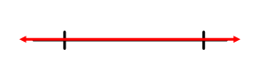 R: 

Interval notation: D: (-∞, ∞} R: (-∞, ∞)

Set notation: D: {x|-∞ ≤ x ≤ ∞, x $ϵ$ R} R: {y|-∞ ≤ y ≤ ∞, y $ϵ$ R}

b) Words: All real numbers between 2 and 8, inclusive, belong to the domain. All real numbers between 1 and 7, inclusive, belong to the range.

Number line: D: 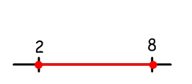 R: 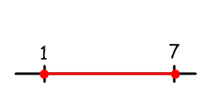

Interval notation: D: [2, 8] R: [1, 7]

Set notation: D: {x|2 ≤ x ≤ 8, x $ϵ$ R} R: {y|1 ≤ y ≤ 7, y $ϵ$ R}

c) Words: All real numbers greater than or equal to -4 belong to the domain. All real numbers greater than or equal to 0 belong to the domain.

Number line: D: 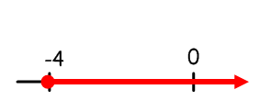 R: 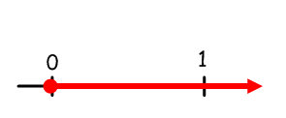

Interval notation: D: [-4, ∞) R: [0, ∞)

Set notation: D: {x|-4 ≤ x, x $ϵ$ R} R: {y|0 ≤ y, y $ϵ$ R}

d) Words: All real numbers between -2 and 2, inclusive, belong to the domain. All real numbers between

-5 and -1, inclusive, belong to the range.

Number line: D: 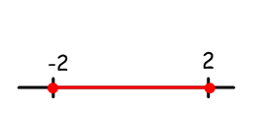 R: 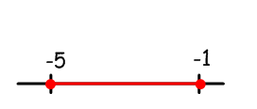

Interval notation: D: [-2, 2] R: [-5, -1]

Set notation: D: {x|-2 ≤ x ≤ 2, x $ϵ$ R} R: {y|-1 ≤ y ≤ -5, y $ϵ$ R}

e) Words: All real numbers belong to the domain. All real numbers less than or equal to 7 belong to the range.

Number line: D:  R: 

Interval notation: D: (-∞, ∞) R: (-∞, 7]

Set notation: D: {x|-∞ ≤ x ≤ ∞, x $ϵ$ R} R: {y|y ≤ 7, y $ϵ$ R}

f) Words: All real numbers less that 1 belong to the domain. All real numbers less that -1 belong to the range.

Number line: D: 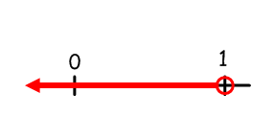 R: 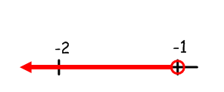

Interval notation: D: (-∞, 1) R: (-∞, -1)

Set notation: D: {x|x < 1, x $ϵ$ R} R: {y|y ≤ -1, y $ϵ$ R}

6a) No b) D: {3, 4, 5, 6}

R: {isosceles triangle, equilateral triangle, right triangle, scalene triangle, square, rectangle, rhombus,

trapezoid, parallelogram, pentagon, hexagon}

c) Yes d) D: {isosceles triangle, equilateral triangle, right

triangle, scalene triangle, square, rectangle,

rhombus, trapezoid, parallelogram, pentagon,

hexagon}

R: {3, 4, 5, 6}

**Practice #3**

1) B; Discussion

2a) F; 640 kg b) A; 0.7 m c) D and E; 400 kg d) D and H; 2.25 m

3) AB – constant decrease; BC – no change; CD – decrease, not constant

DE – increase, not constant; EF – constant decrease; FG – constant increase

4) Discussion

5) Discussion

6) Line that starts high – vinyl albums;

Line that starts low – cassette tapes;

Line that starts half way along time – compact disks;

Line that end highest – digital

7) Discussion

8) Discussion

|  |  |
| --- | --- |
| **OUTCOMES** | **ASSESSMENT RUBRICS** |
| **FP10.7 Demonstrate, with and without the use of technology, understanding of slope (concretely, pictorially, and symbolically) with respect to: line segments and lines, rate of change, ratio of rise to run, parallel lines, perpendicular lines** | |

|  |  |  |  |  |
| --- | --- | --- | --- | --- |
| **Level**  **Criteria** | **Intervention 1**  **Spend some extra time with the criteria and ask for help.** | **Instructional 2**  **Good start. You are beginning to make sense of this on your own. You are consistent with the basic learning goals for this outcome.** | **Independence 3**  **You did it and you did it on your own. You are able to complete the processes for this outcome. Your work is thorough and consistently accurate.** | **Mastery 4**  **Great work! This is going extra well for you. You have understood the outcome, are able to explain your strategies and apply these to situations. Your work is always accurate.** |
| **Outcome 7:** Students will demonstrate understanding of linear relations by determining rate of change/slope | I need more help with becoming consistent with the criteria. | I am consistently able to determine the rate of change/slope of a linear relation from a graph (rise/run), from two given points (slope formula), from a given equation. I am consistently able to classify lines as having positive or negative slopes | I am consistently able to determine the slope of parallel lines and perpendicular lines given the slope of one of the lines. I am consistently able to determine if lines are parallel, perpendicular or neither. I am able to draw the graph of a relation given the slope. | I am able to justify why lines are parallel, perpendicular or neither.  I am able to explain what the rate of change/slope represents in the context of the question. |

**Practice #1 – Relations and Functons**

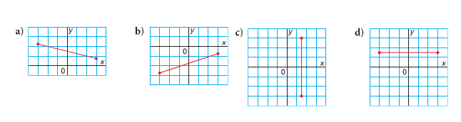Level 2

1. For each line segment, is its slope positive, negative, zero, or not defined?

2. For each line segment, determine its rise, run, and slope.

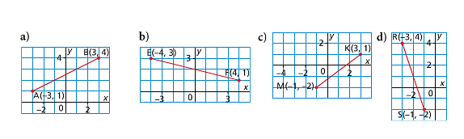

a) b)

c) d)

Level 3

3. Sketch a line whose slope is:

a) positive b) zero c) negative d) not defined

4. Draw a line segment that has slope. Be sure to label each line  
a)  b)  c)  d) 

5. a) Draw a line segment that has slope of  and goes through the point (-4, -4)

b) Draw a line segment that has slope  and goes through the origin.

Level 4

6. Create a graph showing the melting of a 75 cm high snow bank in spring. Plot the height, in centimeters, of the snow bank on the vertical axis and time, in days, on the horizontal axis. Draw a segment with a slope of -3, with one endpoint at (0, 75) and the other endpoint along the horizontal axis.

a) What does each point on the graph represent?

b) What does the endpoint along the horizontal axis represent?

c) Explain the meaning of slope in this situation.

7. When you look at a line on a grid, how can you tell whether its slope is positive, negative, 0, or not defined? Give examples.

**Practice #2 – Relations and Functions**

Level 2

1. Determine the slope of the line that passes through each pair of points.

a) P(1, 2) and Q(3, 6) b) S(0, 1) and T(8, 5)

c) V(-1, 4) and R(3, -8) d) U(-12, -7) and W(-6, -5)

2. a) Draw the line through each pair of points. Determine the slope of each line.

i) B(0, 3) and C(5, 0) ii) D(0, -3) and C(5, 0)

iii) D(0, -3) and E(-5, 0) iv) B(0, 3) and E(-5, 0)

b) How are the slopes of the lines in part a related?

3. For each equation, identify the slope of the line

a)  b)  c) 

d) e)  f) 

g)  h)  i) 

j)  k)  l)

Level 4

4. Four students determined the slope of the line through B(6, -2) and C(-3, -5). Their answers were: .

a) Which number is correct for the slope of line BC? Give reasons for your choice.

b) For each incorrect answer, explain what the student might have done wrong to get that answer.

5. Explain why the slope of a horizontal line is zero

6. Explain why the slope of a vertical line is undefined.

**Practice #3 – Relations and Functions**

Level 3

1. The slopes of lines are given below. For each line, what is the slope of a parallel line?

a)  b)  c) 3 d) 0 e) -5

2. The slopes of lines are given below. For each line, what is the slope of a perpendicular line?

a)  b)  c) 9 d) -5 e) 0

3. The slopes of two lines are given. Are the two lines parallel, perpendicular or neither?

a) 4, 4 b)  c)  d) 

4. For each grid below:

i) Predict if the lines are parallel, perpendicular, or neither by simply looking at the graphs.

ii) Write the coordinates of the 2 labeled points on each line

iii) Determine the slopes of the 2 lines

iv) Are the two lines parallel, perpendicular, or neither? Justify your answer

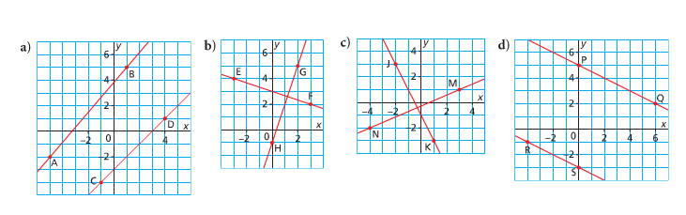

5. The coordinates of the endpoints of segments are given below. Are the two line segments parallel, perpendicular, or neither? Justify your answer.

a) S(-4, -1), T(-1, 5) and U(1, 1), V(5, -1)

b) B(-6, -2), C(-3, 3) and D(2, 0),E(5,5)

c) N(-6, 2), P(-3, -3) and Q(1, -3) R(3, 4)

d) G(-2, 5), H(4, 1) and J(1, -4), K(7, 0)

6. Identify whether the pair of lines is parallel, perpendicular, or neither. Explain how you know.

a) $y = -6x$ b)  c) $y = -x + 8$

$y = 6x + 1$ $y = -5x – 4$ $y = -x + 2$

Level 4

7. Sheldon was asked if line segment AB with A(-9, 2) and B(-3, 4) is parallel to line segment CD with C(-7, -7) and D(1, -3). He sketches a graph of the two line segments and concludes that they appear parallel.

a) Is it correct to assume from a sketch that the two line segments are parallel? Explain.

b) How could you prove that two lines segments are parallel?

c) Is line segment AB parallel to line segment CD? Justify your answer.

8. The coordinates of the vertices of ∆DEF are D(-3, -2), E(1, 4) and F(4, 2). Is ∆DEF a right triangle? Justify your answer.

9. Is the following statement always true, sometimes true, or never true? “The slopes of perpendicular lines are always negative reciprocals of each other.” Explain your reasoning.

**Practice #4 – Relations and Functions**

Level 4

1. This graph shows the area, A, square meters, that paint covers as a function of its volume, V litres.

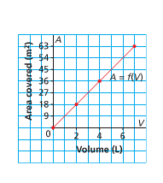

a) What is the rate of change? What does it represent?

b) What area is covered by 6 L of paint?

c) What volume of paint would cover 45 m2?

2. This graph shows the cost for a cab at Eagle Taxi Cabs. The cost, C dollars, is a function of the distance travelled, d kilometers.

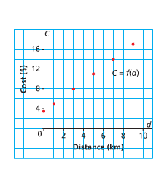

a) Determine the rate of change. What does it represent?

b) What is the cost when the distance is 7 km?

c) What is the distance when the cost is $9.50?

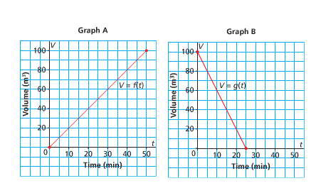3. The capacity of each of 2 fuel storage tanks is 100 m3. Graph A represents the volume of fuel in one tank as a function of time as the tank is filled. Graph B represents the volume of fuel in another tank as a function of time as the tank is emptied.

a) Does it take longer to fill the empty tank or empty the full tank? How do you know?

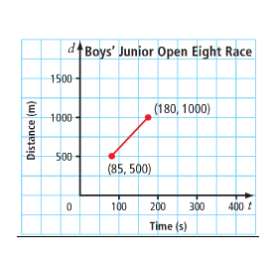b) In the time it takes for one tank to be half empty, about how much fuel would be in a tank that was being filled from empty?

4. The Brentwood Regatta in Mill Bay, BC, is the largest junior rowing regatta hosted by a single school in North America. The races are all 1500 m in length. The graph shows the approximate times at the 500 m mark and the 1000 m mark for one of the boys’ races. Determine the average rate of change for this portion of the race.

5. The Penny Ice Cap glacier in Auyuittuq National Park on Baffin Island, NU is melting. In 2009, some areas of the glacier were about 1000 ft thick. It is estimated that if the glacier continues to melt at its current rate, the ice cap could be 967 ft thick by 2020. What is the estimated rate of change in thickness? What does this mean?

6. In 1800, the wood bison population in North America was estimated at 168 000. The population declined to only about 250 animals is 1893. That year, Wood Buffalo National Park was established on the Alberta/Northwest Territories border. In 2006, there were about 5600 bison in the park.

a) What was the average rate of change in the bison population from 1800 to 1893? Describe the meaning of this rate.

b) What was the average rate of change in the bison population from 1893 to 2006? Describe the meaning of this rate.

7. Since the speed of light is faster that the speed of sound, you see lightning before you hear the sound of the thunderclap. If a thunderstorm is 1100 m away, the sound of thunder is heard in 3.2 s. If the storm is 4950 m away, the sound reaches you in 14.5 s.

a) Determine the average rate of change, to the nearest metre per second.

b) What does this rate of change represent?

c) If you hear thunder 30 s after you see lightning, how far away is the storm?

8. How can you tell from a graph whether a linear function has a positive or negative rate of change?

**Answers**

**Practice #1**

1a) negative b) positive c) undefined d) zero

2a)  b)  c)  d) 

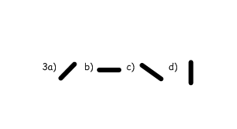

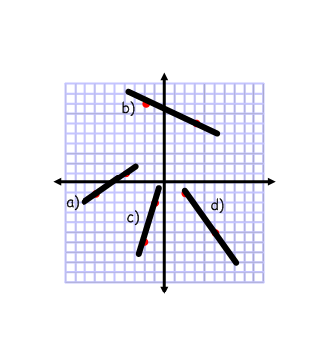

4)

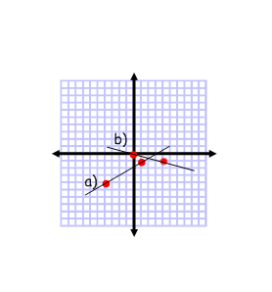5)

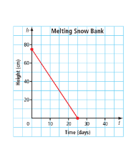

6)

a) The height of the snow bank after the number of days defined by that point

b) The segment ends at (25, 0). After 25 days the snow bank has completely melted

c) The slope represents the rate at which the snow bank is losing height, which is 3 cm per day

7) Discussion

**Practice #2**

1a)  b)  c)  d) 

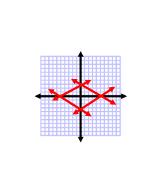

2i)  ii)  iii)  iv) 

b) They are opposites

3a) 4 b) 1 c) 

d) 11 e)  f) 0

g) -4 h) 3 i) 1

j) 5 k)  l) 

4a)  b) Discussion

5) Discussion

6) Discussion

**Practice #3**

1a)  b)  c) 3 d) 0 e) -5

2a)  b)  c)  d)  e) undefined

3a) parallel b) neither c) neither d) perpendicular

4a) slope AB =  slope CD =  therefore neither

b) slope EF =  slope GH =  therefore perpendicular

c) slope JK = -2 slope MN =  therefore neither

d) slope RS =  slope PQ =  therefore parallel

5a) ST = 2 UV =  perpendicular

b) BC =  DE =  parallel

c) NP =  QR =  neither

d) GH =  JK =  neither

6a) neither, not equal or negative reciprocals

b) perpendicular, slopes are negative reciprocals

c) parallel, slopes are equal

7a) No. Discussion

b) Discussion

c) AB =  CD =  not parallel because not equal

8) Discussion

9) Discussion

**Practice #4**

1a) 9 m2/L; This means that one litre of paint will cover 9 m2 of area

b) 54 m2

c) 5 L

2a) $1.50/km; This means the taxi costs $1.50 per km (on top of the base fee)

b) $14.00

c) approx. 4 km

3a) fill; It took 50min to fill 100 m3, but only 25 minutes to empty the same amount

b) 25m3

4) 5.3 m/s

5) -3 ft./year. This means that the glacier is melting 3 feet of thickness per year

6a) -1804 bison/year. The wood bison population diminished at a rate of approximately 1804 wood bison per year.

b) 47 bison/year. The wood bison population increased at a rate of approximately 47 wood bison per year.

7a) 341 m/s

b) the speed of sound

c) approximately 10 221 m, or approximately 10 km

8) Discussion

|  |  |
| --- | --- |
| **OUTCOMES** | **ASSESSMENT RUBRICS** |
| **FP10.8: Demonstrate understanding of linear relations including: 1) representing in words, ordered pairs, tables of values, graphs, function notation, and equations 2) Determining characteristics including intercepts, slope, domain and range.** | |

|  |  |  |  |  |
| --- | --- | --- | --- | --- |
| **Level**  **Criteria** | **Intervention 1**  **Spend some extra time with the criteria and ask for help.** | **Instructional 2**  **Good start. You are beginning to make sense of this on your own. You are consistent with the basic learning goals for this outcome.** | **Independence 3**  **You did it and you did it on your own. You are able to complete the processes for this outcome. Your work is thorough and consistently accurate.** | **Mastery 4**  **Great work! This is going extra well for you. You have understood the outcome, are able to explain your strategies and apply these to situations. Your work is always accurate.** |
| **Outcome 8A**: Students will demonstrate and understanding of linear relations by representing in words, ordered pairs, tables of values, graphs, function notation and equations | I need more help with becoming consistent with the criteria. | I am able to consistently determine if a relation is linear. I can consistently state the independent, dependent variable, x-intercept and y intercept of a linear relation. | I am able to interpolate and extrapolate a linear relation in function notation, a graph, and an equation. I can state the domain and range of a linear function. I can determine and explain restrictions on domain and range of a linear relation. | I am able to analyze a graph to predict values in situational questions. I can explain why a function is a linear function. I am able to explain the relationship between related domain and range values |

**Practice #1 – Linear Functions**

Level 2

1. Which tables of values represent linear relations? Explain your answers.

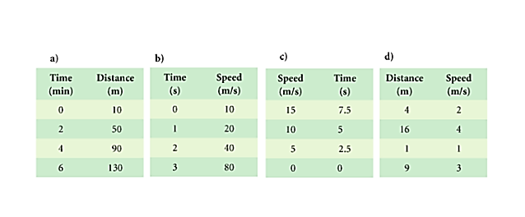

2. Which sets of ordered pairs represent linear relations? Explain your answers.

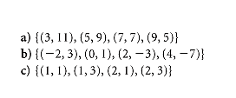

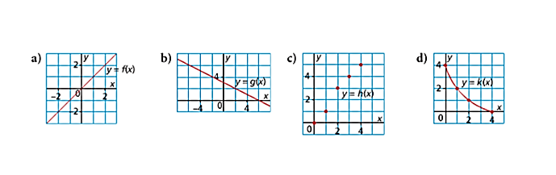3. Which graphs represent linear relations? Explain your answers.

4. Which equations represent linear relations? Explain your answers.

a) b) c)

d) e) f)

5. Determine whether each relation is linear or non-linear. Explain your decision.

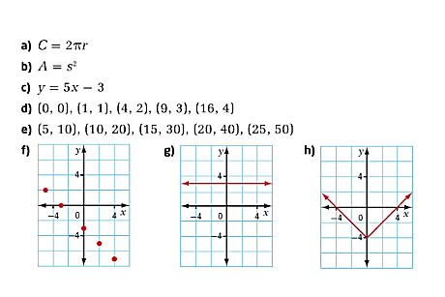

6. Which situations represent linear relations? Explain how you know.

a) A hang glider starts her descent at an altitude of 2000 m. She descends at a constant speed to an altitude of 1500 m in 10 min.

b) A population of bacteria triples every hour for 4 h.

c) A taxi service charges a $5 flat fee plus $2 for each kilometer travelled.

d) The cost to print each yearbook is $5. There is a start-up fee of $500 to set up the printing press.

e) An investment increases in value by 12% each year.

7. Sophie and 4 of her friends plan a trip to the Edmonton Chateau for one night. The hotel room is $95 for the first 2 people, plus $10 for each additional person in the room. The total cost is related to the number of people. Is the relation linear? How do you know?

8. Consider the relation described by the equation  and the three graphs shown. Without performing any calculations, predict which graph matches this relation. Check your prediction against a partner’s. Discuss your answers.

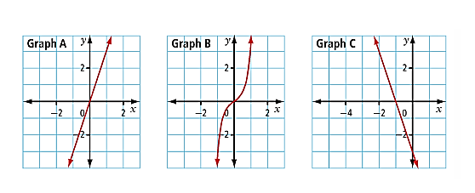

Level 3

9. Match each description of a linear relation with its equation and set of ordered pairs below. Explain your choices.

a) The amount a person earns is related to her hourly wage.

b) The cost of a banquet is related to a flat fee plus an amount for each person who attends.

c) The volume of gas in a car’s gas tank is related to the distance driven since the time when the tank was filled.

Equation 1: $y = 500 + 40x$ Set A: {(100, 29), (200, 23), (300, 17), (400, 11)}

Equation 2: $y = 35 – 0.06x$ Set B: {(1, 20), (5, 100), (10, 200), (15, 300)}

Equation 3: $y = 20x$ Set C:{(0,500),(40, 2100),(80, 3700),(100,4500)}

Level 4

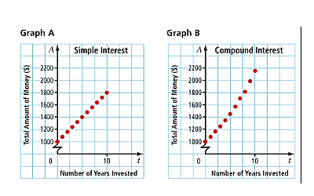10. The graphs represent different investments based on investing $1000 today. The first graph shows simple interest of 8% per year. The second graph shows compound interest at 8% per year.

1. Which graph is linear? Which is non-linear? Explain.
2. In one interest calculation, you receive a set percent of your original investment each year. In the other interest calculation, you receive a set percent of the amount that you have in your account. Identify which graph represents each of these scenerios. Explain your reasoning.

11. Critique the statement “any straight line is the graph of a linear function.”

12. Explain why a linear function would never have a term of x2 when in simplified form.

**Practice #2 – Linear Functions**

Level 2

1. Rewrite the following functions as an equation in 2 variables.

a) f(n) = 2n – 7 b) g(x) = -5x + 1 c) D(t) = -80t + 300

d) H(r) = 3.343r + 81.224 e) M(a) = 2.89a + 70.64

2. Rewrite the following equations in function notation

a) y = 5x – 3 b) C = 5.3d + 2 c) H = 3.27r + 89.92

Level 3

3. For the function f(x) = -5x + 11, determine the related range value for the given domain value.

a) f(1) b) f(-3) c) f(0) d) f(1.2)

4. For the function g(x) = -5x + 1, determine x (domain value) when

a) g(x) = 41

b) g(x) = -14

5. For the function h(x) = 3x – 5, determine the related domain and range values.

a) for the domain value x = 5, find the range value h(5)

b) for the range value h(x) = -14, find the domain value x

6. Consider the function p(x) = -4x + 2

a) What is the value of p(0)?

b) Determine x so that p(x) = -2

Level 4

7. Mike currently has $200 and saves $20 each week. The function M(w) = 20w + 200 describes his savings pattern. Ali currently has $200 and spends $20 each week. The function A(w) = 200 – 20w describes her spending pattern.

a) What does the variable w represent in each function?

b) Explain the meaning of M(w) and A(w).

c) What is the value of each function when w = 4? Explain your answer.

d) Determine the value of w when A(w) = 0. Explain your answer.

8. Using skeletal remains, a forensic anthropologist can accurately determine the sex, race, age, and height of a person.

a) The height, h, in centimeters, of a male can be determined using the function

h(L) = 2.9L + 70.6, where L is the length, in centimeters, of his humerus. Suppose you find a humerus of a male and measure the bone to be 36.87 cm in length.

How tall was the man?

b) The function h(L) = 2.8L + 71.4 can be used to determine the height, h, in centimeters, of a female, where L is the length, in centimeters of her humerus. a) Determine h(36.87).

b) What does h(36.87) represent?

c) Measure the length of your radius bone (your wrist bone to elbow bone). Use the appropriate function to determine your height. How accurate is the prediction?

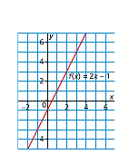

9. This is the graph of the function f(x) = 2x – 1.

a) Determine the range value(y) when the domain value(x) is 0.

b) Determine the domain value(x) when the range value(y) is 5.

10. St. Adolphe, Manitoba, is located in the flood plain of the Red River. To help prevent flooding, backhoes were used to build dikes around houses and farms in the town. This graph shows the labour costs for running a backhoe.

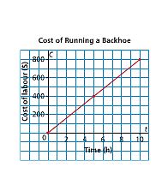

a) What is the cost to run the backhoe for 7h?

b) For how many hours is the backhoe run when the cost is $360?

11. After an animal dies, the amount of radioactive carbon-14 in its bones declines. Archaeologists use this fact to determine the age of a bone based on the percent of carbon-14 remaining in the fossilized bones. The relation shows the age, A, in years, of an animal based on the percent, c, of carbon-14 remaining.

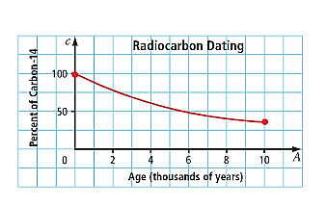a) Is this relation a function? Why?

b) At Head-Smashed-In Buffalo Jump, in southwestern Alberta, the most recent bison bones found had 98% of the carbon-14 still remaining. From the graph, estimate the age of these bones.

c) The oldest bison bones found at Head-Smashed-In Buffalo Jump were about 5800 years old. Estimate the percent of carbon-14 still remaining in these bones.

12. Explain the difference between f(2) and f(x) = 2.

**Practice #3 – Linear Functions**

1. St. Adolphe, Manitoba, is located in the flood plain of the Red River. To help prevent flooding, backhoes were used to build dikes around houses and farms in the town. This graph shows the labour costs for running a backhoe.

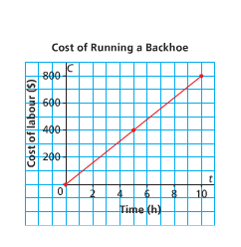

Level 2

a) Identify the independent and dependent variables. Justify your choices.

Level 3/4

b) Why are the points on the graph connected?

c) Write the domain and range. Are there any restrictions on the domain and range? Explain.

2. Northlands School Outdoor Club had a fundraiser to help purchase snowshoes. The club had 300 power bars to sell. This graph shows the profit made from selling power bars.

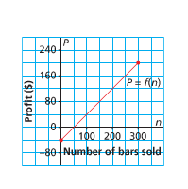

Level 2/3

1. What are the vertical and horizontal intercepts?
2. Describe the domain and range for the function. Are there any restrictions on the domain and range? Explain.

3. This graph shows the recommended maximum heart rate of a person, R beats per minute, as a function of her or his age, a years, for a stress test.

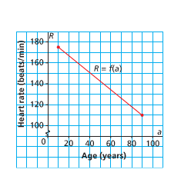

Level 2/3

Write the domain and range. Are there any restrictions on the domain and range? Explain.

4. Each graph shows the altitude, A feet, of a small plane as a function of time, t minutes. For each graph:

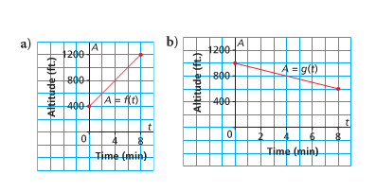

a) Determine the vertical intercept. Write the coordinates of the point where the graph intersects the axis. What do these coordinates represent?

b) Determine the domain and range

c) Determine the dependent variable and the independent variable.

5. Each graph below shows distance, d kilometers, as a function of time, t hours. For each graph:

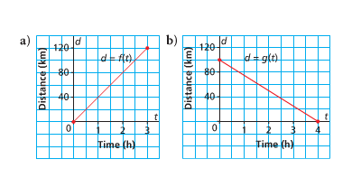

i) Determine the vertical and horizontal intercepts. Write the coordinates of the points where the graph intersects the axes. What do these coordinates represent?

ii) Determine the domain and range

iii) Determine the dependent variable and the independent variable.

6. A Smart car and an SUV have full fuel tanks, and both cars are driven on city roads until their tanks are nearly empty. The graphs show the fuel consumption for each vehicle.

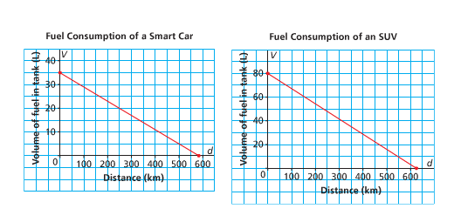

a) Determine the vertical and horizontal intercepts. Write the coordinates of the points where the graph intersects the axes. What do these points represent?

b) Determine the domain and range.

c) Determine the dependent variable and independent variable.

Level 4

1. 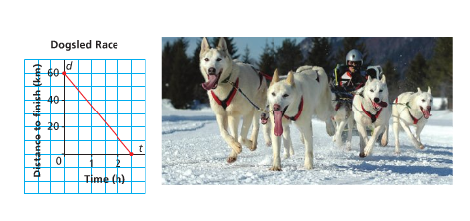This graph shows the distance to the finish line, d kilometers, as a function of time, t hours, for one dogsled in a race near Churchill, Manitoba.

a) What was the length of time it took the dogsled to finish the race? What do we call this point on the graph?

b) How long was the race in kilometers? What do we call this point on the graph?

c) Determine the domain and range.

d) Determine the dependent and independent variables.

**Answers**

**Practice #1**  
1a) Yes; constant increase in both domain and range

b) No; constant increase in domain, but not range

c) Yes; constant decrease in both domain and range

d) No; not constant in domain

2a) Yes; constant increase in domain, constant decrease in range

b) No; constant increase only in domain

c) No, not constant in either

3a) yes b) yes c) no d) no

4a) yes b) yes c) no

d) yes e) yes f) yes

5a) linear b) non-linear c) linear d)non-linear

e) linear f) linear g) linear h)non-linear

6a) linear b) non-linear c) linear

d) linear e) non-linear

7) Linear

8) Discussion

9a) Equation 3; Set B b) Equation 1; Set C c) Equation 2; Set A

10a) Graph A is linear; Graph B is non-linear

b) Discussion

11) Discussion

12) Discussion

**Practice #2**

1a) y = 2n – 7 b) y = -5x + 1 c) D = -80t + 300

d) H = -3.343r + 81.224 e) M = 2.89a + 70.64

2a) f(x) = 5x – 3 b) C(d) = 5.3d + 2 c) H(r) = 3.27r + 89.92

3a) 6 b) 26 c) 11 d) 5

4a) -8

b) 3

5a) 10

b) -3

6a) 2 b) 1

7a) The number of weeks

b) M(w) is amount Mike has saved after w weeks; A(w) is amount Ali has left after w weeks

c) M(w) = 280; A(w) = 120

d) 10

8a) 177.523 cm

b) 174.636 cm represents the height of the female

c) Discussion

9a) -1

b) 3

10a) $550

b) 4 hours

11a) Yes

b) 100 years

c) 50%

12) Discussion

**Practice #3**

1a) time – independent; cost – dependent

b) Both cost and time can have partial values

c) D: [0, 10] R: [0, 800]

Restrictions: The domain can be any number of hours 0 hours or higher to the maximum number of hours a person would work in a day – maybe 14 or 15.

The range can be any value of $0 to the cost associated with the maximum number of hours worked in the day

2) D: [0, 300] R: [-40, 200]

Restrictions: The domain can be any whole number up to the number of bars available to be sold.

The range will not be less than -40 and can be as high as the profit allotted for the amount of bars available to sell

3) D: [10, 90] R: [110, 175]

Restrictions: The domain can be any whole number up to the maximum age a person can live to (depends on what the Guinness book of records says for the oldest recorded living person).

The range would be the lowest possible heart rate of a living person to the maximum possible heart rate of a living person

4a) Graph A: (0, 400); This is the altitude of the plane at 0 minutes

Graph B: (0, 1000); This is the altitude of the plane at 0 minutes

b) Graph A: D: [0, 8] R: [400, 1200]

Graph B: D: [0, 8] R: [600, 1000]

c) Both Graphs – time is independent; altitude is dependent

5a) Graph A: vertical – (0,0), horizontal (0,0) These show the distance at time 0.

Graph B: vertical – (0, 100) at 0 minutes the distance is 100 km

horizontal – (4, 0) it takes 4 minutes to have a distance of 0 km

b) Graph A: D: [0, 3] R: [0, 120]

Graph B: D: [0, 4] R: [0, 100]

c) Both graphs: time is independent; distance is dependent

6a) Graph A: vertical (0, 35) before driving the tank has 35L of fuel

horizontal (575, 0) the tank runs out at 575 km

Graph B: vertical (0, 80) before driving the tank has 80 L of fuel

horizontal (625, 0) the tank runs out at 620 km

c) Both graphs – distance is independent; volume is dependent

7a) 2.5 hours; the horizontal intercept

b) 60 km; the vertical intercept

c) D: [0, 2.5] R: [0, 60]

d) time is independent; distance is dependent

|  |  |
| --- | --- |
| **OUTCOMES** | **ASSESSMENT RUBRICS** |
| **FP10.8: Demonstrate understanding of linear relations including: 1) representing in words, ordered pairs, tables of values, graphs, function notation, and equations 2) Determining characteristics including intercepts, slope, domain and range.** | |

|  |  |  |  |  |
| --- | --- | --- | --- | --- |
| **Level**  **Criteria** | **Intervention 1**  **Spend some extra time with the criteria and ask for help.** | **Instructional 2**  **Good start. You are beginning to make sense of this on your own. You are consistent with the basic learning goals for this outcome.** | **Independence 3**  **You did it and you did it on your own. You are able to complete the processes for this outcome. Your work is thorough and consistently accurate.** | **Mastery 4**  **Great work! This is going extra well for you. You have understood the outcome, are able to explain your strategies and apply these to situations. Your work is always accurate.** |
| **Outcome 8B:** Students will demonstrate understanding of linear relations through graphing a linear relation | I need more help with becoming consistent with the criteria. | I am consistently able to graph a linear relation given a table of values/ordered pairs | I am consistently able to graph a linear relation given the equation. | I am able to perform error analysis.  I can explain my graphing strategy.  I am able to graph a linear relation given the context of the relation. |

**Practice #1 – Graphing Linear Relations**

Level 2

1. Graph the following equations using a table of values.

a) $y = 2x – 3$ b) $y = -4x + 8$ c) 

d) $x + y – 1 = 0$ e) $3x + 4y – 8 = 0$ f) $0.5x – y + 1.25 = 0$

**Practice #2 – Graphing Linear Relations**

Level 3

1. Sketch the graph of each line using the slope and y-intercept

a) b) c)

d)  e)  f)

2. Rewrite the following in slope-intercept form and the sketch the graph of each line

a) $2x + y – 9 = 0$ b) $4x – y – 8 = 0$ c) $x – 2y + 10 = 0$

d) $3x – 8y – 24 = 0$ e) $4x + 5y + 6 = 0$

**Practice #3 – Graphing Linear Relations**

Level 3

1. Determine the intercepts of each line. Then, graph the line

a) $2x + y – 9 = 0$ b) $4x – y – 8 = 0$ c) $x – 2y + 10 = 0$

d) $3x – 8y – 24 = 0$ e) $4x + 5y + 6 = 0$ f) $y = -x + 8$

g) $y = 7x – 5$ h)  i) $x = 4$

j) $y = 0$ k) $4x – 12 = 0$ l) $x + 4 = 0$

m) $y – 5 = -3(x + 1)$ n) $y + 2 = 4(x – 1)$

Level 4

2. Name a strategy you could use to sketch the graph of a linear relation in general form? Are there other strategies? Explain.

3. Is it easier to graph a linear relation with its equation in general form or slope-intercept form? Explain.

4. Of the three strategies we discussed for graphing linear equations (table of values, slope-intercept form, intercepts) which do you prefer. Explain.

**Practice #4 – Graphing Linear Relations**

Level 4

1. Rebecca makes and sells Nanaimo bars. She uses pans that hold 12 bars or 36 bars. Rebecca uses these pans to fill an order for 504 Nanaimo bars. Generate some data for this relation, then graph the data.

2. Amy is making a ribbon shirt. She has 60cm of ribbon that she will cut into 5 pieces with 2 different lengths: 2 pieces have the same length and the remaining 3 pieces also have equal lengths. Generate some data for this relation showing the possible lengths of the pieces and then graph the data.

3. Pascal saves loonies and toonies. The value of his coins is $24. Generate some data for this relation and then graph the data.

Level 3

4. Graph the following:

|  |  |
| --- | --- |
| **X** | **y** |
| -2 | 5 |
| -1 | 2 |
| 0 | -1 |
| 1 | -4 |
| 2 | -7 |

5. Graph each equation. Which strategy did you use each time?

a) $x – 2y + 10 = 0$ b) $y = 4x + 7$ c) $y = -2x + 6$

d) $7x + 4y + 4 = 0$ e) $y – 3 = -2(x + 1)$ f) $y+2=-3(x–2)$

**Answers**

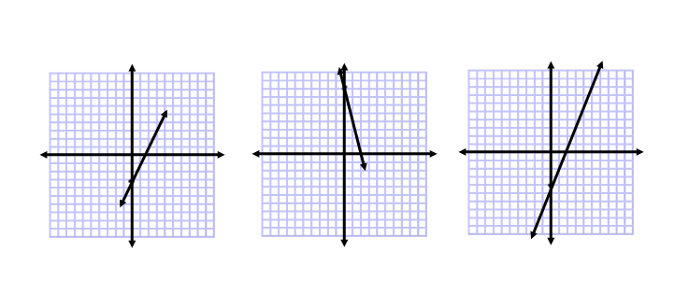**Practice #1**

1a) b) c)

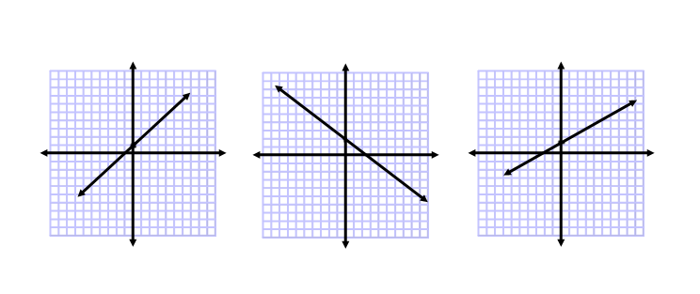

d) e) f)

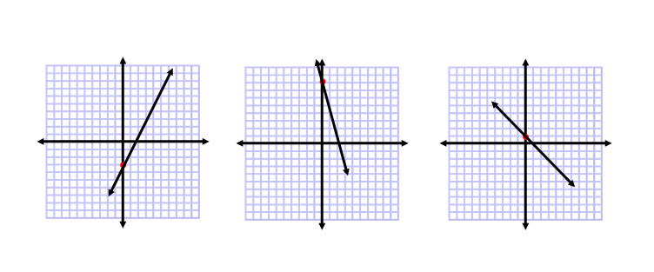**Practice #2**

1a) b) c)

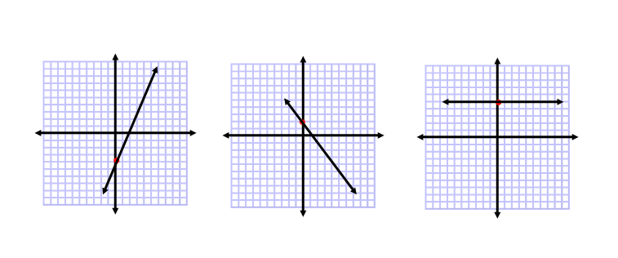

d) e) f)

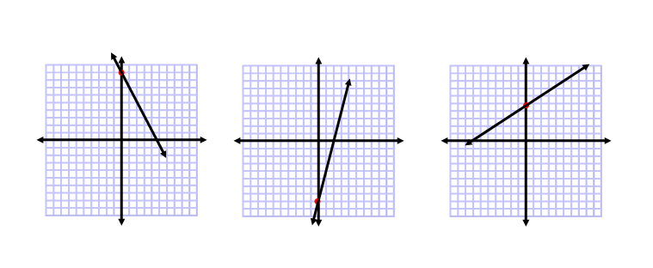

2a) b) c)

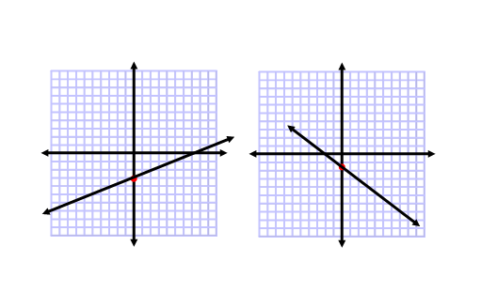

d) e)

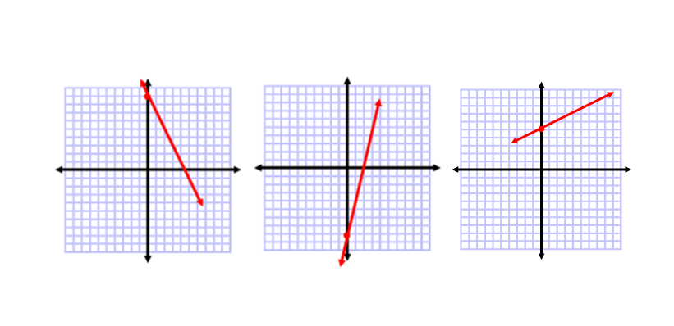**Practice #3**

1a) b) c)

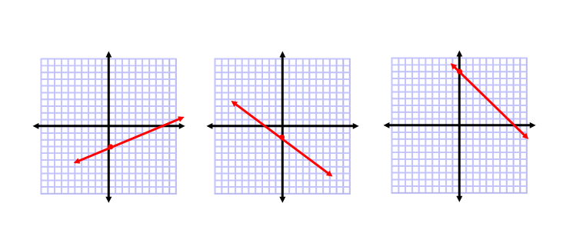

d) e) f)

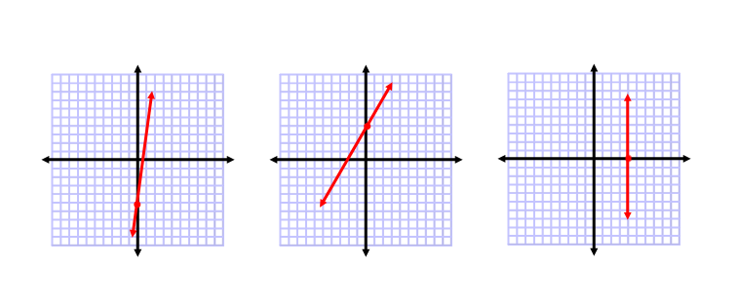

g) h) i)

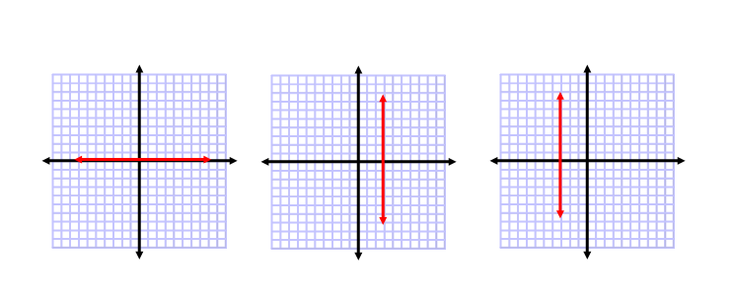

j) k) l)

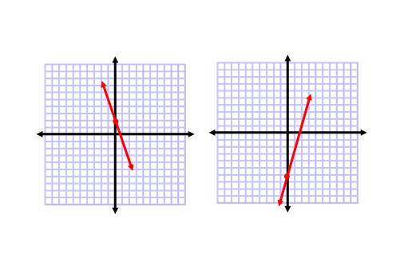

m) n)

2) Discussion

3) Discussion

4) Discussion

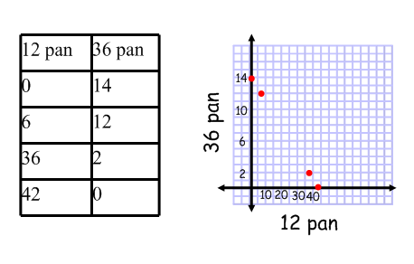**Practice #4**

1)

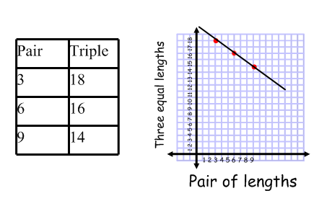

2)

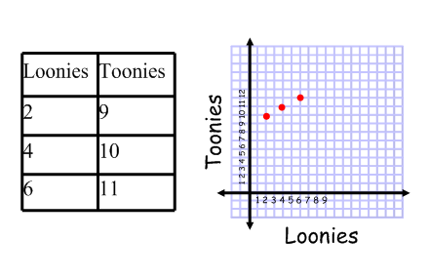

3)

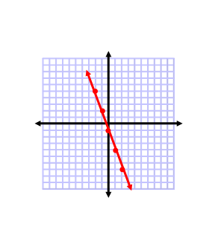4)

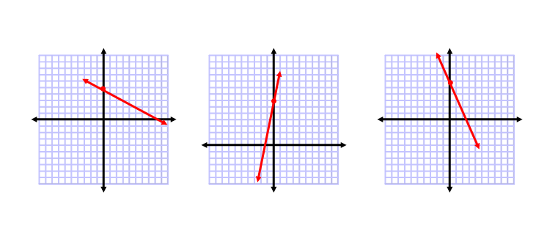

5a) b) c)

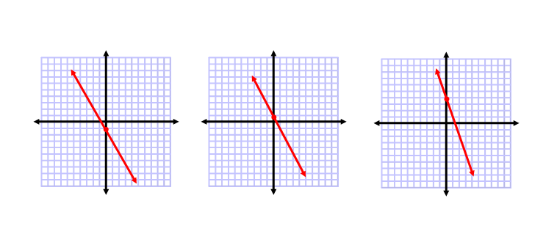

d) e) f)

|  |  |
| --- | --- |
| **OUTCOMES** | **ASSESSMENT RUBRICS** |
| **FP10.9 Demonstrate understanding of the writing and application of equations of linear relations, given: a graph of a relation, a point that satisfies a relation and the slope of the relation, two distinct points that satisfy a relation, a point that satisfies the relation and the equation of a line parallel or perpendicular to the relation** | |

|  |  |  |  |  |
| --- | --- | --- | --- | --- |
| **Level**  **Criteria** | **Intervention 1**  **Spend some extra time with the criteria and ask for help.** | **Instructional 2**  **Good start. You are beginning to make sense of this on your own. You are consistent with the basic learning goals for this outcome.** | **Independence 3**  **You did it and you did it on your own. You are able to complete the processes for this outcome. Your work is thorough and consistently accurate.** | **Mastery 4**  **Great work! This is going extra well for you. You have understood the outcome, are able to explain your strategies and apply these to situations. Your work is always accurate.** |
| **Outcome 9:** Students will demonstrate understanding of linear relations through writing the equation of the relation | I need more help with becoming consistent with the criteria. | I am consistently able to write the equation of a line when given the slope and a point. | I can consistently write linear equations in slope-intercept form, slope-point form and general form given any acceptable pieces of information (excluding parallel or perpendicular lines). | I am able to write an equation when dealing with parallel or perpendicular lines.  I am able to write an equation from a given situation.  I am able to describe my strategies of writing equations.  I can verify my equations using points on the line. |

**Practice #1 – Equations of Linear Relations**

Level 2

1. What are the slopes and y-intercept of each line?

a) b)  c)

d) e) f)

2. Write the equation of each line in the form y = mx + b

a) slope = -3, y-intercept = 2 b) slope = , y-intercept = -4

c) slope = -0.75, y-intercept = -5 d) slope = 1, y-intercept = -7

e) slope = -1, y-intercept = 0 f) slope = 0, y-intercept = 

3. What are the slope and y-intercept of each line? Write the equation of each line in slope-intercept form. Verify your equation.

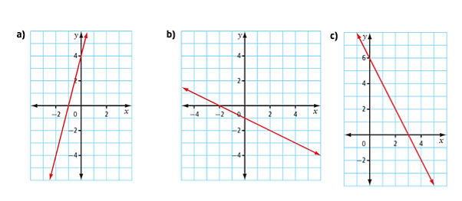

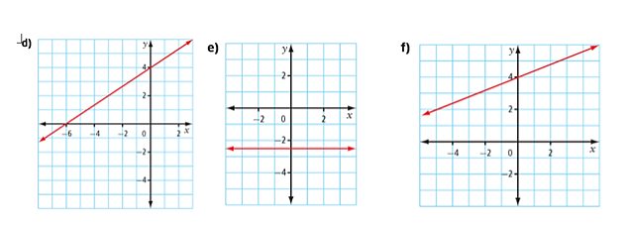

4. State the slope and y-intercept of each equation. Then, identify the graph that matches the equation.

a) $y = -2x + 3$ b)

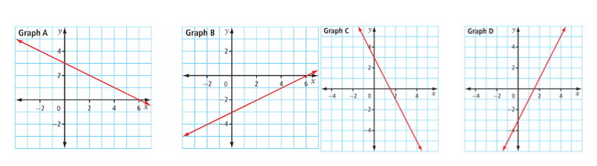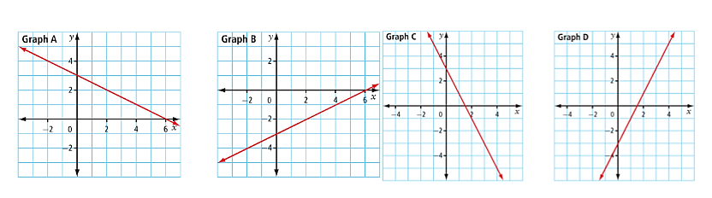c)  d) 

Level 3

5. Rewrite the equations in slope-intercept form. State the slope and y-intercept of each line.

a) $3x + 2y – 18 = 0$ b) $x + 3y + 9 = 0$

c) $3x – 2y – 16 = 0$ d) $5x – 2y + 12 = 0$

Level 4

6. Parents of members of the cheerleading squad rent a hall. They arrange a talent show as a fundraiser. The relationship between the number of tickets sold, x, and the profit, y in dollars, may be represented by the equation 12x – y – 840 = 0.

a) Rewrite the equation in slope-intercept form

b) What is the slope of the line? What does the slope represent?

c) Identify the y-intercept. What does it represent?

d) How many tickets must the parents sell to reach the break-even point?

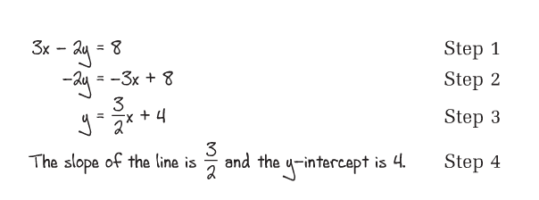7. Omar determines the slope and y-intercept of the line 3x – 2y – 8 = 0. His work is shown.

a) In which line did Omar first make an error?

b) Correct Omar’s work

8. When a real-world situation can be modeled by a linear function, what do the slope and vertical intercept usually represent?

9. When you are given the graph of a linear function, how can you determine an equation that represents that function?

**Practice #2 – Equations of Linear Relations**

Level 4

1. Write an equation to represent each situation

a) The cost, C, to take n students to the theatre is $300 to rent a bus and $6.25 per ticket.

b) The taxi fee, T, is $3.60 to start plus $1.48 for each kilometer travelled, x.

c) A rewritable Blu-ray disc has 1024 MB of data stored on it. When new data is added to the disc, the total data, D, in megabytes, stored on the disc at time t seconds increases at a rate of 54 MB/s.

d) A water delivery truck is filling the water tank in Simeonie’s house. The truck arrived with 2500 L of water. The number of litres of water, L, remaining in the truck at time t minutes decreases at a rate of 120 L/min.

2. An online music site charges a one-time membership fee of $20, plus $0.80 for every song that is downloaded.

a) Write an equation for the total cost, C dollars, for downloading n songs.

b) Jacques downloaded 109 songs. What was the total cost?

c) Michele paid a total cost of $120. How many songs did she download?

3. To join the local gym, Karim pays a start up fee of $99 plus a monthly fee of $29.

a) Write an equation for the total cost, C dollars, for n months at the gym.

b) Suppose Karim went to the gym for 23 months. What was the total cost?

c) Suppose the total cost was $505. For how many months did Karim use the gym?

d) Could the total cost be exactly $600? Justify your answer.

1. Asha has selected a hotel for her wedding reception. The cost involves a fee for the deluxe ballroom and a buffet charge that depends on the number of guests. This is shown in the table.

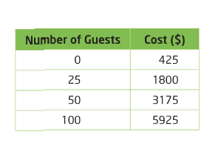

a) Sketch a graph of the data in the table.

b) What are the slope and y-intercept of the line? What does each parameter represent?

c) Write an equation that describes the relationship between the cost and the number of guests. Express the equation in slope-intercept form.

d) What is the cost for 140 guests?

e) Asha would like the total cost to be no more that $15000. What is the maximum number of guests that can attend?

f) Did you need to draw the graph to determine the equation or was there enough information in the table of values?

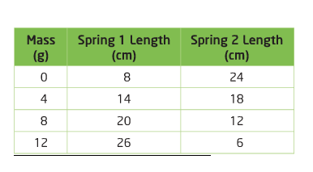5. A group of students tested how different masses changed the lengths of two different coil springs. The results of their experiments are summarized in the table.

a) For each spring, write an equation to model how spring length, L, in centimeters, changes with mass, x, in grams. Express each equation in slope-intercept form.

b) What does a negative slope represent in the experiment?

6. Consider the equation y = 3x + b. What is the value of b if a graph of the line passes through the point (4, 9)?

7. For the equation y = mx – 2, what is the value of m if the line passes through the point (-2, 8)?

8. A decorator’s fee can be modeled by the equation F = 75t + b. In the equation, F represents the fee, in dollars, t represents time, in hours, and b represents the cost of the initial consultation, in dollars.

a) Suppose the decorator spends 4 h working for a client and charges the client $450. Determine the value of the parameter b.

b) How many hours does the decorator work if a client is charged $975?

**Practice #3 – Equations of Linear Relations**

Level 3

1. Express each equation in general form, Ax + By + C = 0

a) $y = 7x – 5$ b) $y = -x + 8$ c) 

d)  e) $y = 0.25x – 0.3$ f) 

g) $y + 3 = x – 5$ h) $y+4=2\left(x+3\right)$ i) $y – 6 = 4(x + 1$

j) $y + 2 = -5(x + 3)$ k)  l) 

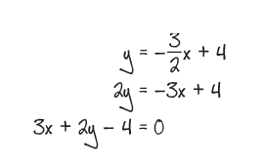2. Janelle was asked to convert the equation  to general form. Her work is shown.

Identify Janelle’s error, then correct her work.

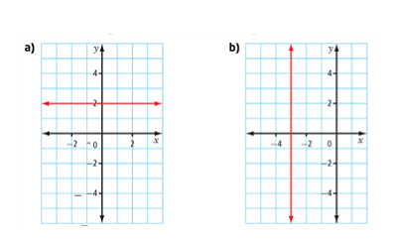

3. What is the equation of the line in general form?

4. Write an equation, in general form, for each line described

a) a vertical line passing through the point (3, 5)

b) a horizontal line passing through the point (-2, 6)

c) the x-axis

d) the y-axis

Level 4

5. Brooke wants to save $336 to decorate her bedroom. She has two part-time jobs. On weekends, she works as a snowboard instructor and earns $12 per hour. On weeknights, she earns $16 per hour working as a high school tutor.

a) Write an equation to represent the number of hours Brooke needs to work as a snowboard instructor, S, and as a tutor T. Write the equation in general form.

b) What is the S-intercept of a graph of the equation? What does the S-intercept represent?

c) What would the T-intercept be? What does it represent?

d) Suppose Brooke works 8 h as a snowboard instructor. How many hours will she need to work as a tutor?

**Practice #4 – Equations of Linear Relations**

Level 3

1. For each equation, identify the slope of the line it represents and the coordinates of a point on the line.

a) $y – 5 = -4(x – 1)$ b) $y + 7 = 3(x – 8)$ c) $y+11=(x+15)$

d) $y = 5(x – 2)$ e)  f)

Level 2/3

2. Determine the equation of each line using slope-point form. Then, express each equation in slope-intercept form.

a) (5, -2), $m = 6$ b) (-3, -5), $m = -2$

c) (-8, 3),  d) (12, -6), 

3. Determine the equation of each line using slope-point form. Then, express each equation in general form.

a) (3, -5), $m = 3$ b) (-2, -1), $m = -5$

c) (-3, 2),  d) (15, -3), 

4. Write an equation in slope-point form of each line passing through the given point.

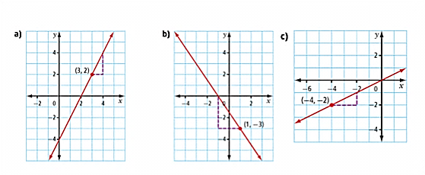

**Practice #5 – Equations of Linear Relations**

Level 3

1. Write the equation of the line in slope-intercept form that passes through:

a) (5, 1) and (3, -7) b) (5, -8) and (1, 4) c) (4, 5) and (2, 6)

2. Write the equation of the line in general form that passes through:

a) (8, -3) and (4, -6) b) (5, -1) and (3, -4) c) (3, 6) and (-1, 0)

3. What is the equation of each line in slope-intercept form?

a) slope of 3 and x-intercept of 4

b) x-intercept of 2 and y-intercept of -6

c) slope of -2 and y-intercept of 3

4. What is the equation of each line in general form?

a) slope of -2 and x-intercept of 5

b) x-intercept of -3 and y-intercept of 5

c) slope of 5 and y-intercept of 7

5. A line passes through G(-3, 11) and H(4, -3)

a) Determine the slope of line GH

b) Write an equation for line GH using point G and the slope

c) Write an equation for line GH using point H and the slope

d) Verify that the two equations are equivalent. What strategy did you use? What different strategy could you have used to verify that the equations are equivalent?

Level 4

6. The speed of sound in air is a linear function of the air temperature. When the air temperature is 10oC, the speed of sound is 337 m/s. When the air temperature is 30oC, the speed of sound is 349 m/s.

a) Write a linear equation to represent this function.

b) Use the equation to determine the speed of sound when the air temperature is 0oC.

**Practice #6 – Equations of Linear Relations**

Level 4

1. Write an equation of a line in slope-intercept form that is parallel to each line and passes through the given point.

a) y = 2x + 5, (1, -6) b) 5x + y – 1 = 0, (3, -8)

c) y = -7x – 2, (2, 5) d) 4x + 2y – 5 = 0, x-intercept of 3

2. Write an equation of a line in general form that is parallel to each line and passes through the given point

a) y = -3x + 7, (-2, 5) b) 6x – 2y + 10 = 0, (3, -5)

c) y = 8, (3, 4) d) x – 5 = 0, (-1, -8)

3. Write an equation of a line in slope-intercept form that is perpendicular to each line and passes through the given point

a) y = 3x + 5, (9, 5) b) x + 3y + 4 = 0, (5, -9)

c) x + 5y – 10 = 0, x-intercept of -2 d) y = -5x + 4, y-intercept of 3

4. Write an equation of a line in general form that is perpendicular to each line and passes through the given point.

a) y = -4x + 7, (-12, -7) b) 4x – 3y – 6 = 0, (-2, -1)

c) x – 2 = 0, (-3, 7) d) y = -5, (4, -6)

5. Write the general form equation of a line that passes through (7, 5) and is:

a) parallel to the x-axis

b) perpendicular to the y-axis

6. Determine an equation representing each line

a) parallel to 5x + y + 4 = 0 with a y-intercept of -6

b) perpendicular to x + 5y – 10 = 0 with the same y-intercept as y = 4x – 3

c) perpendicular to 5x + 4y -2 = 0 with the same x-intercept as 3x – 5y = 15

**Answers**

**Practice #1**

1a) m = -5; b = 4 b) m = $\frac{3}{4}$; b = 1 c) m = 1; b = -7

d) m = -4; b = 0 e) m = 0; b = -3 f) m = 0.5; b = -1.25

2a) $y = -3x + 2$ b) $y=\frac{5}{6}x-4$ c) $y = -0.75x – 5$

d) $y = x – 7$ e) $y = -x$ f) $y=\frac{1}{3}$

3a) m = 4; b = 4; $y = 4x + 4$ b) m = $-\frac{1}{2}$; b = -1; $y=-\frac{1}{2}x-1$ c) m = -2; b = 6; $y = -2x + 6$

d) m = $\frac{2}{3}$; b = 4; $y=\frac{2}{3}x+4$ e) m = 0; b = -2.5; $y = -2.5$ f) m = $\frac{2}{5}$; b = 4; $y=\frac{2}{5}x+4$

4a) m = -2, b = 3, Graph C b) m = 2; b = -3; Graph D

c) m = $\frac{1}{2}$; b = -3; Graph B d) m = $-\frac{1}{2}$; b = 3; Graph A

5a) $y=-\frac{3}{2}x+9$ b) $y=-\frac{1}{3}x-3$

c) $y=\frac{3}{2}x-8$ d) $y=\frac{5}{2}x+6$

6a) y = 12x – 840

b) m = 12, $12/ticket

c) -840, the costs to put on the show

d) 70 tickets

7a) Step 3 – should be -4

b)

8) Discussion

9) Discussion

**Practice #2**

1a) C = 6.25n + 300

b) T = 1.48x + 3.60

c) D = 54t + 1024

d) L = -120t + 2500

2a) C = 0.80n + 20

b) $107.20

c) 125

3a) C = 29n + 99

b) $766

c) 14

d) No

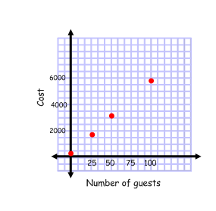4a)

b) m = 55; b = 425

$55/person; $425 cost of ballroom

c) C = 55n + 425

d) $8125

e) 265

f) Discussion

5a) Spring 1: $y = 1.5x + 9$

Spring 2: $y = -1.5x + 24$

b) Discussion

6) -3

7) -5

8a) 150

b) 11 hours

**Practice #3**

1a) 7x – y – 5 = 0 b) x + y – 8 = 0 c) 3x - 2y + 8 = 0

d) 3x + 5y + 10 = 0 e) 25x – 100y – 30 = 0 f) 20x + 8y – 1 = 0

g) x – y – 8 = 0 h) 2x – y + 2 = 0 i) 4x – y + 10 = 0

j) 5x + y + 17 = 0 k) x + 2y + 2 = 0 l) 2x + 3y + 15 = 0

2) Forgot to multiply 4 x 2; 3x + 2y – 8 = 0

3a) y – 2 = 0 b) x + 3 = 0

4a) x – 3 = 0 b) y – 6 = 0

c) y = 0 d) x = 0

5a) 12S + 16T – 336 = 0

b) 28; This means if she only worked as a snowboard instructor she would have to work 28 hours to make $336.

c) 21; This means if she only worked as a tutor she would have to work 21 hours to make $336.

d) 15 hours

**Practice #4**

1a) m = -4; (1, 5) b) m = 3; (8, -7) c) m = 1; (-15, -11)

d) m = 5; (2, 0) e) m = $\frac{4}{7}$; (-3, -6) f) m = $-\frac{8}{5}$; (-16, 21)

2a) y = 6x – 32 b) y = -2x – 11 c) $y=\frac{1}{2}x+7$

d) $y=-\frac{2}{3}x+2$

3a) 3x – y – 14 = 0 b) 5x + y + 11 = 0 c) 2x – 3y + 12 = 0

d) 2x + 3y – 21 = 0

4a) y – 2 = 2(x – 3) b) $y+3=-\frac{3}{2}(x-1)$ c) $y+2=\frac{1}{2}(x+4)$

**Practice #5**

1a) y = 4x – 19 b) y = -3x + 7 c) $y=-\frac{1}{2}x+7$

2a) 3x – 4y – 36 = 0 b) 3x – 2y – 17 = 0 c) 3x – 2y + 3 = 0

3a) y = 3x – 12 b) y = 3x – 6 c) y = -2x + 3

4a) 2x + y – 10 = 0 b) 5x – 3y + 15 = 0 c) 5x – y + 7 = 0

5a) -2 b) y – 11 = -2(x + 3)

c) y + 3 = -2(x – 4) d) 2x + y–5=0

6a) $y-349=\frac{3}{5}(x-30)$ b) y = 331

**Practice #6**

1a) y = 2x – 8 b) y = -5x + 7

c) y = -7x + 19 d) y = -2x + 6

2a) 3x + y + 1 = 0 b) 3x – y – 14 = 0

c) y – 4 = 0 d) x + 1 = 0

3a) $y=-\frac{1}{3}x+8$ b) y = 3x – 24

c) y = 5x + 10 d) $y=\frac{1}{5}x+3$

4a) x – 4y – 16 = 0 b) 3x + 4y + 10 = 0

c) y – 7 = 0 d) x – 4 = 0

5a) y – 5 = 0 b) y – 5 = 0

6a) y = -5x – 6 b) y = 5x – 3 c) $y=\frac{4}{5}x-4$

|  |  |
| --- | --- |
| **OUTCOMES** | **ASSESSMENT RUBRICS** |
| **FP10.10 Solve problems that involve systems of linear equations in two variables, graphically, and algebraically** | |

|  |  |  |  |  |
| --- | --- | --- | --- | --- |
| **Level**  **Criteria** | **Intervention 1**  **Spend some extra time with the criteria and ask for help.** | **Instructional 2**  **Good start. You are beginning to make sense of this on your own. You are consistent with the basic learning goals for this outcome.** | **Independence 3**  **You did it and you did it on your own. You are able to complete the processes for this outcome. Your work is thorough and consistently accurate.** | **Mastery 4**  **Great work! This is going extra well for you. You have understood the outcome, are able to explain your strategies and apply these to situations. Your work is always accurate.** |
| **Outcome 10:** Students will demonstrate understanding of systems of linear equations. | I need more help with becoming consistent with the criteria. | I am able to determine the solution to a system of linear equations when the graphs of the systems are given. I can explain the meaning of this solution.  I am able to determine if a point is a solution to the system.  I am able to solve a basic system of linear equations algebraically (basic means coefficients are already the same or a variable is isolated). | I am able to solve a system of linear equations to find the exact solution when there are no fraction or decimal coefficients.  I can determine the number of solutions to a linear system if the equations are already in slope-intercept form. | I am able to solve a system of linear equations to find the exact solution when fraction or decimal coefficients are involved.  I am able to solve problems involving systems of linear equations.  I am able to analyze a system of linear equations to determine how many solutions it will have.  I am able to solve a system multiple ways and discuss the solutions found. |

**Practice #1 – Systems of Linear Equations**

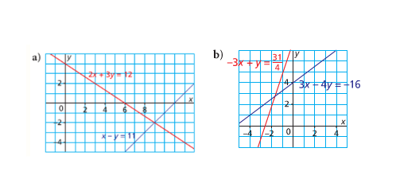Level 2

1. For each linear system, use the graphs to determine the solution. Explain how you know whether the solution is exact or approximate.

2. Is each given point a solution to the system of linear equations? Explain.

a) y = 3x – 5 b) 4x + 3y = 5 c) 2x – 3y = 18

y = 11 – x x + 4y = 13 x + 2y = -26

(4, 7) (-1, 3) (-6, -10)

d) 3x – y = 2 e) 2x + 3y = -12 f) 12x – 3y = 7

x + 4y = 22 4x – 3y = -6 y = 4.5x – 3

(2, 5) (-3, -2) (1.2, 2.4)

**Practice #2 – Systems of Linear Equations**

Level 3

1. Graph these equations. Solve this linear system.

a) 2x + 3y = 3 b) 2x + 4y = -1 c) x – y = -1 d)-3x+y=5

x – y = 4 3x – y = 9 x + y = 5 x+3y=-5

Level 4

2. What are some limitations to solving a linear system by graphing?

3. When you solve a linear system graphically, how can you determine whether the solution is approximate or exact?

**Practice #3 – Systems of Linear Equations**

Level 2/3

1. Solve the following linear systems using substitution.

a) x – y = -5 b) y = 9 – x c) 2x – 3y = -9

x = -1 2x + 3y = 11 x + y = -2

d) x + 2y = 13 e) -2x + y = -4 f) m – 3n = -8

2x – 3y = -9 -x + y = 1 2n – m = 5

g) 5x – y = 12 h) 3m – n = 4 i) 3x – y = 16

18 – x = y m = 2n + 3 2x + 3 = y + 16

Level 4

2. Solve the following linear system by substitution.





3. What are some advantages of solving a linear system using the substitution strategy rather than graphing?

4. Compare solving a linear system by substitution to solve graphically. How are the methods similar? How are they different?

**Practice #4 – Systems of Linear Equations**

Level 2/3

1. Solve the following linear systems by elimination.

a) 3x + y = 5 b) 3x – 4y = 0 c) 15x – 2y = 9

9x – y = 15 5x – 4y = 8 5x + 4y = 17

d) 2x + y = -5 e) 2x + 7y = 24 f) 8x – 3y = 38

3x + 5y = 3 3x – 2y = –4 3x – 2y = -1

Level 4

2. Use an elimination strategy to solve the following linear systems.

a)  b) 



3. You have used graphing, substitution, and elimination to solve a linear system. For each strategy, give an example of a linear system that you think would be best solved using that strategy. Justify your choices.

**Practice #5 – Systems of Linear Equations**

Level 4

1. A mixed farming operation has both cattle and chickens as well as grain. One day, the owner, not having much to do, noticed that the chickens and cows had a total of 162 eyes and 258 legs. How many of each are there?

2. After a game, Mr. Carduner tells his team that he will buy them a treat at the local restaurant. When the first of the players arrived he bought 8 hamburgers and 5 servings of French fries for $24.00. When the rest of the team arrived, he bought 6 more hamburgers and 2 more servings of French fries for $16.60. If the burgers and fries were all the same, what was the price of one hamburger and one serving of fries?

3. Tickets to the September dance cost $2.50 for freshies and $5.00 for seniors. If 425 tickets were sold for a total of $1662.50, how many freshies attended the dance and how many seniors were at the dance?

4. Frankie earned $10.50 per hour and his assistant Johnny earns $6.75 per hour. If together they worked a total of 72 hours and earned a total of $643.50, how many hours did each work?

**Practice #6 – Systems of Linear Equations**

Level 3

1. Determine the number of solutions for each linear system

a) y = x + 2 b) y = 2x – 4 c) y = 3x + 2

y = x + 2 y = x + 1 y = 3x – 5

d) y = 56 – 2x e) y = 60 + 3x f) y = -4x – 3

y = 10 + x y = 60 – 5x y = 4x – 3

Level 4

2. Determine the number of solutions for each linear system (you may want to rearrange into slope-intercept form first)

a) x + 2y = 6 b) 3x + 5y = 9 c) 2x – 5y = 30

x + y = -2 6x + 10y = 18 4x – 10y = 15

d) x + 3y = 6 e) 3x – y = 12 f) x – 4y = 8

 4x – y = 12 x + 4y = 20

3. Given the equation –6*x* + *y* = 3, write another linear equation that will form a linear system with:

* 1. exactly one solution
  2. no solution
  3. infinite solutions

4. Suppose you are given only the following pieces of information about a system of linear equations. Would you be able to predict the number of solutions to the system? Explain.

a) The slopes of the lines are the same

b) The y-intercepts of the lines are the same

c) The x-intercepts are the same, and the y-intercepts are the same.

5. Mark wrote the two equations in a linear system in slope-intercept form. He noticed that the signs of the two slopes were different. How many solutions will this linear system have? Explain.

6. Use substitution to show that the linear system y = 2x + 5 and 2y – 4x = -15 has no solution. How do you know there is no solution?

**Answers**

**Practice #1**

1a) (9, -2) b) (-1.6, 2.8)

2a) yes b) no c) yes

d) no e) yes f) no

**Practice #2**

1a) (3, -1) b) (2.5, -1.5) c) (2, 3) d) (-2, -1)

2) Various

3) Various

**Practice #3**

1a) (-1, -4) b) (16, -7) c) (-3, 1)

d) (3, 5) e) (5, 6) f) (1, 3)

g) (5, 13) h) (1, -1) i) (3, -7)

2) (4, -6)

3) Discussion

4) Discussion

**Practice #4**

1a) $\left(\frac{5}{3},0\right)$ b) (4, 3) c) (1, 3)

d) (-4, 3) e) (0.8, 3.2) f) $\left(\frac{75}{7},\frac{116}{7}\right)$

2a) (8, 4) b) (20, -6)

3) Discussion

**Practice #5**

1) 33 chickens, 48 cows

2) $2.50 hamburger; $0.80 fries

3) 185 freshies; 240 seniors

4) Johnny 30h; Frankie 42 h

**Practice #6**

1a) infinite b) one c) zero

d) one e) one f) one

2a) one b) zero c) one

d) infinite e) one f) one

3a) Various b) Various c) Various

4) Discussion

5) One; discuss why

6) Discussion