Math 20 Foundations Textbook

Please do NOT write in this textbook (other than on this page!). If this textbook is lost you will be charged a fee for it.

Name | Teacher’s Name | Semester/year

Table of Contents

Outcome |  | Questions | Answers
1 | Math project | 5 | N/A
2 | Inductive and deductive reasoning | 6 | 17
3A | Rates | 23 | 27
3B | Scale factor | 28 | 32
3C | Surface area and volume | 33 | 37
4 | Properties of angles | 38 | 47
5 | Laws of sine and cosine | 51 | 60
6 | Normal distribution | 63 | 69
7 | Statistical reasoning | 71 | 74
8A | Linear inequalities | 75 | 81
8B | Optimization problems | 83 | 92
9 | Quadratic functions | 94 | 102

OUTCOMES | ASSESSMENT RUBRICS
FM20.1 Demonstrate understanding of the mathematics involved in a historical event or an area of interest
Level  Criteria | Intervention 1  Spend some extra time with the criteria and ask for help. | Instructional 2  Good start. You are beginning to make sense of this on your own. You are consistent with the basic learning goals for this outcome. | Independence 3  You did it and you did it on your own. You are able to complete the processes for this outcome. Your work is thorough and consistently accurate. | Mastery 4  Great work! This is going extra well for you. You have understood the outcome, are able to explain your strategies and apply these to situations. Your work is always accurate.
Outcome 1: Demonstrate understanding of the mathematics involved in a historical event or an area of interest | I need more help with becoming consistent with the criteria. | I am able to show how math was involved in my event/area.  I collected data/stated facts that were relevant to my topic | I am able to explain the connection to math in my event/area.  If there were any bias or points of view then I could identify these.  I was able to identify my data collection method or where I found my facts. | I am able to explain the importance of the math involved in my event/area.  I am able to interpret my data/facts as to how it impacts society.  I can identify any controversial issues and present multiple sides of the issues with supporting data, if applicable.

OUTCOMES | ASSESSMENT RUBRICS
FM20.2 Demonstrate understanding of inductive and deductive reasoning including: analyzing conjectures, analyzing spatial puzzles and games, providing conjectures, solving problems
Level  Criteria | Intervention 1  Spend some extra time with the criteria and ask for help. | Instructional 2  Good start. You are beginning to make sense of this on your own. You are consistent with the basic learning goals for this outcome. | Independence 3  You did it and you did it on your own. You are able to complete the processes for this outcome. Your work is thorough and consistently accurate. | Mastery 4  Great work! This is going extra well for you. You have understood the outcome, are able to explain your strategies and apply these to situations. Your work is always accurate.
Outcome 2: Demonstrate understanding of inductive and deductive reasoning | I need more help with becoming consistent with the criteria. | I can make a conjecture by observing patterns and identifying properties.  I can provide counterexamples to a conjecture with false conclusions. | I can analyze an argument for its validity.  I can prove algebraic number relationships.  I can prove conjectures.  I can determine strategies for solving puzzles or winning games and explain these strategies. | I can justify the reasoning to my conjecture.  I can identify situations involving inductive and/or deductive reasoning.  I can identify errors in proofs. I can solve situational questions. I can compare inductive and deductive reasoning.  I can create a variation of a puzzle or game and describe a strategy for solving the puzzle or winning the game.

Practice #1 – Inductive and Deductive Reasoning
Level 2
- Tomas gathered the following evidence and noticed a pattern.

17(11) = 187 23(11) = 253
41(11) = 451 62(11) = 682

Tomas made this conjecture: When you multiply a two digit number by 11, the first and last digits of the product are the digits of the original number. Is Tomas’s conjecture reasonable? Develop evidence to test his conjecture and determine whether it is reasonable.

- Make a conjecture about the sum of two even integers. Develop evidence to test your conjecture.

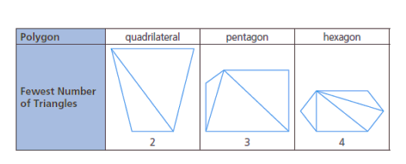
- Use the evidence given in the chart below to make a conjecture. Provide more evidence to support your conjecture.

- Make a conjecture about the sum of one odd integer and one even integer. Test your conjecture with at least three examples.

- Sally noticed a pattern when dividing the squares of an odd number by 4. Determine the pattern and make a conjecture.

- Paula claims that whenever you square an odd integer, the result is an odd number. Is her conjecture reasonable? Justify your decision.

Level 4
- Text messages often include cryptic abbreviations, such as L2G (love to go), 2MI (too much information), LOL (laugh out loud), and MTF (more to follow) used in text messages. Make a conjecture about the cryptic abbreviations used in text messages, and provide evidence to support your conjecture.

- Farmers, travelers and hunters depend on their observations of weather and storm systems to make quick decisions and to survive in different weather conditions. Weather predictions, passed on through oral tradition or cited in almanacs, are often based on long-term observations. Two predictive statements about weather are given below:

- If cows are lying down, then it is going to rain
- Red sky at night; sailor’s delight

Find another such predictive statement from oral tradition, an Elder, a family member, an Internet source, or a text. Explain how and why this prediction may have been reached.

- Lou says that conjectures are like inferences in literature and hypotheses in science. Sasha says that conjectures are related only to reasoning. With a partner, discuss these two opinions. Explain how they both may be valid.

- In advertising, we often see statements such as “four out of five dentists recommend it”. Is this a conjecture? Justify your decision.

Practice #2 – Inductive and Deductive Reasoning

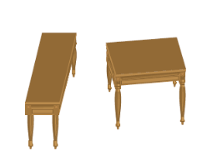
Level 3
- Make a conjecture about the dimensions of the two tabletops. How can you determine if your conjecture is valid?

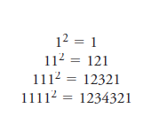
- Examine the number pattern. Make a conjecture about this patter. What steps can you take to determine if your conjecture is valid.

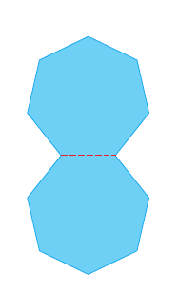
- If two congruent regular heptagons are positioned so that they share a side, a dodecagon (12-sided polygon) is formed. If two congruent regular hexagons are positioned so that they share a side, a decagon is formed. If two congruent regular pentagons are positioned so that they share a side, an octagon is formed. Make a conjecture about positioning two congruent regular quadrilaterals so that they share a side. Determine whether your conjecture is valid. Record your evidence.

Practice #3 – Inductive and Deductive Reasoning

Level 2
- Show that each statement is false by finding a counterexample.
- A number that is not negative is positive
- All prime numbers are odd.
- All basketball players are tall.
- The height of a triangle lies inside the triangle
- On maps, the north arrow always points up
- The square root of a number is always less than the number.
- The sum of two numbers is always greater than the greater of the two numbers.
- As you travel north, the climate gets colder.

Level 3
- Jim claims that whenever you multiply two whole numbers, the product is greater than either of the two factors. Do you agree or disagree? Justify your decision.

- Colin made the following conjecture: If a quadrilateral has two opposite angles that are right angles, the quadrilateral is a rectangle. Do you agree or disagree? Justify your decision.

- Patrice studied the following table and made this conjecture: The sums of the squares of integers separated by a value of 2 will always be even.

(-1)² + 1² = 2 | 2² + 4² = 20 | (-3)² + (-5)² = 34 | 4² + 6² = 52 | 0² + 2² = 4

Is Patrice’s conjecture reasonable? Explain.

- Blake claimed that all odd numbers can be expressed as the sum of three prime numbers. Explain, with evidence, the reasonableness of his claim.

- Jarrod discovered a number trick in a book he was reading: Choose a number. Double it. Add 6. Double again. Subtract 4. Divide by 4. Subtract 2.

- Try the trick several times. Make a conjecture about the relation between the number picked and the final result.
- Can you find a counterexample to your conjecture? What does this imply?

- Create a general statement that is true in some cases but not in every case. Provide examples that support your statement. Provide a counterexample.

- What relationship exists among inductive reasoning, evidence, and counterexamples?

- Max claims that the expression n² + n + 2 will never generate an odd number for a positive integer value of n. Do you agree or disagree? Justify your decision.

Practice #4 – Inductive and Deductive Reasoning

- Jim is a barber. Everyone whose hair is cut by Jim gets a good haircut. Austin’s hair was cut by Jim. What can you deduce about Austin?

- Examine the following example of deductive reasoning. Why is it faulty?

Given: Khaki pants are comfortable. Comfortable pants are expensive.
Adrian’s pants are not khaki pants.

Deduction: Adrian’s pants are not expensive.

- David created this number trick: Choose a number. Multiply it by 4. Add 10. Divide by 2. Subtract 5. Divide by 2. Add 3.

a) Show inductively with three examples that the result is always equal to 3 more than the chosen number.
b) Prove deductively that the result is always equal to 3 more than the chosen number.

- Recall Jarrod’s number trick from practice #3. Choose a number. Double it. Add 6. Double again. Subtract 4. Divide by 4. Subtract 2.

Prove that any number chosen will be equal to the result.

- Prove that the sum of two even integers is always even.

- Prove that the product of an even integer and an odd integer is always even.

- Prove that whenever you square an odd integer, the result is odd.

- Prove that any four-digit number is divisible by 2 when the last digit in the number is divisible by 2.

- Prove that any two-digit number is divisible by 5 when the last digit in the number is divisible by 5.

- To determine if a number is divisible by 9, add all of the digits and determine if that sum is divisible by 9. If yes, the original number is divisible by 9. Prove that this is true for all two and three digit numbers.

- Chuck made the conjecture that the sum of any seven consecutive integers is 7 times the median. Prove Chuck’s conjecture.

- Cleo noticed that, no matter whether she was looking for the difference between the squares of two consecutive odd numbers or the difference between the squares of two consecutive even numbers, the result was always a multiple of 4. Show by induction that this pattern exists, then prove it deductively.

Practice #5 – Inductive and Deductive Reasoning
Level 4
- Determine the error in each example of deductive reasoning.

- All runners train on a daily basis. Gabriel is a runner. Therefore, Gabriel trains daily.

- All squares have four right angles. Quadrilateral PQRS has four right angles. Therefore, PQRS is a square.

- According to this proof, 5 = 7. Identify the error.
Proof: 1 = 1 + 1
2(1) = 2(1 + 1)
2(1) + 3 = 2(1 + 1) + 3
2 + 3 = 4 + 3
5 = 7
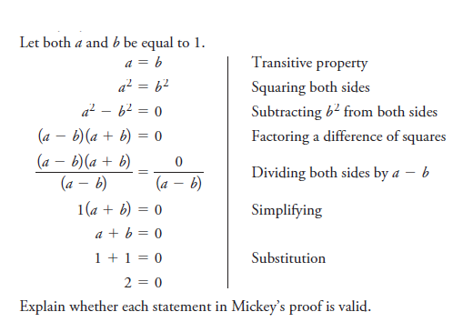
- Mickey says that he can prove that 2 = 0. Here is his proof.

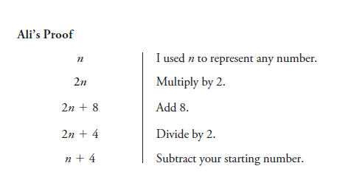
- Ali created a math trick in which she always ended with 4. When Ali tried to prove her trick, however, it did not work.

Identify the error in Ali’s proof, and explain why her reasoning is incorrect.

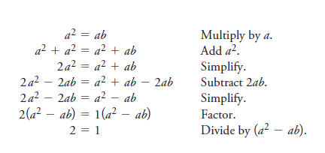
- According to this proof, 2 = 1. Determine the error in reasoning.
Let a = b

- Discuss how false proofs can appear to be both reasonable and unreasonable at the same time.

Practice #6 – Inductive and Deductive Reasoning

Level 4
- Explain which type of reasoning is demonstrated by each statement.

- Over the past 12 years, a tree has produced plums every other year. Last year, the tree did not produce plums. Therefore, the tree will produce plums this year.

- Mammals have hair. Dogs are mammals. Therefore, dogs have hair.

- Every Thursday, a train arrives at 2:30pm. Today is Thursday, so the train will arrive at 2:30 pm.

- Every even number has a factor of 2. 24 is an even number. Therefore, 24 has a factor of 2.

- For the pattern 3, 12, 21, 30, 39, the next term is 48.

- A farmer wants to get a goat, a wolf, and a bale of hay to the other side of a river. His boat is not very big, so it can only carry him and one other thing. If the farmer leaves the goat alone with the bale of hay, the goat will eat the hay. If he leaves the wolf alone with the goat, the wolf will eat the goat. When the farmer is present, the goat and the hay are safe from being eaten. How does the farmer manage to get everything safely to the other side of the river?

- Determine the unknown term in this pattern: 17, 22, ____, 35, 43. Explain your reasoning.

- Suppose that you are marooned on an island where there are only liars and truth-tellers. Liars always tell lies, and truth-tellers always tell the truth. You meet two siblings. The brother says, “My sister told me that she is a liar.” Is he a liar or a truth-teller? Explain how you know.

- Bob, Kurt, and Morty are football players. One is a quarterback, one is a receiver, and one is a kicker. The kicker, who is the shortest of the three, is not married. Bob, who is Kurt’s father in law, is taller than the receiver. Who plays which position?

- Max, Karl, Terri and Suganthy live on the first floor of an apartment building. One is a manager, one is a computer programmer, one is a singer, and one is a teacher.

- Use the statements below to determine which person is the manager
- Suganthy and Terri eat lunch with the singer
- Karl and Max carpool with the manager
- Terri watches football on television with the manager and the singer

- Describe the reasoning you used to solve this problem.

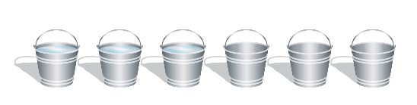
- There are six pails in a row. The first three pails are filled with water. How can you move only one pail to make the following pattern: full pail, empty pail, full pail, empty pail, full pail, empty pail?

- How do you recognize a problem that can be solved using inductive reasoning? How do you recognize a problem that can be solved using deductive reasoning? Is it always possible to tell which kind of reasoning is needed to solve a problem? Explain.

Practice #7 – Inductive and Deductive Reasoning

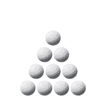
Level 3
- Rearrange three golf balls so that the arrowhead points down instead of up.

2a) Draw a diagram like the one below. Place the numbers 1 through 9 in the circles so that the sum of the numbers on each side of the triangle is 17.
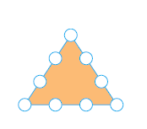
b) Explain the strategy you used.
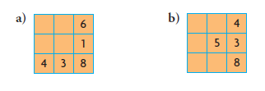
- Fill in the missing numbers from 1 to 9, so that the sum of the numbers in each row, column and diagonal is 15.

- Who started this game of tic-tac-toe: player X or player O? Explain. Assume that both players are experienced at playing tic-tac-toe.
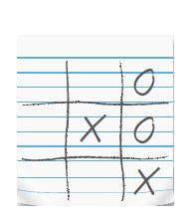
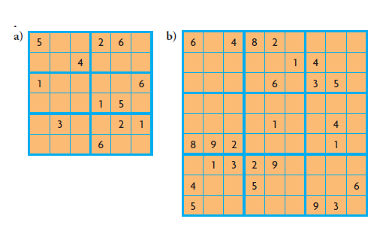
- Sudoku requires both inductive and deductive reasoning skills. The numbers that are used to complete a Sudoku puzzle relate to the size of the grid. For a 6 by 6 grid, the numbers, 1 to 6 are used. For a 9 by 9 grid, the numbers 1 to 9 are used. The grid must be filled so that each column, row, or block contains all the numbers. No number can be repeated within any column, row, or block. Solve each of the Sudoku puzzles below.

Level 4
- Examine this square. It has a magic sum.

- Describe the patterns you see.
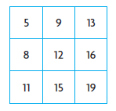
- Selva noticed that when he added three numbers that were not in the same row or column, the sum was 36 (the magic sum). This number is 3 times the number in the middle square. Create your own magic square using the patterns you identified. Do Selva’s observations hold in your square?

- Prove algebraically that Selva’s observations hold in any square that is created using these patterns.

- Explain how inductive and deductive reasoning can help you develop a strategy to play a game or to solve a puzzle.

Inductive and Deductive Reasoning Answers

Practice #1
1) Tomas’s conjecture is not reasonable. 99(11) = 1089
Example: The sum of two even integers is always even.

2) For example, 6 + 12 = 18 34 + 72 = 106
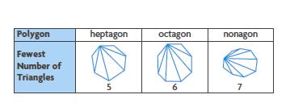
Example: The fewest number of triangles in a polygon is the number of sides subtracted by 2.

3)

4) Example: The sum of one odd integer and one even integer is always odd.
3 + 4 = 7; -11 + 44 = 33; 90 + 121 = 211

5) Example: The result is always an even number ending with a decimal of .25
6) Example: Paula’s conjecture is reasonable. When you multiply an odd digit with an odd digit, the result is odd: 1(1) = 1; 3(3) = 9; 5(5) = 25; 7(7) = 49; 9(9) = 81 Since the ones of a product are the result of a multiplication of two digits, squaring an odd integer will always result in an odd integer

7) Example: Text messages are written using small keypads or keyboards, making text entry difficult. Abbreviations reduce the difficult typing that needs to be done, example LOL is 3 characters, “laugh out loud” is 14.

8) Example: If March comes in like a lamb, it will go out like a lion. People may have noticed that when the weather was mild at the beginning of March, or near the end of winter, there would be bad weather at the end of March, or near the beginning of spring.

9) Example: A conjecture is a belief, and inferences and hypotheses are also beliefs. However, conjectures, inferences, and hypotheses are validated differently because they relate to different subjects: mathematics/logic, literature, and science.

10) Example: The statement is not a conjecture. The company making the claim probably surveyed some dentists to get their opinion; however, these dentists’ opinion may not represent that of all dentists.

Practice #2
1) Example: The dimensions of the tabletops are the same. A rule may be used to measure them.

2) Example: The pattern will continues until 12345678987654321; after that it will change. I can test my conjecture using a spreadsheet.
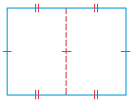
3) Example: When two congruent polygons are positioned so that there is a common side, the polygon formed will have 2n – 2 sides, where n is the number of sides in one original polygon. My conjecture is invalid. The resulting figure is 4-sided:

Practice #3
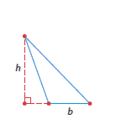
1) Examples:
a) 0 is a number that is not negative, and is not positive
b) 2 is a prime number that is not odd
c) Muggsy Bogues was an NBA player who was 1.6 m (5 ft. 3 in.) tall
d) The height of a triangle can lie outside the triangle

e) If a city’s shape is roughly rectangular and it lies along a northeast-southwest axis, then the map will be set to accommodate the city’s shape, and the north arrow would instead point toward a corner of the map.
f) $\sqrt{0.01}=0.1$
g) -10 + 5 = -5
h) Travelling north in the southern hemisphere generally results in a warmer climate

2) Disagree. Example: 1(10) = 10

3) Disagree. Example: a kite with angles of 90º, 45º, 90º, and 135º

4) Example: Patrice’s conjecture is reasonable. Integers separated by a value of 2 will both be odd or both be even, and their squares will both be odd or both be even. Adding two even numbers together and adding two odd numbers together result in an even number.

5) Example: Blake’s claim is not valid. The number 3 cannot be written as the sum of three primes.

6a) The number picked and the final results are the same.

b) I cannot find a counterexample. This does not imply that the conjecture is valid, but it does strengthen it.

7) Example: Any real number is divisible by another real number.

$$\frac{425.353}{1.35}=315.076… \frac{π}{\sqrt[3]{9}}=1.510…$$
Counterexample: 0 is a real number for which division is not defined.

8) Example: Inductive reasoning can be used to make a conjecture; a conjecture is supported by evidence and can be invalidated by a counterexample.

9) Agree. Example: If n is odd, its square will be odd. Two odd numbers and one even number added together result in an even number. If n is even, then three even numbers are added together, and that results in an even number.

Practice #4
1) Austin got a good haircut

2) Example: The premise that khaki pants are comfortable does not exclude other pants from being comfortable.
3a) b)

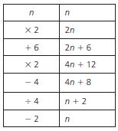
4)

5) Example: Let 2n and 2m represent any two even integers.

2n + 2m = 2(n + m)

Since 2 is a factor of the sum, the sum is even

6) Let 2n + 1 be any odd integer and 2m be any even integer.

2m(2n + 1) = 4mn + 2m
= 2(2mn + m)

Since 2 is a factor of the product, the product is even.

7) Let 2n + 1 be any odd integer.

(2n + 1)² = 4n² + 2n + 2n + 1
= 4n² + 4n + 1
= 2(2n² + 2n) + 1

Since 2 is a factor of 4n² + 4n, this part is even. Adding 1 makes the result odd.

8) Let abcd be any 4 digit integer.

abcd = 1 000a + 100b + 10c + d
= 2(500a + 50b + 5c) + d

The number abcd is only divisible by 2 if d is divisible by 2.

9) Let ab be any 2 digit integer.

ab = 10a + b
= 5(2a) + b

The number ab is only divisible by 5 if b is divisible by 5.

Let abc be any 3 digit integer.

abc = 100a + 10b + c
abc = 5(20a + 2b) + c
The number abc is only divisible by 5 if c is divisible by 5.

10) Let ab be any 2 digit integer.

ab = 10a + b
= 9a + a + b

The number ab is only divisible by 9 if a + b is divisible by 9.

Let abc be any 3 digit integer

abc = 100a + 10b + c
= 99a + 9b + a + b + c
= 9(11a + b) + a + b + c

The number abc is only divisible by 9 is a + b + c is divisible by 9.

11) Let n be any integer.

(n-3) + (n-2) + (n-1) + n + (n+1) + (n+2) + (n+3) = 7n n = the median

or

n + (n+1) + (n+2) + (n+3) + (n+4) + (n+5) + (n+6) = 7n + 21
= 7(n+3) n+3 = the median

Practice #5
1a) the statement “all runners train on a daily basis” is invalid.
b)The reasoning leading to the conclusion is invalid. Rectangles also have four right angles.

2) The first line of the proof is invalid.

3) In line 5, Mickey divides by (a – b), which is invalid because a – b = 0.

4) Ali did not correctly divide by 2 in line 4.

5) In line 7, there is a division by 0. Since a = b, a² – ab = 0
6) Example: false proofs appear true because each mathematical step involved in the reasoning seems sound. In a false proof, there is one (or more) incorrect steps that are misinterpreted as being correct.

Practice #6
1a) inductive b) deductive c) inductive d) deductive e) inductive

2) Let A represent one side of the river and B the other. Move goat to B; return to A. Move wolf to B; return with goat to A. Move hay to B; return, Move goat to B.

3) 28

4) The brother is a liar

5) Bob is the quarterback, Kurt is the receiver, and Morty is the kicker

6a) Suganthy
b) Deductive

7) Pour water from the second pail into the fifth one.

8) A problem can be solved using inductive reasoning if it has a pattern that can be continued. A problem can be solved using deductive reasoning if general rules can be applied to obtain the solution. It is not always possible to tell which kind of reasoning is needed to solve a problem.

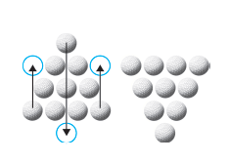
Practice #7
1)

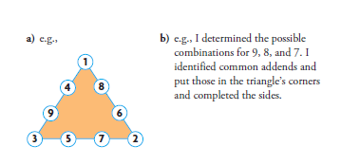

2

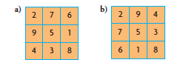
3

4) Player O started the game.

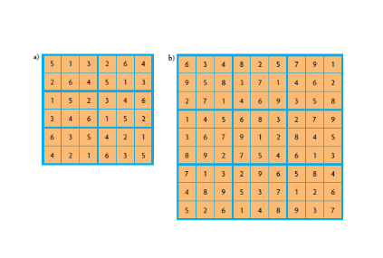
5

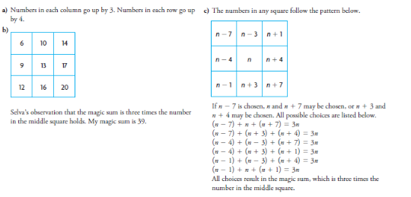
6

7) Using inductive reasoning, I can observe a pattern and use it to determine a solution. Using deductive reasoning, I can apply logical rules to help me solve a puzzle or determine a winning strategy for a game.

OUTCOMES | ASSESSMENT RUBRICS
FM20.3 Expand and demonstrate understanding of proportional reasoning related to: rates, scale diagrams, scale factor, area, surface area, volume
Level  Criteria | Intervention 1  Spend some extra time with the criteria and ask for help. | Instructional 2  Good start. You are beginning to make sense of this on your own. You are consistent with the basic learning goals for this outcome. | Independence 3  You did it and you did it on your own. You are able to complete the processes for this outcome. Your work is thorough and consistently accurate. | Mastery 4  Great work! This is going extra well for you. You have understood the outcome, are able to explain your strategies and apply these to situations. Your work is always accurate.
Outcome 3A: Demonstrate understanding of proportional reasoning related to rates | I need more help with becoming consistent with the criteria. | I can determine and compare unit rates. | I can solve rate problems.  I can determine rates from graphs and tables.  I can relate slope of a graph to rate.  I can describe situations where a rate might occur.  I can analyze situations in which unit rates are determined and give reasons if the rate should be used or not. | I can justify my work.  I can create non symbolic representations for rates.  I can explain the meanings of rate in a situation and can explain the effect of factors within a situation that could influence the rate.  I can solve situational questions.

Practice #1 – Proportional Reasoning

Level 2
- 8kg of cheddar cheese costs $68. Determine the price for 1 kg of cheese.

- 44L of fuel costs $41.36. Determine the cost for 1 L of gas.

- Apple juice is sold in 1 L bottles and 200 mL boxes. A 1L bottle sells for $1.75, and fifteen 200 mL boxes sell for $4.99.
- Determine the unit rate, in dollars per milliliter for each size. (1000mL = 1L)
- Which size has the lower cost per milliliter?

- The list price for a 925 mL container of paint is $20.09. A 3.54 L container of the same paint costs $52.99. Which container has the lower unit cost?

Level 3
- On Thursday, a crew paved 10 km of road in 8h. On Friday, the crew paved 15 km in 10 h. Draw a graph to compare the crew’s daily paving rates.

- Shelley has two choices for a long-distance telephone plan:
- Her telephone company which charges 4 cents per minute
- A device that plugs into her Internet modem, which costs $19.95 with an additional charge of 1.5 cents per minute.
Shelley makes, on average, 50 minutes of long distance calls per month. Which option would be cheaper on an annual basis? Justify your decision.

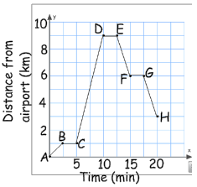
- A hotel shuttle bus takes David from the airport to his hotel. The graph shows how the distance from the airport changes over time.

- Over which interval of time is the bus
Travelling the slowest?
- Over which interval of time is the bus
Travelling the fastest?
- When does David get to his hotel? How far is the hotel from the airport?
- What does a zero slope mean in this context of the graph?
- Over which interval is the bus travelling at a rate of 1.2 km /min.
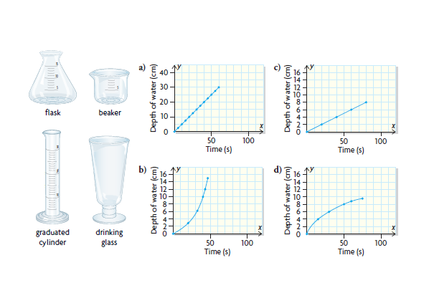
- Suppose that tap water, flowing from a faucet at a constant rate, is used to fill these containers. Match each of the following graphs with the appropriate container. Justify your choices.

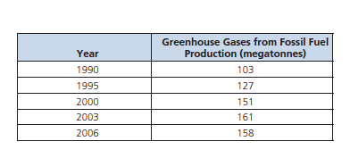
- The following table shows the amount of greenhouse gases emitted by fossil fuel production in Canada from 1990 to 2006. During which period was the amount emitted increasing at the greatest rate? Justify your decision.

Practice #2 – Proportional Reasoning
Level 3
- 50 L of oil costs $163. How much oil, to the nearest litre, could you buy for $30?

- 8 kg of beef costs $68.00. How much will it cost, to the nearest cent, for 1.5 kg of beef?
- Two competing stores have 350 mL cans of pop on sale this week. Supersaver is selling a case of 24 cans for $5.99. Gord the Grocer is selling cans of the same pop in cases of 12, with three cases for $9.99.
- Which store is selling soft drinks at the lower price per can?
- Besides price, what other factors should be considered when determining which store offers the better buy for a consumer?

- The Wildcats won 12 of their first 20 games. At this rate, predict how many games they will win during the 30 game season.

- Melanie wants to defrost a frozen roast, which weighs 2.68 kg, in her microwave. To find out how much time she needs, she looks in a cookbook. She reads that 2 lb of meat takes 15 min to defrost. How long, to the nearest minute, should she set the timer for? (1 kg = 2.2 lb)

Level 3/4
- Describe a situation in which each rate might be used. Identify any factors that could influence the rate in this situation
- $7.23/kg b) 20 mL/90kg c) $1.08/100g
- -1.5ºC/km e) 20 g/L f) $4.99/ft²

Level 4
- Chris and her friend Elena drove from Vancouver to Yellowknife for a reunion. They took turns driving, so they only needed to stop for gas or food. They drove the 2359 km distance in 36 h 12 min.
- Determine their average speed to the nearest tenth of a kilometer per hour.
- They used 231.2 L of fuel. Determine their average fuel consumption per 100 km.
- Chris and Elena spent $252.05 on fuel. What was the average cost of a litre of gas?

- Max has taken a job as a doctor in Tuktoyaktuk, NWT. He plans to ship his car, furniture, and personal effects to Tuktoyaktuk by barge from Vancouver. He has found these shipping rates online:

- Light duty vehicles: $0.2015/lb
- Furniture and personal effects $0.2734/lb

He knows that his car has a mass of 1250 kg. He estimates that he has roughly 550 lb of furniture and personal effects. Calculate his cost to ship these items to his destination. (1 kg = 2.2 lbs)
Proportional Reasoning Answers
Practice #1
1) $8.50/kg

2) $0.94/L

3a) 1 L bottle - $0.00175/mL 200mL box - $0.00166/mL
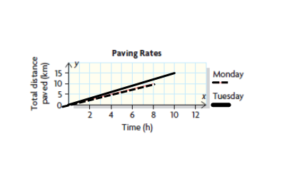
b) the 200 mL box

4) 925 mL can - $0.0217/mL; 3.54L can - $0.015/mL; The 3.54L can is the better deal

5)

6) Telephone company - $24.00 /year; Internet - $28.95/year; Telephone company is cheaper

7a) BC, DE and FG – no slope b) CD – rate is 1.6 km/min
c) 20 min; 3 km d) the bus is not moving
e) EF and GH

8a) graduated cylinder b) flask c) beaker d) drinking glass

9) The rates for 1990 – 1995 and 1995 – 2000 are both 4.8 megatonnes/year

Practice #2
1) 9L

2) $12.75

3a) Supersaver is $0.25 per can; Gord’s is $0.28 per can; Supersaver is cheaper
b) various answers

4) 18

5) 44 min

6a) cost for meat in a grocery store b) amount of medicine per body mass
c) cost for cold cuts at the deli counter d) change in temperature as altitudes changes
e) density of a substance when climbing a mountain
f) cost of flooring at a hardwood store

7a) 65.2 km/h b) 9.8 L c) $1.09

8) $704.50

OUTCOMES | ASSESSMENT RUBRICS
FM20.3 Expand and demonstrate understanding of proportional reasoning related to: rates, scale diagrams, scale factor, area, surface area, volume
Level  Criteria | Intervention 1  Spend some extra time with the criteria and ask for help. | Instructional 2  Good start. You are beginning to make sense of this on your own. You are consistent with the basic learning goals for this outcome. | Independence 3  You did it and you did it on your own. You are able to complete the processes for this outcome. Your work is thorough and consistently accurate. | Mastery 4  Great work! This is going extra well for you. You have understood the outcome, are able to explain your strategies and apply these to situations. Your work is always accurate.
Outcome 3B: Demonstrate understanding of proportional reasoning related to scale diagrams | I need more help with becoming consistent with the criteria. | I can do 3 of 5 of the following: determine scale factor of 2D drawings, determine scale factor of 3D objects, determine unknown dimensions of 2D drawings, determine unknown dimensions of 3D objects, draw a scale diagram of a 2D shape. | I can determine scale factor of 2D drawings, determine scale factor of 3D objects, determine unknown dimensions of 2D drawings, determine unknown dimensions of 3D objects, draw a scale diagram of a 2D shape. | I can solve situational problems involving scale diagrams of 2D shapes and 3D objects.

Practice #3 Proportional Reasoning
Level 2/3
- Determine the scale factor that was used to transform diagram X into diagram Y. Express your scale factor as a fraction and a percent.
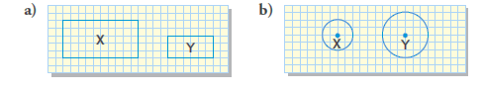

- Determine the scale factor used in each situation.
- The actual diameter of a penny is 19mm. In a scale diagram, the diameter of a penny is 5.7 cm.
- The actual width of a door is 30 in. In a scale diagram, the width of the door is 1.5 in.
- The diagonal of an actual stamp is 2.5 cm long. In a scale diagram, the diagonal is 1.0 m long.
- The height of an actual communication tower is 55 ft. In a scale diagram, the height of the tower is 6 in.

- Determine if the original will be larger or smaller than the scale diagram after the given scale factor is applied.

- Scale factor: 112% b) scale factor: 0.75 c) scale factor: $\frac{4}{9}$

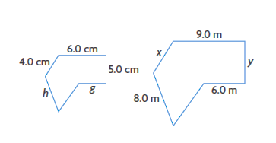
- The following two polygons are similar. Determine the lengths of sides g, h, x, and y to the nearest tenth of a unit.

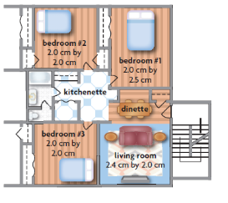

- The floor plan of an apartment is drawn using a scale factor of 0.005.
- What are the actual dimensions of each bedroom?
- What are the actual dimensions of the living room?
- Which room has the greatest area?
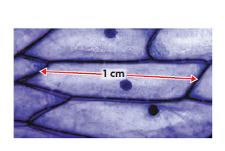
- A computer chip on a circuit board has a rectangular shape, with a width of 6 mm and a length of 9 mm. Plans for the circuit board must be drawn using a scale factor of 15. Draw a scale diagram of the computer chip as it would appear on the plans.

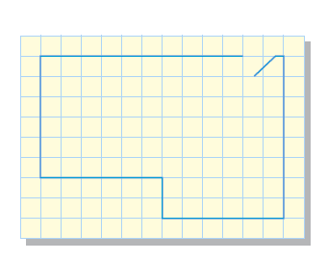
- Sara has a microscope with a lens that magnifies by a factor of 40. She was able to capture the image of a slide containing onion cells, as shown. In the image, the cell was about 1 cm long. How long is the actual onion cell, to nearest hundredth of a millimeter?

- This scale diagram, drawn on 0.5cm grid paper, shows the floor plan of a greenhouse, drawn using a scale ratio of 1:75. Determine the perimeter of the greenhouse.

Practice #4 – Proportional Reasoning
Level 2/3
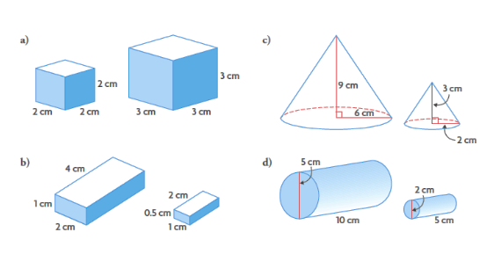
- For each of the following, determine whether the two objects are similar and justify your decision.

- The National Basketball Association (NBA) uses a basketball with a diameter of 25 cm. The Women’s National Basketball Association (WNBA) uses a basketball with a diameter of 22 cm.

- Are these balls similar? Explain.
- Determine the scale factor that relates
- The NBA ball to the WNBA ball
- The WNBA ball to the NBA ball

Level 4
- Last summer, Ed visited the Royal Tyrrell Museum in Drumheller, Alberta, to see the fossil and dinosaur exhibits. While he was there, he purchased a 1:40 scale model of the Albertosaurus libratus, which was native to the area over 70 million years ago. The length of the model is 21.5 cm, and the height is 9.5 cm. Determine the length and height of this species of dinosaur.
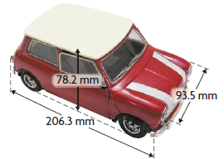
- A 1:18 scale model of a car has the dimensions shown. Determine the dimensions of the actual car.

- A carving of Tecumseh, the Shawnee leader of a confederacy that fought in the war of 1812, is located in the Wood Carving Museum in Windsor, Ontario. The carving is $6\frac{1}{2}$ ft tall by $2\frac{1}{2}$ ft wide. The museum wants to sell replica models that are 26 in. tall in the gift shop.

- What scale factor must be used to produce these models?
- Determine the width of these models.

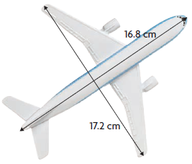
- The measurements of a scale model of a passenger jet are shown. The model was made using a scale factor of $\frac{1}{200}$. The floor of Hanger 77 at the Calgary International Airport measures 46.6 m long by 71.9 m wide. How many of these passenger jets could fit in this hangar?

Proportional Reasoning Answers
Practice #3
1a) 3/5 or 60% b) 3/2 or 150%

2a) 3 b) 1/20 c) 40 d) 1/110

3a) smaller b) larger c) larger

4) g = 4 h = 5.3 y = 7.5 x = 6

5a) bedroom 1 – 4 m x 5 m bedrooms 2 and 3 – 4 m x 4m
b) 4.8m x 4 m
c) bedroom 1

6) The rectangle would have dimensions 9 cm by 13.5 cm

7) 0.25

8) 15 m

Practice #4
1a) similar b) similar c) similar d) not similar

2a) Yes, all spheres are similar
b) i) 25/22 ii) 22/25

3) length: 8.6 m; height 3.8 m

4) 1.41 m by 1.68 m by 3.71 m

5a) 1/3 b) 10 in.

6) 2

OUTCOMES | ASSESSMENT RUBRICS
FM20.3 Expand and demonstrate understanding of proportional reasoning related to: rates, scale diagrams, scale factor, area, surface area, volume
Level  Criteria | Intervention 1  Spend some extra time with the criteria and ask for help. | Instructional 2  Good start. You are beginning to make sense of this on your own. You are consistent with the basic learning goals for this outcome. | Independence 3  You did it and you did it on your own. You are able to complete the processes for this outcome. Your work is thorough and consistently accurate. | Mastery 4  Great work! This is going extra well for you. You have understood the outcome, are able to explain your strategies and apply these to situations. Your work is always accurate.
Outcome 3C: Demonstrate an understanding of proportional reasoning related to area, surface area and volume | I need more help with becoming consistent with the criteria. | Given the scale factor of a 2D shape or 3D object, I can find the ratio of areas, surface area or volume. | Given the ratio of areas, surface area or volume of an object I can determine the scale factor and apply this to solve for a value | I can solve situational questions.  I can explain the effect of a change in scale factor on the area of a 2D shape or the surface area or volume of a 3D object.

Practice #5 – Proportional Reasoning
Level 2
- The scale factor of two pentagons is 3:5. What is the ratio of their areas?

- The scale factor of two rectangles is 4:7. What is the ratio of their areas?

Level 3
- The ratio of the areas of two hexagons is 25:64. What is their scale factor?

- The ratio of the areas of two decagons is 9:4. What is their scale factor?

- Two cylinders have a scale factor of similarity of 3:5. If the surface area of the smaller cylinder is 2250 cm², find the surface area of the larger cylinder.

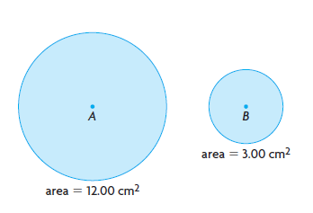
- Two pentagons are similar. If the area of the larger pentagon is 81 cm², and the area of the smaller pentagon is 64 cm², find the ratio of the perimeter of the smaller pentagon to the perimeter of the larger pentagon?

7. a) Determine the scale factor that relates Circle B to Circle A.

- Determine the scale factor that relates Circle A to Circle B

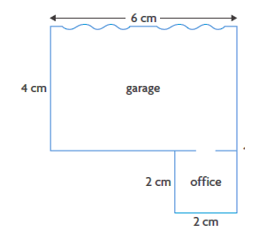
- The sketch below of a service garage and an attached office was drawn using a scale ratio of 1:500. On this diagram, the area of the garage is 24 cm² and the area of the office is 4 cm². Determine the area of the actual garage and the actual office in square metres.

Level 4
- A rectangular display, with the dimensions 2 m by 3 m, is located in the lobby of city hall to show the citizens the layout for the new People’s Park. The display was created using a scale ratio of 1:120.

- The parks department estimates that the city spends $0.75/m² to maintain a park from spring through fall. Determine the cost to maintain People’s Park based on this estimation.
- A rectangular model, with the same dimensions, was used to represent Meadow Park. The scale ratio used was 1:250. Estimate the cost to maintain Meadow Park

- Explain the difference between the following processes:
- Reduce a 2D shape by a scale factor of $\frac{1}{2}$.
- Divide the area of the same 2D shape by 2.

Use examples to support your explanation.
Practice #6 – Proportional Reasoning
Level 2
- If the scale factor of two similar solids is 5:7, then determine
- The ratios of their surface areas
- The ratios of their volumes

- If the scale factor of two similar solids is 2:5, then determine
- The ratios of their surface areas
- The ratios of their volumes

Level 3
- If the ratios of the volumes of two similar solids is 64:216, then determine
- Their scale factor
- The ratios of their surface areas

- If the ratios of the surface areas of two similar solids is 16:49, then determine
- Their scale factor
- The ratios of their volumes

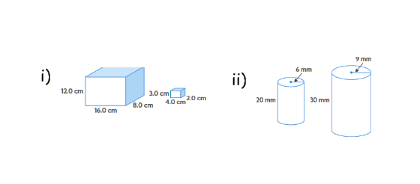
- Each pair of objects is similar.
- By what factor is the surface area of the larger object greater than the surface area of the smaller object?
- By what factor is the volume of the larger object greater than the volume of the smaller object?

- An oil tank has a capacity of 32 m³. A similar oil tank has dimensions that are larger by a scale factor of 3. What is the capacity of the larger tank?

- The dimensions of a right octagonal pyramid are enlarged by a scale factor of 1.5. Determine the value of each of the following ratios:

- Volume of large pyramid b) surface area of large pyramid
Volume of small pyramid surface area of small pyramid

Level 4
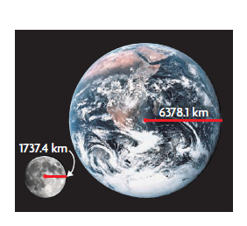
- Sam wants to compare Earth and the moon by creating spherical models. He has decided to represent Earth with a sphere that has radius of 10.0 cm.

- What is the radius of the sphere he should use to represent the Moon? Round to the nearest tenth of a centimetre.

- Determine the ratio that compares the circumference of the model of Earth to the circumference of the model of the moon.

- Determine the ratio that compares the surface area of the model of Earth to the surface area of the model of Moon.

- Determine the ratio that compares the volume of the model of Earth to the volume of the model of the Moon.

- A baseball has a diameter of about 2.9 in. A softball has a diameter of about 3.8 in. If a softball uses 45 in. of leather to cover the ball, how much leather is used to cover a baseball?

- Suppose that your class is sending shoeboxes filled with school supplies to schools in need after a devastating earthquake. A cardboard manufacturer has donated two sizes of shoeboxes. The small shoebox is 18.0 cm long, 11.5 cm wide, and 9 cm high. The large shoebox is 36.0 cm long, 23 cm wide, and 18 cm high.

- Matty claims that it will take about twice as much paper to wrap the large shoebox for shipping. Do you agree? Justify your decision.

- Is the volume of the small shoebox half the volume of the large shoebox? Explain how you know.

Proportional Reasoning Answers
Practice #5
1) 9:25

2) 16:49

3) 5:8

4) 3:2

5) 6250 cm²

6) 8:9

7a) 0.5 b) 2

8) garage 600 m²; office 100 m²

9a) $64800 b) $281250

10) example: In process A the area is divided by 4, not by 2 as in process B

Practice #6
1a) 25:49 b) 125:343

2a) 4:25 b) 8:125

3a) 4:6 or 2:3 b) 16:36 or 4:9

4a) 4:7 b) 64:343

5i) a – 9/4 b – 27/8 ii) a – 16 b - 64

6) 864m³

7a) 3.375 b) 2.25

8a) 2.7 cm b) 3.7 c) 13.5 d) 49.5

9) 26 in.

10a) No, it will take about 4 times as much (sf = 2, sf² = 4)
b) No, it is 1/8 the volume of the large shoebox (sf = ½, sf³ = 1/8)
OUTCOMES | ASSESSMENT RUBRICS
FM20.4 Demonstrate understanding of the properties of angles and triangles including: deriving proofs based on theorems and postulates about congruent triangles; solving problems
Level  Criteria | Intervention 1  Spend some extra time with the criteria and ask for help. | Instructional 2  Good start. You are beginning to make sense of this on your own. You are consistent with the basic learning goals for this outcome. | Independence 3  You did it and you did it on your own. You are able to complete the processes for this outcome. Your work is thorough and consistently accurate. | Mastery 4  Great work! This is going extra well for you. You have understood the outcome, are able to explain your strategies and apply these to situations. Your work is always accurate.
Outcome 4: Demonstrate understanding of applying the properties of angles and triangles | I need more help with becoming consistent with the criteria. | I can find missing angle measures in BASIC diagrams of parallel lines cut by a transversal; triangles; and polygons | I can find missing angle measures in any type of diagram of parallel lines cut by a transversal; triangles; and polygons.  I can derive basic proofs.  I can identify errors in a proof. | I can find missing angle measures when the given angles are a polynomial expression.  I can construct parallel lines.  I can perform error analysis.  I can explain why certain angles are equal in parallel lines.  I can derive proofs.  I can verify if angles formed by non-parallel lines and transversals create the same relationships as those created parallel lines.

Practice #1 – Properties of Angles
Level 4
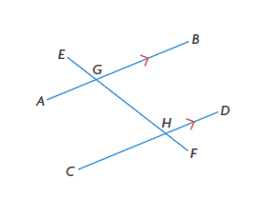
- Which pairs of angles are equal in this diagram? Explain how you know. Is there a relationship between the measures of the pairs of angles that are not equal?

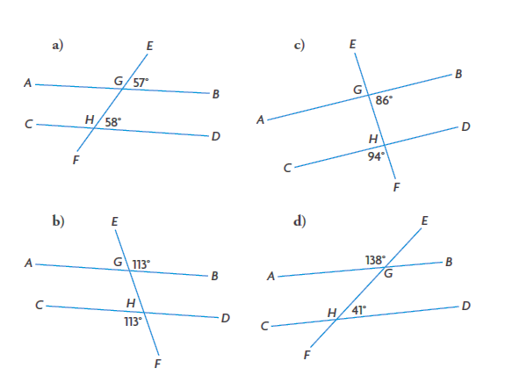
- In each diagram, is AB parallel to CD? Explain how you know.

- Explain how you could construct parallel lines using only a protractor and a ruler. Try it.

Practice #2 - Properties of Angles
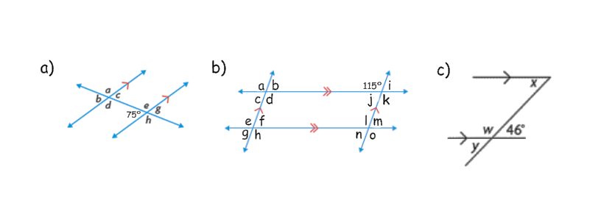
Level 2
- Determine the measures of the indicated angles.

Level 3
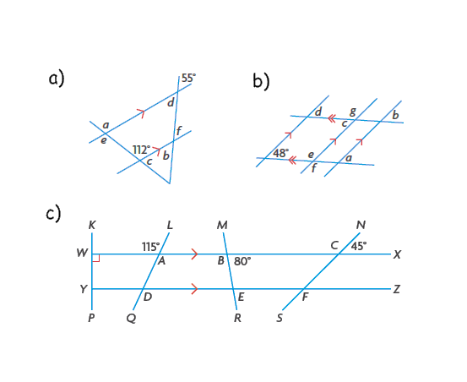
- Determine the measures of the indicated angles.

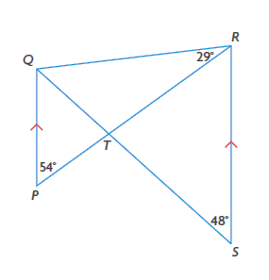
- Determine the measures of all the unknown angles in this diagram.

- Jason wrote the following proof.
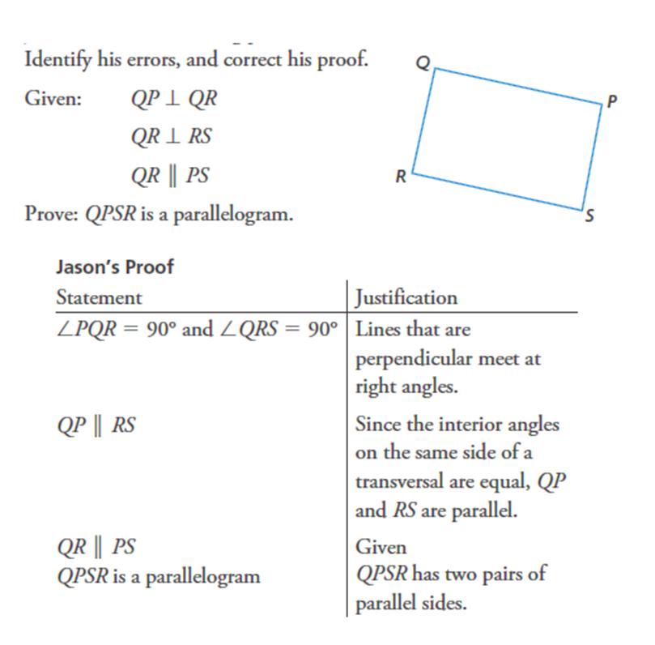

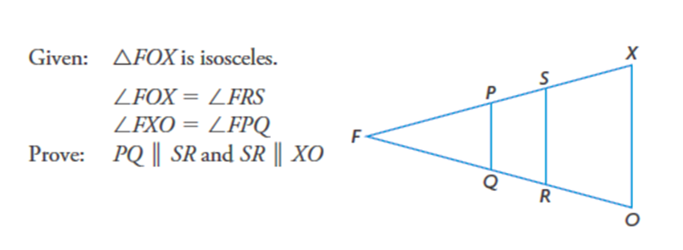

Level 4
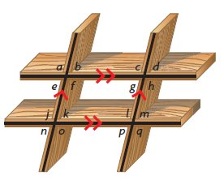
- In the diagram for question 3, explain why each of the following statements is true.

a) <k = <p b) <a = <j
c) <j = < q d) <g = <d
e) <b = <m f) <e = <p
g) <n = <d h) <f + <k = 180º

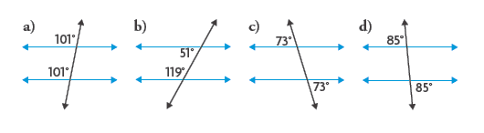
- For each diagram, decide if the given angle measures prove that the lines are parallel. Justify your decisions.

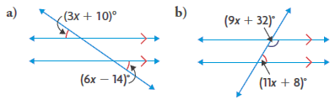
- Solve for x.

Practice #3 Properties of Angles

Level 2
- Determine the following unknown angles
- <YXZ, <Z b) <A, <DCE
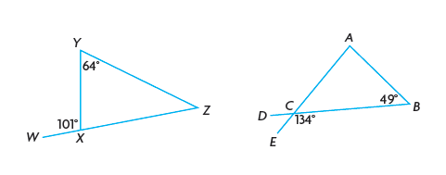
Level 3
- Determine the measures of the interior angles of ΔFUN
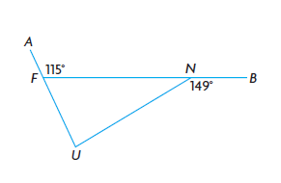
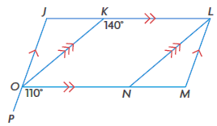
- Use the given information to determine the measures of <J, <JKO, <JOK, <KLM, <KLN, <M, <LNO, <LNM, <MLN, <NOK, and <JON

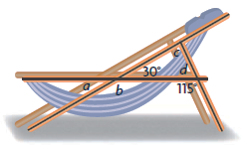
- A manufacturer is designing a reclining lawn chair, as shown. Determine the measures of <a, <b, <c, and <d.

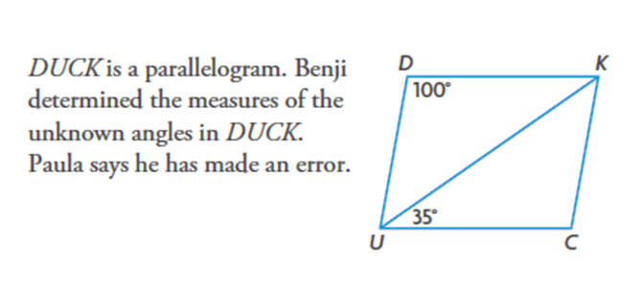

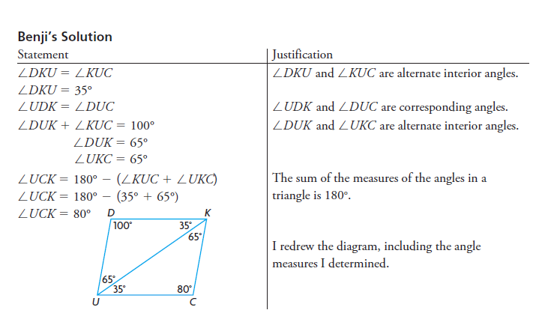

- Explain how you know that Benji made an error.
- Correct Benji’s solution.

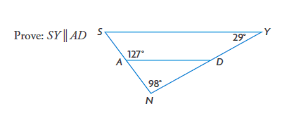

Level 4
- Each vertex of a triangle has two exterior angles, as shown.

a) Make a conjecture about the sum of the measures of <a, <c, and <e.
b) Does your conjecture also apply to the sum of the measures of <b, <d, and <f? Explain.
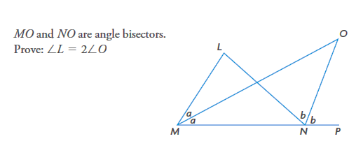
c) Prove or disprove your conjecture.

Practice #4 Properties of Angles
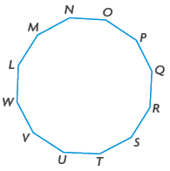
Level 2
1. a) Determine the sum of the measures of the interior angles of a regular dodecagon.

b) Determine the measure of each interior angle of a regular dodecagon.

- Determine the sum of the measures of the angles in a 20-sided convex polygon.

- The sum of the measures of the interior angles of an unknown polygon is 3060º. Determine the number of sides that the polygon has.

Level 3
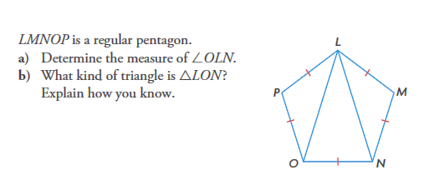
- Three exterior angles of a convex pentagon measure 70º, 60º, and 90º. The other two exterior angles are congruent. Determine the measures of the interior angles of the pentagon.

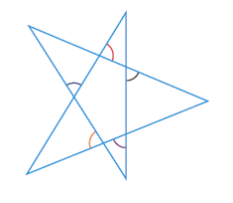
- Determine the sum of the measures of the indicated angles.

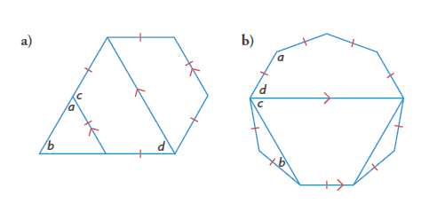
- In each figure, the congruent sides form a regular polygon. Determine the values of a, b, c, and d

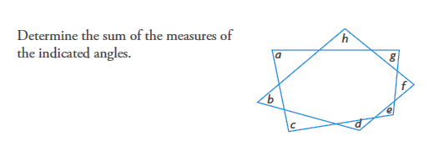

- Each interior angle of a regular convex polygon measures 140⁰.
a) Prove that the polygon has nine sides.
b) Verify that the sum of the measures of the exterior angles is 360º.

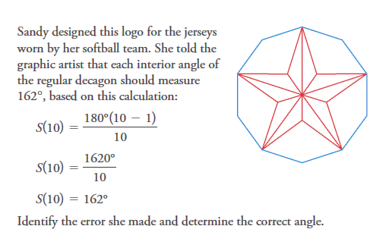
Level 4

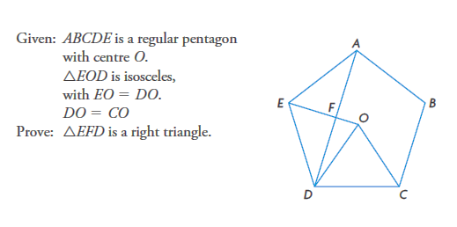

Properties of Angles Answer Key
Practice #1
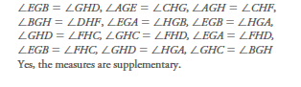

2a) No. Corresponding angles are not equal
b) Yes. Corresponding angles are equal
c) Yes. Corresponding angles are equal
d) No. Corresponding angles are not equal

3) example: draw a line and a transversal, then measure one of the angles between them. Use a protractor to create an equal corresponding angle elsewhere on the same side of the transversal. Use that angle to draw the parallel line.

Practice #2
1a) <a = 105⁰ <b = 75º <c = 75º <d = 105º
<e = 105º <g = 75º <h = 105º
b) <a = 115º <b = 65º <c = 65º <d = 115º
<e = 115º <f = 65º <g = 65º <h = 115º
<i = 65º <j = 65º <k = 115º <l = 115º
<m = 65º <n = 65º <o = 115º
c) <w = 134º, <x = 46º, < y = 46º

2a) <a = 112, <e = 112, <b = 55, <d = 55,
<f = 55, <c = 68
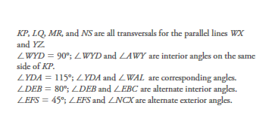
b) <a = 48, <b = 48, <c = 48, <d = 48,
<e = 132, <f = 132, <g = 132
c)

3) <PTQ = 78, <PQT = 48, <RQT = 49, <QTR = 102,
<SRT = 54, <PTS = 102

4) Error: interior angles should be stated as supplementary, not equal. Since <PQR + <QRS = 180º, the statement that QP//RS is still valid.
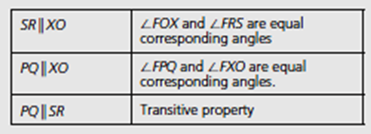
5)

6a) alternate interior angles are equal
b) corresponding angles are equal
c) alternate exterior angles are equal
d) opposite angles are equal
e) <b and <k and <m are all equal in measure; <b and <k are corresponding angles; <k and <m are corresponding angles
f) <e and <n and <p are all equal in measure; <e and <n are corresponding angles, <n and <p are corresponding angles
g) <n and <p and <d are all equal in measure; <n and <p are corresponding angles, <p and <d are alternate exterior angles
h) <f and <k are interior angles on the same side of a transversal

8a) Yes. Corresponding angles are equal
b) No. Interior angles on the same side of the transversal are not supplementary.
c) Yes. Alternate exterior angles are equal
d) Yes. Alternate exterior angles are equal.

9a) 8 b) 7

Practice #3
1a) <YXZ = 79, <Z = 37
b) <DCE = 46, <A = 85
2) <UNF = 31, <NFU = 65, <FUN = 84
3) <J = 110, <M = 110, <JKO = 40, <NOK = 40,
<KLN = 40, <LMN = 40, <MLN = 30, <JOK = 30,
<LNO = 140, <KLM = 70, <JON = 70

4) <a = 30, <b = 150, <c = 85, <d = 65
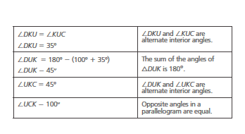
5a) <D ≠ <C
b)

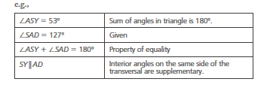
6)

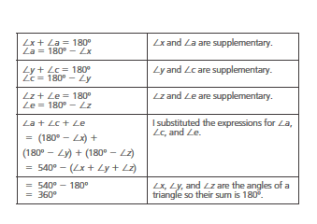
7a) The sum of <a, <c, and <e is 360º
b) Yes. <b = <a. <d = <c, <f = <e
c)

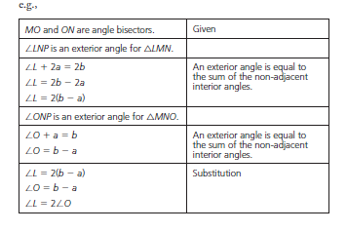
8)

Practice #4
1a) 1800º b) 150º

2) 3240º

3) 19

4) 100º, 120º, 90º, 110º, 110º

5) 36⁰ ; isosceles triangle

6) 360º

7a) <a = 60, <b = 60, <d = 60, <c = 120
b) <a = 140, <b = 20, <c = 60, <d = 60

8) 720º
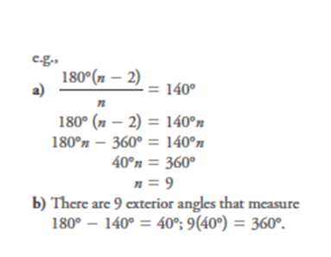
9)

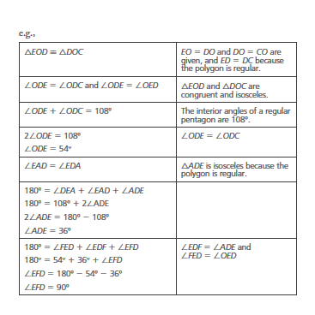
10) The numerator of the formula for S(10) should be 180º(10 – 2); S(10) = 144º

11)

OUTCOMES | ASSESSMENT RUBRICS
FM20.5 Demonstrate understanding of the cosine law and sine law (including the ambiguous case)
Level  Criteria | Intervention 1  Spend some extra time with the criteria and ask for help. | Instructional 2  Good start. You are beginning to make sense of this on your own. You are consistent with the basic learning goals for this outcome. | Independence 3  You did it and you did it on your own. You are able to complete the processes for this outcome. Your work is thorough and consistently accurate. | Mastery 4  Great work! This is going extra well for you. You have understood the outcome, are able to explain your strategies and apply these to situations. Your work is always accurate.
Outcome 5: Demonstrate understanding of the cosine law and sine law | I need more help with becoming consistent with the criteria. | I can solve for a missing side or angle (excluding ambiguous case) when the diagram is given (including those in situational questions) | I can solve situational questions involving non right triangles (excluding the ambiguous case).  I can illustrate and explain the possibilities for a given set of measurements for the ambiguous case. | I can explain the steps in a given proof of the sine law and cosine law.  I can illustrate and explain the possibilities for a given set of measurements for the ambiguous case.  I can perform error analysis.  I can solve situational problems that involve the ambiguous case.

Practice #1 - Trigonometry
Level 2
- Solve for the unknown side length or angle measure. Round all answers to the nearest tenth of a unit.

- $w^{2}={15}^{2}+{16}^{2}-2\left(15\right)\left(16\right)cos{75}^{o}$
- $k^{2}={32}^{2}+{35}^{2}-2\left(32\right)\left(35\right)cos{50}^{o}$
- ${48}^{2}={46}^{2}+{45}^{2}-2\left(46\right)\left(45\right)cosY$
- ${13}^{2}={17}^{2}+{15}^{2}-2\left(17\right)\left(15\right)cosG$

- Determine each unknown side length to the nearest tenth
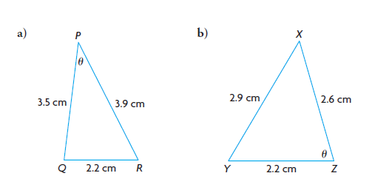
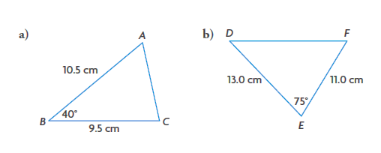
- Determine the measure of each indicated angle to the nearest degree.

Level 3
- Solve each triangle. Round all answers to the nearest tenth of a unit.

- In ΔDEF, d = 5.0 cm, e = 6.5 cm, and <F = 65º
- In ΔPQR, p = 6.4 m, q = 9.0 m, and <R = 80º
- In ΔLMN, l = 5.5 cm, m = 4.6 cm, and n = 3.3 cm

- Determine the perimeter of ΔSRT, if <S = 60º, r = 15cm and t = 20cm. Round your answer to the nearest tenth of a centimeter.

- Emilie makes stained glass windows to sell at the Festival du Bois in Maillardville, BC. Each piece of glass is surrounded by lead edging. Emilie claims that she can create an acute triangle in part of a window using pieces of lead that are 15 cm, 36cm, and 60cm. Is she correct? Justify your decision.
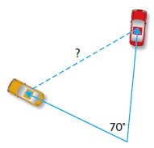
- Two drivers leave their school at the same time and travel on straight roads that diverge by 70º. One driver travels at an average speed of 33.0 km/h. The other driver travels at an average speed of 45.0 km/h. How far apart will the two drivers be after 45 min, to the nearest tenth of a kilometer?

Practice #2 – Trigonometry

Level 2
- Determine the indicated side lengths to the nearest tenth of a unit and the indicated angle measures to the nearest degree.
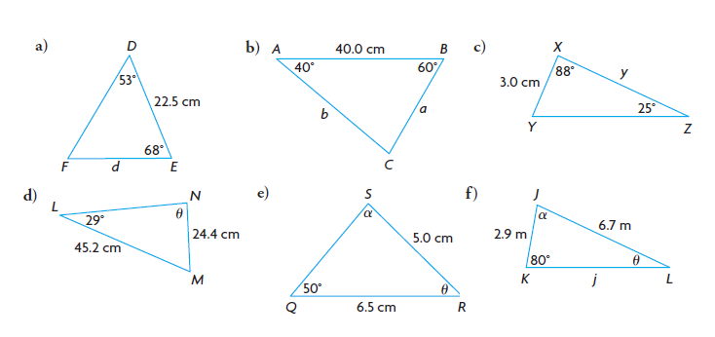
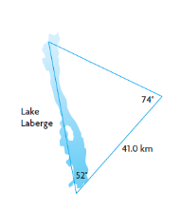
- Scott is studying the effects of environmental changes on fish populations in his summer job. As part of his research, he needs to know the distance between two points on Lake Laberge, Yukon. Scott makes the measurements shown and uses the sine law to determine the lake’s length as 36.0km.
- Amy, Scott’s research partner, says that his answer is incorrect. Explain how she knows.
- Determine the distance between the two points to the nearest tenth of a kilometer.
Level 3
- Draw a labeled diagram for each triangle. Then determine the required side length or angle measure.
- In ΔSUN, n = 58cm, <N = 38º, and <U = 72º. Determine the length of side u to the nearest centimeter
- In ΔWXY, w = 12.0cm, y = 10.5cm, and <W = 60º. Determine the measure of <Y to the nearest degree.

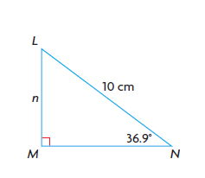
- In ΔCAT, <C = 32º, <T = 81º, and c = 24.1 m. Solve the triangle. Round sides to the nearest tenth of a metre.

- a) Determine the value of n to the nearest tenth using
- a primary trig ratio
- the sine law
b) Explain why your answers for part a) are the same.

Practice #3 – Trigonometry
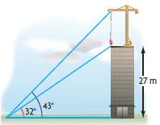
Level 2
- A crane stands on top of a building, as shown.

- How far is the point on the ground from the base of the building, to the nearest tenth of a metre?
- How tall is the crane?

Level 3
- A radar operator on a ship discovers a large sunken vessel lying parallel to the ocean surface, 200 m directly below the ship. The length of the vessel is a clue to which wreck has been found. The radar operator measures the angles of depression to the front and back of the sunken vessel to be 56º and 62º. How long, to the nearest tenth of a metre, is the sunken vessel?

- Two support wires are fastened to the top of a communications tower from points A and B on the ground. The points are on opposite sides of the tower and in line. One wire is 18m long, and the other wire is 12 m long. The angle of elevation of the longer wire to the top of the tower is 38º.
- How tall is the tower, to the nearest tenth of a metre?
- How far apart are points A and B, to the nearest tenth of a metre?
Practice #4 - Trigonometry

- Which of the following equations are valid? Give reasons for your choices.

- $sin{25}^{o}=sin{65}^{o}$ b) $cos{70}^{o}=-cos{110}^{o}$
c) $tan{46}^{o}=tan{134}^{o}$ d) $sin{122}^{o}=sin{58}^{o}$
e) $cos{135}^{o}=cos{45}^{o}$ f) $tan{175}^{o}=-tan5^{o}$

- Calculate each ratio to four decimal places. Predict another angle that will have an equal or opposite trigonometric ratio. Check your prediction.

- $sin{15}^{o}$ b) $cos{62}^{o}$ c) $tan{35}^{o}$ d) $sin{170}^{o}$

- Determine two angles between 0º and 180º that have each sine ratio.

- 0.64 b) $\frac{1}{3}$ c) 0.95 d) $\frac{7}{23}$

- a) Identify pairs of angles with equal sine ratios in the five triangles below
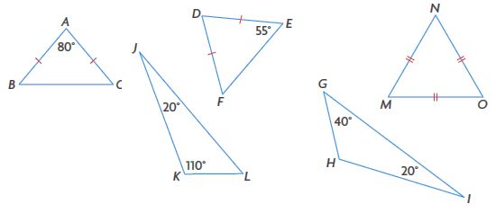

- What do you know about the cosine and tangent ratios for these pairs of angles?

Practice #5 – Trigonometry

Level 2
- Which law could be used to determine the unknown angle measure or side length in each triangle? For your answer, choose one of the following: sine law, cosine law, both or neither. Explain your choice. 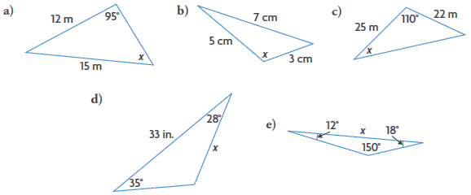

- Determine the unknown side length in each triangle, to the nearest tenth of a centimeter.
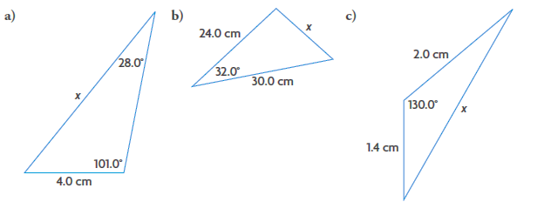

- Determine the unknown angle measure in each triangle, to the nearest degree.

- Determine each unknown angle measure to the nearest degree and each unknown side length to the nearest tenth of a centimeter.

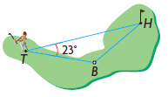
- While golfing, Sam hits a tee shot from T toward a hole at H. Sam hits the ball at an angle of 23º to the hole and it lands at B. The scorecard says that H is 295 yd from T. Sam walks 175 yd. to her ball. How far to the nearest yard, is his ball from the hole?
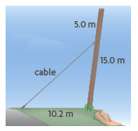
- A 15.0 m telephone pole is beginning to lean as the soil erodes. A cable is attached 5.0m from the top of the pole to prevent the pole from leaning any further. The cable is secured 10.2 m from the base of the pole. If the cable is 15.2 m long, how far is the pole leaning from the vertical, to the nearest tenth of a degree?

Level 4
- Tim made a mistake when using the cosine law to determine the unknown angle measure below. Identify the cause of the error message on his calculator. Then determine $θ$ to the nearest tenth of a degree.
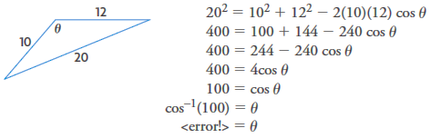

Practice #6 – Trigonometry
Level 3
- Decide whether each description of a triangle involves the SSA situation. If it does, determine the number of triangles (zero, one or two) that are possible with the given measurements. Draw the triangle(s), and justify your answer.

- In ΔABC, <A = 51º, a = 5m, and b = 14m
- In ΔABC, <C = 30º, a = 6 mm, and c = 12 mm
- In ΔABC, <B = 40º, a = 12cm, and b = 10cm
- In ΔABC, <A = 155º, b = 15 m and c = 12m

Level 4
- A landowner claims that his property is triangular, with one side that is 430m long and another side that is 110 m long. The angle that is opposite one of these sides measures 35º.

- Determine the length of the third side of the property, to the nearest meter.
- Improve the description of the property to avoid confusion.

- An obtuse triangle has two known side lengths: 4.0m and 4.2 m. The angle that is opposite the shorter side measures 64.0º.

- Calculate the obtuse angle in the triangle, to the nearest tenth of a degree.
- Is there only one possible answer? Explain.

- In an extreme adventure triathlon, participants swim 1.7 km from a dock to one end of an island, run 1.5 km due north along the length of the island, and then kayak back to the dock. From the dock, the angle between the lines of sight to the ends of the island measures 15º. How long is the kayak leg of the race?

- Draw a SSA situation in which there is no possible triangle.

- Label the sides and angle, and use trigonometry to confirm that there is no possible triangle.
- Determine the angle that would be necessary for there to be one possible triangle.
- What angle would be necessary for there to be two possible triangles?

Practice #7 – Trigonometry
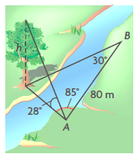
Level 4
- Bert wants to calculate the height of a tree on the opposite bank of a river. To do this, he lays out a baseline that is 80 m long and measures the angles shown in the diagram. Is the information that Bert has gathered sufficient to determine the height of the tree? Justify your answer.

- Mount Logan, in Yukon Territory, is Canada’s highest peak. In North America, it is second in height only to Mount McKinley. An amateur climber is trying to calculate the height of Mount Logan. From her campsite, the angle of elevation to the summit measures 35º. She walks 500m closer, up a 10º inclined slope, and measures the new angle of elevation as 38º. Her campsite is at an altitude of 1834 m. Determine the height of Mount Logan, to the nearest 10 m.

- The Leaning Tower of Pisa is 55. 9 m tall and leans 5.5º from the vertical. What is the distance from the top of the tower to the tip of its shadow, when its shadow is 90.0m long? (Assume that the ground around the tower is level). Round your answer to the nearest metre.

Trigonometry Answers
Practice #1
1a) w = 18.9 b) k = 28.4 c) <Y = 63.7º d) <G = 47.4º

2a) 6.9 cm b) 14.7 cm

3a) 34⁰ b) 74⁰

4a) f = 6.3 cm, <D = 45.9º, <E = 69.1º
b) r = 10.1 m, <P = 38.6º, <Q = 61.4º
c) <L = 86.6º, <M = 56.6º, <N = 36.8º

5) 53.0 cm

6) No, for example, when you put the side lengths into the cosine law expression, you do not get $-1≤cosθ≤1$

7) 34.4 km

Practice #2
1a) d = 21.0 cm b) a = 26.1 cm, b = 35.2 cm c) y = 6.5 cm
d) $θ={64}^{0}$ e) $θ={45}^{0},α={85}^{0}$ f) $θ={25}^{0},α={75}^{0},j=6.6m$

2a) example: The lake’s length is opposite the largest angle of the triangle and must also be the longest side. A length of 36 km would not make it the longest side.
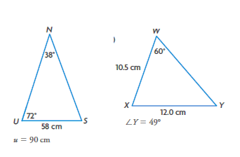
b) 48.7 km

3a) b)

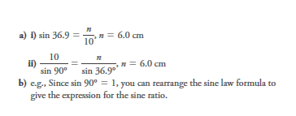
4) a = 41.9 m, t = 44.9 m, <A = 67⁰

5

Practice #3
1a) 43.2 m b) about 13.3 m

2) 241.2 m

3a) 11.1 m b) 18.8 m

Practice #4
1a) not valid b) valid c) not valid d) valid
e) not valid f) valid

2a) 0.2588, 165º b) 0.4695, 118º c) 0.7002, 145º d) 0.1735, 10⁰

3a) 40⁰, 140⁰ b) 19⁰, 161⁰ c) 72⁰, 108⁰ d) 18⁰, 162⁰

4a) sin D = sin K, sin H = sin M, sin H = sin N, sin H = sin O,
sin M = sin N, sin M = sin O, sin N = sin O
b) The cosine and tangent ratios for <D and <K, and for <M and <H are opposites. The other angles have equal cosine and tangent ratios.

Practice #5
1a) sine law b) cosine law c) both
d) sine law e) neither

2a) 8.4 cm b) 16.0 cm c) 3.1 cm

3a) 161⁰ b) 108⁰ c) 150⁰

4a) m = 15.0 cm, <L = 46⁰, <N = 29⁰ b) t = 13.9 cm, r = 15.7 cm, <R = 32⁰
c) <A = 98⁰, <B = 30⁰, <C = 52⁰ d) y = 8.1 cm, z = 12.9 cm, <X = 124º

5) 150 yards

6) 7.6º

7) Tim made a mistake from line 3 to line 4. The domain of inverse cosine is -1 to 1; 100 is outside the domain. $θ={130.5}^{0}$

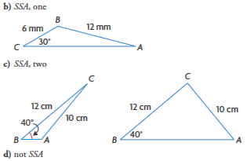
Practice #6
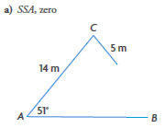
1

2a) 515 m
b) The 35⁰ angle is opposite the side that is 430m long

3a) 109.3⁰
b) Yes there is only one possible answer. The 4.2 cm side must be opposite the obtuse angle. If it is not, then the triangle is an acute triangle.

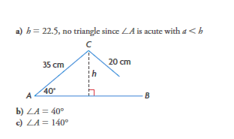
4) 3.1 km or 0.2 km

5

Practice #7
1) example: Yes. Bert can use the sine law and the triangle with vertices A, B, and the base of the tree to determine the distance from A to the base of the tree. He can then use the tangent ratio and the 28⁰ angle to determine the height of the tree

2) 4410 m

3) 101 m

OUTCOMES | ASSESSMENT RUBRICS
FM20.6 Demonstrate an understanding of normal distribution, including standard deviation
Level  Criteria | Intervention 1  Spend some extra time with the criteria and ask for help. | Instructional 2  Good start. You are beginning to make sense of this on your own. You are consistent with the basic learning goals for this outcome. | Independence 3  You did it and you did it on your own. You are able to complete the processes for this outcome. Your work is thorough and consistently accurate. | Mastery 4  Great work! This is going extra well for you. You have understood the outcome, are able to explain your strategies and apply these to situations. Your work is always accurate.
Outcome 6: Demonstrate an understanding of normal distribution, standard deviation and z-scores | I need more help with becoming consistent with the criteria. | I can consistently determine the following: mean, median, mode, standard deviation and z-score | I can consistently determine area under the curve.  I can consistently sketch a normal distribution and analyze data to determine if it approximates normal distribution.  I can compare normally distributed data sets and explain what it tells me.  I can determine z-scores to fit a situation. | I can explain the application, meaning and purpose of: standard deviation, properties of a normal curve, z-score.  I can solve situational questions.

Practice #1 – Statistical Reasoning

Level 2
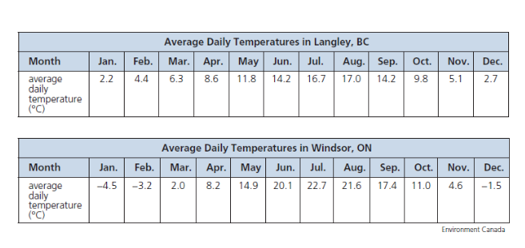
- The average daily temperatures in Langley, BC and Windsor, Ontario are indicated in the following tables.

- Determine the range, mean, and median for the average daily temperatures in the two cities.

- Compare the temperatures in the two cities
- Why might a comparison of the two sets of data be useful?

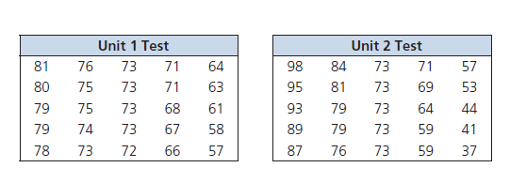
2. a) Use the range and measures of central tendency (mean, median and mode) to compare the results for two geography tests given by the same teacher to the same class in the same semester.

b) Did the class perform better on the Unit 1 test or Unit 2 test? Justify your decision.

c) Were the modes useful to compare in this situation? Explain.

Practice #2 – Statistical Reasoning

Level 3
- A cherry orchard has 30 trees with these heights, given in inches.

78 70 83 79 74 81 80 65 66 76
85 82 74 63 75 76 86 80 72 72
80 69 71 80 77 81 75 75 64 87

a) Make a frequency table with six intervals to organize the heights.
b) Construct a histogram of the data.
c) Draw a frequency polygon for the data.
d) Which range of heights occurs most frequently? Which occurs less frequently?

- The amounts withdrawn from an ATM, in dollars, are recorded for a single Wednesday.

20 120 50 70 60 80 140 120 80 160
80 60 110 100 100 80 180 160 40 100
50 80 200 140 160 60 40 80 60 140
100 140 160 200 140 20 80 20 100 70
40 20 120 40 140 100 40 50 180 60

a) What interval width will give a good representation of how the data is distributed?
b) Sort the amounts in a frequency distribution table.
c) Construct a histogram to represent the table in part b).
d) Describe how the data is distributed.

Practice #3 – Statistical Reasoning

Level 2
- Ali bowls in a peewee league. Determine the mean and standard deviation of Ali’s bowling scores, rounded to two decimal places.

135 156 118 133 141 127
124 139 109 131 129 123

Level 3
- Milt Stegall broke the CFL record for most yards receiving.
- Determine the mean and standard deviation of his statistics, to one decimal place.

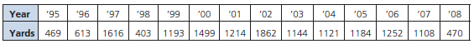

- Allen Pitts, who played for the Calgary Stampeders, held the CFL record for most yards receiving until Milt Stegall surpassed him. Pitts had the following statistics for yards gained per year: mean 1353.7 and standard deviation 357.1. Which player was more consistent in terms of yards gained per year?

- Jaime has 20 min to get to her after school job. Despite her best efforts, she is frequently late. Her employer says that unless she arrives to work on time consistently, she will lose her job.

She has recorded her travel time (in minutes) for the last two weeks: 18, 20, 22, 27, 16, 23, 25, 26, 19, 28.

Over the next two weeks, she continues to record her travel times: 22, 20, 19, 16, 20, 23, 25, 18, 19, 17.

Do you think Jamie will lose her job? Use statistics to justify your answer.

Level 4
- Twins Jordana and Jane wrote a total of 10 tests in math class. They have the same mean test score, but different standard deviations. Explain how this is possible?

Practice #4 – Statistical Reasoning

Level 3
- A school of 130 bottlenose dolphins is living in a protected environment. The life expectancy of the dolphins is normally distributed, with a mean of 39 years and a standard deviation of 3.5 years. How many of these dolphins can be expected to live more than 46 years?

- In a dog obedience class, the masses of the 60 dogs enrolled were normally distributed, with a mean of 11.2 kg and a standard deviation of 2.8 kg. How many dogs would you expect to fall within each range of masses?

- Between 8.4 kg and 14.0 kg
- Between 5.6 kg and 16.8 kg
- Between 2.8 kg and 19.6 kg
- Less than 11.2 kg

- The ages of members of a senior curling club are normally distributed, with a mean of 63 years and a standard deviation of 4 years. What percent of the curlers is in each of the following age groups?

- Between 55 and 63 years old
- Between 67 and 75 years old
- Older than 75 years old

- A manufacturer offers a warranty on its coffee makers. The coffee makers have a mean lifespan of 4.5 years, with a standard deviation of 0.7 years. For how long should the coffee makers be covered by the warranty, if the manufacturer wants to repair no more than 2.5% of the coffee makers sold?
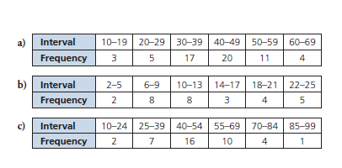
- Is the data in each set normally distributed? Explain.

- Explain why a selection of 10 students from a class can have marks that are not normally distributed, even when the marks of the whole class are normally distributed.

Practice #5 – Statistical Reasoning
Level 2
- Determine the z-score for each value of x.
- $μ=112$, $σ=15.5$, $x = 174$ b) $μ=245$, $σ=22.4$, $x = 300$

Level 3
2.Determine the percent of data to the left of each z-score
a) z = 0.56 b) z = -1.76 c) z = -2.98 d) z = 2.39

3. Determine the percent of data to the right of each z-score
a) z = -1.35 b) z = 2.63 c) z = 0.68 d) z = -3.14

4. Determine the percent of the data between each pair of z-scores
a) z = 0.24 and z = 2.53 b) z = -1.64 and 1.64

5. Determine the z-score for each situation
a) 33% of the data is to the left of the z-score
b) 20% of the data is to the right of the z-score

Level 4
6. A medical diagnostic test counts the number of blood cells in a sample. The red blood cell count (in millions per cubic microliter) is normally distributed, with a mean of 4.8 and a standard deviation of 0.3.

a) What percent of people have a red blood cell count that is less than 4?
b) What percent of people have a count between 4.7 and 5.0?
c) What red blood cell count would someone have if 95% of people have a lower count?

7. An MP3 player has a one-year warranty. The mean lifespan of the player is 2.6 years, with a standard deviation of 0.48 years.

a) A store sells 4000 players. How many of these players will fail before the warranty expires.
b) Tyler is offered an extended warranty, for one extra year, when he buys a player. What is the likelihood that he will make a claim on this warranty if he takes it?

8. A manufacturer of plasma televisions has determined that the televisions require servicing after a mean of 67 months, with a standard deviation of 7.2 months. What length of warranty should be offered, if the manufacturer wants to repair less than 1% of the televisions under the warranty?

9. What is a z-score, how do you determine it, and what is it used for?

Normal Distribution Answers
Practice #1
1a) Langley, BC – range 14.8, mean 9.4, median 9.2
Windsor, ON – range 27.2, mean 9.4, median 9.6
b) The mean temperature for each city is the same, and the medians are close; however, the temperature in Windsor has a much greater range: it gets colder in winter and warmer in summer.
c) If you were living in one of the locations and moving to the other location

2a) Unit 1 Test – range 24, mean 71.2, median 73, mode 73
Unit 2 Test – range 61, mean 71.2, median 73, mode 73
b) The class performed better on the Unit 1 test because the range of scores was smaller, with the mean, median and mode being equal
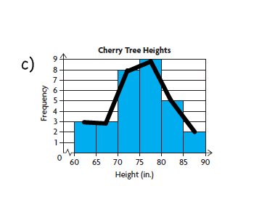
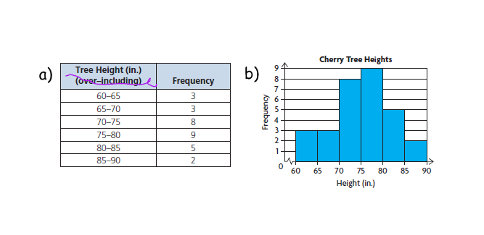
c) The modes were not very useful to compare in this context because they only tell me which mark occurred most often, not on which test the class performed better.

Practice #2
1)

d) The range of heights 75 – 80 inches occurs most frequently.
The range of heights of 85 – 95 inches occurs least frequently

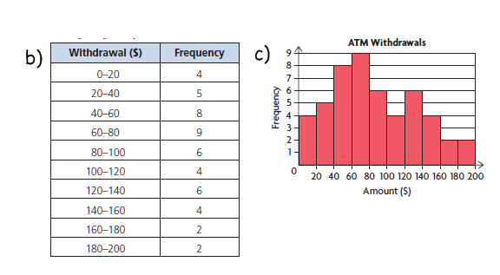
2a) Most withdrawals are multiples of 20. An interval width of 20 would give a good representation of the distribution of data.

d) There are a lot more withdrawals under $100 than there are over $100. Withdrawals between $40 and $80 are the most frequent. Not many people made withdrawals over $160.

Practice #3
1) mean 130.42 points, standard deviation 11.51 points

2a) mean 1082 yards gained; standard deviation 428.8 yards gained b) Allen Pitts

3) Jaime’s mean travel time is about 21.2 minutes and her standard deviation is 3.5 minutes. Since her mean time is more than 20 minutes, Jaime will lose her job.
4) Sample answer: One twin is more consistent, while the other is less consistent, resulting in the same mean (85%) with different standard deviations (2.6%, 12.0%).

Jane’s scores: 80, 85, 82, 87, 86, 84, 87, 85, 85, 89
Jordana’s scores: 78, 92, 99, 64, 72, 82, 77, 95, 98, 93
Practice #4
1)2.5% of about 3 dolphins

2a) 68% or about 41 dogs b) 95% of about 57 dogs
c) 99.7% or about 60 dogs d) 50% or about 30 dogs

3a) 47.5% b) 15.85% c) 0.15%

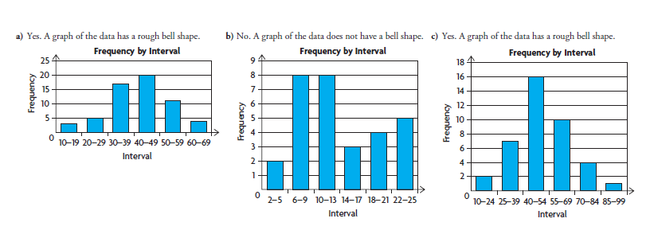
4) about 3 years

5

6) Sample Answer: The 10 students could all have the highest marks in the class, so they would not be normally distributed.

Practice #5
1a) 4 b) 2.455…

2a) 71.23% b) 3.92% c) 0.14% d) 99.16%

3a) 91.15% b) 24.83% c) 0.43% d) 99.92%

4a) 39.95% b) 89.90%

5a) -0.439… b) 0.841…

6a) 0.38% b) 37.81% c) 5.29

7a) about 2 b) 10.56%

8) 50 months, or round down to 4 years

9) A z-score is a value that indicates the number of standard deviations of a data value above or below the mean. It is calculated by subtracting the mean from the data value, and then dividing by the standard deviation. Knowing the z score of two or more pieces of data in different data sets allows you to compare them, which is useful for making decisions.
OUTCOMES | ASSESSMENT RUBRICS
FM20.7 Demonstrate an understanding of the interpretation of statistical data, including: confidence intervals; confidence levels; margin of error
Level  Criteria | Intervention 1  Spend some extra time with the criteria and ask for help. | Instructional 2  Good start. You are beginning to make sense of this on your own. You are consistent with the basic learning goals for this outcome. | Independence 3  You did it and you did it on your own. You are able to complete the processes for this outcome. Your work is thorough and consistently accurate. | Mastery 4  Great work! This is going extra well for you. You have understood the outcome, are able to explain your strategies and apply these to situations. Your work is always accurate.
Outcome 7: Demonstrate understanding of the interpretation of statistical data | I need more help with becoming consistent with the criteria. | I am able to identify the confidence level, confidence interval and margin of error. | I am able to determine the range of the data in a poll/survey.  I can explain how the size of the random sample used impacts the data.  Using confidence intervals I can make inferences and decisions about a population from sample data. | I am able to critique real life examples in which statistical data is used to support a particular position.  I can support a position by analyzing statistical data, as well as consider other factors.

Practice #1 – Statistical Reasoning
Level 2
- A poll determined that 81% of people who live in Canada know that climate change is affecting Inuit more than the rest of Canadians. The results of the survey are considered accurate within ±3.1 percent points, 19 times out of 20.

Level 2
- State the confidence level.
- Determine the confidence interval.

Level 3
- The population of Canada was 33.5 million at the time of the survey. State the range of the number of people who knew that climate change is affecting Inuit more than the rest of Canadians.

- An advertisement for a new toothpaste states that 64% of users reported better dental checkups. The results of the poll are accurate within 3.4 percent points, 9 times out of 10.

Level 2
- State the confidence level.
- Determine the confidence interval.

Level 3
- If all 32 students in a mathematics class used this toothpaste, determine the range of the mean number of classmates who could expect better dental checkups.

- In a 2006 Centre de recherché sur l’opinion publique (CROP) poll, 81% of Canadians indicated that they support bilingualism in Canada and that they want Canada to remain a bilingual country. This poll was reported accurate ±2.2%, 19 times out of 20.

Level 3
- Interpret the poll.

Level 4
- Mark claims that this poll must be flawed because if the majority of Canadians felt this way, then most people would speak both French and English, but they don’t. Do you agree with Mark? Justify your decision.
- Toxic materials, such as arsenic, lead, and mercury, can be released into the air if a discarded cellphone is incinerated. Toxins can be released into groundwater if a discarded cellphone ends up in a landfill. In a recent survey, 89% of those surveyed answered yes to the following question: Would you recycle your cellphone if it were convenient? The survey is considered accurate to within 4.3 percent points, 99 times out of 100.

Level 2
- Determine the confidence level and the confidence interval.

Level 3
- If 23 500 000 people in Canada own cellphones, state the range of the number of people who would indicate that they would recycle their cellphone if it were convenient.

Level 3
- Use confidence intervals to interpret each of the following statements:

- In a recent survey, 54% of post-secondary graduates indicated that they expected to earn at least $100 000/year by the time they retire. The survey is considered accurate within ±4.5%, 9 times in 10.

- A market research firm found that among online shoppers, 63% search for online coupons or deals when they purchase something on the Internet. The survey is considered accurate within ±2.1 percent points, 99% of the time.

- A recent report indicated that Canadians spend an average of 18.1 h per week online, compared with 16.9 h per week watching television. The results are considered accurate with a margin of error ±3.38%, 19 times out of 20.

- A survey conducted at the expense of the political party that holds office indicated that 39% of decided voters said they would not vote for candidates of that party in the next election. The result is considered accurate within ±3%, 95% of the time.

- Explain why, for a given confidence level:

- The margin of error decreases as the sample size increases
- The margin of error increases as the confidence level increases.

Statistical Reasoning Answers

1a) 95% b) 77.9% - 84.1% c) 26.1 million to 28.2 million

2a) 90% b) 60.6% - 67.4% c) about 19 – 22 students

3a) With 95% confidence, is can be said that 78.8% to 83.2% of Canadians support bilingualism in Canada and that they want Canada to remain a bilingual country.
b) I disagree with Mark. Without having more information about how the poll was conducted, it is impossible to tell if the poll was flawed.

4a) 99%; 84.7% to 93.3% b) 19 904 500 to 21 925 500

5a) With 90% confidence, it can be said that 49.5% to 58.5% of post-secondary graduates can be expected to earn at least $100 000 /year by the time they retire
b) With 99% confidence, it can be said that 60.9% to 65.1% of online shoppers search for coupons or deals when shopping on the internet
c) With 95% confidence, it can be said that Canadians spend an average of 17.5 h to 18.7 h online, compared to 16.3 h to 17.5 h watching television per week.
d) With 95% confidence, it can be said that 36% to 42% of decided voters will not vote for the political party in the next election.

6a) As the sample size increases, a larger proportion of the population is sampled, making the results more representative of the population, therefore reducing the margin of error.
b) For the confidence level to increase, the size of the confidence interval must increase, therefore, the more confident you are that a value falls within the range, the more the margin of error increases.

OUTCOMES | ASSESSMENT RUBRICS
FM20.8 Demonstrate understanding of systems of linear inequalities in two variables
Level  Criteria | Intervention 1  Spend some extra time with the criteria and ask for help. | Instructional 2  Good start. You are beginning to make sense of this on your own. You are consistent with the basic learning goals for this outcome. | Independence 3  You did it and you did it on your own. You are able to complete the processes for this outcome. Your work is thorough and consistently accurate. | Mastery 4  Great work! This is going extra well for you. You have understood the outcome, are able to explain your strategies and apply these to situations. Your work is always accurate.
Outcome 8A: Demonstrate understanding of systems of linear inequalities | I need more help with becoming consistent with the criteria. | I can graph the solution of one linear inequality.  I can determine the solution of a linear inequality.  I can determine if a point is in the solution of a linear inequality.  I can match a graph with its linear inequality. | I can write a system of linear inequalities for a given graph.  I can graph the solution of a system of linear inequalities.  I can determine if a point is in the solution of a system of linear inequalities.  I can determine if the boundaries and their points of intersection are part of the solution region.  I can match situations and the graphs of set of linear inequalities. | I can solve situational questions.  I can verify my solution.  I can justify my choice of solid or broken lines.
Practice #1 – Systems of Linear Inequalities

- Graph the following linear equations
- $y = x + 4$ b) $y = 6x + 3$ c) $y = -2x + 8$
d) $y = 6$ e) $2x + 3y = 5$ f) $-4x – 8 = 4$
g) $3y = 9x + 12$ h) $10x – 12 = -y$ i) $4x + 3y = -12$
j) $2x – y = 5y+2x+12$ k) $2x+2=5+x$ l) $x + 6y – 14 = 0$
m) $2y = x$

Practice #2 – Systems of Linear Inequalities

Level 2
- Graph the solution of each inequality. Assume all variables are real numbers.
- $y < x + 4$ b) $-y < -6x + 3$ c) $y > -2x + 8$
d) $-3y≤9x+12$ e) $y < 6$ f) $-4x – 8 > 4$
g) $10x – 12 < -y$ h) $4x+3y≥-12$

- Consider the graph of this inequality: $2x + 3y > 5$. Make each of the following decisions, and provide your reasoning:
- Whether the boundary should be dashed or solid
- Whether the half plane above or below the boundary should be shaded
- Whether each pair is in its solution region:
i) (1, 1) ii) (1, 0) iii) (1, 2)

Practice #3 – Systems of Linear Inequalities

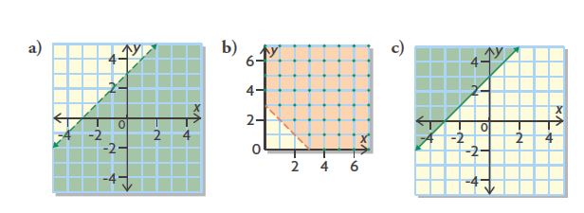
Level 2
- Match each graph with its linear inequality, and justify your match.

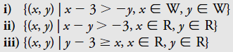

- Graph the solution set for each linear inequality.
a) {(x,y) | x + 6y – 12 < 0, x ε W, y ε W}
b) {(x,y) | 2x – y ≤ 2, x ε I, y ε I}
c) {(x,y) | 5x – y ≤ 4, x ε W, y ε W}
d) {(x,y) | 2x + 2 ≤ 5 + x, x ε I, y ε I}
e) {(x,y) | -2y > 20, x ε R, y ε R}
f) {(x,y) | 4x – 5y < 10 x ε R, y ε R}
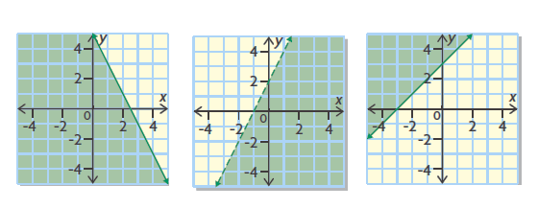
- Determine the inequality for the following graphs
- b) c)

Practice #4 – Systems of Linear Inequalities

Level 4
- Betsy and Flynn work at an ice cream stand. If Betsy worked three times as many hours as she usually does and Flynn worked twice the number of hours that he usually does, together they would work less than 25 h. The situation can be modelled by the following linear inequality: 3b + 2f < 25.

- What do the variables b and f represent?

- What restrictions does the context place on the variables? Explain.

- Suppose you were to graph the inequality.

- Describe the boundary.

- Would you shade in the half plane above or below the boundary.

- Would your graph involve all four quadrants? Explain.

- What does a solution to this inequality represent?

- Grace’s favourite activities are going to the movies and skating with friends. She budgets herself no more than $75 a month for entertainment and transportation. Movie admission is $10 per movie, and skating costs $5 each time. A student bus pass for the month costs $25.

- Define the variables and write a linear inequality to represent the situation.
- What are the restrictions on the variables? How do you know?
- Graph the linear inequality. Use your graph to determine:

- A combination of activities that Grace can afford and still have some money left over.
- A combination of activities that she can afford with no money left over.
- A combination of activities that will exceed her budget.

- Jeff coaches a hockey team of 18 players. He plans to buy new practice jerseys and hockey sticks for the team. The supplier sells practice jerseys for $50 each and hockey sticks for $75 each. Jeff can spend no more than $3000 in total. He wants to know how many jerseys and sticks he should buy.

- Write a linear inequality to represent the situation.

- Use your inequality to model the situation graphically.

- Determine a reasonable solution to meet the needs of the team, and provide your reasoning.

- For every teddy bear that is sold at a fundraising banquet, $10 goes to charity. For every ticket sold, $25 goes to charity. The organizer’s goal is to raise at least $5000. The organizers need to know how many teddy bears and tickets must be sold to meet their goal.

- Define the variables and write a linear inequality to represent the situation.

- What are the restrictions on the variables? How do you know?

- Graph the linear inequality to help you determine whether each of the following points is in the solution set. The first coordinate is the number of teddy bears and the second is the number of tickets.

- (400, 20) ii) (205, 120) iii) (156, 105)

- A banquet room is set up to seat, at most 960 people. Each rectangular table seats 12 people, and each circular table seats 8 people.

- Define the variables and write a linear inequality to represent the number of each type of table needed. Then graph your inequality.
- The organizers of the banquet would like to have as close to the same number of rectangular tables and circular tables as possible. What combination of tables could they use? Explain your choice.
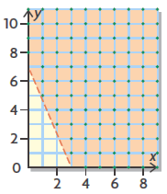
- Joelle used deductive reasoning to conclude that the graph below represents a linear inequality.

- What evidence has she used to arrive at this conclusion
- State some other things you know about this inequality. Provide reasoning for each.

Practice #5 – Systems of Linear Inequalities

Level 3
- Graph each system. Determine a solution for each.
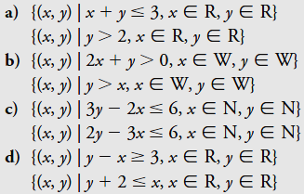

2. a) Graph the solution set for the following system of inequalities. Determine a solution. Check its validity.
$$9x+18y<18$$
$$3x-6y≤18$$

b) Is each point below a possible solution to the system? How do you know?
i) (4, -1) ii) (-2, 2) iii) (-4, -2)
iv) (9, 1) v) (-2.5, -1.5) vi) (2, -2)
- Graph the solution set for this system of linear inequalities to determine two valid solutions.

Practice #6 - Systems of Linear Inequalities

- The staff in a cafeteria are making two kinds of sandwiches: egg salad, and ham and cheese:
- A maximum of 450 sandwiches are needed
- Based on previous demand, there should be at least twice as many ham and cheese sandwiches as egg salad sandwiches

- Define the variables and write a system of inequalities that models this situation.
- Describe the restrictions on the variables in this situation.
- Graph the system to determine the solution set
- Suggest two combinations of numbers of sandwiches that the cafeteria staff could make.

- Trish is setting up her social networking page:
- She wants to have no more than 500 friends on her new social networking page
- She also wants to have at least three school friends for every rugby friend

- Define the variables and write a system of inequalities that models this situation
- Describe the restrictions on the domain and range of the variables.
- Graph the solution set to determine two possible combinations of school friends and rugby friends she could have.

- Spence, a disc jockey, is often hired to play weddings.
- His contract states that he will play no longer than 3 h, with no more than 12 songs each hour.
- He likes to play two or more songs for young listeners for every one song he plays for older listeners.

Determine three possible combinations of numbers of songs he could play.
- Create a system of two linear inequalities for each situation.
- The boundaries of the solution region are included in the solution set, and all the points in the solution region are valid solutions.
- The boundaries of the solution region are not included in the solution set, and only whole number points in the solution region are valid solutions.

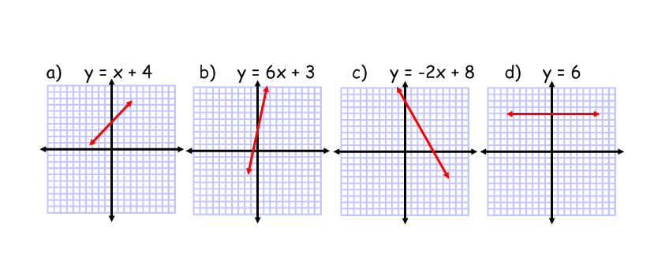
Systems of Linear Inequalities Answers
Practice #1
1.

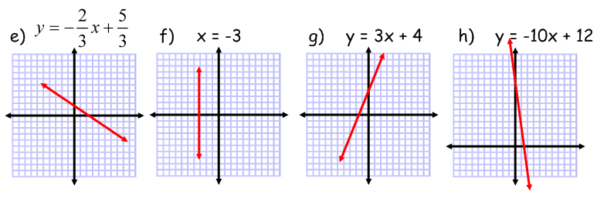

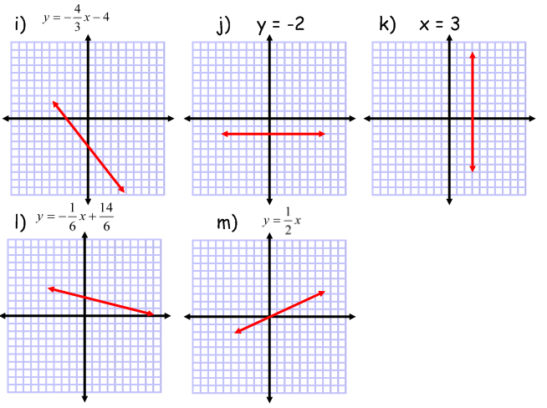

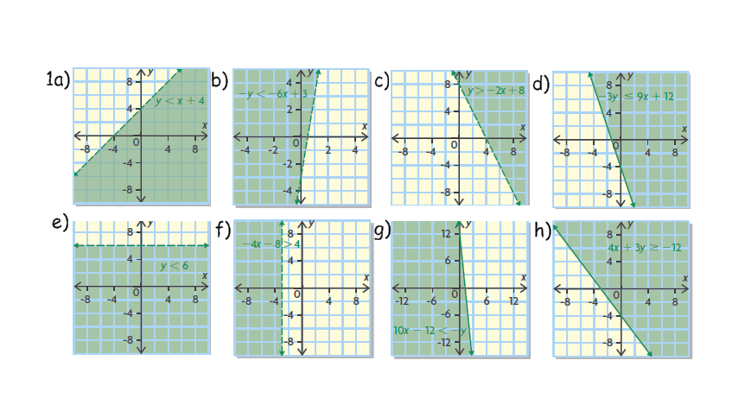
Practice #2

2a) dashed
b) above
c) i) no ii) no iii) yes

Practice #3
1a) ii b) i c) iii
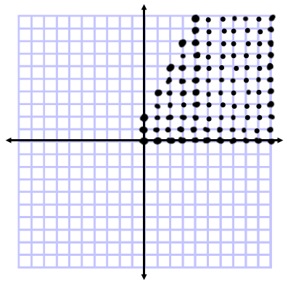
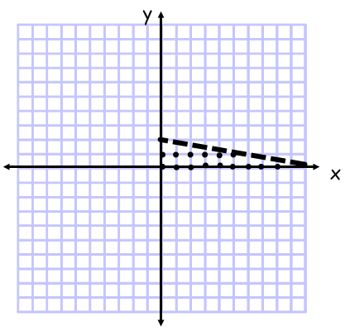
2a) no solution b) c)

3a) $y≤-2x+5$
b) $y<2x+2$
c) $y≥x+3$
Practice #4
1a) b is the number of hours usually worked by Betsy, f is the number of hours usually worked by Flynn
b) real numbers, f and b must be greater than zero
c) i) dashed ii) below iii) no, only quadrant 1
d) the number of hours each usually works

2a) Let x be the number of movie tickets Grace buys.
Let y be the number of times Grace goes skating.
{(x,y) | 10x + 5y + 25 ≤ 75, x Є W, y Є W }
b) The variables must be whole numbers, x Є W, y Є W
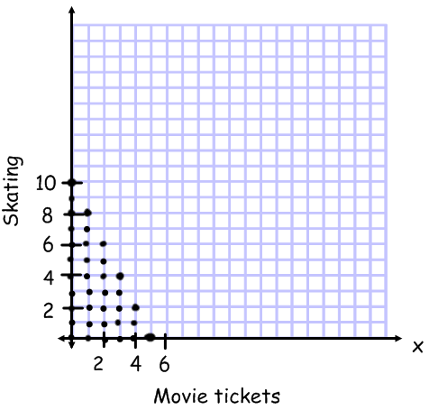
c) i) For example, seeing 3 movies and going skating 4 times
ii) For example, seeing 4 movies and going skating 1 time
iii) For example, seeing 5 movies and going skating 2 times

3a) Let x be the number of jerseys.
Let y be the number of hockey sticks.
{(x,y) | 50x + 75y ≤ 3000, x Є W, y Є W}
b) The variables must be whole numbers, x Є W, y Є W

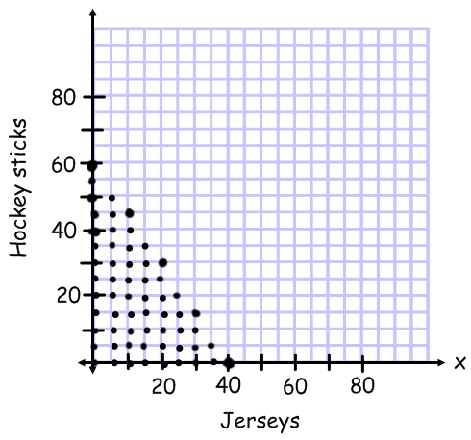
c) For example, Jeff could buy 20 practice jerseys and 22 hockey sticks for his team; it will cost him $2600. It is reasonable to buy a few extra jerseys and sticks.

4a) Let x be the number of teddy bears.
Let y be the number of tickets.
{(x,y) | 10x + 25y ≥ 5000, x Є W, y Є W}
b) The variables must be whole numbers, x Є W, y Є W
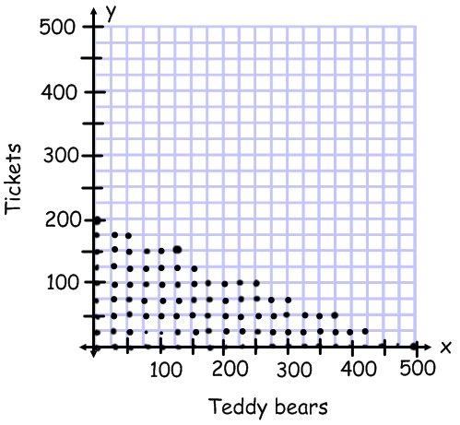
c) i) No
ii) Yes
iii) No

5a) Let x be the number of rectangular tables.
Let y be the number of circular tables.
{(x,y) | 12x + 8y ≤ 960, x Є W, y Є W}
b) The variables must be whole numbers, x Є W, y Є W

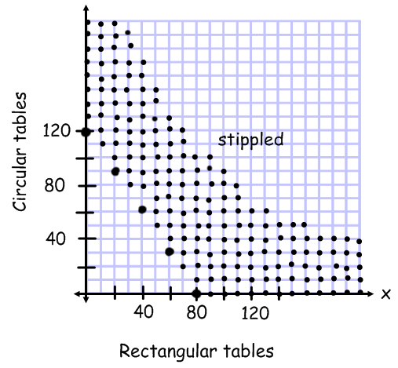
6a) e.g., The boundary is a straight line and a half plane is shaded.
b) e.g., Only discrete whole number points in the shaded region and on the axes are included; the domain and range is the set of whole numbers; the linear inequality is
$\{(x,y)|y>-\frac{7}{3}x+7,x∈W, y∈W\}$.

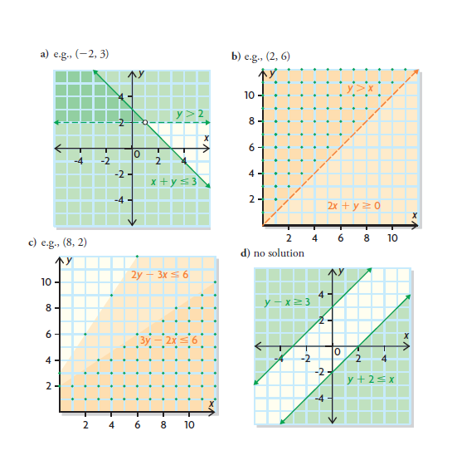
Practice #5
1

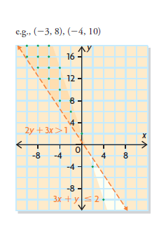
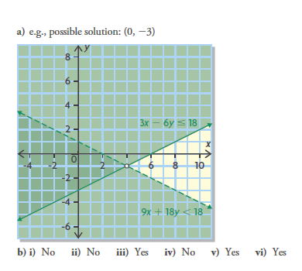

2 3)

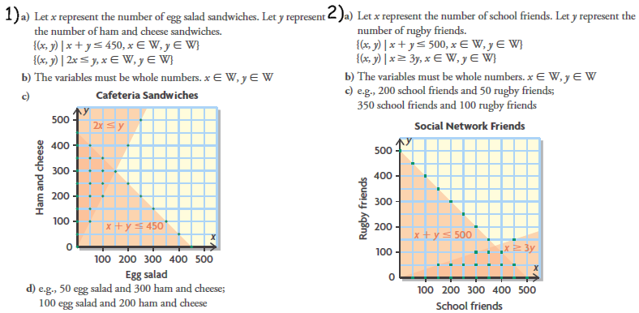
Practice #6

OUTCOMES | ASSESSMENT RUBRICS
FM20.8 Demonstrate understanding of systems of linear inequalities in two variables
Level  Criteria | Intervention 1  Spend some extra time with the criteria and ask for help. | Instructional 2  Good start. You are beginning to make sense of this on your own. You are consistent with the basic learning goals for this outcome. | Independence 3  You did it and you did it on your own. You are able to complete the processes for this outcome. Your work is thorough and consistently accurate. | Mastery 4  Great work! This is going extra well for you. You have understood the outcome, are able to explain your strategies and apply these to situations. Your work is always accurate.
Outcome 8B: Demonstrate understanding of optimization problems | I need more help with becoming consistent with the criteria. | Given an optimization problem with the constraints, objective function and graph, I am able to find the vertices and max/min values of the objective function. | Given the restrictions, constraints, and objective function, I am able to graph and find the coordinates of the vertices and determine possible solutions to the question. | I can solve an optimization problem given just the situation.  I can justify and explain feasible regions, coordinates of vertices and other parts of optimization problems.

Practice #1 – Optimization Problems

- A fast food concession stand sells hotdogs and hamburgers.

- Daily sales can be as high as 300 hamburgers and hotdogs combined
- The stand has room to stock no more than 200 hotdogs and no more than 150 hamburgers
- Hotdogs are sold for $3.25, and hamburgers are sold for $4.75.
Create a model that could be used to determine the combination of hamburgers and hotdogs that will result in a maximum sale.

- A vending machine sells juice and pop.

- The machine holds, at most, 240 cans of drink
- Sales from the vending machine show that at least 2 cans of juice are sold for each can of pop
- Each can of juice sells for $1.00, and each can of pop sells for $1.25.

Create a model that could be used to determine the maximum revenue from the vending machine.

- A student council is ordering signs for the spring dance. Signs can be made in letter size or poster size.

- No more than 15 of each size are wanted.
- At least 15 signs are needed altogether.
- Letter-size signs cost $9.80 each, and poster-size signs cost $15.75 each.

Create a model that could be used to determine a combination of the two sizes of signs that would result in the lowest cost to the council.

- A football stadium has 50000 seats.

- Two-fifths of the seats are in the lower deck
- Three-fifths of the seats are in the upper deck
- At least 30000 tickets are sold per game
- A lower deck ticket costs $120 and an upper deck ticket costs $80.

Create a model that could be used to determine a combination of tickets for lower deck and upper deck seats that should be sold to maximize revenue.

- Sue and Faith has weekend jobs at a marina, applying anti-fouling paint to the bottom of boats.
- Sue can work no more than 14 h per weekend
- Faith is available no more than 18 h per weekend.
- The marina will hire both of them for 24 h or less per weekend
- Sue paints one boat in 3 h, but Faith needs 4 h to paint one boat.
The marina wants to maximize the number of boats that are painted each weekend.
- Create a model to represent this situation
- Suppose that another employee, Frank, who can paint a boat in 2h, replaced Faith for a weekend. How would your model change?
- A Saskatchewan farmer is planting wheat and barley.

- He wants to plant no more than 1000 ha altogether.
- The farmer wants at least three times an many hectares of wheat as barley
- The yield per hectare of wheat averages 50 bushels, and the yield per hectare of barley averages 38 bushels.
- Wheat pays the farmer $5.25 per bushel, and barley pays $3.61 per bushel.

The farmer wants to plant a combination of wheat and barley that will maximize revenue. Create a model to represent this situation.

Practice #2 – Optimization Problems
Level 2
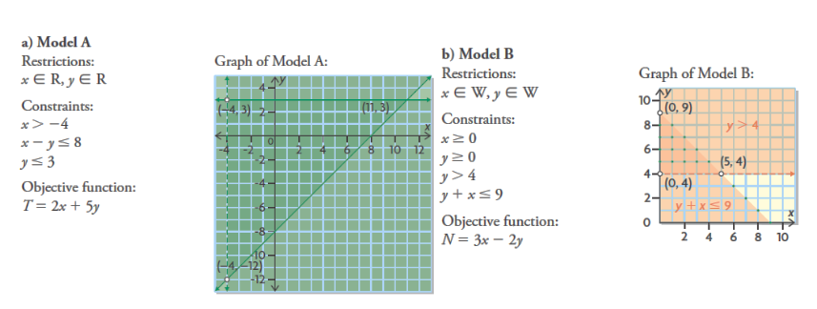
- Where might you find the maximum and minimum solutions to each objective function below? Explain how you know.

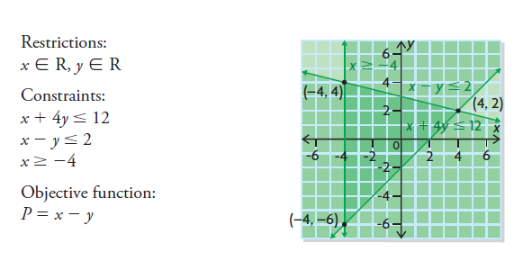
- Consider the model below. What point in the feasible region would result in the minimum value of the objective function? How could you have predicted this from examining the objective function?

- Meg is building a bookshelf to display her cookbooks and novels.

- She has no more than 50 cookbooks and no more than 200 novels.
- She wants to display at least 2 novels for every cookbook.
- The cookbooks’ spines are about half an inch wide, and the novel spines are about a quarter of an inch wide.

Meg wants to know how long to make the bookshelf. The following model represents this situation.

Let c represent the number of cookbooks
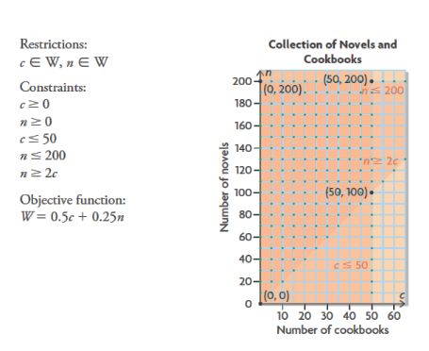
Let n represent the number of novels
Let W represent the width of the bookshelf.

- Which point in the feasible region represents the greatest number of books (both cookbooks and novels) that Meg could have? Explain.

- Can she display the same number of cookbooks as novels? Explain.

- What point represents the most cookbooks and the fewest novels?

- What point represents the number of cookbooks that would require the longest shelf? How long would the shelf have to be?

- What point represents the number of cookbooks that would require the shortest shelf?

Practice #3 – Optimization Problems
Level 2
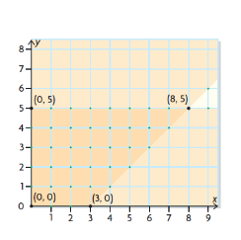
- Determine the optimal solutions for the system of linear inequalities graphed below, using the objective function G = 2x + 5y

Level 3
- The following model represents an optimization problem. Determine the maximum solution.
Optimization Model
Restrictions: x $∈$ W, y $∈$ W
Constraints: x ≥ 0, y ≥ 0, x + y ≤ 5, 2x + y ≥ 5
Objective Function: K = -x + 2y

- The following model represents an optimization problem. Determine the minimum solution.
Optimization Model
Restrictions: x $∈$ W, y $∈$ W
Constraints: x ≥ 0, y ≥ 0, 3x + y ≥ 15, x ≤ 10, x ≤ 9
Objective Function: P = 5x + 3y

Level 4
- A school is organizing a track and field meet.
- There will be no more than 250 events and no fewer than 100 events to be scheduled.
- The organizers allow 15 min for each track event and 45 min for each field event.
- They are considering different combinations of track and field events

What are the least and greatest amounts of time they should allot?

- Sophie has two summer jobs.

- She works no more than a total of 32 h a week. Both jobs allow her to have flexible hours but in whole hours only.
- At one job, Sophie works no less than 12 h and earns $8.75/h.
- At the other job, Sophie works no more than 24 h and earns $9.00/h.

What combination of numbers of hours will allow her to maximize her earnings? What can she expect to earn?

- A jewellery store sells diamond earrings: small earrings (no more than 1 carat of diamonds) and large earrings (more than 1 carat of diamonds).

- They sell at least four pairs of small earrings for every pair of large earrings.
- They also sell no more than 120 pairs of earrings, in total, per month.
- The small earrings sell for about $800 a pair, and the large earrings sell for about $1500 a pair.

What combination of the two categories of earrings should they try to sell to maximize their revenue? What amount of sales can they expect?

Optimization Problem Answers
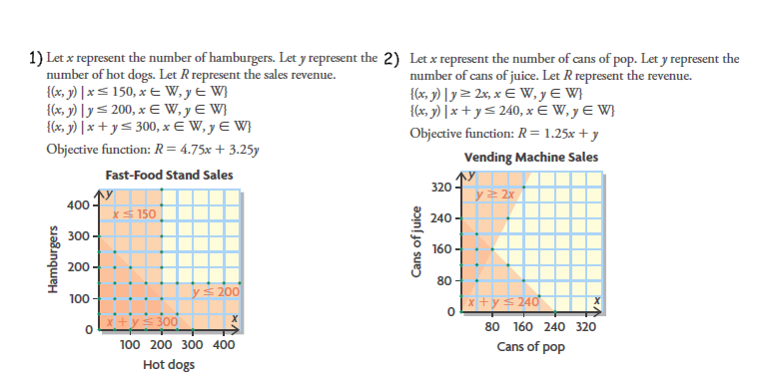
Practice #1

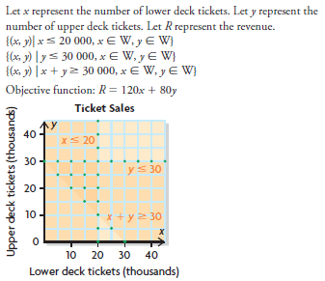
4)

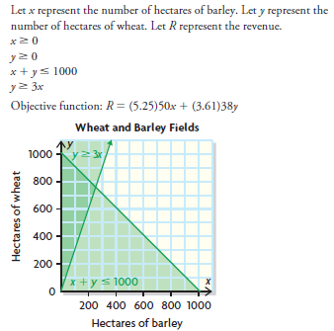
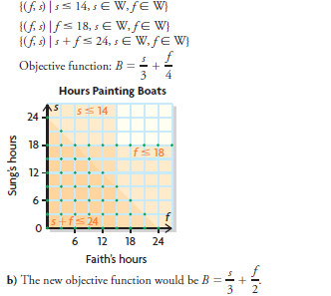
5) 6)

Practice #2
1a) Model A: maximum: (11, 3), minimum: near (-4, -12)
b) Model B: maximum: near (5, 4), minimum: near (0, 9)

2) (-4, 4); e.g., The objective function is the difference of x and y and the other two points have a positive difference
3a) (50, 200); e.g. farthest point from both axes
b) No. These points are not in the feasible region.
c) (50, 100)
d) (50, 200); 75 in.
e) (0, 0) would require no shelving

Practice #3
1) minimum (0, 0); maximum (8, 5)
2) (0, 5)
3) (5, 0)
4) 1500 min or 25 hours; 11 250 min or 187 hours 30 min
5) 12 hours at $8.75, 20 hours at $9.00; $285
6) 96 small earrings and 24 large earrings; $112 800
OUTCOMES | ASSESSMENT RUBRICS
FM20.9 Demonstrate an understanding of the characteristics of quadratic functions of the form y = a(x – p)² + q, including: vertex, intercepts, domain and range, axis of symmetry
Level  Criteria | Intervention 1  Spend some extra time with the criteria and ask for help. | Instructional 2  Good start. You are beginning to make sense of this on your own. You are consistent with the basic learning goals for this outcome. | Independence 3  You did it and you did it on your own. You are able to complete the processes for this outcome. Your work is thorough and consistently accurate. | Mastery 4  Great work! This is going extra well for you. You have understood the outcome, are able to explain your strategies and apply these to situations. Your work is always accurate.
Outcome 9: Demonstrate an understanding of the characteristics of quadratic functions of the form  y = a(x – p)² + q, including: vertex, intercepts, domain and range, axis of symmetry | I need more help with becoming consistent with the criteria. | I can determine:  * a, p and q  * the coordinates of the vertex  * the equation of the axis of symmetry  * max/min value  * opens up/down  * domain and range | I can:  * write the equation of the function given the graph  * identify the roots/zeros/x-intercepts  * determine y-intercept  * sketch the graph of a quadratic function  * determine the axis of symmetry given the x-intercepts | I can:  * explain the relationship between the roots, zeros and x-intercepts  * explain what domain and range means in a situation  * explain the number of possible x-intercepts a quadratic function has  *explain the effects on the graph when a, p and q are changed  * I can solve situational questions

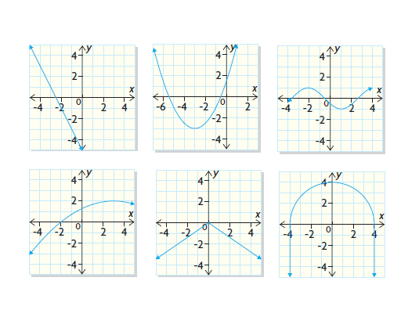
Practice #1 – Quadratic Equations

- Which graphs appear to represent quadratic relations? Explain.
- b) c)

d) e) f)

- Which of the following relations are quadratic? Explain.
- y = 2x – 7 b) y = 2x(x + 3) c) y = (x + 4)² + 1
d) y = x² – 5x – 6 e) y = 4x³ + x² – x f) y = x(x + 1)² – 7

Level 2
- Identify a, p and q in the following quadratic functions.
a)Y = (x – 3)² + 7 b) y = -2(x + 7)² – 3 c) y = 7(x – 2)² – 9
d)Y = -2x² + 5 e) y = -(x – 2)² – 5 f) y = 2(x – 4)²

Practice #2 – Quadratic Functions
Level 2
- Identify a, p and q for the following quadratic functions.
- y = 2(x – 1)² + 3 b) y = -3(x + 4)² – 5 c) y = (x – 3)² + 1

- Which variable determines if the parabola opens up or down?

- Determine if the following quadratic functions open up or down
- y = 2(x – 3)² + 4 b) y = -5(x + 2)² – 1 c) y = -(x – 5)² + 2
d) y = (x + 4)² + 2 e) y = -3(x – 1)² – 2 f) y = 7(x + 2)²

- Which variable determines if the vertex (the point at which the parabola reaches its maximum or minimum) moves left or right?
- Determine if the following quadratic functions will have their vertex to the left or the right of the y-axis.
- y = 2(x – 3)² + 4 b) y = -5(x + 2)² – 1 c) y = -(x – 5)² + 2
d) y = (x + 4)² + 2 e) y = -3(x – 1)² – 2 f) y = 7(x + 2)²

- Which variable determines if the vertex moves up or down?

- Determine if the following quadratic functions will have their vertex above or below the x-axis
- y = 2(x – 3)² + 4 b) y = -5(x + 2)² – 1 c) y = -(x – 5)² + 2
d) y = (x + 4)² + 2 e) y = -3(x – 1)² – 2 f) y = 7(x + 2)² + 3

- Match each equation with its corresponding graph. Explain your reasoning.
- y = (x – 3)² b) y = -(x + 4)² – 2
c) y = -x² – 3 d) y = (x – 4)² + 2
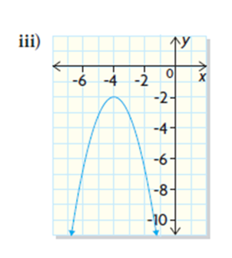
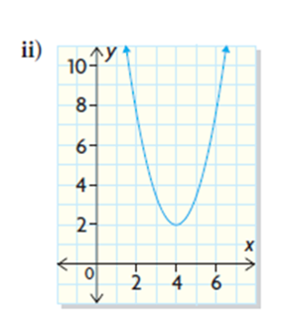
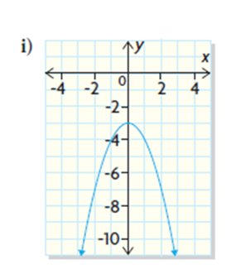
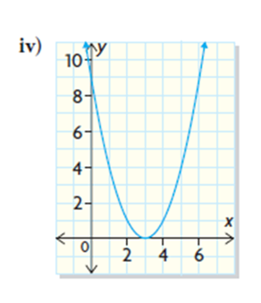

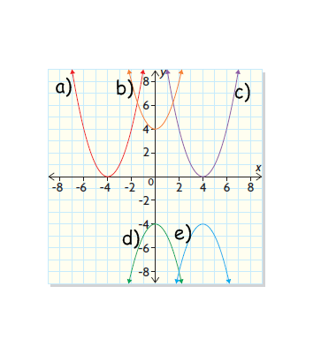
Level 3
- State the equation of each function (assuming the parabola is normal width meaning a = 1 or a = -1).

- Sketch a graph of the following quadratic functions
- y = (x – 3)² + 1 b) y = (x + 2)² + 3
c) y = -(x – 2)² - 4 d) y = -(x + 5)² - 2
Practice #3 – Quadratic Functions
Level 2
- For each of the following quadratic functions, determine
- The a, p and q values
- The coordinates of the vertex
- The equation of the axis of symmetry
- If the parabola opens up or down
- If there is a maximum or minimum value
- What the maximum/minimum value is

- y = -2(x + 1)² + 3 b) y = -(x – 3)² – 2
c) y = -4(x – 2)² + 3 d) y = 4(x + 1)² + 3
e) y = (x + 3)² – 4 f) y = 2(x – 3)² + 5
g) y = 5(x – 2)² – 1 h) y = -(x + 2)²

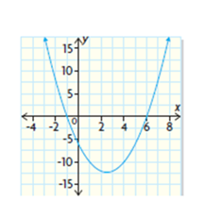
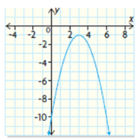
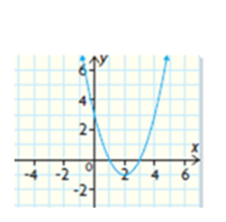
- For each function, identify the equation of the axis of symmetry, the coordinates of the vertex, if there is a maximum or minimum value and what that value is.
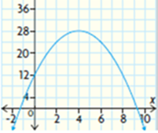
- b) c) d)

Level 3
- For each of the following, both points, (x, y) are located on the same parabola. Determine the equation of the axis of symmetry for each parabola.

- (0, 2) and (6, 2) b) (-6, 0) and (2, 0) c) (1, -3) and (9, -3)

Level 4
- Explain how you would determine whether a parabola contains a minimum value or a maximum value when the quadratic function that defines it is in vertex form: y = a(x – p)² + q. Support your explanation with examples of functions and graphs.

- If a horizontal line intersects a parabola at two points, can one of the points be the vertex? Explain.

Practice #4 – Quadratic Functions

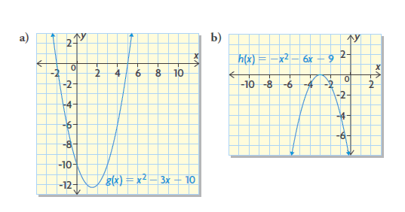
Level 3
- For each graph, determine the roots of the corresponding quadratic equation.

- For each graph, determine the x-intercepts
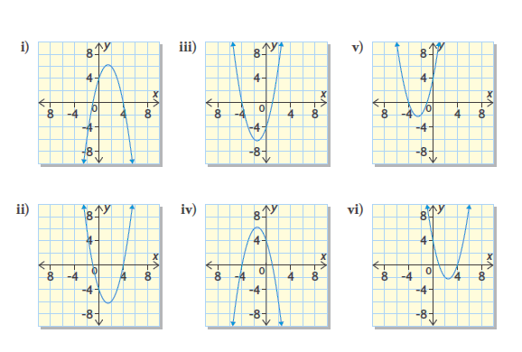
- Determine the x and y intercepts. State the domain and range.

- y = (x – 3)² – 7 b) y = 2(x + 7)² – 3

c) y = 3(x – 2)² – 9 d) y = -(x + 2)² + 5

e) y = (x + 4)² + 2 f) y = 2(x – 4)² – 2

- For the following equations determine:
- The values of a, p and q
- The coordinates of the vertex
- The equation of the axis of symmetry
- If there is a maximum or minimum value
- What the maximum/minimum value is
- If the parabola opens up or down
- The x-intercepts (if any)
viii) The y-intercept
ix) The domain
x) The range

- y = (x – 3)² – 9 b) y = -2(x + 5)² + 8 c) f(x) = - $\frac{1}{2}$(x+6)² + 1

Level 4
- Is it possible for a quadratic equation to have more than two roots? Use a graph to explain.

Practice #5 – Quadratic Functions

Level 3
- Determine each of the following for the quadratic functions
- The coordinate of the vertex
- The equation of the axis of symmetry
- It the parabola opens up or down
- The y-intercept
- The x-intercepts
- If there is a maximum or minimum value
- The maximum/minimum value
viii)The domain
ix) The range
x) Draw a sketch of the graph

- y = (x – 1)² – 4 b) y = -(x + 3)² + 9

c) y = -2(x + 4)² + 2 d) $y=\frac{1}{2}{(x-2)}^{2}-18$

e) y = 5(x – 1)² + 40 f) y = (x + 2)²

Level 4
2. Marleen and Candice are both 6ft tall, and they play on the same college volleyball team. In a game, Candice set up Marleen with an outside high ball for an attack. The path of the ball is described by this function:
h(x) = -0.03(x - 9)² + 8 where h is the horizontal distance, measured in feet, from one edge of the court.

- Determine the axis of symmetry of the parabola
- Marleen hit the ball at the highest point. How high above the court was the ball when she hit it?
- How high was the ball when Candice set it, if she was 2ft from the edge of the court?
- State the range for the ball’s path between Candice and Marleen. Justify your answer.

Practice #6 – Quadratic Functions

Level 3
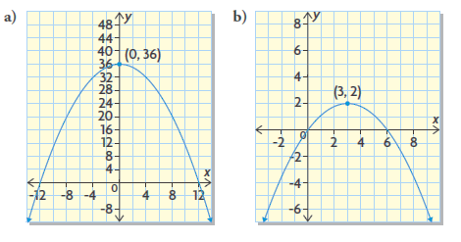
- Determine the equation of the quadratic function that defines each parabola.

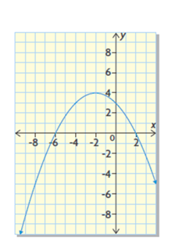
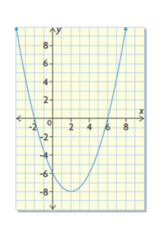
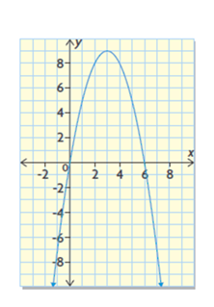

c) d) e)

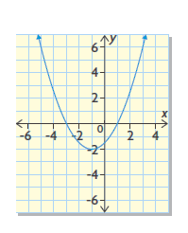
- Identify key characteristics you could use to determine the quadratic function that defines this graph. Explain how you would use these characteristics.

Practice #7 – Quadratic Functions

Level 4
- Duncan dives with a junior swim club. In a dive off a 7.5m platform, he reaches a maximum height of 7.94m after 0.30s. How long does it take him to reach the water?

- On the north side of Sir Winston Churchill Provincial Park, located near Lac La Biche, Alberta, people gather to witness the migration of American white pelicans. The pelicans dive underwater to catch fish. Someone observed that a pelican’s depth underwater over time could be modelled by a parabola. One pelican was underwater for 4 s, and its maximum depth was 1m.

- Determine the quadratic function that defines the parabola
- State the domain and range of the variables in this situation.

- In a suspension bridge, the main supporting cable is in the shape of the parabola. The supporting towers are 400m apart and 100m tall. What was the equation used during the construction if the shortest distance between the main cable and the deck of the bridge is 5m?

Quadratic Functions Answers

Practice #1
1a) No b) yes c) no d) yes e) no f) no

2a) no b) yes c) yes d) yes e) no f) no

3a) a = 1, p = 3, q = 7 b) a = -2, p = -7, q = -3 c) a = 7, p = 2, q = -9
d) a = -2, p = 0, q = 5 e) a = -1, p = 2, q = -5 f) a = 2, p = 4, q = 0

Practice #2
1a) a = 2, p = 1, q = 3 b) a = -3, p = -4, q = -5 c) a = 1, p = 3, q = 1

2) a

3a) up b) down c) down d) up e) down f) up

4) p

5a) right b) left c) right d) left e) right f) left

6) q

7a) above b) below c) above d) above e) below f) above

8a) iv b) iii c) i d) ii

9a) y = (x + 4)² b) y = x² + 4 c) y = (x – 4)²
d) y = -x² – 4 e) y = -(x – 4)² – 4

10a) b) c) d)
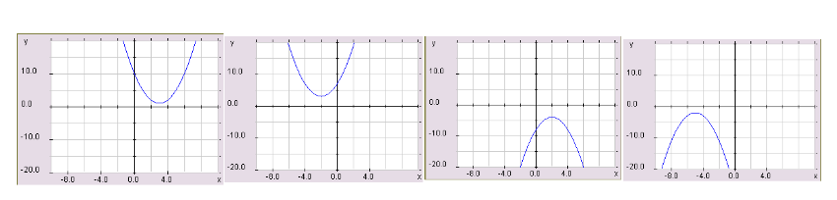

Practice #3
1a) i) a = -2, p = -1, q = 3 ii) (-1, 3) iii) x = -1 iv) down v) max vi) 3
b) i) a = -1, p = 3, q = -2 ii) (3, -2) iii) x = 3 iv) down v) max vi) -2
c) i) a = -4, p = 2, q = 3 ii) (2, 3) iii) x = 2 iv) down v) max vi) 3
d) i) a = 4, p = -1, q = 3 ii) (-1, 3) iii) x = -1 iv) up v) min vi) 3
e) i) a = 1, p = -3, q = 4 ii) (-3, 4) iii) x = -3 iv) up v) min vi) 4
f) i) a = 2, p = 3, q = 5 ii) (3, 5) iii) x = 3 iv) up v) min vi) 5
g) i) a = 5, p = 2, q = -1 ii) (2, -1) iii) x = 2, iv) up v) min vi) -1
h) i) a = -1, p = -2, q = 0 ii) (-2, 0) iii) x = -2 iv) down v) max vi) 0
2a) x = 2, (2, -1), min, -1
b) x = 4, (4, 28), max, 28
c) x = 3, (3, -1), max, -1
d) x = 2.5, (2.5, -12.5), min, -12.5

3a) x = 3 b) x = -2 c) x = 5

4) Discussion

5) Discussion

Practice 4
1a) x = 2, x = 5 b) x = -3

2i) x = -1, x = 4 ii) x = -1, x = 4 iii) x = -4, x = 1
iv) x = -4, x = 1 v) x = -4, x = -1 vi) x = 1, x = 4

3a) x-intercepts: 0.4 and 5.6 y-intercept: 2 domain: (-∞,∞) range: [-7,∞)
b) x-intercepts: -5.8 and -8.2 y-intercept: 95 domain: (-∞,∞) range: [-3,∞)
c) x-intercepts: 0.3 and 3.7 y-intercept: 3 domain: (-∞,∞) range: [-9,∞)
d) x-intercepts: 0.2 and -4.2 y-intercept: 1 domain: (-∞,∞) range: (-∞,5]
e) x-intercepts: none y-intercept: 18 domain: (-∞,∞) range: [2,∞)
f) x-intercepts: 3 and 5 y-intercept: 30 domain: (-∞,∞) range: [-2,∞)

5) No. Explanations will vary

Practice 5
a b c d e f
(1, -4) | (-3, 9) | (-4, 2) | (2,-18) | (1, 40) | (-2, 0)
x = 1 | x = -3 | x = -4 | x = 2 | x = 1 | x = -2
up | down | down | up | up | up
y = -3 | y = 0 | y = -30 | y = -16 | y = 45 | y = 4
-1 and 3 | -6 and 0 | -3 and -5 | -4 and 8 | none | -2
min | max | max | min | min | min
-4 | 9 | 2 | -18 | 40 | 0
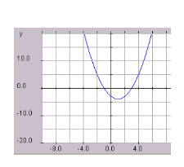  (-∞,∞) | (-∞,∞) | 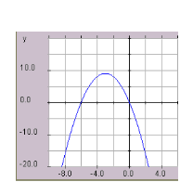  (-∞,∞) | (-∞,∞) | 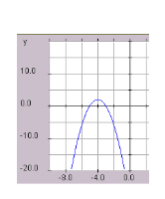  (-∞,∞) | (-∞,∞)
[-4, ∞) | (-∞,9] | (-∞,2] | [-18, ∞) | [40, ∞) | [0, ∞)
- b) c)

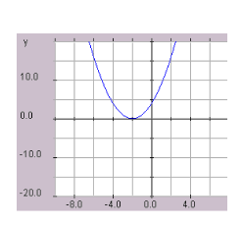
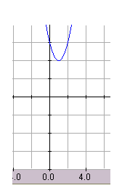
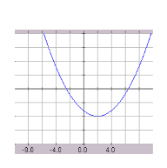
d) e) f)

2a) x = 9 b) 8 ft c) 6.53 ft d) [6.53, 8] Justification will vary

Practice 6
1a) f(x) = -0.25x² + 36 b) $f\left(x\right)=-\frac{2}{9}(x-3)^{2}+2$
c) f(x) = 0.5(x – 2)² – 8 d) f(x) = -0.25(x + 2)² + 4
e) f(x) = -(x – 3)² + 9

2) Discussion

Practice 7
- About 1.6 s

2a) y = 0.25(x – 2)² – 1
b) Domain: [0, 4] Range [-1, 0]

- About 2:00 pm

