Math 30 Foundations Textbook

Please do NOT write in this textbook (other than on this page!). If this textbook is lost you will be charged a fee for it.

Name | Teacher’s Name | Semester/Year

Table of Contents
Outcome | Practice Pages | Answers | Video Lessons Link
30-1A | 3 | 14
30-1B | 17 | 26
30-2 | 28 | 36
30-3 | 41 | 51
30-4 | 54 | 59
30-5 | 61 | 68
30-6 | 71 | 87
30-7A
30-7B
30-7C
30-8

Outcome 30-1A
OUTCOMES | ASSESSMENT RUBRICS
FM30.1 Demonstrate understanding of financial decision making including analysis of:
- renting, leasing, and buying
- credit
- compound interest
- investment portfolios
Level  Criteria | Intervention 1  Spend some extra time with the criteria and ask for help. | Instructional 2  Good start. You are beginning to make sense of this on your own. You are consistent with the basic learning goals for this outcome. | Independence 3  You did it and you did it on your own. You are able to complete the processes for this outcome. Your work is thorough and consistently accurate. | Mastery 4  Great work! This is going extra well for you. You have understood the outcome, are able to explain your strategies and apply these to situations. Your work is always accurate.
Outcome 30.1A Demonstrate understanding of financial decision making involving investing money, including analysis of compound interest and investment portfolios. | I need more help with becoming consistent with the criteria. | I can determine the value of a missing variable in a simple/ compound interest problem. | I can answer questions based on compound interest questions (ie. find interest earned, rate of return, rank investments, compare investments, etc.)  I can use the Rule of 72  I can graph an investment and analyze the graph  I can calculate the value of a basic investment portfolio. | I can calculate the value of a complex investment portfolio.  I can compare investment portfolios and make recommendations  I can demonstrate my understanding of what it means to be financially literate.

Simple Interest
- Term: The contracted duration of an investment or loan.
- Interest: The amount of money earned on an investment or paid on a loan
- Fixed Interest Rate: An interest rate that is guaranteed not to change during the term of an investment or loan
- Principal: The original amount of money invested or loaned
- Future Value: the amount, A, than an investment will be worth after a specified period of time
- Rate of Return: The ratio of money earned (or lost) on an investment relative to the amount of money invested, usually expressed as a decimal or percent.
- Simple interest The amount of interest earned on an investment or paid on a loan based on the original amount (the principal) and the simple interest rate
- Maturity: The contracted end date of an investment or loan, at the end of the term
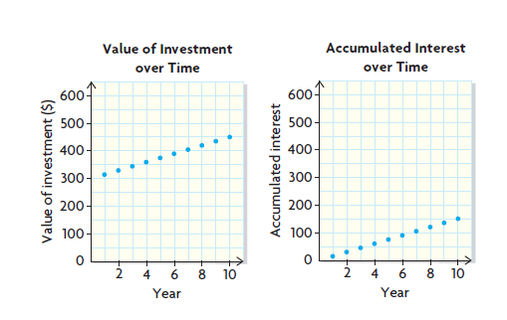
The value of an investment that earns simple interest over time is a linear function. The accumulated simple interest earned over time is also a linear function. Since the interest is paid at the end of each period, the growth is not continuous. For example, the following graphs show principal of $300 invested at 5% interest, paid annually, over a term of 10 years.

- The amount of simple interest earned on an investment can be determined using the formula I = Prt where I is the interest, P is the principal, r is the annual interest rate expressed as a decimal, and t is the time in years
- The future value or amount, A, of an investment that earns simple interest can be determined using the formula A = P(1 + rt) where P is the principal, r is the interest rate expressed as a decimal, and t is the time in years.
- Interest rates are communicated as a percent for a time period. Since most often the time period is per year or per annum (abbreviated as /a), a given percent is assumed to be annual unless otherwise stated. For example, an interest rate of 4% means 4%/a or 4% interest per year.
- Even though interest rates are usually annual, interest can be paid out at different intervals, such as annually, semi-annually, monthly, weekly, and daily.

Practice #1
- Chad invested $4000 at a simple interest rate of 2.3%
- What is the value of his investment after 5 years.
- What is its value after 10 years?

- Both Brad and Chris purchased a $15 000 GIC.
Brad’s GIC has a term of 6 years and a simple interest rate of 3.2%
Chris’s GIC has a term of 5 years at a simple interest rate of 3.3%
Whose GIC will have the greater future value at maturity? Explain.

- A principal of $1000 is invested at 5% simple interest, paid annually for 5 years. What is the rate of return?

4. On July 1, Desiree deposited $3600 into a savings account that earns 2.5% simple interest, paid daily. On the same day, her sister Latoya deposited $3500 into a savings account that earns 3% simple interest, paid daily.
a) Who will have more money on December 31? How much more?
b) Determine the difference in the interest that the sisters will earn over the 6 months.
c) Compare their rates of return.

5. Lin invested $4700. After 8 years, the investment’s value was $9400.
a) What was the annual simple interest rate?
b) Suppose that the interest rate continued for another 8 years. What would be the value of the investment?

6. Shaun has been looking at houses. He has $10 000 that he wants to invest, hoping that he can end up with $15 000 to make a down payment on a house. He has an opportunity to invest at 6.5% simple interest, paid annually. How long will it take before Shaun can make a down payment of $15 000?

7. A bank is offering a simple interest rate of 3.2% for a guaranteed investment certificate with a 5 year term.
a) What principal would you need to invest if you wanted to have $20 000 at the end of the term?
b) How long will it take for the value of the GIC to be $25 000?

8 a) Predict which investment will earn the greater amount of interest over 5 years. Explain your predictions, and then verify it.
A. $1000 in a simple interest investment at 6% paid semi annually
B. $1000 in a simple interest investment at 6% paid monthly
b)Is there an advantage if interest is paid more often? Explain.
c) Why might someone choose investment B over investment A?

Future Value of Compound Interest
- Compound interest : The interest that is earned or paid on both the principal and the accumulated interest.
- Compound interest is determined by applying the interest rate to the sum of the principal and any accumulated interest. Previously earned interest is reinvested over the course of the investment.
- Compounded Annually: When compound interest is determined or paid yearly.
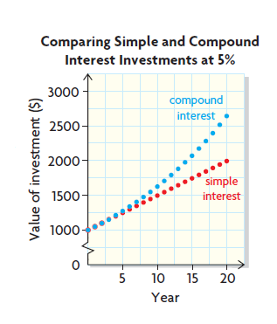
- Compounding Period: The time over which interest is determined; interest can be compounded annually, semi-annually (every six months), quarterly (every three months), monthly (12), weekly (52) or daily (365)
- If the same principal is invested in a compound interest
account and a simple interest account, with the same
interest rate for the same term, the compound interest
investment will grow faster (non linear) than the simple
interest investment (linear). For example, the graphs
show principal of $1000 invested over 20 years at 5%
simple interest and 5% compound interest, both paid
annually.
- Financial institutions pay compound interest on investments at regular equal intervals. If interest is paid annually, it is calculated at the end of the first year on the principal and then added to the principal. At the end of the second year, the interest is calculated on the balance at the end of the first year (principal plus interest earned from the previous year). This pattern continues every year until the end of the investment term
- The future value of an investment that earns compound interest can be determined using the compound interest formula $A=P(1+i)^{n}$ where A is the future value, P is the principal, i is the interest rate per compounding period (expressed as a decimal), and n is the number of compounding periods.
- The more frequent the compounding and the longer the term, the greater the impact of the compounding on the principal and the greater the future value will be.
- When using the compound interest formula, use an exact value for i. For example, for an annual interest rate of 5% compounded monthly, substitute $\frac{0.05}{12}$ for i instead of the rounded value 0.00416…
- Compounding frequencies are given in the table below. The table shows how the interest rate per compounding period (i) and the number of compounding periods (n) are determined.
Compounding Frequency | Times per Year | Interest Rate per Compounding Period (i) | Number of compounding periods (n)
Annually | 1 | i = annual interest rate | n = number of years
Semi-annually | 2 | $$i=\frac{annual interest rate}{2}$$ | n = (number of years)(2)
Quarterly | 4 | $$i=\frac{annual interest rate}{4}$$ | n = (number of years)(4)
monthly | 12 | $$i=\frac{annual interest rate}{12}$$ | n = (number of years)(12)
Weekly | 52 | $$i=\frac{annual interest rate}{52}$$ | n = (number of years)(52)
Daily | 365 | $$i=\frac{annual interest rate}{365}$$ | n = (number of years)(365)
- The total compound interest earned on an investment (i) after any compounding period can be determined using the formula $I=P[(1+i)^{n}-1]$
- The Rule of 72 is a simple strategy for estimating doubling time. It is most accurate when the interest is compounded annually. For example, $1000 invested at 3% interest, compounded annually, will double in value in about $\frac{72}{3}$ or 24 years; $1000 invested at 6% will double in about $\frac{72}{6}$ or 12 years.

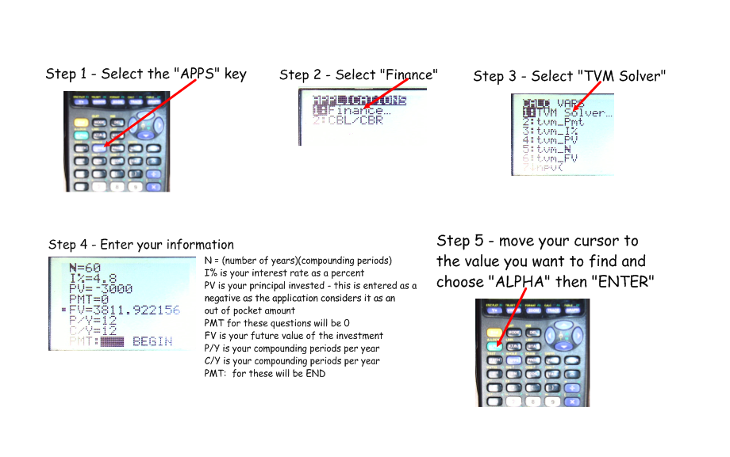
- To use a TI-83PLUS
graphing calculator

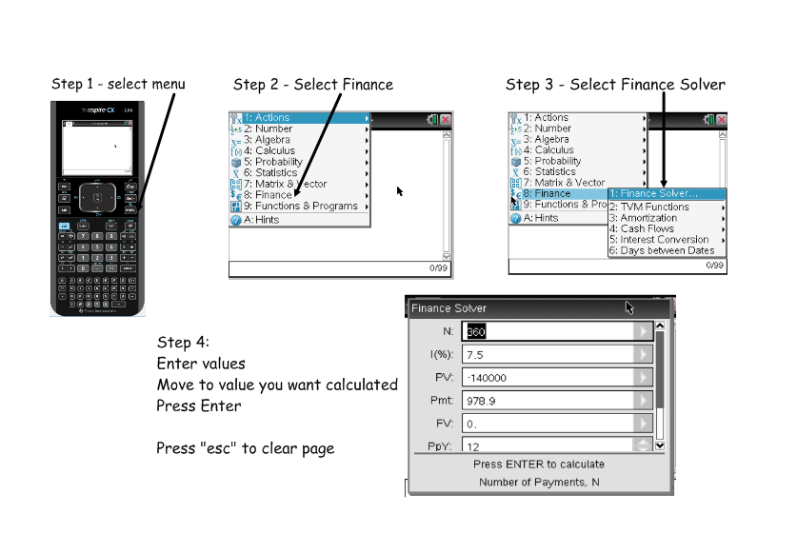
- To use a Ti-Nspire graphing calculator

Practice #2
- For each investment determine the future value and the total interest earned
 | Principal (P) $ | Rate of Compound Interest per Annum (%) | Compounding Frequency | Term (years)
a) | 7000 | 6.8 | Annually | 35
b) | 850 | 9.2 | Monthly | 20
c) | 12500 | 15.6 | Weekly | 5
d) | 40000 | 2.7 | Semi-annually | 8

- Determine the future value and the total interest earned for an investment of $520 for 8 years at 4.5% compounded monthly.

- Suppose that you are searching online for the best interest rates on a GIC. You find these rates:
- Bank A offers 6.6%, compounded annually
- Bank B offers 6.55% compounded semi-annually
- Bank C offers 6.5% compounded quarterly
Rank these rates from greatest to least return on an investment of $20000 for a term of 2 years.
Practice #3
- Estimate how long it would take for $1000 to grow to $16000 at each interest rate, compounded annually
- 6% b) 12%

- When Sara was born, her grandparents set up two investments of $3000 for her. One earns 9%, compounded annually; the other earns 9%, compounded monthly.
- Sara is now 18. Determine the current value of each investment.
- Graph the interest earned over time for both investments on the same grid. Plot at least five points for each investment.
- How does the compounding frequency affect the growth of interest?

- For each investment, use the Rule of 72 to estimate the doubling time and then determine the doubling time.
 | Principal (P) $ | Rate of Compound Interest per Annum (%) | Compounding Frequency | Term (years)
a) | 7000 | 6.8 | Annually | 35
b) | 850 | 9.2 | Monthly | 20
c) | 12500 | 15.6 | Weekly | 5
d) | 40000 | 2.7 | Semi-annually | 8
- Trust funds are investments that are set up for a specific purpose. A local business invested $250000 in a charitable trust fund so that a school can offer scholarships. The interest rate is 3.8% compounded semi-annually. Only the interest earned can be used to provide the scholarships. How much is available from the trust fund for scholarships each year?

- Angie deposited some money into an account with a fixed rate of interest, compounded annually, for 3 years. The growth of the investment is shown in the table below. What is the annual rate of interest? What was the principal that Angie invested?
End of Year | Value of Investment ($)
1 | 852.00
2 | 907.38
3 | 966.36

- Sam bought a $40000 corporate bond (an investment in the form of a loan to a company that earns interest). The bond earns 4.8% compounded semi-annually. After 4 years, the interest rate changed to 6% compounded annually. Determine the value of Sam’s investment after 6 years.

- Compare simple and compound interest investments by describing what they have in common and what is unique to each.

- Why would someone choose an investment that paid compound interest over an investment that paid simple interest, assuming that the principal, interest rate, and term are the same?

Present Value of Compound Interest
- Present Value: The amount that must be invested now to result in a specific future value in a certain time at a given interest rate
- The present value of an investment that earns compound interest can be determined using the formula $P=\frac{A}{(1+i)^{n}}$ where P is the present value (or principal), A is the amount (or future value), i is the interest rate per compounding period (expressed as a decimal), and n is the number of compounding periods.

Practice #4
- Complete the table
 | Future Value (amount in $) | Present Value (principal is $) | Interest rate per Annum (%) | Compounding Period | Investment Term (years)
a) | 2 500.00 | ? | 7.8 | Annually | 8
b) | 3 500.00 | 2000.00 | ? | Semi-annually | 5
c) | 11 000.00 | ? | 2.4 | Quarterly | 12
d) | 100 000.00 | 609.35 | 13.6 | Annually | ?
e) | 23 500.00 | 16 150.00 | ? | monthly | 2
- Claire wants a down payment of $17500 to buy a house in 10 years when she turns 30. Her bank offers her an investment with 5.6% interest, compounded semi-annually. What present value will she need to invest now?

3. Sasha predicts that she will need $24000 to remodel her carpentry workshop in 6 years. She has found three investment options to consider:
A. 4.80% compounded annually
B. 4.75% compounded semi-annually
C. 4.70% compounded quarterly
a)Compare the rates of return for these three options. Which option should she choose? Why?
b)How much interest will she earn?
4. Frank invested money at 6.9% compounded annually, while David invested money at 6.9% compounded monthly. After 30 years, each investment is worth $25000. Who made the greater original investment, and by how much was is greater?

5. Ben would like to send his parents on a $15000 safari for their 35th wedding anniversary in 10 years. He has the opportunity to invest in a GIC that earns 5.5% compounded semi-annually. His brother and sister have agreed to split the cost of the GIC with him. How much will each sibling contribute to the cost of the GIC?

6. A $15000 GIC earns 3.8% compounded annually for 10 years.
a) Graph the value of the investment ($) against time (years)
b) Change either the interest rate or the principal. Graph the value of the new investment against time on the same grid.
c) Make another change to the same variable you changed in part b. Graph the value of the new investment against time on the same grid.
d) How did the changes in the variable affect the shape of the graph?

7. Imagine that you are a financial advisor. You have a client who knows nothing about investments. Explain the key features that your client should look for in a fixed-interest investment opportunity. Use the terms present value, future value, simple interest, compound interest, interest rate, compounding frequency, and term in your explanation.

8. How do you know what form of the compound interest formula to use when solving a problem?

Investments Involving Regular Payments
- For an investment that involves a series of equal deposits or payments made at regular intervals, the future value is the sum of all the regular payments plus the accumulated interest
- The future value of an investment involving regular payments can be found by determining the sum of all the future values of each regular payment:
A = R(1 + i)⁰ + R(1 + i)¹ + R(1 + i)² + R(1 + i)³ + R(1 + i)^{n-1}
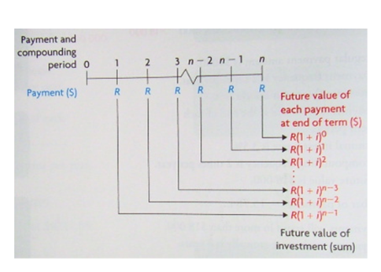
Where A is the amount, or future value of the investment, R is the regular payment; i is the interest rate per compounding period, expressed as a decimal, and n is the number of compounding periods.

- Investments involving regular payments can be solved using the formula:
$$A=\frac{R\left[{\left(1+i\right)}^{n}-1\right]}{i}$$
Where A is the future value, R is the amount of the equal regular payments, n is the number of regular payments and i is the interest rate per compounding period.
- Problems that involve the future value of an investment with regular payments can be solved using spreadsheet software or using the financial application on a graphing calculator or spreadsheet.
- You can still use your calculator, but instead of using PV, you will use PMT for the regular payment amount. Still enter this as a negative. Make sure you PV is set to 0.
- The future value of a single deposit has a greater future value than a series of regular payments of the same total amount
- Small deposits over a long term can have a greater future value than large deposit over a short term because there is more time for compound interest to be earned.

Practice #5
- Determine the unknown values
 | Regular Payment ($) | Interest Rate (%) | Compounding and Payment Frequency | Term (years) | Future Value ($)
A | 200 | 4.8 | Monthly | 50 | ?
B | 1750 | 5.6 | Semi-annually | 20 | ?
C | 50 | 8.4 | Quarterly | 40 | ?
D | 5500 | 6.5 | Semi-annually | 12 | ?
E | 100 | ? | Monthly | 6 | 7800.61
F | ? | 3.5 | Semi-annually | 7 | 3927.38
G | 20 000 | 4.75 | Quarterly | ? | 1 054 970.01
- Zoey deposited the same amount of money at the end of each month for 2 years in a savings account that earned 6% interest, compounded monthly. He ended up with $5000. How much did Zoey deposit each month?

- What interest rate, compounded monthly, is required to make monthly payments of $500 grow to $35000 in 5 years?

- How long will it take for $1000 payments every 6 months to grow to more than $10000 if the interest rate is 7.5% compounded semi-annually?

- Aaron and Casey started investing at the same time. Aaron makes payments of $25 at the end of each month into an investment that earns 4.2% compounded monthly. Casey made a single payment into an investment that earns 4.2% compounded annually.
- At the end of 5 years, what is the future value of Aaron’s investments?
- Casey’s investment has the same future value as Aaron’s in 5 years. How much principal did Casey invest?
- Predict whose investment will be worth more at the end of 10 years. Explain and then verify your prediction.
- Both Jill and Vaughn set up a 30 year investment and want to have $250 000 at the end of the term. Jill’s bank pays a rate of 7.4%, compounded monthly. Vaughn is investing through the company he works for, at a rate of 11.6% compounded monthly.
- How much more does Jill need to invest than Vaughn over the 30 years?
- Vaughn decides to make the same payments at the end of each month as Jill. How much will he have at the end of 30 years?

- Tim has found his dream sailboat in Victoria. It is selling for $120 000. He intends to sell his current sailboat in 2 years for $50 000. During those 2 years, Tim is going to put $300 at the end of each week into an investment that earns 10.5% compounded weekly. Will he have enough to buy his dream sailboat? Explain.

- How does the future value of a single payment investment compare with the future value of an investment involving regular payments?

Investment Portfolio Problems
- Portfolio: One or more investments held by an individual investor or by a financial organization
- Rate of return is a useful measure for comparing investment portfolios.
- An investment portfolio can be built from different types of investments , such as single payment investments (for example, CSBs and GICs) and investments involving regular payments. Some of these investments, such as CSBs, lock in money for specified periods of time, thus limiting access to the money, but offer higher interest rates. Other investments, such as savings accounts, are accessible at any time but offer lower interest rates. Investments that involve greater principal amounts invested or greater regular payment amounts when contracted tend to offer higher interest rates.
- The factors that contribute to a larger return on an investment are time, interest rate, and compounding frequency. The longer that a sum of money is able to earn interest at a higher rate compounded more often, the more interest will be earned. For investments involving regular payments, the payment frequency is also a factor.
- Financial applications on calculators or spreadsheets and online financial tools at banking websites are valuable tools for analyzing and comparing investment portfolios.

Practice #6
- Hugh has created the following investment portfolio:
- At the end of each year, for the past 10 years, he has purchased a 10 year $1000 CSB, with an average annual interest rate of 3.4%, compounded annually.
- He has a trust account that was set up when he was born, 42 years ago, with a single deposit of $3000. The trust fund earns an average annual interest rate of 4.3%, compounded quarterly.
- He has a $10000 GIC, with a 10 year term, that he purchased 10 years ago and earned 3.95% compounded semi-annually.
Hugh intends to redeem everything and then invest all the money in a 5 year bond that earns 5.1% compounded annually. How much will Hugh’s bond be worth in 5 years?

- Paula is 18 years old and is about to start a 3 year college program. She lives with her family, but she still needs about $2000 each year for expenses.
- Paula has been working part time for the past 3 years and has deposited $50 each month into an investment account that earns 2.7% compounded monthly.
- When she was born, her parents opened an RESP account that earns 3.2% compounded monthly. Her parents have deposited $10 each month into this account.
- How much money does Paula have when she starts her first year?
- Paula decides to redeem her investments when she starts first year, and she withdraws $2000 for her expenses. She then reinvests the rest of the money in a savings account that earns 3.5% compounded daily. Will she have enough money for her expenses when she starts second year? Explain.
- If Paula withdraws another $2000 for second year, will she have enough money for third year? If not, how much does she need to save over the summer between second and third year?
- When Wade was 20, he started to build an investment portfolio.
- He opened a savings account and invested $50 a month until he was 40 and earned an average annual rate of 2.7% compounded monthly.
- When Wade was 40, he redeemed the savings account and invested the entire amount in a 10 year GIC that earned 4.2% compounded monthly.
- At maturity, he reinvested the entire value of the GIC in another 10 year GIC that earned 4.3% compounded monthly.
- When he was 40, he also purchased a 10 year $500 bond that earned 3.9% compounded annually.
- He reinvested the money at the same interest rate when the bond matured.
- What is the value of Wade’s portfolio when he turns 60?
- What is Wade’s rate of return?

- Derek was laid off, after 20 years of service. His severance pay was $18 638. Since Derek found another job immediately, he decided to invest his severance pay. Which of the two options would you advise his to choose for the next 10 years? Explain.
- A 10 year $15000 GIC at 4.1% compounded annually, and a high interest savings account at 3.9% compounded weekly for the remaining $3638
- A high interest savings account at 3.9% compounded daily for all the severance pay.

- Jayne’s investment portfolio is described below:
- When Jayne was born, 40 years ago, her parents opened a trust account for her. They invested $500 at the end of each year into the trust account until she was 20. Since then, there have been no more deposits, but the account has continued to earn interest at an average annual rate of 5% compounded annually.
- 10 years ago, Jayne purchased a 10 year $10 000 GIC that earned 4.4% compounded semi-annually.
- 5 years ago, she started buying a 5 year $1000 CSB at the beginning of each year. The first two CSBs earned 4.7% compounded annually, the next two CSBs earned 4.8% compounded annually and the last CSB earned 4.9% compounded annually.
How much is Jayne’s investment portfolio worth now? What is her rate of return?

- What factors do you need to keep in mind when creating or evaluating an investment portfolio? Explain.

- How can you evaluate or compare investment portfolios that are made up of multiple investments?

Answers
Practice #1
1a) $4460.00 b) $4920.00
2) Brad: $17880.00; Chris: $17475.00; Brad will have more at maturity
3) 0.25 or 25%
4a) Desiree: $3645.00; Latoya: $3552.50; Desiree has $92.50 more b) Desiree: $45; Latoya: $52.50; Latoya earns $7.50 more in interest c) Desiree: 1.25%; Latoya: 1.5%; Latoya has a better rate of return
5a) 12.5% b) $14100
6) approx. 8 years
7a) $17241.38 b) 14.1 years
8a) Prediction is your own opinion; Verify by showing amounts over time; they will have the same amount. b) ie. No, with simple interest there is no advantage to having it paid more often c) ie. They may need the interest money to pay a monthly bill

Practice #2
1a) A = $69999.01; I = $62999.01 b) A = $5314.63; I = $4464.63
- A = $27236.58; I = $14736.58 d) A = $49572.41; I = $9572.41
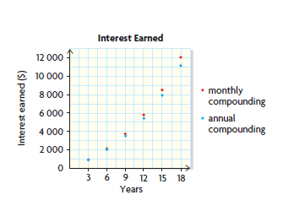
2) A = $744.83; I = $224.83
3) Bank A: $22727.12 Bank B: $22751.54 Bank C: $22752.78; Bank C, B, A

Practice #3
1a) 48 years b) 24 years
2a) #1: $14151.36 #2: $15067.91 b)
c)The more frequent the more interest

3a) 10.6; 10.54 b) 7.8; 7.6 c) 4.6; 4.45 d) 26.7; 25.67
4) $9590.25
5) 6.5%; $800
6) $54333.96 after 6 years
7) In both cases interest is earned on the principal. For compound interest, interest is also earned on the interest.
8) Simple interest is earned only on the principal of the investment, while compound interest is earned on the principal and any accumulated interest. So, when the principal, interest rate, and term are the same, a compound interest investment will earn more interest than a simple interest investment.

Practice #4
1a) $1370.85 b) 11.5% c) $8254.48 d) 40 years e) 18.9%
2) $10073.39
3a) A: 32.49%; B: 32.53%; C: 32.36%; Option B gives you the best rate of return b) $5891.43
4) Frank: $3377.60; David: $3173.40; Frank invested more money; $204.20 more
5) $2906.25 each
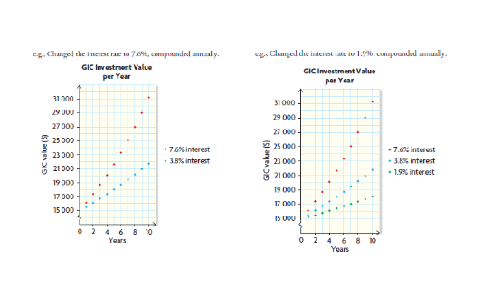
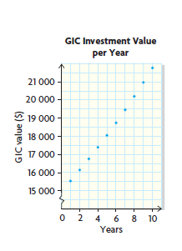
6a) b) c)

- Changing the interest rate changes the rate at which the value of the investment increases
7) In an investment, you agree to lend a sum of money to another entity (like a company); the amount you lend is called the present value of the principal. The interest rate dictates the amount of money they pay you for the loan, for a given time period, called the term. Simple interest pays you a percentage of the loaned amount at the end of the term. With compound interest, the interest is paid out more often, defined by the compounding frequency. You don’t get the compound interest immediately, but effectively lend the entity the interest as well, until the end of the term. The PV plus the interest you earn is the FV. A higher interest rate and higher compounding frequency will earn you more interest.
8) You can use any equivalent form of the compound interest formula, but you might prefer to use a form that simplifies your calculations. You can also use a financial application to determine any unknown variable in a compound interest problem situation if you know the other variables. This is recommended when determining the term of the investment (n).

Practice #5
#1a) $498526.60 b) $126127.32 c) $63820.79 d) $195389.47
- 2.675% f) $250 g) 10.5 years
2) $196.60
3) 6.13%
4) 4.5 years
5a) $1665.90 b) $1356.16 c) Aaron: $3720.34; Casey: $2046.39
6a) Jill: $68140.80; Vaughn: $28134; Jill will invest $40006.80 more b) $605469.20
7) $84679.08; No he will not have enough. He will be short $35320.92

8) Alike: Each payment in a regular payment investment is like a single payment investment. The future value of the regular payment investment is the sum of the future values of all the payments.
Different: If the regular payments are invested as a single payment under the same conditions, the future value would be greater. This is because the entire amount invested in a single payment investment earns compound interest for the entire term. In contrast, if an investment involves regular payments, only the first payment earns interest for the full term. Each payment after that earns interest over less time.

Practice #6
- Investment #1: $11677.32; Investment #2: $18083.03; Investment #3: $14786.80 for current total $44547.15; new investment $57125.96
2a) Investment #1: $1872.72; Investment #2: $2915.79; Total $4788.51
b)$2887.83; Yes she has more than $2000
c)$919.45; No she needed to save $1080.55
3a) Investment #1: 40yrs $15888.14; 50yrs $24163.41; 60yrs $37116.85
Investment #2: $1074.69 Total: $38191.54
b)206%
4) A: $27790.56 B: $27527.39 Option A
5) An investment portfolio may consist of single payment investments or regular payment investments. Some investments may lock in funds for a period of time, limiting access, but often offer a higher interest rate. Investments offering a lower interest rate usually allow access to the funds. A higher investment amount usually tends to offer higher interest rates. The greater the principal, term, interest rate and compounding frequency, the faster the investment will grow.
6) You can use their rates of return. It is particularly useful when comparing investments in which the principal or term is different.

Outcome FM30-1B
OUTCOMES | ASSESSMENT RUBRICS
FM30.1 Demonstrate understanding of financial decision making including analysis of:
- renting, leasing, and buying
- credit
- compound interest
- investment portfolios
Level  Criteria | Intervention 1  Spend some extra time with the criteria and ask for help. | Instructional 2  Good start. You are beginning to make sense of this on your own. You are consistent with the basic learning goals for this outcome. | Independence 3  You did it and you did it on your own. You are able to complete the processes for this outcome. Your work is thorough and consistently accurate. | Mastery 4  Great work! This is going extra well for you. You have understood the outcome, are able to explain your strategies and apply these to situations. Your work is always accurate.
Outcome 30.1B Demonstrate understanding of financial decision making involving borrowing money including analysis of renting, leasing, buying and credit.. | I need more help with becoming consistent with the criteria. | I can determine the value of a missing variable in a financial problem involving renting, leasing, buying or credit. | I can solve questions based on financial problems involving renting, leasing, buying or credit (ie. find total interest paid, total cost of loan, time to pay off loan, basic cost and benefit analysis, etc.) | I can demonstrate my understanding of financial decisions to be made involving borrowing money.  I can solve a complex cost and benefit analysis

Analyzing Loans
- Collateral – An asset that is held as security against the repayment of a loan.
- Amortization Table – A table that lists regular payments of a loan and shows how much of each payment goes toward the interest charged and the principal borrowed, as the balance of the loan is reduced to zero.
- Mortgage – A loan usually for the purchase of real estate, with the real estate purchased used as collateral to secure the loan
- The large majority of commercial loans are compound interest loans, although simple interest loans are also available
- The cost of a loan is the interest charged over the term of the loan
- A loan can involve regular loan payments over the term of the loan or a single payment at the end of the term
- The same formulas that are used for investment situations are also used for loans with a single payment at the end of the term:
- For a loan that charges simple interest, A = P + Prt or A = P(1 + rt)
- For a loan that charges compound interest, A = P(1 + i)^{n}
- Technology can be used to determine unknown variables in compound interest loan situations for both single payment loans and regular payment loans.
- The interest that is charged on a loan will be less under any or all of these conditions:
- The interest rate is decreased
- The interest compounding frequency is decreased
- Regular payments are made
- The regular payment amount is increased
- The payment frequency is increased
- The term is decreased
- With each payment period, the interest paid decreases while the principal paid increases. This occurs because each payment decreases the balance of the loan, so the interest on the remainder of the balance will be less on the next payment. Also, because the payment amount stays the same, more of the payment goes toward paying off the principal, since less is being paid toward the interest.
- Technology can be used to investigate and analyze “what if” situations that involve borrowing money.

Outcome FM30-1B Practice #1
- Alex borrowed $2500 to help pay for his summer school tuition. His bank offered him a simple interest rate of 2.4%, with the entire amount to be paid in full in 1 year.
- What amount did Alex need to pay back?
- How much interest did Alex need to pay?

- In November, Holly borrowed $1200 at 11.2% compounded monthly, to buy gifts for her family. Holly arranged to pay off the loan in 6 months, with a single payment.
- What amount did Holly need to pay back?
- What amount of interest did Holly pay?

- Matt is laying new floors in three rooms of his house and needs a loan that he will not have to pay back for 18 months. The interest rate for the loan is 4.9%, compounded quarterly. On the maturity date, Matt wants to make a single payment of no more than $12000.
- What is the most that Matt can borrow?
- How much interest will Matt pay on his loan?

- David mows the lawn as a part time job. He needs to buy a new lawn tractor, which will cost $6583. The bank offers him a loan as 12.4%, compounded monthly, with payments of $250 at the end of each month.
- How long will David need to make payments?
- How much interest will he pay?

- Evan’s bank has approved a personal loan of $14000 at 7.5%, compounded quarterly, so that Evan can pave his driveway. Evan wants to repay the loan at the end of 4 years, with a single payment.
- How much will Evan need to repay?
- For each situation below, predict whether Evan would end up paying more or less than the amount in part a). Explain your prediction. Then verify your prediction by calculating how much more or less
- He took twice the time to repay the loan
- He paid off the loan in half the time

- Luke, an art dealer, wants to borrow money at 5.6% compounded monthly, to purchase a soapstone sculpture. He believes that he can sell the sculpture for a profit within a year. Luke wants to make a single payment of no more than $12000.
- What is the most that Luke can borrow if he repays the loan at the end of a year?
- How much interest will be pay?

- Sara has found a small house in Prince Albert. She can buy the house for $179 900. After negotiating with her bank, she has been offered a mortgage for 90% of the cost at 4.5% compounded semi-annually, with regular weekly payments for 15 years.
- How much will the down payment be?
- How much will the principal of the mortgage be?
- What will the regular payment amount be?
- How long will it take before she has paid off half the loan?
- How much interest will she pay in all?

- Sharon wants to customize her car so that she can enter some races. She negotiates a loan at 3.8%, compounded weekly, with regular payments of $25 at the end of each week. She wants to repay the loan in 1 year.
- What is the most she can borrow?
- How much will she pay in interest?

- Paul wants to buy a new car for $17 899. The dealership has offered him $2000 for his old car and has agreed to finance a loan at 2.1%, compounded semi-annually for 4 years.
- What would Paul’s payment be semi-annually?
- Create an amortization table for the loan. When will he have paid off half of the loan?
- How much interest will Paul end up paying altogether?

- Katelyn has a $30 000 loan at 6.4% compounded monthly, for 5 years.
- Suppose that she pays off the loan in one payment at the end of the term. How much will she have to pay? How much of this amount will be interest?
- Suppose that she decides to make regular monthly payments instead.
- What will each payment be?
- What will the balance be on the loan after each of the 5 years?
- What total interest will she pay by the end of the 5 year term?

- For the upcoming season, Mike plans to buy a new biathlon rifle that costs $2152.
- The sporting goods store has offered to finance the purchase at 16.5%, compounded monthly, for a term of 3 years with payments at the end of each month
- Mike could also borrow the money from a bank at 8.5%, compounded weekly, for a term of 2 years with weekly payments
- How much would the rifle cost if he financed it through the store?
- How much would the rifle cost if he financed it through the bank?
- What is the difference in the amount of interest that Mike would pay for the two loans?
- What features of the loan from the sporting goods store might encourage Mike to choose it over the bank loan?
- What can you determine about the variables of a loan from its amortization table below?
 | A | B | C | D | E
1 | Payment Period | Payment ($) | Interest Paid ($) | Principal Paid ($) | Balance ($)
2 | 0 |  |  |  | 5000
3 | 1 | 689.93 | 112.5 | 577.43 | 4422.57
4 | 2 | 689.93 | 99.50783 | 590.4222 | 3832.15
5 | 3 | 689.93 | 86.22333 | 603.7067 | 3228.44
6 | 4 | 689.93 | 72.63993 | 617.2901 | 2611.15
7 | 5 | 689.93 | 58.7509 | 631.1791 | 1979.97
8 | 6 | 689.93 | 44.54937 | 645.3806 | 1334.59
9 | 7 | 689.93 | 30.02831 | 659.9017 | 674.69
10 | 8 | 689.93 | 15.18052 | 674.6895 | .00017
11 |  | 5519.38 | 519.3802 | 5000

Exploring Credit Card Use
- Incentives and promotions are sometimes offered to entice people to use credit cards. For example, an immediate cash rebate may be offered on the first purchase using a credit card. Low interest rates, rewards, or no annual fees may be offered.
- The full cost of borrowing should be considered before making a decision about using a credit card. This includes the total interest charged, as well as the total payments and the time it will take to pay off the balance.
- Credit cards usually have a minimum amount that must be paid each month, based on a percent of the outstanding balance. If there is no outstanding balance from the previous month and the new balance is paid off in full by the payment due date, no interest is charged.
- If a credit card does not have an outstanding balance and it is used for a single purchase, it can be treated as a loan. The purchase price is the principal borrowed, and regular payments can be made until the balance is paid off.
- The cost of using credit is not just the amount of interest charged. There are incentives, such as cash rebates, that reduce the principal. This may end up costing more in interest but result in a lower total loan payment amount.

Outcome FM30-1B Practice #2
- Kayley is buying a used trailer for $5000 on credit. She plans to travel through the Rockies over the summer. She can afford payments of $200 each month and is considering these two options:
- The dealership credit card at 15.8%, compounded daily, and an immediate rebate of 2.4% off her first purchase.
- A bank loan at 9.8% compounded monthly
- How much would Kayley end up paying, in total, with each option?
- How much interest would she pay for each option?
- How long will it take her to pay off the balance for each option?
- What should she use: the credit card or the bank loan? Why?
- Brady goes to McGill University. He needs to fly home to Saskatoon, SK. Next week for a wedding. The ticket costs $2150.66 and he intends to use credit to pay for it. He can afford payments of $200 monthly, and he has two credit cards he could use. Which credit card should he use? Explain.
- Card Blue charges 18.5% compounded daily. At the end of each year, he gets a 3% cash rebate on all new purchases
- Card Red offers an interest rate of 16.25% compounded daily

- Annie and Peter live in Uluhaktok, on Victoria Island. Northwest Territories. They order most of their groceries from a supply company, which ships the groceries by barge in the summer. Annie and Peter’s grocery order totals $3678, and the shipping costs $785. They can afford to pay $400 each month. Whose credit card should they use?
- Annie’s credit card charges 15.5% compounded daily. It has an annual fee of $75, which is added to the balance at the beginning of the year.
- Peter’s credit card charges 18.7% compounded daily

- Cassie is buying a computer that costs $1186 on credit. She can afford regular payments of $125 each month and has these two credit cards to choose from:
- Card A charges 8.9%, compounded daily with an annual fee of $25
- Card B charges 14.9% compounded daily with an annual fee of $50
- For each card, how much would she pay, in total, to buy the computer?
- Which incentive below would make card B a more attractive choice than card A?
- An immediate rebate of $75
- 1% cash back on all purchases at the end of the year
- No annual fee

- What factors are critical when making a decision about borrowing money?

Solving Problems Involving Credit
- Line of credit – A pre-approved loan that offers immediate access to funds, up to a pre-defined limit, with a minimum monthly payment based on accumulated interest; a secure line of credit has a lower interest rate because it is guaranteed against the client’s assets, usually property.
- Bank of Canada prime rate – A value set by Canada’s central bank, which other financial institutions use to set their interest rates.
- Forms of credit that can be used to make purchases or acquire cash include bank loans, lines of credit, credit cards, payday loans, and dealership or in-store financing.
- There are many factors that determine the best credit option, such as the interest charged, the total payment, the amount of each payment, and the length of time it takes to pay off the loan. All of these factors must be considered carefully before making a decision.
- Credit cards have a credit limit, which is the maximum amount you can borrow. The credit limit varies from person to person, based on credit history.
- Cash advances on credit cards have no period in which no interest is charged and sometimes have a greater interest rate than purchases.
- A line of credit has a lower interest rate than most loans and credit cards. Because of this, a line of credit can be used for consolidating debt.
- As with a credit card, a line of credit allows for flexibility in how the loan is paid back, as long as the minimum payment is made. The minimum payment is often based on the accumulated interest each month.
- Credit that is offered in conjunction with a special offer of promotion must be considered very carefully. There may be conditions for how the loan is paid back, which may result in unexpected costs or penalties
- Payday loans must also be considered carefully, since the fee for borrowing is often high
- An amortization table is particularly useful when you need to know interim values and when payment amounts or interest rates vary throughout the term of the loan.

Outcome FM30-1B Practice #3
- Rylie bought a new chair for $526.83. She paid for the chair with her credit card at 19.7%, compounded daily
- If Rylie repays the loan in 1 year, how much will her payments be?
- When Rylie checked her mail, she had an offer for a new bank credit card with a $100 rebate and an interest rate of 16.7%, compounded daily.
- If she had used the new credit card instead, what would her payments have been?
- How much would she have saved with the new credit card?

- Jenna is buying a new car for $36425, plus a shipping charge of $1300. She is considering the following two credit options:
- Financing through the dealership at 4.3% compounded monthly, for a term of 4 years, with the incentive that the dealership will pay the $1300 shipping charge
- A bank loan at 4%, compounded monthly, for a term of 5 years.
- What are the monthly payments for each option?
- What is the total payment for each option?
- What are the advantages and disadvantages of each option?

- While Sage was in the Caribbean, she used her credit card and her cellphone. When she got home, she received a cellphone bill for $1450 and a credit card statement with a balance of $3465.47. She considered these options for being debt-free in 10 months:
* She could pay the $1450 cellphone bill with her credit card (which already has a balance of $3465.47) at 14.3%, compounded daily, and then pay off the entire balance on the credit card in 10 months.
- She could consolidate both debts using her line of credit at 9.95%, compounded monthly, and pay it off in 10 months
- What would her monthly payments be for each option?
- How much interest will she have to pay for each option?

- Troy already had a balance of $104.75 on his credit card when he used it to purchase items totaling $128.37. His minimum monthly payment is 4% of the balance or $20, whichever is greater, and the interest is 18.7%, compounded daily.
- How long will it take Troy to pay off the balance if he pays only the minimum?
- How much interest will he pay?

- Andrea used her new credit card when she paid for ski lift tickets for her two friends and herself. The tickets cost $448.50 altogether. Her credit card has a promotional offer of 0% interest for 3 months. After this period, the rate is 18.9%, compounded daily.
- If Andrea pays $60 per month, how long will it take her to pay off the balance
- How much interest will she pay?
- If the credit card did not have the promotional offer, how much more interest would Andrea have to pay?

- Janelle needs to use credit to buy a new dinghy, which costs $3600 plus $450 for the motor. Janelle wants to have the loan repaid in 4 months. She is considering two credit options:
- Her line of credit at 10.4% compounded monthly
- Her new credit card, which has a $100 rebate on its first use and an interest rate of 13.7%, compounded daily.
Janelle thinks that she should choose her line of credit because it has a lower interest rate. Do you agree?

- In May, Arianna received a bill for $3500 from a landscaping company. She plans to use her secured line of credit, at 2% above the Bank of Canada rate, to pay the bill. She can afford payments of $400 each month.
- If the Bank of Canada rate stays at 0.5%, compounded monthly, how long will it take Arianne to pay off her line of credit?
- If the rate increases by 3%, how much longer will it take her to pay off her line of credit?

- Travis was behind in his rent by $750 because of unexpected car repair bills. He had no credit cards, and the bank would not give him a loan. He went to a money market for a $750 loan. He agreed to repay the loan in 3 months for a flat processing fee of $20, plus a fee of $20 for each $100 borrowed.
- How much will Travis have to repay altogether?
- What annual simple interest rate is equivalent to the fees charged by the money market?

- Jennifer got a $200 cash advance using her credit card, which charges 19.995%, compounded daily. She already had a balance of $481.73.
- Suppose Jennifer wanted to pay off her credit card in 2 months. How much would she need to pay each month? How much interest would she pay?
- Suppose that Jennifer wanted to pay $50 each month until she paid off her credit card. How long would this take? How much interest would she pay?

- Lana and Mike have agreed to stop using their credit cards and reach a zero balance at the same time.
- Lana’s balance is $1618.76, and the interest is 19.9% compounded daily. She plans to pay $150 each month until she pays off the balance
- Mike has a balance of $1893.28 and will make monthly payments of $175.
- What is the interest rate on Mike’s credit card?
- Who will pay more interest? How much more?

- Describe two or more factors that might influence a decision about the best credit option to choose. How do the factors you describe relate to each other?

- Why can you not assume that the payment method (such as credit card, line of credit, or bank loan) with the lowest interest rate is the best choice for borrowing money?

Buy, Rent, or Lease
- Lease – A contract for purchasing the use of property, such as a building or vehicle, from another, the lessor, for a specified period
- Equity – The difference between the value of an item and the amount still owing on it; can be thought of as the portion owned. For example, if a $25000 down payment is made on a $230000 home, $205000 is still owing and $25000 is the equity or portion owned
- Asset – An item or portion of an item owned; also known as property. Assets include such items as real estate, investment portfolios, vehicles, art, and gems.
- Appreciation – Increase in the value of an asset over time
- Depreciation – Decrease in the value of an asset over time
- Disposable Income – The amount of income that someone has available to spend after all regular expenses and taxes have been deducted
- When deciding whether to rent, buy (with or without financing), or lease, each situation is unique. A cost and benefit analysis should take everything into account.
- Costs include initial costs and fees, short term costs, long term costs, disposable income, the cost of financing, depreciation and appreciation, penalties for breaking contracts, and equity.
- Benefits include convenience, commitments, flexibility, and personal needs or wants, such as how often you want to buy a new car
- Since each situation is unique, it is impossible to generalize about whether renting, leasing, or buying is best
- When renting, leasing and buying, you often need to make payments up front. Some payments go toward the overall cost, such as a down payment on a house or a lease deposit and the first and last month’s rent. Other deposits, such as a rental damage deposit, are refunded at a later date.
- Appreciation and depreciation affect the value of a piece of property and should be considered when making decisions about renting, buying, or leasing, based on the particular situation. They are usually expressed as a rate per annum.
- Equity can make buying a house a form of investment.

Outcome FM30-1B Practice #4
- Krista, a physiotherapist, works 4 month contracts in communities in northern Saskatchewan. She has two options for housing:
- She can rent a room with a kitchenette at a hotel for $75 per day, which includes cleaning services and utilities.
- She can take a 4 month lease of a furnished apartment for $1600 per month. This requires the first and last month’s rent up front, along with a refundable damage deposit of $1600. As well, Krista would need to pay utilities, at about $125 each month.
- Analyze the costs and benefits of leasing versus renting.
- Which option would you recommend? Why?
- Paul and Ali are planning a 2 week canoe trip on the Yukon River from Lindeman Lake to Dawson City, tracing the journey of the Gold Rush Trail of 1898. For past canoe trips, they rented their gear at $45 per day. They now wonder, however, if they should purchase instead. A Kevlar canoe costs $3000, safety equipment costs $160, and three paddles cost $120 each.
- For a 2 week trip, is it more economical to rent or buy? Explain.
- For how many days could they rent at the same cost as buying?
- Suppose that they average 30 days of canoeing each year. After how many full canoeing seasons would purchasing become more economical than renting?
- Why might Paul and Ali not choose to buy?
- Kami needs a new septic bed for her home’s sewage system. Since she is in the business of landscaping, she can do the job herself. Kami estimates that the job will take at least 3.5 days to complete, but she will need a backhoe. She could pay $6000 to rent a backhoe for a week, or she could pay $700 per half day. Which should she do? Explain.
- Cherie purchased a limited edition print of a Robert Bateman painting for $7800. Bateman’s prints appreciate, on average, 1.5% annually.
- How long will Cherie need to keep the print until its value exceeds $10 000?
- About how long will Cherie need to keep the print until its value has doubled?
- Joe is a house painter and needs scaffolding for his next job. He has three options:
- Rent steel scaffolding for $340 per month
- Buy new scaffolding for $1302.80
- Buy used scaffolding at 60% of the purchase price when new.
- What is the cost of each option?
- If the job will take 3 months to complete, which option is better for Joe?
- A landscaping company needs a small tractor to use from March to November.
- Predict whether the company should rent, buy, or lease, based on the costs described below. Justify your prediction.
- A new tractor costs $18600 and can be financed at 5.6% compounded monthly for 9 months
- Renting a tractor will cost $60 per day
- Leasing costs are $2000 down and $1345 per month for 9 months
- Verify your prediction
- What factors might make renting the best option? Explain.

- A community recreation centre needs new sound equipment every 18 months. The manager is looking at these two options:
- Buy equipment for $11200 on credit at 0.7%, compounded monthly, for 18 months. The store selling the equipment guarantees that it will take the equipment back as a trade in for new equipment in 18 months. The trade in value will be $5000.
- Lease equipment for $1000 down and $455.56 per month for 18 months.
The recreation centre will recoup some of the cost of the equipment by charging groups that use the centre $35 a night. As well, the centre will rent out the equipment an average of 4 nights a week.
- What would a lease cost the centre?
- What would the centre pay to buy the equipment if it makes one payment at the end of 18 months?
- How much would the centre earn from renting the equipment over 18 months? How does this affect the overall cost of each option?
- What would you advise the manager to do? Explain.

- Kyle has just inherited $25 000 and is looking for a good investment.
- One option is to buy a house as an investment. The house he is considering would cost $250 000, with a 10% down payment. He could get a 30 year mortgage at 3.5% compounded monthly. He is counting on an annual appreciation of 3.1%. He would live in the house for 5 years and then sell it. How much could he make on the house as an investment?
- Kyle is also thinking about investing the $25000 in a 5 year bond. What fixed interest rate, with monthly compounding, would he need to make the bond a comparable investment to the house?
- If Kyle could make the same amount investing in a bond as investing in a house, why might he prefer one investment over the other?

- Jake and Archie are looking for places to live.
- Jake decides to rent a house for $1400 per month.
- Archie buys a house for $189 900 with a down payment of 10%. The bank has offered Archie a 20 year mortgage for the remainder of the cost, at 4% compounded semi annually, with payments every two weeks.
Jake and Archie both move after 5 years. Archie’s house has depreciated by 2% per year. Compare Jake and Archie’s housing costs.

- Describe a situation in which renting, buying, or leasing is the best option, once both costs and benefits are taken into account.
- Create and solve a cost and benefit problem with a scenario that involves two costs to compare (two of buying, renting and leasing)
- Why can you not generalize that buying is always better than leasing or renting?

Answers
Practice #1
1a) $2560 b) $60
2a) $1268.79 b) $68.79
3a) $11154.61 b) $845.39
4a) 31 months b) $1140.25
5a) $18845.60 b) i) more; $25368.33 ii) less; $16243.10
6a) $11347.95 b) $652.05
7a) $17990 b) $161910 c) $284.63 d) 454 weeks e) $60101.40
8a) $1275.15 b) $24.85
9a) $2082.42 b) 2 years 6 months c) $760.36
10a) $41278.72; $11278.72 b) i) $585.58 ii) $24740.54; $19134.42; $13158.80; $6789.32; $0
iii)$5134.80
11a) $2742.84 b) $2342.08 c) $400.76 d) ie. Mike would make smaller payments to the store each month, and has one additional year to pay off the loan
12) Principal: $5000; Interest rate/period: 2.25%; number of payments: 8; payment amount: $689.93; total interest paid: $519.38

Practice #2
1a) Dealership: $5933.80; Bank: $5615.42 b) Dealership: $1053.80; Bank: $615.42
c)Dealership: 30 months; Bank: 29 months d) Bank because she will pay it off faster and with less interest and total cost
2) Card Blue; she will save about $34.52.
3) Annie’s credit card will cost them less
4a) Card A: $1259.50; Card B: $1320.25 b) option i)
5) The main consideration is to keep the cost of borrowing to a minimum. Three factors are important: a) Generally the lower the interest rate and the less frequent the compounding, the less interest you will be charged. b) Another factor is how the loan is repaid, whether in a lump sum at the end of the term or in regular payments. If regular payments are required, the greater and more frequent the payments, the less interest you will have to pay. c) A third factor is incentives, such as credit card promotions. You need to consider the amount you will end up paying overall to purchase an item using credit.

Practice #3
1a) $48.77 b) i) $38.89 ii) $118.56
2a) Dealership: $827.34; Bank: $694.76 b) Dealership: $39712.30; Bank: $41685.60
c)dealership financing advantages: lower total interest, lower total payment, no shipping charge, debt paid off sooner; disadvantages: higher monthly payments; bank loan advantages: lower monthly payments; disadvantages: higher total interest, higher total payment, must pay shipping charge, debt takes longer to pay off
3a) Option 1: $524.53; Option 2: $514.24 b) Option 1: $329.83; Option 2: $226.93
4a) 13 months b) $26.38
5a) 8 months b) $12.22 c) $20.47 more
6) No; with the rebate, she will pay less in total with the credit card option. The line of credit total is $4138.12; the credit card is $4064
7a) 9 months b) It will still take 9 months, but the last payment will be more
8a) $910 b) 85.3% simple interest
9a) $349.48; $17.23 b) 16 months; $98.99
10a) 19.4% b) Mike; $25.48 more
11) ie. Interest rate: The lower the rate the better the credit option if all other factors are equal. Total number of payments: The higher the total number of payments, the more interest is paid in total. As the interest rate rises, so does the total number of payments.
12) Usually the payment method with the lowest interest rate is the best choice, but special promotions, such as rebates, can change this.

Practice #4
1a) ie. renting: costs (120 days): $9000; benefits: cleaning service, utilities; leasing: costs: $8500; benefits: $1600 refund if no damage b) ie. I would recommend leasing. Even if the deposit is lost, it is less expensive
2a) Rent. Ie. it is cheaper b) 78 days c) 3 years d) ie. They might need to buy new equipment sooner than 3 years.
3)ie. She should pay $700 per half day if she is confident she can finish in 4 days or less, weather permitting, or she should pay $6000 for the week so she has a few extra days for unforeseen problems that may arise.
4a) about 17 years b) about 47 years
5a) rent: $340 per month; buy new: $1302.80; buy used: $781.68 b) buy used
6a) ie. Lease, because it seems cheaper than renting and no need to purchase, because tractor is only required for 9 months b) buying: $19 036.71; renting (275 days): $16 500; leasing: $14 105 c) ie. Renting is the most flexible option; the tractor may not be needed for the full 9 months. Renting is better than buying if the depreciated value of the tractor is less than $2536 in 9 months.
7a) $9200.08 b) $6318.18, including trade in value c) $10 920.00; leasing: profit of $1719.92; buying: profit of $4601.82 d) ie. If the manager is sure they will stay with the same store after 18 months, they should buy. Otherwise they should lease to keep their options open
8a) $3788.69 b) about 2.83% c) ie. The bond is less risky; if he bought the house, he would not need to pay rent
9) Jake: $84 000; Archie: $49 170.74
10) ie. Renting, buying, or leasing a car for 3 years: Renting may be the best option if only occasional use is needed. Either buying or leasing may be the cheapest option, depending on financing, but leasing may give the flexibility to change cars earlier
11) ie. Equipping an office with a computer network for 2 years. Option 1: Buying the equipment for $7500 financed at 5.5% interest, compounded monthly, paid back over 2 years, with depreciation of 40% per year on resale; Option 2: Leasing the equipment at $230 per month. Cost of buying is $5237.22; cost of leasing is $5520; buying is slightly cheaper, but leasing avoids the costs and uncertainties of resale.
12) ie. Generalizing about which option is best is not possible because each situation is different. What is best for a short term need may not be the same as what is best for a long term need. Short term and long term costs, depreciation and appreciation, penalties, and equity are examples of cost factors that need to be considered. Benefits such as convenience, flexibility, and personal needs or wants are also factors. An analysis of costs and benefits should take all factors into account.

Outcome FM30-2
OUTCOMES | ASSESSMENT RUBRICS
FM30.2 Demonstrate understanding of inductive and deductive reasoning including:
- analysis of conditional statements
- analysis of puzzles and games involving numerical and logical reasoning
- making and justifying decisions
- solving problems.
Level  Criteria | Intervention 1  Spend some extra time with the criteria and ask for help. | Instructional 2  Good start. You are beginning to make sense of this on your own. You are consistent with the basic learning goals for this outcome. | Independence 3  You did it and you did it on your own. You are able to complete the processes for this outcome. Your work is thorough and consistently accurate. | Mastery 4  Great work! This is going extra well for you. You have understood the outcome, are able to explain your strategies and apply these to situations. Your work is always accurate.
Demonstrate understanding of inductive and deductive reasoning | I need more help with becoming consistent with the criteria. | I can:  *Identify the hypothesis,  *Identify the conclusion  *Write the converse  *Find a counterexample  *Write the inverse  *Write the contrapositive | I can:  *Write a conditional statement  *Write a biconditional statement  *Determine and verify if a statement is true  *Determine if a conditional statement is biconditional  * Solve a basic puzzle/game/problem | I can demonstrate my understanding of conditional statements.  I can demonstrate my understanding of analysis of puzzles and games

Conditional Statements and Their Converse
- Conditional statement: An “if-then” statement; for example, “if it is Monday, then it is a school day.”
- Hypothesis: An assumption; for example, in the statement “If it is Monday, then it is a school day” the hypothesis is “It is Monday.”
- Conclusion: The result of a hypothesis; for example, in the statement “If it is Monday, then it is a school day,” the conclusion is “it is a school day.”
- Counterexample: An example that disproves a statement; for example, “If it is Monday, then it is a school day” is disproved by the counterexample that there is no school on Thanksgiving Monday. Only one counterexample is needed to disprove a statement.
- Notation: p ⇒ q is notation for "If p, then q."; p ⇒ q is read as "p implies q"
- Converse: A conditional statement in which the hypothesis and the conclusion are switched; for example, the converse of “If it is Monday, then it is a school day” is “If it is a school day then it is Monday.”
- Biconditional: A conditional statement whose converse is also true; in logic notation, a biconditional statement is written as “p if and only if q”. For example, the statement “If a number is even, then it is divisible by 2” is true. The converse, “If a number is divisible by 2, then it is even.” Is also true. The biconditional statement is “A number is even if and only if it is divisible by 2.”
- Notation: p q is notation for “p if and only if q” This means that both the conditional statement and its converse are true statements.
- A conditional statement consists of a hypothesis, p, and a conclusion, q. Different ways to write a conditional statement include the following.
- If p, then q
- P implies q
- p ⇒ q
- To write the converse of a conditional statement, switch the hypothesis and the conclusion.
- A conditional statement is either true or false. A truth table for a conditional statement, p ⇒ q, can be set up as follows:
p | q | p ⇒ q
T | T | T
F | F | T
F | T | T
T | F | F
- A conditional statement is false only when the hypothesis is true and the conclusion is false. Otherwise, the conditional statement is true, even if the hypothesis is false.
- You can represent a conditional statement using a Venn diagram, with the inner oval representing the hypothesis, and the outer oval representing the conclusion. The statement “p implies q” means that p is a subset of q
- Only one counterexample is needed to show that a conditional statement is false.
- If a conditional statement and its converse are both true, you can combine them to create a biconditional statement using the phrase “if and only if”

Outcome FM30.2 Practice #1
- Consider the following conditional statement: “If I am swimming in the ocean, then I am swimming in salt water.”
- Write the hypothesis and the conclusion
- Is the conditional statement true? If it is false, provide a counterexample.
- Write the converse. Is the converse true? If it is false, provide a counterexample.

- Consider the following conditional statement: “If a number is divisible by 4, then it is divisible by 2.”
- Write the hypothesis and the conclusion
- Is the conditional statement true? If false, provide a counterexample.
- Write the converse. Is the converse true? If it is false, provide a counterexample.

- An equilateral triangle has three equal sides.
- Write this statement is “if p then q” form
- Write the converse of your conditional statement in part a
- Is each statement true or false?
- Is the statement biconditional? Explain.

- A Spanish proverb says, “Since we cannot get what we like, let us like what we can get.”
- Write the proverb in “if p, then q” form
- What is the hypothesis? What is the conclusion?

- Consider this conditional statement: “If a number is divisible by 5, then its final digit is a 0.”
- Is this statement true?
- Write the converse.
- Is the converse true? Support your decision.

- Determine whether each statement is biconditional. If the statement is biconditional, rewrite it is biconditional form. If the statement is not biconditional, provide a counterexample.
- If you live in Canada, then you live in North America.
- If you live in the capital of Canada, then you live in Ottawa.

- Use a truth table to determine whether the following statement is biconditional: If $\sqrt{x^{2}}=x$, then x is not negative.

- Write each statement in “if p then q” form. If the statement is biconditional, rewrite it in biconditional form. If the statement is not biconditional, provide a counterexample
- A half-empty glass is half full
- A rhombus has equal opposite angles
- A repeating decimal can be expressed as a fraction

- Write the converse of each statement. Then determine if each statement is biconditional:
- If your pet barks, then it is a dog.
- If your pet is a dog, then it wags its tail.

- Is each statement true or false?
- If x + y = z, then x = z – y
- If p – q = r, then q + r = p

- Write two different statements in “if p, then q” form. Only one of these statements should be biconditional. Justify your biconditional statement and provide a counterexample for your other one.

- How do you decide whether a conditional statement is true or false?

- What is a biconditional statement, and how can you create it?

The Inverse and the Contrapositive of Conditional Statements
- Inverse: A statement that is formed by negating both the hypothesis and the conclusion of a conditional statement; for example, for the statement “If a number is even, then it is divisible by 2,” the inverse is “If a number is not even, then it is not divisible by 2.”
- Contrapositive: A statement that is formed by negating both the hypothesis and the conclusion of the converse of a conditional statement; for example, for the statement “If a number is even, then it is divisible by 2,” the contrapositive is “If a number is not divisible by 2, then it is not even.”
- Notation: In logic notation, the inverse of “if p, then q” is written as “If ¬p, then ¬q”
- Notation: In logic notation, the contrapositive of “if p then q” is written as “If ¬q, then ¬p”
- You form the inverse of a conditional statement by negating the hypothesis and the conclusion
- You form the contrapositive of a conditional statement by exchanging and negating the hypothesis and conclusion.
- If a conditional statement is true, then its contrapositive is true, and vice versa
- If the inverse of a conditional statement is true, then the converse of the statement is also true, and vice versa.

Outcome FM30.2 Practice #2
- Write the converse, inverse, and contrapositive of each conditional statement.
- If you find success before work, then you are looking in a dictionary.
- If you are over 16, then you can drive.
- If a quadrilateral is a square, then its diagonals are perpendicular.
- If n is a natural number, then 2n is an even number

- Consider the following conditional statement: “If an animal has a long neck, then it is a giraffe.”
- Write the converse and the contrapositive of this statement.
- Are the conditional and contrapositive statements both true? Explain.

- Consider this statement: “If a polygon has five sides, then it is a pentagon.”
- Write the converse and the inverse
- Are the converse and inverse both true? Explain.

- Jeb claims that this statement is true: If x² = 25, then x = 5.
- Do you agree or disagree with Jeb? Explain.
- Is the converse true? Explain.
- Is the inverse true? Explain.
- Is the contrapositive true? Explain.

- For each conditional statement below,
- Determine if it is true
- Write the converse and determine if it is true
- Write the inverse and determine if it is true
- Write the contrapositive and determine if it is true
- If any statement is false, provide a counterexample

- If you are in Calgary, then you are in Alberta
- If a puppy is male, then it is not female
- If the Saskatchewan Roughriders won every game this season, then they would be number 1 in the West
- If an integer is not negative, then it is positive

- Complete the following table for the statements in question 5 by indicating whether each statement is true or false
 | Conditional Statement | Inverse | Converse | Contrapositive
A
B
C
d
- Examine your table for question 6
- What do you notice about each conditional statement and its contrapositive?
- What do you notice about the inverse and the converse?

- Examine your table for question 6 again.
- What conclusion can you draw about each conditional statement and its converse?
- What conclusion can you draw about the inverse and the contrapositive?

- Consider this statement: “If the equation of a line is y = 5x + 2, then its y-intercept is 2.”
- Write the converse, the inverse and the contrapositive.
- Verify that each statement is true, or disprove it with a counterexample.

- Suppose that a conditional statement, its inverse, its converse, and its contrapositive are all true. What do you know about the conditional statement?

- For each conditional statement below,
- Verify it, or disprove it with a counterexample
- Verify the converse, or disprove it with a counterexample
- Verify the inverse, or disprove it with a counterexample
- Verify the contrapositive, or disprove it with a counterexample

- If the Moon is a balloon, then a pin can burst the Moon
- If x is a negative number, then –x is a positive number
- If a number is a perfect square, then it is positive
- If a number can be expressed as a terminating decimal, then it can be expressed as a fraction
- If the equation of a function is f(x) = 5x² + 10x + 3, then it’s graph is a parabola
- If a number is an integer, then it is a whole number
- If I am 18, then I am old enough to vote
- If I am Canadian, then I enjoy hockey

- Explain, in your own words, why each statement is true.
- When a conditional statement is true, its contrapositive will be true
- When the converse of a conditional statement is true, its inverse will be true.

- Write a false conditional statement. Show, by counterexample, that the contrapositive is also false.

- Write a true conditional statement. Show that the contrapositive is also true.

- Write a conditional statement whose inverse is false. Show, by counterexample, that the converse is also false.

- Write a conditional statement whose inverse is true. Show that the converse is also true.

- How do you form the converse, inverse, and contrapositive of a conditional statement?
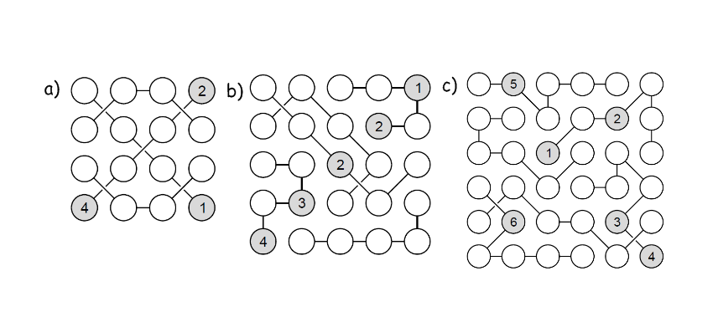
Outcome FM30.2 Practice #3
- Solve the following strimko puzzles

- There are three switches downstairs. Each corresponds to one of the three light bulbs in the attic. You can turn the switches on and off and leave them in any position.
How would you identify which switch corresponds to which light bulb, if you are only allowed one trip upstairs?

- Four tasmanian camels traveling on a very narrow ledge encounter four tasmanian camels coming the other way. As everyone knows, tasmanian camels never go backwards, especially when on a precarious ledge. The camels will climb over each other, but only if there is a camel sized space on the other side. The camels didn't see each other until there was only exactly one camel's width between the two groups.
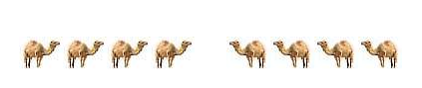
How can all camels pass, allowing both groups to go on their way, without any camel reversing?

- Cathy has six pairs of black socks and six pairs of white socks in her drawer. In complete darkness, and without looking, how many socks must she take from the drawer in order to be sure to get a pair that match?

- Mary's mum has four children. The first child is called April. The second May. The third June. What is the name of the fourth child?
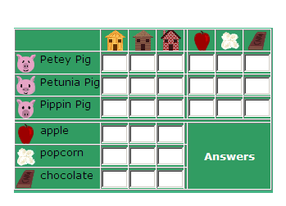
- Three little pigs, who each lived in a different type of house, handed out treats for Halloween. Use the clues to figure out which pig lived in each house, and what type of treat each pig handed out.
Clues:
1) Petey Pig did not hand out popcorn.
2) Pippin Pig does not live in the wood house.
3) The pig that lives in the straw house, handed out
popcorn.
4) Petunia Pig handed out apples.
5) The pig who handed out chocolate, does not live
in the brick house.

7. Solve the following logic problem
A) The astronaut will depart earlier than the commuter who rides a skateboard.
B) Either the commuter who rides a segway or the commuter who rides a skateboard is Kaylin.
C) The commuter who rides a segway is not Kayla.
D) The metalworker is not Wendy or Kayla.
E) The commuter who rides a skateboard is not the metalworker.
F) Of the commuter who rides a scooter and Kaylin, one will depart at 1:30pm and the other is the metalworker.
G) The person whose flight departs at 6:30am doesn't ride a scooter.
H) The metalworker will depart later than Anya.
I) The politician is not Wendy.
J) The person whose flight departs at 3:00pm is the politician.
K) The person whose flight departs at 6:30am is Anya.
L) The commuter who rides a 10-speed bike is not the astronaut.
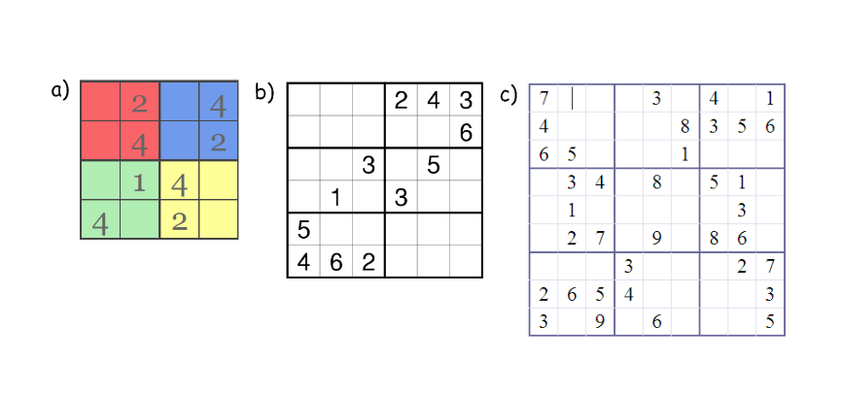
M) The commuter who rides a segway is not Anya or Wendy.

- Solve the following Sudoku puzzles

- Create a short logic problem. You must have at least 3 people/places/things/etc. and at least 3 clues. Solve your problem.

Answers
Practice #1
1a) Hyp: I am swimming in the ocean Con: I am swimming in salt water
b)True
If I am swimming in salt water then I am swimming in the ocean. False ie. some swimming pools are salt water
2a) Hyp: A number is divisible by 4 Con: It is divisible by 2
b)True
If a number is divisible by 2 then it is divisible by 4. False; ie. 6 is divisible by 2 but not 4
3a) If a triangle is equilateral then it has three equal sides.
b)If a triangle has three equal sides then it is equilateral
True
Yes, because both the conditional statement and converse are true.
4a) If we cannot get what we like then let us like what we can get.
b)Hyp: We cannot get what we like Con: Let us like what we can get.
5a) False
b)If the final digit of a number is 0 then it is divisible by 5
True; All numbers that end in 5 or 0 are divisible by 5
6a) It is not biconditional; If you live in North America you may also live in the United States or Mexico
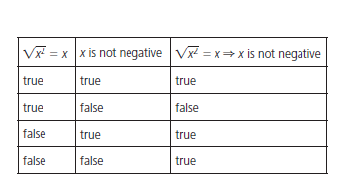
b)Biconditional; You live in the capital of Canada if and only if you live in Ottawa.
7) biconditional ie:

8a) If a glass is half-empty then the glass is half full. Biconditional: A glass is half empty if and only if the glass is half full
b)If it is a rhombus then it has equal opposite angles; not biconditional; ie: a rectangle has equal opposite angles but is not a rhombus
If it is a repeating decimal then it can be written as a fraction. Not biconditional; ie: the fraction ½ is not a repeating decimal.
9a) If your pet is a dog then it barks. It is not biconditional
b)If your pet wags its tail then it is a dog. It is not biconditional
10a) True b) True
11) ie. If it is December, then it is winter. This is not biconditional; January is also in winter
Ie. If a number is even, then it is divisible by 2. This is biconditional. A number is even if and only if it is divisible by 2.
12) Assume that the hypothesis is true. You then need to determine if the conclusion that follows is true or false. If the conclusion is true, then the conditional statement is true. If the conclusion is false, then the conditional statement is false.
13) A biconditional statement is a statement in which both the original conditional statement and its converse are always true. Combine both the statement and its converse using “if and only if.” For example: A number is divisible by 2 if and only if it is even.

Practice #2
1a) Converse: If you are looking in a dictionary, then you find success before word
Inverse: If you do not find success before work, then you are not looking in a dictionary
Contrapositive: If you are not looking in a dictionary, then you will not find success before work
b)Converse: If you can drive then you are over 16
Inverse: If you are not over 16 then you can not drive
Contrapositive: If you can not drive then you are not over 16
Converse: If a quadrilateral’s diagonals are perpendicular then it is a square
Inverse: If the quadrilateral is not a square then the diagonals are not perpendicular
Contrapositive: If a quadrilateral’s diagonals are not perpendicular then it is not a square
Converse: If 2n is an even number then n is a natural number
Inverse: If n is not a natural number then 2n is not an even number
Contrapositive: If 2n is not an even number, then n is not a natural number
2a) Converse: If an animal is a giraffe then it has a long neck
Contrapositive: If an animal is not a giraffe then it will not have a long neck
b)No; ostriches and llamas have long necks\
3a) Converse: If a polygon is a pentagon then it has five sides
Contrapositive: If a polygon is not a pentagon then it does not have five sides
b)Yes, the definition of a pentagon is it has five sides.
4a) Disagree; (-5)² = 25
b)If x = 5 then x² = 25; True
If x² is not 25 then x is not 5; True
If x is not 5 then x² is not 25; False; x could be -5
5a) i) true ii) If you are in Alberta, then you are in Calgary; False
iii)If you are not in Calgary then you are not in Alberta; False
iv)If you are not in Alberta, then you are not in Calgary; True
v)Counterexample for iii and iv could be Red Deer
b)i)True ii) If a puppy is not female then it is male; True
iii) If a puppy is not male then it is female; True
vi)If a puppy is female then it is not male; True
i) True ii) If the SK Roughriders are number 1 in the West then they won every game this season; False iii) If the SK Roughriders do not win every game this season, then they will not be number 1 in the West; False iv) If the SK Roughriders are not number 1 in the West then they will not win every game this season; True v) counterexample for ii – they might finish with a few losses and still be first; for iii – they could still finish in first if they lose a few games
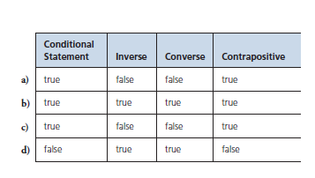
i) False ii) If an integer is positive then it is not negative; true iii) If an integer is negative then it is not positive; true iv) If an integer is not positive then it is negative; false v) counterexample for i) and iv) is zero
6)

7a) They are either both true or both false
b)They are either both true or both false
8a) ie. No conclusion
b)Ie. No conclusion
9a) Converse: If a line has a y-intercept of 2 then the equation of the line is y = 5x + 2
Inverse: If the equation of a line is not y = 5x + 2 then the y-intercept is not 2
Contrapositive: If a line does not have a y-intercept of 2 then the equation of the line is not y = 5x + 2
b)Converse: False; ie. equation could be y= 3x + 2
Inverse: False, ie. equation could be y = 3x + 2
Contrapositive: True
10) ie. It is biconditional
11a) i) False; a pin cannot burst a hot air balloon ii) If a pin can burst the Moon then the Moon is a balloon; False; A pin can burst a bubble iii) If the Moon is not a balloon, then a pin cannot burst the moon; False; the Moon could be a bubble; iv) If a pin cannot burst the Moon then the Moon is not a balloon; False; the Moon could be a hot air balloon
b) i)True ii) If –x is a positive number then x is negative number; true iii) If x is not a negative number then –x is not a positive number; true iv) If –x is not a positive number then x is not a negative number; true
c) i) true ii) If a number is positive then it is a perfect square; false ie. 10 is not a perfect square iii) If a number is not a perfect square then it is not positive; false; 10 is positive but not a perfect square iv) If a number is not positive then it is not a perfect square; true
d) i) true ii) If an number can be expressed as a fraction then it can be expressed as a terminating decimal; false 1/3 is repeating decimal iii) If a number can not be expressed as a terminating decimal then it can not be expressed as a fraction; false 0.33333 can be expressed as 1/3 iv) If a number can not be expressed as a fraction then it can not be expressed as a terminating decimal; true
e) i) true ii) If a graph is a parabola then the equation of the function is f(x) = 5x² + 10x + 3; false; it could by y = x² iii) If the equation of a function is not f(x) = 5x² + 10x + 3 then it’s graph is not a parabola. False; the equation could be y = x² iv) If the graph is not a parabola then the equation of the function is not f(x) = 5x² + 10x + 3; true
f) i) False; it could be -2. ii) If a number is a whole number then it is an integer; true iii) If a number is not an integer then it is not a whole number; true iv) If a number is not a whole number then it is not an integer; false; could be -2
g) i) true ii) If I am old enough to vote then I am 18; false I could be 19 iii) If I am not 18 then I am not old enough to vote; false; I could be 19 iv) If I am not old enough to vote the I am not 18; true
h) i) False; I might not like hockey ii) If I enjoy hockey then I am Canadian; false I could be Swedish and some enjoy hockey iii) If I am not Canadian then I do not enjoy hockey; false I might be Swedish iv) If I do not enjoy hockey then I am not Canadian; false I might be Canadian who doesn’t like hockey
12a) ie. The contrapositive assumes as its hypothesis that the original conclusion is false, which means that the original hypothesis must also not be true. If the original hypothesis is not true, then the conditional statement must be false.
Ie. The inverse of a statement is the contrapositive of the statement’s converse.
13) ie. If you are tall, then you like chocolate. Contrapositive: If you do not like chocolate then you are not tall. This is false. I am tall and do not like chocolate
14) ie. If a traffic light is green, it is not red. Contrapositive: If a traffic light is red, it is not green. This is true: A traffic light can not be two colours
15) ie. If it is Saturday, then it is the weekend. Inverse: If it is not Saturday, then it is not the weekend. Converse: If it is the weekend, then it is Saturday.
16) ie. If a polygon has six sides, then it is a hexagon. Inverse: If a polygon does not have six sides, then it is not a hexagon. Converse: If a polygon is a hexagon, then it has six sides.
17) In the following table, p represents the hypothesis and q represents a conclusion.
Type of Statement | Conditional Statement | Converse | Inverse | Contrapositive
How to Create Statement | The truth of p implies the truth of q | Switch p and q | Negate p and q | Negate and switch p and q
Written in Logic Notation | $p⇒q$ | $$q⇒p$$ | $$¬p⇒¬q$$ | $$¬q⇒¬p$$
Example | If a bird quacks, then it is a duck | If a bird is a duck, then it quacks | If a bird does not quack, then it is not a duck | If a bird is not a duck, then it does not quack
Practice #3
1a) 3 1 4 2 b) 5 2 4 3 1 c) 1 5 2 3 4 6
2 4 1 3 3 4 1 2 5 3 1 6 4 2 5
1 3 2 4 1 5 2 4 3 6 4 1 2 5 3
4 2 3 1 2 3 5 1 4 4 3 5 6 1 2
4 1 3 5 2 2 6 4 5 3 1
5 2 3 1 6 4
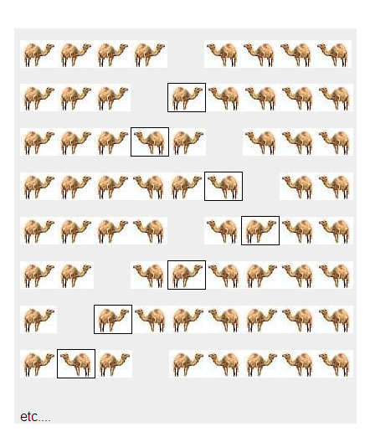
2) Keep the first bulb switched on for a few minutes. It gets warm, right? So all you have to do then is…switch it off, switch another one on, walk into the room with bulbs, touch them and tell which one was switched on as the first one (the warm one) and the others can be easily identified.
3)

4) Socks do not come in left and right, so any black pair will pair with any other black and any white will pair with any other white. If you have three socks and they are either coloured black or white, then you will have at least two socks of the same colour, giving you one matching pair
5) Mary. Mary’s mothers fourth child was Mary herself
6) Petey Pig lives in the wood house and handed out chocolate for Halloween. Petunia Pig lives in the brick house, and handed out apples for Halloween. Pippin Pig lives in the straw house, and handed out popcorn for Halloween. The LOGIC behind the answers: Petey Pig did not hand out popcorn (clue 1) or apples (clue 4), so Petey Pig handed out chocolate. Petey Pig did not live in the straw house (clue 3) , or the brick house (clue 5), so he lived in the wood house. Petunia Pig handed out apples (clue 4), so Pippin Pig must have handed out popcorn. Then Pippin Pig must live in the straw house (clue 3), and Petunia must live in the brick house.
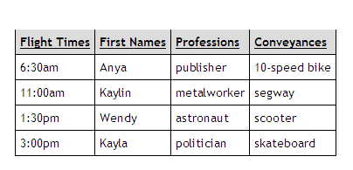
7)

8)

1 3 1 5 6 8 2 6 5 9
3 1 3 2 4 5 1 9 1 2 7
2 4 6 1 3 9 4 2 7 8
2 3 6 5 2 4 9 7 6 2
3 1 8 6 5 2 4 7 9
3 1 4 6 2 5 1 3 4
1 3 5 1 4 8 5 9 6
1 7 9 8
7 8 2 1 4

9) ie. Abby, Bonnie and Cara are married to Frank, George and Harry (in no particular order). One couple has a dog, one a cat, and one a fish. Determine who is married to who and what pet they have.
Clue 1: Abby is not married to Frank
Clue 2: Bonnie and Harry are the only siblings
Clue 3: Bonnie is friend’s with the dog’s owner
Clue 4: The cat owner is a brother to Frank’s wife
Clue 5: Bonnie and Cara have never met.
Solution: Abby is married to George and they have a dog; Bonnie is married to Frank and they have a fish; Cara is married to Harry and they have a cat.

Outcome FM30-3
 | OUTCOMES | ASSESSMENT RUBRICS
FM30.3 Demonstrate understanding of set theory and its applications.
Level  Criteria | Intervention 1  Spend some extra time with the criteria and ask for help. | Instructional 2  Good start. You are beginning to make sense of this on your own. You are consistent with the basic learning goals for this outcome. | Independence 3  You did it and you did it on your own. You are able to complete the processes for this outcome. Your work is thorough and consistently accurate. | Mastery 4  Great work! This is going extra well for you. You have understood the outcome, are able to explain your strategies and apply these to situations. Your work is always accurate.
Solve problems that involve the application of set  theory. | I need more help with becoming consistent with the criteria. | Given a Venn diagram, I can answer questions pertaining to the empty set, disjoint sets, subsets, universal sets, union, intersection. | I can create a Venn diagram for two data sets and analyze the results  I can determine the complement of a set | I can do an analysis of solutions for errors  I can create a Venn diagram for three data sets and analyze the results.  I can demonstrate my understanding of set theory
Types of Set and Set Notation
- Set – A collection of distinguishable objects, for example, the set of whole numbers is W = {0, 1, 2, 3…}
- Element – An object in a set; for example, 3 is an element of D, the set of digits
- Universal Set – A set of all the elements under consideration for a particular context (also called the sample space); for example, the universal set of digits is D = {0, 1, 2, 3, 4, 5, 6, 7, 8, 9}
- Subset – A set whose elements all belong to another set; for example the set of odd digits, O = {1, 3, 5, 7, 9} is a subset of D, the set of digits. In set notation, this relationship is written as O ⊂ D
- Complement – All the elements of a universal set that do not belong to a subset of it; for example, O’ = {0, 2, 4, 6, 8} is the complement of O = {1, 3, 5, 7, 9}, a subset of the Universal set of digits, D. The complement is denoted with a prime sign, O’.
- Empty Set – A set with no elements; for example, the set of odd numbers divisible by 2 is the empty set. The empty set is denoted by { } or ⊘
- Disjoint – Two or more sets having no elements in common; for example, the set of even numbers and the set of odd numbers are disjoint.
- Summary of Notation:
- Sets are defined using brackets. For example, to define the universal set of the numbers 1, 2 and 3, list its elements: U = {1, 2, 3}
- To define the set A that has the numbers 1 and 2 as elements: A = {1, 2}
- All elements of A are also elements of U, so A is a subset of U: A ⊂ U
- The set A’, the complement of A, can be defined as A’ = {3}
- To define the set B, a subset of U that contains the number 4: B = { } or B = ⊘; B ⊂ U
- The phrase “from 1 to 5” means from 1 to 5 inclusive
- In set notation, the number of elements of the set X is written as n(X). For example, if the set X is defined as the set of numbers from 1 to 5: X = {1, 2, 3, 4, 5} and n(X) = 5
- Infinite Set – A set with an infinite number of elements; for example, the set of natural numbers, N = {1, 2, 3, …} is infinite
- Finite Set – A set with a countable number of elements, for example, the set of even numbers less than 10, E = {2, 4, 6, 8}, is finite
- You can represent a set of elements by:
- Listing the elements; for example, A = {1, 2, 3, 4, 5}
- Using words or a sentence, for example, A = {all integers greater than 0 and less than 6}
- Using set notation; for example A = $\left\{x | 0<x<6,x∈I\right\}$
- You can show how sets and their subsets are related using Venn Diagrams. Venn diagrams do not usually show the relative sizes of the sets.
- You can often separate a universal set into subsets, in more than one correct way.
- Sets are equal if they contain exactly the same elements, even if the elements are listed in different orders.
- You may not be able to count all the elements in a very large or infinite set, such as the set of real numbers
- The sum of the number of elements in a set and its complement is equal to the number of elements in the universal set: n(A) + n(A’) = n(U)
- When two sets A and B are disjoint, n(A or B) = n(A) + n(B)

Outcome FM30-3 Practice #1
- Draw a Venn diagram to represent these sets:
- The universal set U = {natural numbers from 1 to 40 inclusive}
- E = {multiples of 8}
- F = {multiples of 4}
- S = {multiples of 17}
- List the disjoint subsets, if there are any.
- Is each statement true or false? Explain
- E ⊂ F ii) F ⊂ E iii) E ⊂ E
iv) F’ = {odd numbers from 1 to 40}
v) in this example, the set of natural numbers from 41 to 50 is { }

- The universal set, U, is a standard deck of 52 cards.
- Represent the following sets and subsets using a Venn diagram
- B = {black cards}
- R = {red cards}
- S = {spades}
- H = {hearts}
- C = {clubs}
- D = {diamonds}
- List all defined sets that are subsets of B
- List all defined sets that are subsets of R
- Are sets S and C disjoint? Explain.
- Suppose you draw one card from the deck. Are the events drawing a heart and drawing a diamond mutually exclusive? Explain.
- Is the following statement correct? n(S or D) = n(S) + n(D) Provide your reasoning. Determine the value of n(S or D).
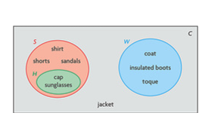
- Kayley drew this Venn diagram.
- Describe what sets C, S, W and H
Might represent
- Where would Kayley put
Running shoes?
- Is S’ equal to W? Explain.
- List the disjoint sets, if there are any.
- Categorize the items another way.

- Consider the following information:
- The universal set U = {set of all natural numbers from 1 to 10 000 inclusive}
- Set X, which is a subset of U
- Set Y, which is a subset of U
- n(X) = 4500
Determine n(Y), if possible. If it is not possible, explain why.

- Determine n(U), the universal set, given n(X) = 34 and n(X’) = 42

- Organize the following sets of numbers in a Venn diagram:
- U = {integers from -10 to 10}
- A = {positive integers from 1 to 10 inclusive}
- B = {negative integers from -10 to -1 inclusive}
- List the disjoint subsets, if there are any
- Is each statement true or false? Explain.
i) A ⊂ B ii) B ⊂ A iii) A’ = B iv) n(A) = n(B)
v) For set U, the set of integers from -20 to -15 is { }

- Abby claims that the ⊂ sign for sets is similar to the $≤$ sign for numbers. Explain whether you agree or disagree.

- Organize the following sets in a Venn diagram:
- The universal set R = {real numbers}
- N = {natural numbers}
- W = {whole numbers}
- I = {integers}
- Q = {rational numbers}
- $\overline{Q}$ = {irrational numbers}
- Identify the complement of each set.
- Identify any disjoint sets
- Are Q’ and $\overline{Q}$ equal? Explain.
- Of which sets is N a subset?
- Joey drew a Venn diagram to show the sets in this question. In his diagram, the area of set Q was larger than the area of set $\overline{Q}$. Can you conclude that Q has more elements than $\overline{Q}$? Explain.

- Explain how to determine each of the following, and given an example.
- Whether one set is a subset of another
- Whether one set is a complement of another

- Do you agree or disagree with the following explanation? Explain. Consider the set U = {natural numbers from 20 to 30}. One empty subset of U is the set of natural numbers from 1 to 19. Another empty subset is the natural numbers greater than 21. Therefore U has two different empty subsets, not one.

- How can you represent the elements in a set?

Exploring Relationships between Sets
- Sets that are not disjoint share common elements
- Each area of a Venn diagram represents something different
- When two non-disjoint sets are represented in a Venn diagram, you can count the elements in both sets by counting the elements in each region of the diagram just once.
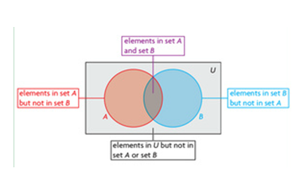
- Each element in a universal set appears only once in a Venn diagram.
- If an element occurs in more than one set, it is placed in the area of the Venn diagram where the sets overlap

Outcome FM30-3 Practice #2
- Consider the following sets:
- U = {2, 3, 4, 6, 8, 9, 10, 12, 14, 15}
- A = {3, 6, 9, 12, 15}
- B = {2, 4, 6, 8, 10, 12, 14}
- Illustrate these sets using a Venn diagram
- Determine the number of elements
- In set A ii) in set A but not in set B iii) in set B
iv) in set B but not in set A v) in set A and set B
vi) in set A or set B vii) in A’
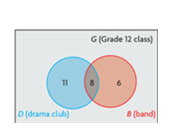
- There are 38 students in a Grade 12 class. The number of
Students in the drama club and the band are illustrated in
The Venn diagram. Use the diagram to answer the
Following questions.
- How many students are in both the drama club and the band?
- How many students are in the drama club but not in the band?
- How many are in the band but not the drama club?
- How many students are in the drama club? How many are in the band?
- How many students are in at least one of the drama club or the band?
- How many students are in neither the drama club nor the band?

- Anna surveyed 45 students about their favorite sports. She recorded her results:
Favorite Sports | Number of Students
Hockey | 20
Soccer | 14
Neither hockey nor soccer | 16
- Determine how many students like hockey and soccer
- Determine how many students like only hockey or only soccer
- Draw and label a Venn diagram to show the data

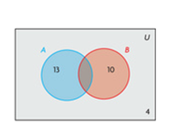
- There are 55 guests at a ski resort in BC. Of these guests, 25 plan to go skiing and 32 plan to go snowboarding. There are 9 guests who do not plan to ski or snowboard.
- Determine how many guests plan to ski and snowboard. Explain.
- Determine how many guests plan to only ski.
- Determine how many guests plan to only snowboard.

- Ryan drew the following Venn diagram incorrectly. There are
25 items in the universal set, U, and 4 items are not in set A
Or set B.
- Determine n(A and B), n(A only), and n(B only)
- Redraw Ryan’s Venn diagram with the data you determined
In part a)

Intersection and Union of Two Sets
- Intersection – The set of elements that are common to two or more sets. In set notation, A ∩ B denotes the intersection of sets A and B; for example, if A = {1, 2, 3} and B = {3, 4, 5} then A ∩ B= {3} It is represented by the region of overlap on a Venn diagram. It is indicated by the word “and”
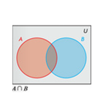
- Union – The set of all elements in two or more sets; in set notation, A ∪ B denotes the union of sets A and B, for example, if A = {1, 2, 3} and B = {3, 4, 5} then A ∪ B = {1, 2, 3, 4, 5}. It is represented by the entire region of these sets on a Venn diagram. It is indicated by the word “or”
- In set notation, A ∩ B is read as “intersection of A and B.” It denotes the
elements that are common to A and B. The intersection is the region where
the two sets overlap in the Venn diagram below.
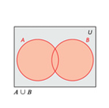

A ∪ B is read as “union of A and B.” It denotes all elements that belong to at least one of A or B. The union is the red region in the Venn diagram below.

- A\B is read as “A minus B.” It denotes the set of elements that are in set A but not in set B. It is the red region in each Venn diagram below.\
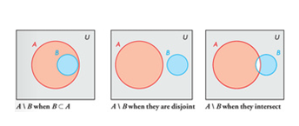
- Principle of Inclusion and Exclusion – the number of elements in the union of two sets is equal to the sum of the number of elements in each set, less the number of elements in both sets; using set notation, this is written as n(A ∪ B) = n(A) + n(B) – n(A ∩ B)
- If two sets, A and B, are disjoint, they contain no common elements: n(A ∩ B) = 0 and
n(A ∪ B) = n(A) + n(B)
- Elements that are in set A but not in set B are expressed as A\B. The number of elements in A and B, n(A ∪ B), can also be determined as follows: n(A ∪ B) = n(A\B) + n(B\A) + n(A ∩ B)
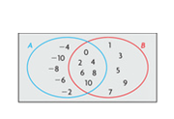
Outcome FM30-3 Practice #3

- Consider the following Venn diagram
- Determine A ∪ B
- Determine n(A ∪ B)
- Determine A ∩ B
- Determine n(A ∩ B)

- Consider the following two sets:
- A = {-10, -8, -6, -4, -2, 0, 2, 4, 6, 8, 10}
- C = {2, 4, 6, 8, 10, 12, 14, 16}
- Determine A ∪ C, n(A ∪ C), A ∩ C, n(A ∩ C)
- Draw a Venn diagram to show these two sets

- Animals that are native to Africa include the lion, camel, giraffe, hippopotamus, and elephant. Animals that are native to Asia include the elephant, tiger, takin, and camel
- Draw a Venn diagram to show these two sets of animals
- Determine the union and intersection of these two sets

- Ryan asked 25 people at a mystery convention if they liked Sherlock Holmes or Hercule Poirot.
- 4 people did not like either detective
- 16 people liked Sherlock Holmes
- 11 people liked Hercule Poirot
Determine how many people liked both detectives, how many liked only Sherlock Holmes, and how many liked only Hercule Poirot.

- John asked 26 people at a gym if they liked to ski or swim.
- 5 people did not like to do either sport
- 19 people liked to ski
- 14 people liked to swim
Determine how many people liked to ski and swim

- Mark surveyed 100 people at a local donut shop.
- 65 people ordered coffee
- 45 people ordered a donut
- 10 people ordered something else
Mark wants to determine how many people ordered coffee and a donut. Determine this.

- Jordan is a real estate agent. He asked 54 clients where they live now.
- 31 people own their own home
- 30 people live in a condominium
- 9 people rent their house
Determine how many people own the condominium in which they live

- Cara asked 32 people what type of television show they liked
- 13 people like reality shows by not contest shows
- 9 people like contest shows but not reality shows
- 4 people like neither type of show
Determine how many people like both types of shows

- Megan solved the following problem:
A total of 48 students were asked how they got to school
- 31 students drive a car
- 16 students take the bus
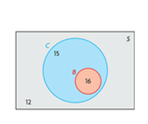
- 12 students do not drive a car or take a bus
- Some students drive a car or take a bus
Megan’s solution:
The total of the three numbers is 59. So, I knew that the region for students who take a bus overlaps the region for students who drive a car. I drew a Venn diagram with 31 students in the car region and 16 students in the bus region. 15 students drive a car but do not take a bus, 12 students do neither. So, 27 students do not take a bus.
Is Megan correct? Justify your answer.
- Given:
n(A) + n(B) = n(A ∪ B) and
n(A) + n(C) > n(A ∪ C)
- Which sets do you know are disjoint?
- Which sets do you know intersect?
- Are there any sets that could either be disjoint or intersect? If so, which sets? Explain.

- Which is more like the addition of two numbers: the union of two sets or the intersection of two sets? Explain.

- The Arctic Winter Games include alpine skiing, cross-country skiing, free-style skiing, badminton, basketball, snowshoe biathlon, ski biathlon, curling, dog mushing, figure skating, gymnastics, hockey, indoor soccer, snowboarding, snowshoeing, speed skating, table tennis, volleyball, and wrestling. There are also two categories of sports that are unique to the Arctic, called Arctic Sports and Dene Games.
- Determine a way to sort the games into sets and subsets
- List each set and subset
- Draw a Venn diagram to illustrate the sets
- Compare your results with your classmates’ results. Is there more than one way to sort the games?

- What is meant by the intersection and union of two sets?

- How can you determine the number of elements in the union of two sets?

Applications of Set Theory
- Set theory is useful for solving many types of problems, including Internet searches, database queries, data analyses, games and puzzles
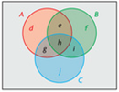
- To represent three intersecting sets with a Venn diagram, use three intersecting circles. For example, in the following Venn diagram,
- A ∩ B ∩ C is represented by region h
- A ∩ B is represented by the union of regions e and h
- A ∩ C is represented by the union of regions g and h
- B ∩ C is represented by the union of regions h and i
Each region of a Venn diagram contains elements that occur only in
That particular region
- You can use the Principle of Inclusion and Exclusion to determine the number of elements in the union of three sets:
n(A ∪ B ∪ C) = n(A) + n(B) + n(C) – n(A ∩ B) – n(A ∩ C) – n(B ∩ C) + n(A ∩ B ∩ C)
- You can use concepts related to sets to search for websites on the Internet:
- Put an exact phrase in quotation marks
- Connect words or phrases with “and” to search for sites that contain both. The word “and” represents the intersection of two or more sets
- Connect words or phrases with “or” to search for sites that contain either one or the other, or both. The word “or” represents the union of two or more sets.
- When solving a puzzle or problem, it is often useful to visualize the problem. First identify which sets are defined by the context. Then identify how the sets overlap. Finally, identify regions of the overlaps that are of interest in the puzzle or problem. It is often advisable to consider how much is known about each region, and use the information about the region that is most known to deduce information about regions that are less well known. A systematic approach will result in answers that are easier to verify.

Outcome FM30-3 Practice #4
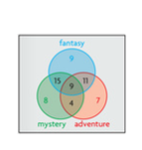
- The members of a book club read fantasy, mystery, and adventure books. The following Venn diagram shows the types of books that the members like:
Use the diagram to determine each amount below:
- n((F ∪ M)\A)
- n((A ∪ F)\M)
- n((F ∪ A) ∪ (F ∪ M))
- n(A\F\M)

- Jami is planning a winter ski holiday in the Canadian Rockies. Give four words or phrases that Jami might use to search for information on the Internet. Use set theory to explain how quotation marks and the word “and” could help her refine her search

- A total of 58 teens attended a sports camp to train in at least one of three sports: swimming, cycling, and running.

- 35 trained in swimming, 32 trained in cycling, and 38 trained in running
- 9 trained in swimming and cycling, but not in running
- 11 trained in cycling and running, but not in swimming
- 13 trained in swimming and running, but not in cycling
A triathlon consists of swimming, cycling, and running. How many teens might be training for the upcoming triathlon?

- Travis wants to buy a specific model of car. He goes into a car dealership in Prince Albert, but the dealer does not have this model. The dealer searches the database and discovers that a Moose Jaw dealership has four models, a Saskatoon dealership has six models, a Shellbrook dealership has five models, and a Melfort dealership has two models.
- What other attributes can the dealer use to narrow down the choices?
- How might the dealer prioritize the search?

- Wilson is searching online for information about local colleges and their athletics programs. He is interested in colleges in Edmonton or Calgary, but not universities.
- His first search term is colleges. How can he categorize colleges in Edmonton or Calgary?
- Since Wilson is interested in colleges and their athletic programs, should he use “and” or “or” to connect them?
- Should Wilson use “and” or “or” to search for one or the other city?
- To exclude universities, Wilson used the notation –university. The minus sign means “not.” What might Wilson’s search instructions look like?
- Try searching for the information that Wilson wants. What is the smallest number of hits you found?
- Represent your results in a Venn diagram.

- A small web-hosting service specializes in websites involving outdoor activities.
- 35 sites involve boats: 20 of these sites deal with fishing boats and 25 deal with power boats
- 21 sites involve fishing: these sites include all the sites that deal with fishing boats, plus 3 sites deal with fly fishing.
- How many sites from this service would appear in a search for fishing boats? Explain.
- Why might a search for fishing and boats turn up a different result that a search for “fishing boats”?
- If the only search word was fishing, how many results would not involve boats?

- John was asked to solve the following problem:
- 240 students were surveyed to determine which restaurants they like.
- 90 like Chicken and More
- 90 like Fast Pizza
- 90 like Gigantic Burger
- 37 like Chicken and More and Fast Pizza, but not Gigantic Burger
- 19 like Chicken and More and Gigantic Burger, but not Fast Pizza
- 11 like Fast Pizza and Gigantic Burger, but not Chicken and More
- 13 like all three restaurants
How many students do not like any of these restaurants?

John solved the problem as follows:
I added up the first six results of the survey and subtracted the number of students who ate at all three restaurants. Then I subtracted this value from the total number of students surveyed.
90 + 90 + 90 + 37 + 19 + 11 – 13 = 324
240 – 324 = -84
This answer is not possible, so I knew that I made an error.
What error did John make? What is the correct answer?

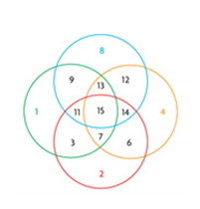
- James searched for “string bean” on the Internet with quotation marks. Ella searched for string bean without quotation marks. Did they get the same results? Explain using set theory and a Venn diagram.

- Explain why the following Venn diagram is not
adequate to show four intersecting sets:

Answers
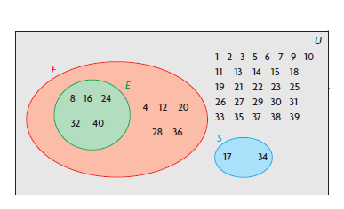
Practice #1
- a) E and S; F and S
b)i) true; multiples of 8 are also multiples of 4
ii) false; not all multiples of 4 are multiples of 8
iii) true; all mulitples of 8 are multiples of 8
iv)false; F’ = {all numbers from 1 to 40 that are
not multiples of 4}
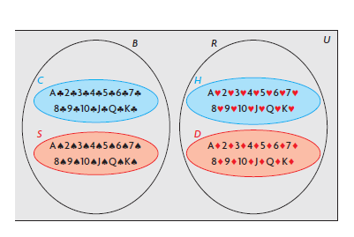
v)true; the universal set includes natural
numbers from 1 to 40
2) b) C and S c) H and D
d) Yes, a card cannot be both a spade and club
e) Yes, you cannot draw a card that is a heart
and a diamond at the same time
f)yes; n(S or D) = 26; n(S) = 13, n(D) = 13; 13+13=26

3)a) C = {all clothes}, S = {summer clothes}, W = {winter clothes}, H = {summer headgear}
b) C c) No; S’ includes jacket, but W does not d) S and W; H and W
e)C = {clothes}, H = {headgear} = {cap, sunglasses, toque}
B = {clothing for body} = {shirt, shorts, coat, jacket} F = {footwear} = {sandles, insulated boots}
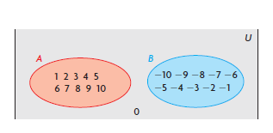
4) Not possible; there may be some elements that are in both X and Y
5) 76
6) a) A and B b) i) false; 1 is not in B
ii) false; -1 is not in A iii) false; 0 is in A’ but not B
iv)true; n(A) = 10, n(B) = 10 v) true; no integer from -20
to -15 is in U
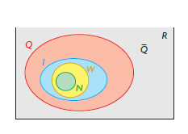
7) Agree, The number of elements in a subset must be equal to or less than the number of elements in the set.
8) a) N’ is set of all non-natural numbers; W’ is set of all non whole numbers; I’ is set of all non integer numbers; Q’ is $\overline{Q}$; $\overline{Q}$’ is Q’
b) N and $\overline{Q}$, W and $\overline{Q}$, I and $\overline{Q}$, Q and $\overline{Q}$ c) Yes
d) W, I , Q, R e) No, the area of a region in a Venn
diagram is not related to the number of elements in the set
9a) A⊂B if all elements of A are also in B. For example, all weekdays are also days of the week,
So weekdays is a subset of the days of the week b) A’ consists of all the elements in the
Universal set but not in A. For example, all days of the week that are not weekdays are
Weekend days. So weekend days is the complement of weekdays
10) Disagree; since both the subsets are empty, they both contain the same elements and are
Therefore the same subset.
11) If the set is finite, you can do the following:
* Describe the set. For example, E = {even numbers between 2 and 10}
* List the elements. For example, the set of days that begin with T can be represented as
T = {Thursday, Tuesday}
- Use set notation: For example, the set of positive integers less than 1000:
$$P=\{\left.x\right|0<x<1000,x∈I\}$$
If the set is infinite, you can either describe it or use set notation. You can choose any letter to name a set.
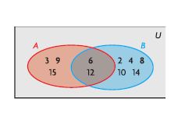
Practice #2
1a) b) i) 5 ii) 3 iii) 7 iv) 5 v) 2 vi) 10 vii) 5

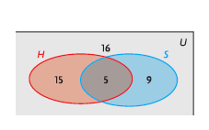
2a) 8 b) 11 c) 6 d) 19;14 e) 25 f) 13
3a) 5 b) 24 c)
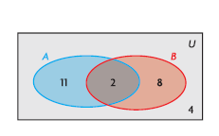

4a) 11 b) 14 c) 21
5a) n(A and B) = 2; n(A only) = 11; n(B only) = 8 b)

Practice #3
1a) {-10, -8, -6, -4, -2, 0, 1, 2, 3, 4, 5, 6, 7, 8, 9, 10} b) 16 c) {0, 2, 4, 6, 8, 10} d) 6
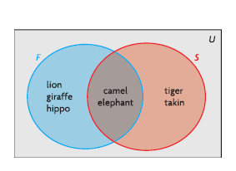
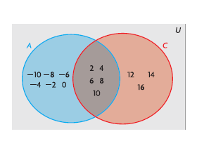
2a) A∪C = {-10, -8, -6, -4, -2, 0, 2, 4, 6, 8, 10, 12, 14, 16}; n(A∪C) = 14
A∩C = {2, 4, 6, 8, 10}; n(A∩C) = 5
2b) 3a)

3b) F∪S = {lion, giraffe, hippo, camel, elephant, tiger, takin}; F∩S = {camel, elephant}
4) Both 6; Sherlock Holmes 10; Hercule Poirot 5
5) 12
6) 20
7) 16
8) 6
9) No, some students take a bus but do not drive a car. So those regions should only be partially overlapping. The total number of students in Megan’s solution is only 43
10a) A and B b) A and C c) Yes; B and C. C intersecting A and A and B being disjoint says nothing about the intersection, if any of B and C
11) The union of two sets is more like the addition of two numbers because all the elements of each set are counted together, instead of just those present in both sets.
12a) indoor, outdoor, races
12b) U = {all sports}
I = {indoor sports} = {badminton, basketball, curling, figure skaing, gymnastics, hockey, indoor soccer, speed skating, table tennis, volleyball, wrestling, Arctic sports, Dene Games}
O = {outdoor sports} = {alpine skiing, cross country skiing, freestyle skiing, snowshoe biathlon, ski biathlon, dog mushing, snowboarding, snowshoeing, Dene Games}
R = {races} = {speed skating, alpine skiing, cross country skiing, biathlon, dog mushing, snowboarding, snowshoeing}

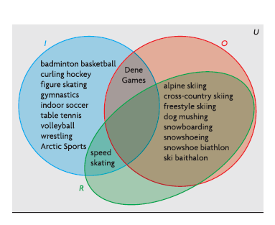
12c)

13) The intersection of two sets, A and B, consist of the elements that are common to both sets. It is represented as A∩B and is read as “A and B”. The union of two sets is the elements in the first set only, the second set only, and the intersection of both sets. It is represented as A∪B and is read as “A or B”
14) Use the Principle of Inclusion and Exclusion. n(A∪B)=n(A) + n(B) – n(A∩B)
If the sets are disjoint, the intersection is the empty set.

Practice #4
1a) 32 b) 27 c) 63 d) 7
2)ie. “Canadian Rockies”, “ski accomodations”, “weather forecast”, “Whistler”. By combining two or more of these terms, Jami can search for the intersection of webpages related to these terms. For example, “ski accomodations” and “Canadian Rockies” is more likely to give him useful information for his trip than either of those terms on its own.
3) 7
4a) ie. The dealer might use exterior colour, interior colour, or year
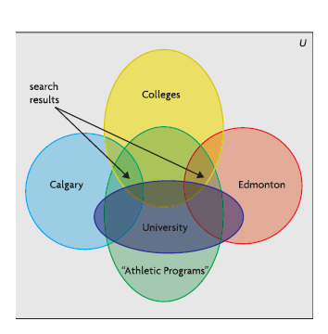
4b) ie. The dealer might prioritize the search according to options Travis wants or by the distance from where Travis lives
5a) He can search for: colleges and (Calgary or Edmonton)
b) “and” c) “or”
5d) colleges and (Calgary or Edmonton) and
“athletics programs” –university e) about 1500 f)

6a) 36; 35 with boats b) Fishing and boats will turn up sites that deal with boats and fishing, not just fishing boats c) 1
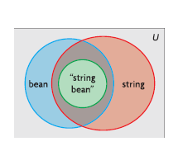
7) He counted the students who like two of the three and undercounted those that like all three. Correct solution: 90 + 90 + 90 – (37 + 13) – (19 + 13) – (11 + 13) + 13 = 177; 240 – 177 = 63
8) No they did not get the same results.
Ella got all of the James results, plus others dealing with
either string or bean, but not both.
9) Let T = {top circle}, R = {right circle}, B = {bottom circle},
L = {left circle}. There is not area representing (T∩B)\(L∪R) or (L∩R)\(T∪B)
Outcome FM30-4
OUTCOMES | ASSESSMENT RUBRICS
FM30.4 Extend understanding of odds and probability
Level  Criteria | Intervention 1  Spend some extra time with the criteria and ask for help. | Instructional 2  Good start. You are beginning to make sense of this on your own. You are consistent with the basic learning goals for this outcome. | Independence 3  You did it and you did it on your own. You are able to complete the processes for this outcome. Your work is thorough and consistently accurate. | Mastery 4  Great work! This is going extra well for you. You have understood the outcome, are able to explain your strategies and apply these to situations. Your work is always accurate.
Extend understanding of odds and probability. | I need more help with becoming consistent with the criteria. | I can express odds as a probability and vice versa. | I can solve contextual problems that involve odds and probability. | I can demonstrate my understanding of odds and probability.

Exploring Probability
- Fair Game A game in which all the players are equally likely to win; for example, tossing a coin to get heads or tails is a fair game
- Sample Space The set of all possible outcomes. For example, when rolling a six sided die, the sample space is {1, 2, 3, 4, 5, 6}
- Event The set of favourable outcomes. For example, rolling a number less than three would be {1, 2}
- Experimental Probability of an event A is represented as P(A) = $\frac{n(A)}{n(T)}$ where n(A) is the number of times event A occurred and n(T) is the total number of trials, T, in the experiment
- Theoretical Probability of event A is represented as P(A) = $\frac{n(A)}{n(S)}$ where n(A) is the number of favourable outcomes for event A, and n(S) is the total number of outcomes in the sample space, S, where all outcomes are equally likely.
- Knowing the probability of an event is useful when making decisions.
- A game is fair when all players are equally likely to win.
- An event is a collection of outcomes that satisfy a specific condition. For example, when throwing a regular die, the event, “throw an odd number” is a collection of the outcomes 1, 3, and 5.
- The probability of an event can range from 0 (impossible) to 1 (certain). You can express probability as a fraction, a decimal, or a percent
- You can use theoretical probability to determine the likelihood that an event will happen.

Outcome FM30-4 Practice #1
- A coin is tossed.
- Write out the sample space
- Write out the event that the toss is a tail

- The ten letters, A, B, C,…., H, I, J are written on individual slips of paper and placed in a hat. One letter will be drawn from the hat.
- Write out the sample space.
- Write out the event that the letter drawn is a vowel.
- Write out the event that the letter is NOT a letter in the word BEAD.
- Write out the event that the letter drawn is NOT a letter in the word DREAM.

- Lisa and Sam completed an experiment of tossing a thirty sided die forty times and the results are as follows:
6 | 19 | 23 | 15 | 12 | 5 | 23 | 8
3 | 8 | 12 | 16 | 16 | 16 | 7 | 25
2 | 25 | 26 | 12 | 21 | 11 | 16 | 22
29 | 13 | 14 | 18 | 1 | 25 | 21 | 27
19 | 13 | 26 | 7 | 27 | 9 | 8 | 30
- What was the experimental probability of tossing a 9?
- What was the experimental probability of tossing an even number?
- What was the experimental probability of tossing a number less than 15?
- What was the experimental probability of tossing a number larger than 24?
- What was the experimental probability of not tossing a number less than 7?
- What was the experimental probability of the complement of #1c?
- What was the experimental probability of tossing a 3, 14, or 27?
- What was the experimental probability of tossing a 12, 16, or 27?

- A single letter is chosen from the word ROUGHRIDERS. Find the probability that the letter chosen is
- An R
- A G
- A consonant
- Not a consonant
- An R, O, or H
- An X

- If P(A) = 7/15, find the value of the complement

- Consider each game below. Is it fair? If it is not fair, which player has the advantage? Explain.
- Matt and Pat each toss a coin. If the coins land as both heads or both tails, Matt wins. If the coins land as a head and a tail, Pat wins.
- Treena, Lana and Gina each toss a coin. If all three coins land as heads, Treena wins. If all three coins land as tails, Lana wins. Otherwise, Gina wins.
- Ann and Dan each roll a die. If the sum of the two dice is greater than 7, Ann wins. If the sum is less than 7, Dan wins. If the sum is 7, they tie.

- Evan says he has a 120% chance of making the school football team. Is this possible? Explain.
- Mike suggest playing Sasha’s game with four slips of paper, numbered 1 to 4. If Kim’s game now fair? If not, who has the advantage? Explain.
- Answer the following multiple choice questions:
i) The likelihood that an event will occur is greater than the likelihood that it won’t occur. Which probability best represents this event?
a) 0.25 b) 0.50 c) 0.75 d) 1.00
ii)If an event has a 50-50 chance of occurring, which probability best represents this situation?
a) 0.25 b) 0.50 c) 0.75 d) 1..00
iii) If you flip a coin and someone agrees to “heads you win, tails they lose” what is the probability of them winning?
a) 0.00 b) 0.25 c) 0.50 d) 1.00
iv) Which probability best represents the probability of an event that is certain to occur?
a) 0.00 b) 0.25 c) 0.75 d) 1.00
v) If the occurrence of an event is impossible, which probability best represents this situation?
a) 0.00 b) 0.25 c) 0.75 d) 1.00
vi) If the occurrence of an event is unlikely, which probability best represents this?
a) 0.00 b) 0.25 c) 0.75 d) 1.00

Probability and Odds
- Odds in Favour The ratio of the probability that an event will occur to the probability that the event will not occur, or the ratio of the number of favourable outcomes to the number of unfavourable outcomes
- Odds Against The ratio of the probability that an event will not occur to the probability that the event will occur, or the ratio of the number of unfavourable outcomes to the number of favourable outcomes.
- Complement All the elements of a universal set that do not belong to a subset of it. For example, O’ = {0, 2, 4, 6, 8} is the complement of O = {1, 3, 5, 7, 9}, a subset of the universal set of digits. The complement is denoted with a prime sign, O’
- Odds express a level of confidence about the occurrence of an event
- P(A’) is the probability of the complement of A, where P(A’) = 1 – P(A)
- If the odds in favour of an event A occurring are m:n, then the odds against event A occurring are n:m.
- If the odds in favour of event A occurring are m:n, then P(A) = $\frac{m}{m+n}$

Outcome FM30-4 Practice #2
- The odds in favour of Marcia passing her driver’s test on the first try are 5:3
- Determine the odds against Marcia passing her driver’s test
- Determine the probability that she will pass her driver’s test

- Colby has 10 coins in his pocket, and 3 of these coins are loonies. He reaches into his pocket and pulls out a coin at random.
- Determine the probability of the coin being a loonie.
- Determine the odds against the coin being a loonie.
- Lily draws a card at random from a standard deck of 52 playing cards.
- Determine the probability of the card being red.
- Determine the odds in favour of the card being red.
- Determine the odds against the card being a spade.
- Determine the probability of the card being a face card.

- Brynn notices that apple juice is on sale at a local grocery store. The last five times that apple juice was on sale, it was available only twice.
- Determine the odds in favour of apple juice being available this time.
- Determine the odds against apple juice being available this time.

- There are 30 students in Frank’s Grade 12 math class. The odds in favour of two students sharing a birthday are 7:3. Determine the probability of two students sharing a birthday.

- Janelle likes to go wall climbing with her friends. In the past, Janelle has climbed to the top of the wall 12 times in 24 attempts.
- Determine the probability of Janelle climbing to the top this time.
- Determine the odds against Janelle climbing to the top.
- The odds from part b) are called “even odds.” Explain what this term might mean.

- The weather forecaster says that there is a 60% probability of snow tomorrow. What are the odds against snow?

- About 8% of men and 0.5% of women see no difference between the colors red and green. These people are often useful in the military because they can detect khaki camouflage much better than people who do see a difference between red and green. What are the odds in favour of Allan being able to detect camouflage?

- Katy plays hockey. She has scored 4 times in 20 shots on goal. She says that the odds in favour of her scoring are 1 to 5. Is she right? Explain.

- Jason has been awarded a penalty shot in a hockey game. Jacob is the goalie. Jason has scored 5 times in his last 10 penalty shots. Jacob has blocked 8 of the last 10 penalty shots.
- Determine the odds in favour of Jason scoring, using his data
- Determine the odds in favour of Jason scoring, using Jacob’s data.
- Explain why your answers to parts a) and b) are different

- A survey in a Western Canadian city determined that the odds in favour of a person between 18 and 35 using a social networking site are 31:19. Determine the probability of a randomly selected person between 18 and 35 using a social networking site.

- The coach of a basketball team claims that, for the next game, the odds in favour of the team winning are 3:2, the odds in favour of the team losing are 1:4, and the odds against a tie are 4:1. Are these odds possible? Explain.
- Ratings for the program Show Trial indicate that 35% of the viewers are female, 65% are male, 30% are under 18, 20% are 19 to 30 years old, 10% are 30 to 45 years old, and 40% are older than 45. Suppose that someone is watching Show Trial.
- What are the odds in favour of the person being male?
- What are the odds in favour of this person being older than 45?

- In a study, 70% of the people who were vaccinated did not get sick, and 42% of the people who were not vaccinated did get sick.
- What are the odds against getting sick if you are vaccinated?
- What are the odds against getting sick if you are not vaccinated?
- Express the odds against from parts a) and b) with the same second term.
- Should you be vaccinated? Explain.

- A high school football team has the ball at the opponent’s 2 yard line. It is the third down. The team is behind by 3 points, with only one second left in the game. The players have two options:
- They can try to score a touchdown. In the past, they have succeeded 5 out of 12 times. If they score a touchdown, they will win the game.
- They can try to kick a field goal. The kicker has scored a field goal from the 20 yard or less in 5 of 6 tries. If they score a field goal, they will get 3 points and tie the game, forcing overtime.
- What are the odds in favour of each option?
- Which option should the coach choose?

- Three people are running for president of the student council. The polls show that Cole has a 45% chance of winning. Matt has a 35% chance of winning, and Kelsey has a 20% chance of winning.
- What are the odds in favour of each person winning?
- Suppose that Kelsey withdraws and offers her support to Matt. Further suppose that her supporters also switch to Matt. What are the odds in favour of Matt winning now?

- Grant is taking a self study course in fitness training. He must pay $285 to take the final exam. If he fails the exam, he must pay an additional $235 to take it again. The fitness training website lists up to date statistics on the pass:fail ratio. The odds that a person with good study habits will pass on his or her first try are 11:9. Grant can prepare for the final exam by buying three practice exams for $65.
- Should Grant buy the practice exams if he has good study habits? Justify your opinion.
- If the odds in favour of passing on the first try were 17:4, should Grant buy the practice exams? What if the odds in favour of passing were 3:7? Explain.

- A) Explain why you can express the odds against an event, A, happening as P(A’):P(A)
- Suppose that the odds in favour of an event happening are a:b. Explain how you can determine the probability of the event happening. Give an example.
- Suppose that the probability of an event happening is $\frac{a}{c}$. Explain how you can determine the odds against the event happening. Give an example.
- Do you prefer to express the likelihood that an event will happen using probability or odds? Explain why, and provide an example.

- Explain, using examples, the relationship between odds (part-part) and probability (part-whole).

- Critique the statement, “If the odds are close, then the probability of the two outcomes also is close.”

Answers
Practice #1
1a) {heads, tails} b) {tail}
2a) {A, B, C, D, E, F, G, H, I, J} b) {A, E, I} c) {C, F, G, H, I, J} d) {B, C, F, G, H, I, J}
3a) $\frac{1}{40}$ b) $\frac{18}{40}or\frac{9}{20}$ c) $\frac{18}{40}or\frac{9}{20}$ d) $\frac{9}{40}$ e) $\frac{35}{40}or\frac{7}{8}$
f)$\frac{22}{40}or\frac{11}{20}$ g) $\frac{4}{40}or\frac{1}{10}$ h) $\frac{9}{40}$
4a) $\frac{3}{11}$ b) $\frac{1}{11}$ c) $\frac{7}{11}$ d) $\frac{4}{11}$ e) $\frac{5}{11}$ f) $\frac{0}{11}$
5) $\frac{8}{15}$
6a) fair b) not fair; Gina has a 6 in 8 chance of winning c) fair
7) No; a certain chance is 100%
8) No; Player 2 has more chances to win
9i) c ii) b iii) a iv) d v) a vi) b

Practice #2
1a) 3:5 b) $\frac{5}{8}$
2a) $\frac{3}{10}$ b) 7:3
3a) $\frac{1}{2}$ b) 1:1 c) 3:1 d) $\frac{12}{52}or\frac{3}{13}$
4a) 2:3 b) 3:2
5) $\frac{7}{10}$
6a) $\frac{12}{24}or\frac{1}{2}$ b) 1:1 c) The odds against and the odds in favor are both 1:1
7) 40:60 or 2:3
8) 8:92 or 2:23
9) No; $\frac{1}{5}$ is her probability. Her odds are 1:4
10a) 5:5 or 1:1 b) 2:8 or 1:4 c) Jason’s data reflects his record against all goalies, not just Jacob’s. Jacob’s data suggests that he is better than average at blocking penalty shots
11) $\frac{31}{50}$
12) Yes; The probability of a win is 3 in 5 (60%), the probability of a loss is 1 in 5 (20%) and the probability of a tie is 1 in 5 (20%). The probability add up to 100%.
13a) 65:35 or 13:7 b) 40:60 or 2:3
14a) 70:30 or 7:3 b) 58:42 or 29:21 c) 49:21; 29:21
d)Yes because your chances of not getting sick are much better if you are vaccinated
15a) 5:7; 5:1 b) field goal
16a) Cole 45:55 or 9:11 Matt 35:65 or 7:13 Kelsey 20:80 or 1:4
b)55:45 or 11:9
17a) Yes, if he pays the $65, he can reduce the 45% chance of having to pay the additional $235
b)No. With odds 17:4, Grant has 19% chance of failing even without practice. Yes, with odds 3:7 his chance of failing is 70% without practice.
18a) If the odds for an event are m:n, then $P\left(A\right)=\frac{m}{m+n}$ and $P\left(A^{'}\right)=\frac{n}{m+n}$, so $P\left(A^{'}\right):P\left(A\right)=\frac{n}{m+n}:\frac{m}{m+n}$ This ratio is equal to n:m
b)The probability of the event happening is $\frac{a}{a+b}$. If the odds in favour of rain tomorrow are 2:3, then the probability is $\frac{2}{2+3}=\frac{2}{5}$ or 40%
c)The odds against the event happening are c – a:a. If the probability of winning the lottery is $\frac{1}{1000000}$ the odds against are 999 999:1
19) various
20) various
21) various

Outcome FM30-5
OUTCOMES | ASSESSMENT RUBRICS
FM30.5 Extend understanding of the probability of two events, including events that are:
- mutually exclusive
- non mutually exclusive
- dependent
*independent
Level  Criteria | Intervention 1  Spend some extra time with the criteria and ask for help. | Instructional 2  Good start. You are beginning to make sense of this on your own. You are consistent with the basic learning goals for this outcome. | Independence 3  You did it and you did it on your own. You are able to complete the processes for this outcome. Your work is thorough and consistently accurate. | Mastery 4  Great work! This is going extra well for you. You have understood the outcome, are able to explain your strategies and apply these to situations. Your work is always accurate.
Demonstrate understanding of the probability of two events. | I need more help with becoming consistent with the criteria. | I can determine if two events are mutually exclusive or non-mutually exclusive  I can determine if two events are independent or dependent  I can solve basic problems that involve the probability of mutually exclusive events  I can solve basic problems that involve the probability of independent events | I can represent mutually exclusive events and non-mutually exclusive events  I can solve problems that involve the probability of two events (exception probability of an event given occurrence of a previous event) | I can create problems that involve the probability of mutually exclusive events or non-mutually exclusive events  I can demonstrate my understanding of the probability of two events.  I can solve problems that find the probability of an event given the occurrence of a previous event

Mutually Exclusive Events
- Mutually Exclusive Events – Two or more events that cannot occur at the same time. You can represent the probability that either A or B will occur by the formula: P(A ∪ B) = P(A) + P(B). A Venn diagram has no overlapping region. The intersection of A and B is the empty set.
- Non-Mutually Exclusive Events – two or more events that can occur at the same time. You can represent the probability that either A or B will occur by the formula:
P(A ∪ B) = P(A) + P(B) – P(A ∩ B) or P(A ∪ B) = P(A\B) + P(B\A) + P(A ∩ B)
- Principle of Inclusion and Exclusion – used to count the element in the union of two sets, to determine the probability of non-mutually exclusive events.

Outcome FM30-5 Practice #1
- Tanya plays the balloon pop game at a carnival. There are 40 balloons, with the name of a prize inside each balloon. The prizes are 8 stuffed bears, 5 toy trucks, 16 decks of cards, 7 yo-yos, and 4 giant stuffed dogs. Tanya pops a balloon with a dart. Determine the odds in favour of her winning either a stuffed dog or a stuffed bear. Are these events mutually exclusive?

- Edward rolls two regular six sided dice. Determine the odds against each event below
- The sum is 5 or 9. Are these events mutually exclusive?
- Both dice are even numbers, or the sum is 8. Are these events mutually exclusive?

- The probability that John will study on Friday night is 0.4. The probability that he will play video games on Friday night is 0.6. The probability that he will do at least one of these activities is 0.8.
- Determine the probability that he will do both activities
- Are these events mutually exclusive? Explain how you know.

- The following Venn diagram shows the number of Canadian athletes who have won medals at the Olympics from 1996 to 2010. In the diagram below,
S = {athletes who have won two or more medals at the Summer Olympics}
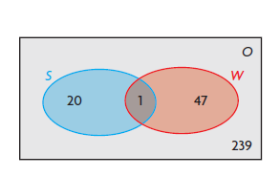
W = {athletes who have won two or more medals at the Winter Olympics}
O = {athletes who have won at least one Olympic medal}

- Are the two events (winning two or more medals at the Summer Olympics and winning two or more events at the Winter Olympics) mutually exclusive? Explain.
- A Canadian athlete who won a medal at the Summer Olympics from 1996 to 2010 is selected at random. Determine the odds in favour of this athlete having won two or more medals
- A Canadian athlete who won a medal at the Summer Olympics or the Winter Olympics from 1996 to 2010 is selected at random. Determine the odds in favour of this athlete having won two or more medals.

- Suppose that you are about to draw a single card, at random, from a standard deck of 52 playing cards. Determine the probability of each event below.
- You draw an 8 or king
- You draw a red card or a face card
- You draw a diamond or an ace
- You draw a black card or a heart

- An Ipsos survey reported that 37% of Prairie households have one or more dogs, 31% have one or more cats, and 47% have neither dogs nor cats. Suppose that a Prairie household is selected at random. Determine each probability.
- There are cats or dogs in the household
- There are cats but no dogs in the household
- There are dogs but no cats in the household

- On Sunday, the weather forecaster says that there is a 60% chance of snow on Monday and a 40% chance of snow on Tuesday. The forecaster also says that there is a 20% chance of snow on both Monday and Tuesday. Determine the probability that there will be snow on Monday or on Tuesday.

- Determine how determining the probability of two mutually exclusive events is different from determining the probability of two events that are not mutually exclusive. Give an example.

- Create a problem that involves determining the probability of two mutually exclusive events. Give your problem to a classmate to solve.

- Create a problem that involves determining the probability of two non-mutually exclusive events. Give your problem to a classmate to solve

- A school newspaper reports on the students’ taste in music.
- 20% like only rock
- 13% like only blues
- 30% like only rap
- 10% like rock and blues, but not rap
- 14% like rock and rap, but not blues
Determine the probability that a randomly selected student will either like all three types of music or like blues and rap, but not rock

- Consider three events, represented by A, B and C. For each situation, determine a formula for P(A ∪ B ∪ C)
- A, B and C are mutually exclusive
- A, B and C are not mutually exclusive

Dependent Events
- Dependent Events – Events whose outcomes are affected by each other; for example, if two cards are drawn from a deck without replacement, the outcome of the second event depends on the outcome of the first event (the first card drawn)
- A tree diagram is often useful for modeling problems that involve dependent events.
- Drawing an item and then drawing another item, without replacing the first item, results in a pair of dependent events.

Outcome FM30-5 Practice #2
- Katelyn draws a card from a well-shuffled standard deck of 52 playing cards. Then she draws another card from the deck without replacing the first card.
- Are these two events dependent or independent?
- Determine the probability that both cards are diamonds

- Josie draws a card from a well-shuffled standard deck of 52 playing cards. Then she puts the cards back in the deck, shuffles again, and draws another card from the deck.
- Are these two events dependent or independent?
- Determine the probability that both cards are diamonds.

- Lexie has six identical black socks and eight identical white socks loose in her drawer. She pulls out one sock at random and then another sock, without replacing the first sock.
- Determine the probability of each event below
- She pulls out a pair of black socks
- She pulls out a pair of white socks
- She pulls out a matched pair of socks; that is, either both are black or both are white
- If Lexie randomly pulled out both socks at the same time, would your answers for part a) change? Explain.

- There are 80 males and 110 females in the graduating class in a Prince Albert school. Of these students, 30 males and 50 females plan to attend the U of S next year.
- Determine the probability that a randomly selected student plans to attend U of S.
- A randomly selected student plans to attend U of S. Determine the probability that the selected student is female.

- Skye has four loonies, three toonies, and five quarters in her pocket. She needs two loonies for a parking meter. She reaches into her pocket and pulls out two coins at random. Determine the probability that both coins are loonies.

6. A computer manufacturer knows that, in a box of 150 computer chips, 3 will be defective. Samuel will draw 2 chips, at random, from a box of 150 chips. Determine the probability that Samuel will draw the following:
a) 2 defective chips
b) 2 non-defective chips
c) Exactly 1 defective chip

7. Three cards are drawn at random from a standard deck of cards without replacement. Determine the probability that:
a) All are hearts
b) All are face cards
c) The first is a king and the last two are aces
d) Exactly one of them is a diamond

8. A computer manufacturer knows that, in a box of 100 computer chips, 4 will be defective. Caleb will draw 3 chips, at random, from a box of 100 chips. Determine the probability that Caleb will draw the following:
a) 3 defective chips
b) 3 non-defective chips
c) More defective chips than non-defective chips

Independent Events
- If the probability of event B does not depend on the probability of event A occurring, then these events are called independent events. For example, tossing tails with a coin and drawing the ace of spades from a standard deck of 52 playing cards are independent events.
- The probability that two independent events, A and B, will both occur in the product of their individual probabilities: P(A ∩ B) = P(A)$×$P(B)
- A tree diagram is often useful for modeling problems that involve independent events.
- Drawing an item and then drawing another item, after replacing the first item, results in a pair of independent events.

Outcome FM30-5 Practice #3
- Camille goes to the gym five days a week. Each day, she does a cardio workout using either a treadmill, an elliptical walker, or a stationary bike. She follows this with a strength workout using either free weights or the weight machines. Camille randomly chooses which cardio workout and which strength workout to do each day.
- Are choosing a cardio workout and choosing a strength workout dependent or independent events? Explain.
- Determine the probability that Camille will use a stationary bike and free weights the next day she goes to the gym.

- Ian also goes to the gym five days a week, but he does two different cardio workouts each day. His choices include using a treadmill, a stepper, or an elliptical walker, and running the track.
- Are the two cardio workouts that Ian chooses dependent or independent events?
- Determine the probability that the next time Ian goes to the gym he will use the elliptical walker and then run the track.

- Determine the probability that the following events will occur:
- A four colour spinner is spun, and a die is roller. The first event is spinning red, and the second event is rolling a 2.
- A red die and a green die are rolled. The first event is rolling a 1 on the red die, and the second event is rolling a 5 on the green die.
- Two cards are drawn, without being replaced, from a standard deck of 52 playing cards. The first event is drawing a king, and the second event is drawing an ace.
- There are 30 cards, numbered 1 to 30, in a box. Two cards are drawn, one at a time, with replacement. The first event is drawing a prime number, and the second event is drawing a number that is a multiple of 5.

- There are two children in the Angel family.
- Draw a tree diagram that shows all the possible gender combinations for the two children.
- Determine the probability that both children are boys
- Determine the probability that one child is a boy and the other child is a girl.

- A particular game uses 40 cards from a standard deck of 52 playing cards: the ace to the 10 from the four suits. One card is dealt to each of two players. Determine the probability that the first card dealt is a club and the second card dealt is a heart. Are these events independent or dependent?

- A die is rolled twice. Determine the probability for the following:
- The first roll is a 1, and the second roll is a 6.
- The first roll is greater than 3, and the second roll is even.
- The first roll is greater than 1, and the second roll is less than 6.

- Jeremy is going on a cruise up the Nile. According to the travel brochure, the probability that he will see a camel is $\frac{4}{5}$, and the probability that he will see an ibis is $\frac{3}{4}$. Determine the probability that Jeremy will see the following:
- A camel and an ibis
- Neither a camel nor an ibis
- Only one of these sights

- Anne and Abby each have 19 marbles: 11 red and 8 blue. Anne placed 7 red marbles and 3 blue marbles in bag 1. She places the rest of her marbles in bag 2. Abby places all of her marbles in bag 3. Anne then draws one marble from bag 1 and one marble from bag 2. Abby draws two marbles from bag 3.
- Are Anne and Abby equally likely to draw two blue marbles from their bags? Explain.
- Determine the probability that Anne and Abby will both draw one red marble and one blue marble. Explain what you did.
- Suppose that Anne now has 5 red marbles and 5 blue marbles in each of her two bags, while Abby has 10 red marbles and 10 blue marbles in her one bag. Who is more likely to draw two red marbles? Explain.
- A paper bag contains a mixture of three types of treats: 10 granola bars, 7 fruit bars, and 3 cheese strips. Suppose that you play a game in which a treat is randomly taken from the bag and replaced, and then a second treat is drawn from the bag. You are allowed to keep the second treat only if it was the same type as the treat that was drawn the first time. Determine the probability of each of the following
- You will be able to keep a granola bar.
- You will be able to keep any treat
- You will not be able to keep any treat

- Tiegan’s school is holding a chocolate bar sale. For every case of chocolate bars sold, the seller receives a ticket for a prize draw. Tiegan has sold five cases, so she has five tickets for the draw. At the time of the draw, 100 tickets have been entered. There are two prizes, and the ticket that is drawn for the first prize is returned so it can be drawn for the second prize.
- Determine the probability that Tiegan will win both prizes
- Determine the probability that Tiegan will win no prizes.

- In the final series of the Stanley Cup playoffs, the first team to win four games becomes the National Hockey League champion. The Original Six teams in the NHL were the Boston Bruins, the Chicago Blackhawks, the Detroit Red Wings, the Montreal Canadians, the New York Rangers, and the Toronto Maple Leafs.
- In 1960, Montreal played Toronto and won the first four games. Suppose that the probability of Montreal winning any single game was 0.65. Determine the probability that Montreal would win the series in four games.
- In 1967, the NHL added six more teams, including the St. Louis Blues. In 1968, Montreal beat St. Louis, winning four games in a row. The odds in favour of this occurring were 5:4. Determine the probability that Montreal would win any single game in the series. What assumptions did you make?

- What are independent events, and how can you determine the probability that both will occur?
- Create a problem that involves determining the probability of two independent events. Solve this problem.
- Create a problems that involves determining the probability of two dependent events. Solve this problem.
- Explain why the formula you would use to calculate P(A ∩ B) would depend on whether A and B are dependent or independent events.
- Give an example of how you would calculate P(A ∩ B) if A and B were independent events.
- Give an example of how you would calculate P(A ∩ B) if A and B were dependent events.

Conditional Probability
- Conditional Probability – The probability of an event occurring given that another event has already occurred.
- P$\left(B | A\right)$ is the notation for a conditional probability. It is read “the probability that event B will occur given that event A has already occurred”
- A formula for conditional probability is: $P\left(B | A\right)=\frac{P(A∩B)}{P(A)}$
- If event B depends on event A occurring, then the probability that both events will occur can be represented as follows: $P\left(A∩B\right)=P\left(A\right)×P\left(B | A\right)$

Outcome FM30-5 Practice #4
- Each day, Melissa’s math teacher gives the class a warm – up question. It is a true-false question 30% of the time and a multiple choice question 70% of the time. Melissa gets 60% of the true-false questions correct, and 80% of the multiple choice questions correct. Melissa answers today’s question correctly. What is the probability that it was a multiple choice question?

- Kayla remembers to set her alarm clock 62% of the time. When she does remember to set her alarm clock, the probability that she will be late for school is 0.20. When she does not remember to set it, the probability that she will be late for school is 0.70. Kayla was late today. What is the probability that she remembered to set her alarm clock?

- The probability that a car tire will last for 5 years is 0.8. The probability that a tire will last for 6 years is 0.5. Suppose that your parents’ tires have lasted for 5 years. Determine the probability that the tires will last for 6 years.

- The probability that a particular pair of badminton shows will last for 6 months is 0.9. The probability that the shoes will last for 1 year is 0.2. Natalie’s shoes have lasted for 6 months. Determine the probability that they will last for 1 year.

- Savannah’s soccer team is playing a game tomorrow. Based on the team’s record, it has a 50% chance of winning on rainy days and a 60% chance of winning on sunny days. Tomorrow, there is a 30% chance of rain. Savannah’s soccer league does not allow ties.
- Determine the probability that Savannah’s team will win tomorrow.
- Determine the probability that her team will lose tomorrow.

- Think of two situations in your life in which the probability of one event happening depends on another event happening. Write two problems, one for each of these situations. Also, write the solutions to your problems. Exchange your problems with a classmate. Solve, and then correct, each other’s problems. Adjust your problems if necessary.

- What is conditional probability and how can you determine it?

Answers
Practice #1
1)12:28 or 3:7; mutually exclusive
2a) 28:8 or 7:2; mutually exclusive b) 25:11; non mutually exclusive
3a) 0.2 b) No, he can do both
4a) No. One athlete won two or more medals at the Summer and winter Olympics
b)21:286 c) 68:239
5a) $\frac{8}{52}$ or about 0.154 b) $\frac{32}{52}$ or about 0.615
c)$\frac{16}{52}$ or about 0.308 d) $\frac{39}{52}$ or about 0.75
6a) 53% b) 16% c) 22%
7) 80%
8) ie. To determine the probability of two events that are not mutually exclusive, you must subtract the probability of both events occurring after adding the probabilities of each event. Example: Female students at a high school may play hockey or soccer. If the probability of a female student playing soccer is 62%, the probability of her playing in goal is 4% and the probability of her either playing soccer or in goal is 64% then the probability of her playing in goal at soccer is 62% + 4% - 64% = 2%.
9) ie. Tricia has a probability of 0.3 cycling to school on any given day and a probability of 0.2 of getting a ride from her older brother, Steve. Otherwise she walks to school. What is the probability that she does not walk to school on any given day?
10) ie. There are 67 Grade 10 students that take art and 37 that take photography. If there are 84 students, how many take both?
11) 13%
12a) P(A∪B∪C) = P(A) + P(B) + P(C)
b)P(A∪B∪C) = P(A) + P(B) + P(C) – P(A∩B) – P(A∩C) – P(B∩C) + P(A∩B∩C)

Practice #2
1a) dependent b) $\frac{1}{17}$ or 0.0588
2a) independent b) $\frac{1}{16}$ or 0.0625
3a) i) $\frac{15}{91}$ or 0.1648 ii) $\frac{4}{13}$ or 0.3077 iii) $\frac{43}{91}$ or 0.4725 b) No
4a) $\frac{8}{19}$ or 0.421 b) $\frac{5}{8}$ or 0.625
5) $\frac{1}{11}$ or 0.091
6a) $\frac{1}{3725}$ or 0.00027 b) $\frac{21462}{22350}$ or 0.960 c) $\frac{147}{3725}$ or 0.0395
7a) $\frac{1716}{132600}$ or 0.0129 b) $\frac{1320}{132600}$ or 0.00995 c) $\frac{48}{132600}$ or 0.00036 d) $\frac{57798}{132600}$ or 0.4359
8a) $\frac{24}{970200}$ or 0.0000247 b) $\frac{857280}{970200}$ or 0.8836 c) $\frac{3480}{970200}$ or 0.0035

Practice #3
1a) independent b) $\frac{1}{6}$
2a) dependent b) $\frac{1}{12}$
3a) $\frac{1}{24}$ b) $\frac{1}{36}$ c) $\frac{4}{663}$ or 0.006 d) $\frac{1}{15}$ or 0.0667
4a) BB, BG, GB, GG b) $\frac{1}{4}$ c) $\frac{1}{2}$
5) dependent; $\frac{100}{1560}$ or 0.0641
6a) $\frac{1}{36}$ b) $\frac{1}{4}$ c) $\frac{25}{36}$
7a) $\frac{12}{20}$ or 0.6 b) $\frac{1}{20}$ or 0.05 c) $\frac{7}{20}$ or 0.35
8a) Anne $\frac{15}{90}$ or 0.167 Abby $\frac{56}{342}$ or 0.164
b)Anne $\frac{47}{90}$ or 0.522 Abby $\frac{176}{342}$ or 0.515 thus 0.26883
c)Anne $\frac{25}{100}$ or 0.25 Abby $\frac{90}{380}$ or 0.237
9a) $\frac{100}{400}$ or 0.25 b) $\frac{158}{400}$ or 0.395 c) $\frac{242}{400}$ or 0.605
10a) $\frac{25}{10000}$ or 0.0025 b) $\frac{9025}{10000}$ or 0.9025
11a) 0.1785 or 17.8% b) 0.8633 or 86.3%
12)Two events are independent if you can determine the probability of one event without considering the probability of the other event. The following formula can be used to determine the probability that two independent events, A and B, will occur: P(A∩B)=P(A)xP(B). For example, determine the probability of rolling a 5 on a standard red die and a 3 on a standard blue die. The number rolled with the red die has no bearing on the number rolled with the blue die, so these events are independent.
P(red die is 5 and blue die is 3) = P(red die is 5) x P(blue die is 3)
P(red die is 5 and blue die is 3) = $\frac{1}{6}×\frac{1}{6}=\frac{1}{36}$
The probability that a 5 is rolled on the red die and a 3 is rolled on the blue die is $\frac{1}{36}$
13)ie. What is the probability of drawing a card from a shuffled standard deck and getting a red card, then replacing it, shuffling and then draw a heart? $\frac{1}{8}$ or 0.125
14)ie. what is the probability of drawing a card and getting red, then drawing a second card without replacement and getting a spade? $\frac{13}{102}$ or 0.127
15) The formula is P(A∩B)=P(A) x P(B) only when A and B are independent events.
16) ie. Drawing two red marbles from a bag containing 5 red and 15 blue, with replacement: A = {red on first} and B = {red on second} are independent events so P(A∩B)=P(A) x P(B) = $\frac{1}{4}×\frac{1}{4}=\frac{1}{16}$
17) ie. Drawing two red marbles from a bag containing 5 red and 15 blue, without replacement: A = {red on first}, B = {red on second} are dependent events so P(A∩B)=P(A)xP(B/A) = $\frac{1}{4}×\frac{4}{19}=\frac{1}{19}$

Practice #4
- 0.757
- 0.318
- 0.625
- 0.222
5a) 0.57 b) 0.43
6)ie. Problem 1: On weekdays I have cereal for breakfast 70% of the time. On the weekends I have cereal for breakfast 40% of the time. On a random day, what is the probability that I do not have cereal? Answer: 0.386
Problem 2: I draw without looking two cards from a well shuffled standard deck, drawing the second card without replacing the first one. If my second card is a red card, what is the probability my first card is black? Answer. 0.510
7) Conditional probability occurs when two events are dependent. It means that you must consider the probability of A to determine the probability of B.

Outcome FM30-6
OUTCOMES | ASSESSMENT RUBRICS
FM30.6 Demonstrate understanding of combinatorics including:
- the fundamental counting principle
- permutations (excluding circular permutations)
- combinations.

Level  Criteria | Intervention 1  Spend some extra time with the criteria and ask for help. | Instructional 2  Good start. You are beginning to make sense of this on your own. You are consistent with the basic learning goals for this outcome. | Independence 3  You did it and you did it on your own. You are able to complete the processes for this outcome. Your work is thorough and consistently accurate. | Mastery 4  Great work! This is going extra well for you. You have understood the outcome, are able to explain your strategies and apply these to situations. Your work is always accurate.
Demonstrate understanding of fundamental counting principle, permutations and combinations | I need more help with becoming consistent with the criteria. | I can evaluate factorials.  I can solve basic permutation and combination problems when I am told which type it is.  I can solve basic fundamental counting principle problems. | I can list all of the options to a counting problem (I may use a graphic organizer)  I can solve permutations with conditions, repetition, where objects are not distinguishable  I can solve combinations from more than one set; with conditions;  I can solve situational questions involving the fundamental counting principle. | I can demonstrate my understanding of counting problems.  I can simplify factorial expressions and olve factorial equations  I can explain how factorials are related to permutations and combinations  I can solve situational questions involving probability and permutations  I can compare and contrast permutations and combinations

Counting Principles
- Fundamental Counting Principle – If there are a ways to perform one task and b ways to perform another, then there are a x b ways of performing both.
- The graphic organizers of outcome tables, organized lists, and tree diagrams can also be used to solve counting problems. They have the added benefit of displaying all the possible outcomes, which can be useful in some problem situations. However, these strategies become difficult to use when there are many tasks involved and/or a large number of possibilities for each task.
- The fundamental counting principle applies when tasks are related by the word AND.
- The fundamental counting principle does not apply when tasks are related by the word OR. In the case of an OR situation,
- If the tasks are mutually exclusive, they involve two disjoint sets, A and B:
n(A$∪$B) = n(A) + n(B)
- If the tasks are not mutually exclusive, they involve two sets that are not disjoint, C and D:
n(C$∪$D) = n(C) + n(D) – n(C$∩$D)

Outcome FM30-6 Practice #1
- Cam is on vacation. In his suitcase he has three golf shirts (red, blue, and green) and two pairs of shorts (khaki and black).
- Use an outcome table to count the total number of outfit variations he has for golfing.
- Use the Fundamental Counting Principle to verify your result in part a)

- Missy is buying her first new car. The model she wants comes in four colours (red, black, white, and silver) and she has a choice of leather or cloth upholstery.
- Use a tree diagram to count all the upholstery-colour choices that are available.
- Use the Fundamental Counting Principle to verify your results in part a)

- For each situation below, indicate whether the Fundamental Counting Principle applies and explain how you know.
- Counting the number of possibilities when rolling a 3 or a 6 with a standard die.
- Counting the number of outfit variations when selecting a shirt, a tie, and shoes to wear to the semiformal dance.
- Counting the number of possibilities when picking the winner in a stock car race in either the fourth, fifth or sixth race of the evening.
d) Counting the number of possibilities to choose from when buying a car with either standard or automatic transmission, air conditioning or not, power windows or not, and GPS navigation or not.

4. a) Kim plays hockey on the A&W Bears. Her team is in a best two out of three playoff series. Create a tree diagram to show all the win-loss possibilities for her team.
b)Use your tree diagram to count the number of ways Kim’s team can win the series despite losing one game.

5.Xtreme clothing company makes snowboarding pants in five colours and sizes of small, medium, large, and extra large. How many different colour-size variations of snowboarding pants does this company make?

- A computer store sells 5 different desktop computers, 4 different monitors, 6 different printers, and 3 different software packages. How many different computer systems can the employees build for their customers?

- Jeb’s Diner offers a lunch special. You have a choice of 3 soups, 5 sandwiches, 4 drinks and 2 desserts. How many meals are possible if you choose one item from each category?

- Tom likes rap music and classic rock. His friend Charlene has 8 rap CDs, 10 classic rock CDs and 5 country and western CDs in her car. How many CDs can Charlene select from to play in her car stereo that will match Tom’s musical tastes?

- Rachelle’s bank card has a five digit PIN where each digit can be 1 to 9.
- How many PINs are possible if each digit can repeat?
- How many PINs are possible if each digit can be used only once?

10. Computers code information in a binary sequence, using 0 or 1 for each term in the sequence. Each sequence of eight terms is called a byte (for example, 00110010). How many different bytes can be created?

11. a) A country’s postal code consists of six characters. The characters in the odd positions are upper case letters, while the characters in the even positions are digits (0 to 9). How many postal codes are possible in this country?
b)Canadian postal codes are similar, except the letters D, F, I, O, and U can never appear. (This is because they might be mistaken for the letters E or V or the numbers 0 or 1). How many postal codes are possible in Canada?

12.A small town in Manitoba has a phone area code of 204 and two different three digit prefixes as shown: 204 – 945 - __ __ __ __ or 204 – 940 - __ __ __ __. How many different phone numbers are possible for this town?

- The code to a garage door opener is programmed by moving each of nine switches to any one of three positions. How many different codes are possible?

- A vehicle rental company has 8 pickup trucks, 10 passenger vans, 35 cars, and 12 sports utility vehicles for rent. How many choices does a customer have when renting just 1 vehicle?

- The “Pizza Shoppe” offers these choices for each pizza:
Thin or thick crust
Regular or whole wheat crust
2 types of cheese
2 types of tomato sauce
20 different toppings
How can you determine the number of different pizzas that can be made as follows:
- A pizza with any crust, cheese, tomato sauce, and 1 topping
- A pizza with a thin whole wheat crust, tomato sauce, cheese and no toppings

- An Alberta license plate has three letters followed by three digits; for example ABC 123. The letters I and O are not used to avoid confusion with the digits 1 and 0.
- How many different Alberta license plates are possible?
- Because of the growing number of vehicles, the province is changing to plates with three letters followed by four digits; for example, ABC 1234. How many more license plates are possible?

17. Counting problems often involve several tasks that are described using the words AND and OR. What is the mathematical meaning behind these words, and how does this affect the strategy you would use to solve counting problems that involve these words? Support your answer using relevant examples.
18. a) Determine the likelihood that each of the following events can occur using a standard deck of cards.
i) Drawing a king or a queen
ii) Drawing a diamond or a club
iii) Drawing an ace or a spade
b)Does the Fundamental Counting Principle apply to any situation in part a)? Explain.

19.How many two digit numbers are not divisible by either 2 or 5?

20. A test has 10 true-false questions. A student attempts every question by guessing. What is the likelihood that the student will get a perfect score?

21.Recall Jeb’s Diner and the lunch special from question 7. There are 3 soups, 5 sandwiches, 4 drinks, and 2 desserts to choose from. How many meals are possible if you do not have to choose an item from a category?

- What is the Fundamental Counting Principle and what is it used for?

Introducing Permutations and Factorial Notation

- Permutation – An arrangement of distinguishable objects in a definite order. For example , the objects a and b have two permutations, ab and ba
- Factorial Notation – A concise representation of the product of consecutive descending natural numbers: n! = n(n – 1)(n – 2)…(3)(2)(1). For example: 4! = 4 x 3 x 2 x 1
- Since factorial notation is defined only for natural numbers, expressions like (-2)! and $\frac{1}{2}!$ have no meaning.

Outcome FM30-6 Practice #2

- Evaluate the following expressions
a) 6! b) 9 x 8! c) $\frac{5!}{3!}$ d) $\frac{8!}{7!}$ e) 3! x 2! f) $\frac{9!}{4!3!}$

2. a) How many permutations are possible of Ken, Sarah and Raj when they line up to buy a slice of pizza? Describe your strategy?
b) Express the number of permutations using factorial notation.

3.Write the following expressions using factorial notation.
a) 5 x 4 x 3 x 2 x 1 b) 9 x 8 x 7 c) $\frac{15×14×13}{4×3×2×1}$ d) 100 x 99

4. Which expressions are undefined? Explain how you know?
a) (-4)! b) 7! c) 5.5! d) $\frac{3}{4}!$

5.Evaluate the following expressions
a) 8 x 7 x 6! b) $\frac{12!}{10!}$ c) $\frac{8!}{2!6!}$
d) $\frac{7×6!}{5!}$ e) $4\left(\frac{6!}{2!2!}\right)$ f) 4! + 3! + 2! + 1!

6. Simplify each of the following expressions where n $∈$ I
a) $\frac{n!}{\left(n-1\right)!}$ b) (n + 4)(n + 3)(n + 2)! c) $\frac{\left(n+1\right)!}{n!}$
d) $\frac{n!}{\left(n-3\right)!}$ e) $\frac{\left(n+5\right)!}{\left(n+3\right)!}$ f) $\frac{\left(n-2\right)!}{\left(n-1\right)!}$

7. How many different permutations can be created when nine students line up to buy tickets for the afternoon rodeo at the Calgary Stampede?

8. The environmental club has five members. They want to select a president, vice-president, a secretary, a treasurer, and a spokesperson. How many different ways can this be done?

9. Amy and Tracy are planning a summer trip to Vancouver Island in BC. They plan to spend six days in Tolfino. While they are there, they have decided to take part in the following activities: whale watching, hiking, surfing, sea kayaking, snorkeling, and fishing. They plan to do a different activity each day. In how many different ways can they sequence these activities over the six days?

10. Visitors to a movie website will be asked to rank 28 movies. The website will present the movies in a different order for each visitor to reduce bias in the poll. How many permutations of the movie list are possible?

11. Solve for n, where n $∈$ I.
a) $\frac{\left(n+1\right)!}{n!}=10$ b) $\frac{\left(n+2\right)!}{n!}=6$
c) $\frac{\left(n-1\right)!}{\left(n-2\right)!}=8$ d) $\frac{3\left(n+1\right)!}{\left(n-1\right)!}=126$

12. A baseball coach is determining the batting order for the nine players he is fielding. The coach has already decided that he wants the pitcher to hit in last position. How many different batting orders are possible?

13. On an assembly line for a company that makes digital cameras, seven-digit serial numbers are assigned to each camera under the following conditions:
* Only the digits from 3 to 9 are used.
* Each digit is to be used only once in each serial number
How many different serial numbers are possible? Express your answer using factorial notation and explain why your answer makes sense.

14. A model train has an engine, a caboose, a tank car, a flat car, a boxcar, a livestock car, and a refrigerator car. How many different ways can the cars be arranged between the engine and the caboose?
15. Eight drivers have made it to the final chuckwagon race at Back to Batoche Days, although Brant’s wagon is considered certain to win. In how many different orders can the eight chuckwagons finish, if Brant’s wagon wins?

16. Consider the word YUKON and all the ways you can arrange its letters using each letter only once.
a) One possible permutation is KYNOU. Write three other possible permuations.
b) Use factorial notation to represent the total number of permutations possible. Explain why your expression makes sense.

17. a) For what values of n is n! greater than 2^{n}?
b) For what values of n is n! less than 2^{n}?

18. Darlene and Arnold belong to the Asham Stompers, a 10 member dance troupe based in Winnipeg, that performs traditional Metis dances. During the Red River Jig, they always arrange themselves in a line, with Darlene and Arnold next to each other. How many different arrangements of the dancers are possible for the Red River Jig?

19. Create a permutation problem that can be solved by evaluating 10!

20. What is factorial notation and what does n! represent?

Permutations when all objects are distinguishable
- Permutation Formula: The number of permutations from a set of n objects, where r of them are used in each arrangement, can be calculated using the formula _{n}P_{r} = $\frac{n!}{\left(n-r\right)!}$ Where 0≤r≤n
- When all n objects are used in each arrangement, n is equal to r and the number of arrangements is represented by _{n}P_{n} = n!
- If order matters in a counting problem, then the problem involves permutations. To determine all possible permutations, use the formula _{n}P_{r} or _{n}P_{n} depending on whether all or some of the objects are used in each arrangement. Both of these formulas are based on the Fundamental Counting Principle.
- By definition, 0! = 1.
- If a counting problem has one or more conditions that must be met
- Consider each case that each condition creates first, as you develop your solution, and
- Add the number of ways each case can occur to determine the total number of outcomes.

Outcome FM30-6 Practice #3
- Evaluate the following expressions
- ₅P₂ b) ₈P₆ c) ₁₀P₅ d) ₉P₀ e) ₇P₇ f) ₁₅P₅

- Kelly, Jess, Sam and Evan are running for student council.
- Show all the ways that a president and vice-president can be elected.
- Verify your results from part a) using the formula _{n}P_{r}
- Verify your results from part b) using the Fundamental Counting Principle

- How many different ways can six different chocolate bars be distributed to each set of children, if each child is to receive only one?
- 4 children b) 1 child

- Without calculating, predict which value is larger: ₁₀P_{8 or 10}P₂. Explain your prediction. Verify.

- Nine girls are available to fill three positions on a hockey team: centre, winger, and defence. If all the girls are equally competent in each position, how many different ways can the positions be filled?

- The photo club must select an executive committee to fill the roles of president, vice-president, treasurer and secretary. All 15 members of the club are eligible. How many different executive committees are possible?

- The MV UMIAVUT (umiavut means “our boat: in Inuktitut) is a cargo ship that sails the Northwest Passage. If it carries eight different coloured signal flags, how many different signals could be created by hoisting all eight flags on the ship’s flagpole in different orders?

- A wheelchair basketball team sold 5000 tickets in a draw to raise money. How many ways can the tickets be drawn to award the first, second, and third prizes if each winning ticket drawn is not put back prior to the next draw?
- If a Canadian social insurance number begins with the digit 6, it indicates that the number was registered in Manitoba, Saskatchewan, Alberta, Northwest Territories, or Nunavut. If the number begins with a 7, the number was registered in British Columbia or the Yukon. How many different SINs can be registered in each of these groups of provinces and territories?

- Sandy belongs to the varsity basketball team. There are 12 students on the team. How many ways can the coach select the following:
- The starting five players (a point guard, a shooting guard, a small forward, a power forward, and a centre)
- The starting five players, if the tallest student must start at the centre position
- The starting five players if Sandy and Natasha must play the two guard positions

- There are six different marbles in a bag. Suppose you reach in and draw one at a time, and do this four times. How many ways can you draw the four marbles under each of the following conditions?
- You do not replace the marble each time
- You replace the marble each time
- Compare your answers for part a) and b). Does it make sense that they differ? Explain.
- How many ways can five different graduation scholarships be awarded to 20 students under each of these conditions?
- No student may receive more than one scholarship.
- There is no limit to the number of scholarships awarded to each student.

- All phone numbers consists of a three digit area code, a three digit exchange, and then a four digit number. A town uses the 587 area code and exchange 355, for example, 587 – 355 – 1234. How many different phone numbers are possible in this town under the following conditions?
- There are four different digits in the last four digits of the phone number
- At least one digit repeats in the last four digits of the phone number

- Five cards are drawn from a standard deck of cards and arranged in a row from left to right in the order in which they are drawn. Determine each of the following.
- The number of possible arrangements
- The likelihood that an arrangement contains black cards only
- The likelihood that an arrangement contains hearts only

- Solve each equation for n. State any restrictions on n
- _{n}P₂ = 20 b) _{n+1}P₂ = 72

- Solve each equation for r. State any restrictions on r
a) ₆P_{r} = 30 b) 2(₇P_{r}) = 420

- a) Describe how the formulas for calculating permutations, _{n}P_{n} and _{n}P_{r} where r ≤ n are the same and how they are different.
- Provide an example of a counting problem that could be solved using each formula.

- How do you determine the number of permutations possible from a group of different objects when you do not use all of them in each permutation?

Permutations When All Objects are Identical
- There are fewer permutations when some of the objects in a set are identical compared to when all the objects in a set are different. This is because some of the arrangements are identical.
- The number of permutations of n objects, where a are identical, another b are identical, another c are identical, and so on, is $P=\frac{n!}{a!b!c!…}$
- Dividing n! by a!, b!, c! and so on deals with the effect of repetition caused by objects in the set that are identical. It eliminates arrangements that are the same and that would otherwise be counted multiple times.

Outcome FM30-6 Practice #4
- How many different signals can be made from 6 flags hung in a vertical line, using 2 identical white flags, 2 identical red flags, and 2 identical blue flags?
- Six nickels are flipped simultaneously. How many ways can three coins land as heads and three coins land as tails?
- A hockey team has a record of 10 wins, 5 losses, and 3 ties in 18 games. How many different ways could this record have occurred?

- Norm bought 3 chocolate chip cookies, 2 peanut butter cookies, and 4 oatmeal cookies from the corner bakery to give to his 9 grandchildren. How many ways can he distribute 1 cookie to each grandchild?

- How many different arrangements can be made using all the letters in each word?
- YUKON b) ALBERTA c) MANITOBA d) SASKATCHEWAN

- A clerk at a bookstore is restocking a shelf of best selling novels. He has five copies each of three different novels.
- How many different ways can he arrange the books on the shelf?
- How many different ways can these books be arranged on the shelf if the copies of the same novel must be grouped together?
- Create a counting problem that can be solved using the expression $\frac{8!}{2!4!}$

- Determine the number of routes there are to get from point A to point B, if you travel only south or east.
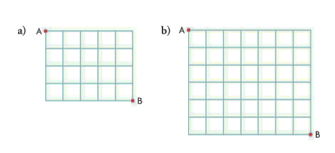
- Jess always walks to her friend’s house, which is eight blocks north and five blocks west of her house. How many different routes can she take if she always walks either north or west?

- How many different routes are there from A to B, if you travel only north or west?
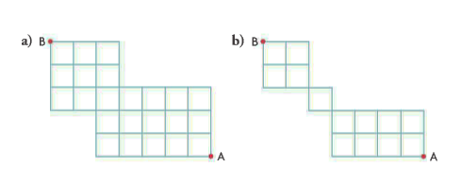
11. A true-false test has eight questions. How many different permutations or answers can the teacher create if five answers are true and three answers are false?
12. a) How many ways can 9 coins (3 dimes, 4 quarters, and 2 loonies) be arranged in a line? State any assumptions you are making.
b)What if the line must begin and end with a loonie? State any assumptions you are making.

13. Karlee, Chase and 8 of their friends are playing outside on a hot summer day. How many ways can 10 freezies (3 grape, 2 lime, and 5 orange) be distributed among the 10 children if Karlee much have lime and Chase must have grape?

14. How many permutations are possible using all the letters of the word STATISTICS for each condition described below:
a) You must start with A and end with C
b) The two I’s must be together

15. Consider the words BANANAS and BANDITS. Explain why there are 12 times the number of permutations possible using all the letters of BANDITS compared to the number of permutations possible using all the letters of BANANAS.

16. How many ways can 20 soccer players on a travelling team be assigned to hotel rooms for each situation?
a) There are only 10 double rooms
b) There are 5 quadruple rooms

17. A bag contains three identical red marbles and three identical white marbles. Four marbles are drawn out of the bag and arranged in a row from left to right.
a) How many different arrangements might be made?
b) what is the likelihood that the arrangement is, from left to right, red, white, white, red?

18. A Rubik’s cube can be thought of as a grid in three dimensions. How many routes are there from the top rear vertex of the cube to the lower front vertex of the cube, if each route must be as short as possible and follow the grid lines?

19. Explain why _{n}P_{n} = n! cannot be used to determine the number of arrangements of a group of n items when there are a identical items in the group and a < n.

20. Why does a set of n objects containing some identical objects have fewer permutations than a set of n different objects?

Exploring Combinations
- Combination – A grouping of objects where order does not matter. For example, the two objects a and b have one combination because ab is the same as ba.
- When all n objects are being used in each combination, there is only one possible combination.
- From a set of n different objects, there are always fewer combinations than permutations when selecting r of those objects where r ≤ n.

Outcome FM30-6 Practice #5
- Brian, Rachelle, and Leah volunteer at the food bank on Saturdays.
- In the morning, each person is needed for different jobs: stacking cans, stocking dry goods, and cleaning fruits and vegetables. In how many different ways can they be chosen for these jobs?
- List all the ways the three volunteers can be assigned the jobs in part a)
- In the afternoon, all three volunteers are needed to unload vehicles arriving from food drives. In how many ways can the be chosen for this job?
- In the situations above, which involved permutations and which involved combinations? Explain how you know.

- Explain the main difference between the following:
- Permutations of 4 objects out of a group of 6 different objects
- Combinations of 4 objects out of a group of 6 different objects

- There are 10 members of student council. How many ways can 4 of the members be chosen to serve on the dance committee?

- There are 12 dogs at the local animal shelter. To increase the likelihood that the dogs will be adopted, 3 of them will appear on a TV morning show. How many ways can 3 of the 12 dogs be selected to appear?
- Why are there fewer combinations of a set of n objects than permutations of the same n objects?

Combinations
- You can solve counting problems where order is not important by calculating the number of combinations
- The number of combinations from a set of n different objects, where only r of them are used in each combination, can be denoted by _{n}C_{r} and is calculated using the formula _{n}C_{r} = $\frac{n!}{\left(n-r\right)!r!}$
Where 0 ≤ r ≤ n.
- The formula for _{n}C_{r} is the formula for _{n}P_{r} divided by r!. Dividing by r! eliminates the counting of the same combination of r objects arranged in different orders
- When solving problems involving combinations, it may also be necessary to use the Fundamental Counting Principle.
- Sometimes combination problems can be solved using direct reasoning. This occurs when there are conditions involved. To do this, follow the steps below:
- Consider only cases that reflect the conditions
- Determine the number of combinations for each case
- Add the results of step 2 to determine the total number of combinations
- Sometimes combination problems that have conditions can be solved using indirect reasoning. To do this, follow these steps:
- Determine the number of combinations without any conditions
- Consider only cases that do not meet the conditions
- Determine the number of combinations for each case identified in step 2.
- Subtract the results of step 3 from step 1

Outcome FM30-6 Practice #6
- Joe has a choice of four flavours of ice cream for his two scoop sundae: vanilla, strawberry, chocolate and butterscotch.
- List all the permutations for a two flavor sundae
- List all the combinations for a two flavor sundae
- How is the number of two flavor permutations related to the number of two flavor combinations. Explain.

- From a group of five students, three students need to be chosen for a car wash committee.
- How many committees are possible?
- How many committees are possible, if only two students are needed on the committee?
- Compare your answers for part a) and b). What do you notice? Explain why this occurred.

- How many ways can 6 people be selected from a group of 12 to form a dodge ball team.
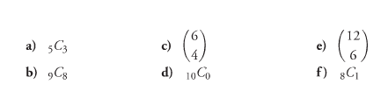
- Evaluate the following

- How many ways can 6 players be chosen to start a volleyball game from a team of 10?

- An online music store offers 5 free songs when you join. It has 55 hip hop songs available. How many different combinations of hip hop songs can you download for free?
- The card game Crazy Eights is played with a standard deck of playing cards. How many different 8 card hands can be dealt?

- Connie’s softball team has 15 players. How many ways can the coach choose his starting lineup of 9 players, if Connie must be the pitcher?
- Does this problem involve permutations or combinations? Explain.
- Solve the problem

- Suppose that 5 teachers and 8 students volunteered to be on a graduation committee. The committee must consists of 2 teachers and 3 students. How many different graduation committees does the principal have to choose from?

- How many 5 person committees can be formed from a group of 6 women and 4 men, under each of the following conditions.
- There are no conditions
- There must be exactly 3 women
- The must be exactly 4 men.
- There can be no men
- There must be at least 3 men
- A youth hostel has 3 rooms that contains 5, 4, and 3 beds, respectively. How many ways can 12 students be assigned to these rooms?

- A children’s hospital in a city of about one million people is running a charity lottery called Lucky Six to raise money. Players choose six numbers from the numbers 1 to 66. The player wins if the six numbers chosen match six numbers drawn at random by the organizers.
- How many ways could the player win?
- How many ways could the player lose?
- Is this a reasonable game for the hospital to run? Explain.

- There are 7 boys and 13 girls in the school art club. A group of 5 is needed to set up an art exhibit. How many different groups of 5 students with at least 2 boys are there to choose from?

- A CD player hold five different CDs. The CD player is set on shuffle so it randomly selects songs to play from the five CDs. This chart show the number of songs there are on each CD.
CD Number | 1 | 2 | 3 | 4 | 5
Number of Songs | 12 | 14 | 15 | 12 | 18
Determine the probability that each of the following events will happen during the first five songs played.
- The five songs will be from CD 2 and CD 4
- One of the five songs will be from each CD
c) Your favourite song from each of the 5 CDs will be played

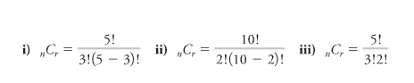
- a)For each expression, state the number of different objects in the set and how many are used in each combination?

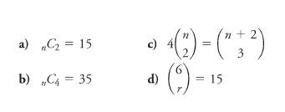
b)Choose one expression from part a) and create a combination problem that could be solved using that expression.

16. Solve each equation. State any restrictions on the variable.

17.a) How are combinations and permutations similar? How are they different? Use examples in your answers.
b)If you know the value of _{n}P_{r} how can you determine the value of _{n}C_{r}? Use examples in your answer.

Solving Counting Principles
- When solving counting problems, you need to determine if order plays a role in the situation. Once this is established, you can use the appropriate permutation or combination formula.
- Once you have established whether a problem involves permutations or combinations you can also use these strategies:
- Look for conditions. Consider these first as you develop your solution
- If there is a repetition of r of the n objects to be eliminated, it is usually done by dividing by r!
- If a problem involves multiple tasks that are connected by the word AND, then the Fundamental Counting Principle can be applied: multiply the number of ways that each task can occur
- If a problem involves multiple tasks that are connected by the word OR, the Fundamental Counting Principle does not apply: add the number of ways that each task can occur. This typically is found in counting problems that involve several cases.
Outcome FM30-6 Practice #7
- Identify whether each situation involves permutations or combinations. Explain how you know.
- Choose 3 toppings for a pizza from 25 different possibilities
- Choose a CEO, president, and vice-president from a group of 20 candidates
- Determine the number of outcomes possible when rolling 3 dice: 1 red, 1 blue and 1 white
- Determine the number of ways 5 children from a group of 11 can start in a game of pickup basketball

- Consider two situations:
- Situation A: A committee of 3 is to be selected from a group of 10 people
- Situation B: An executive committee consisting of a president, vice-president, and a secretary is to be selected from 10 people.
Determine which of these situations involves combinations and which involves permutations. Explain your answer.

- Maddy arrived at an auction, and there were only 8 items left to bid on. She likes all 8 items but especially likes 3 items. She can afford to have winning bids on only 3 items. How many ways can she bid on 3 items under each of the following conditions?
- She bids on only her 3 favourite items
- She bids on any 3 of the 8 items

- From a standard deck of 52 cards, how many different four card hands are there with one card from each suit?

- How many ways can the top five cash prizes be awarded in a lottery that sold 200 tickets
- If each ticket is not replaced when drawn
- If each ticket is replaced when drawn
- How many ways can the 5 starting positions on a basketball team (1 centre, 2 forwards, and 2 guards) be filled from a team of 2 centres, 4 guards and 6 forwards?

- How many ways can five different pairs of identical teddy bears be arranged in two rows of five for a photograph?

- Five different signal flags fly on the flag pole of a coast guard ship. You can send signals using one or more of the flags. How many different signals can be sent using at least three of these flags?

9. Six different types of boats have pulled into a marina and want to dock at the six available slips. The six slips are adjacent to each other. How many ways can the six boats dock so that the two cabin cruisers, which are travelling together, are docked next to each other?

10. a) How many different arrangements are possible for the letters in the word FUNNY if there are no conditions?
b)How many different arrangements are possible if each arrangement must start and end with an N?

- A combination lock opens when the right sequence of three numbers from 0 to 99 is used. The same number may be used more than once. How many sequences are there that consist entirely of odd numbers?

- How many different routes can you take to get to a location five blocks south and six blocks east, if you travel only south or east?

- Three vehicles are taking 16 musicians to a concert: a 5 person car driven by Joe, a 4 person car driven by Kami, and a 7 passenger van driven by Brett. How many ways can the 16 people be assigned to the 3 vehicles?

- How many different five card hands that contain at most three hearts can be dealt from a standard deck of playing cards?

- This week six boys and seven girls signed up for a ski trip. Only six students can go, so they are to be selected at random. What is the probability that there will be three boys and three girls on the trip?

- How many four letter arrangements can be made using the letters in the word ALASKA?

- How do you decide what strategy to use to solve a counting problem?

Probabilities Using Counting Methods

Outcome FM30-6 Practice #8
- In a card game called Crazy Eights, players are dealt 8 cards from a standard deck of 52 playing cards. Determine the probability that a hand will consist of 8 hearts.

- From a committee of 12 people, 2 of these people are randomly chosen to be president and secretary. Determine the probability that Ben and Jen will be chosen.

- Five boys and six girls have signed up for a trip to see Francophone artists compete at Festival International de la Chanson de Granby. Only four students will be selected to go on the trip. Determine the probability for the following:
- Only boys will be on the trip
- There will be equal numbers of boys and girls on the trip.
- There will be more girls than boys on the trip.

- A high school athletics department is forming a beginners curling team to play in a social tournament. Nine students, including you and your three friends have signed up for the four positions of skip, third, second and lead. The positions will be filled randomly, so every student has an equal chance of being chosen for any position.
- Determine the probability that you and your three friends will be chosen.
- How would this probability change if only eight students had signed up for the team?

- A student council has 15 members, including Danica, Dara and Krista.
- The staff advisor will select three members at random to be treasurer, secretary, and liaison to the principal. Determine the probability that the staff advisor will select Danica to be treasurer, Dara to be secretary and Krista to be liaison.
- The staff advisor will also select three members at random to clean up after the pep rally. Determine the probability that the staff advisor will select Danica, Dara and Krista to do this.

- Five friends, including Jordyn and Nicole are sitting in a row in a theatre.
- Determine the probability that Jordyn and Nicole are sitting together.
- Determine the probability that they are not sitting together.

- Doc deals you eight cards at random from a standard deck of 52 playing cards. Determine the probability that you have the following hands.
- A, 2, 3, 4, 5, 6, 7, 8 of the same suit
- Eight cards of the same color
- Four face cards and four other cards

- Erynn has letter tiles that spell CABINET. She has selected three of these tiles at random. Determine the probability that the tiles she selected are two vowels and one consonant.

Answers
Practice #1
1a) b) 6
 | khaki | black
Red | Red/khaki | Red/black
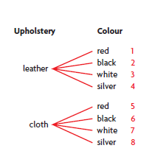  Blue | Blue/khaki | Blue/khaki
green | Green/khaki | Green/black
2a) b) 8

3a) No; the possibilities are related by the word OR
b)Yes; the outfit consists of a shirt, a tie, AND shoes
c) No, the possibilities are related by the word OR
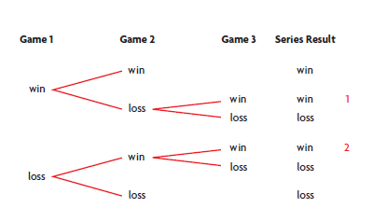
d) yes, the possibilities include type of transmission, air conditioning option, type of window AND GPS option
4a) b) Two ways, WLW and LWW

5)20 6) 360 7) 120 8) 18 9a) 59049 b) 15120 10) 256
11a) 17576000 b) 9261000 12) 20000 13) 19683 14) 65
15a) 320 b) 4 16a) 13824000 b) 124416000
17) If multiple tasks are related by AND, it means the Fundamental Counting Principle can be used and the total number of solutions is the product of the solutions to each task. For example: A 4 digit PIN involves choosing the 1st digit AND the 2nd digit AND the 3rd digit AND the 4th digit. So the number of solutions is 10 x 10 x 10 x 10 = 10000. OR means the solution must meet at least one condition so you must add the number of solutions to each condition, and then subtract the number of solutions that meet all conditions. For example, calculating the number of 4 digit PINs that start with 3, plus the number of PINs that end with 3, minus the number of PINs that both start and end with 3: 1000 + 1000 – 100 = 1900
18a) i) 8 in 52 or 2 in 13 ii) 26 in 52 or 1 in 2 iii) 16 in 52 or 4 in 13 b) No because the Fundamental Counting Principle only applies where tasks are related by the word AND
19) 36 20) 1 in 1024 21) 359
22) The Fundamental counting principle is used to calculate the number of ways a set of tasks can occur in a counting problem. The product of the number of ways each task can occur results in the number of ways that all the tasks can occur. Look for the connecting word AND between each task to identify when the Fundamental Counting Principle should be used. If a problem involves two or more tasks connected by the word, OR, the fundamental counting principle does not apply. In this type of problem, the number of ways each task can occur are added together.
Practice #2
1a) 720 b) 362880 c) 20 d) 8 e) 12 f) 2520
2a) 6 b) 6 3a) 5! b) $\frac{9!}{6!}$ c) $\frac{15!}{12!4!}$ d) $\frac{100!}{98!}$
4a) undefined, can’t have negative b) defined c) undefined, must be natural number
- Undefined, must be natural number
5a) 40320 b) 132 c) 28 d) 42 e) 720 f) 33
6a) n b) (n+4)! c) n + 1 d) n(n-1)(n-2)
- (n + 5)(n + 4) f) $\frac{1}{n-1}$
7) 362880 8) 120 9) 720 10) 28! Or 3.048883446 x 10²⁹
11a) 9 b) 1 c) 9 d) 6
12) 40320 13) 5040 14) 120 15) 5040
16a) YKONU; NOKUY; KONYO b) 120
17a) $n≥4$ b) $1≤n≤3$ or {1, 2, 3} 18) 725760
19) ie. Suppose that 10 people log in to an online ticket website at the same time to purchase concert tickets to the same show. In how many different ways can the computer put their requests in the quene for the processing agent?
20) Factorial notation is a short form for representing the product of decreasing consecutive natural numbers. n! = n(n – 1)(n – 2) … (3)(2)(1) The expression n! can be used to calculate the number of ways you can make ordered arrangements, or permutations, using n different objects.

Practice #3
1a) 20 b) 20160 c) 30240 d) 1 e) 5040 f) 360360
2a) b) 12 c) 12
President | Vice-President
Kelly | Jess
Kelly | Sam
Kelly | Evan
Jess | Kelly
Jess | Sam
Jess | Evan
Sam | Kelly
Sam | Jess
Sam | Evan
Evan | Kelly
Evan | Jess
Evan | Sam
3a) 360 b) 6 4) ₁₀P₈ = 1814400; ₁₀P₂ = 90; ₁₀P₈ is more
5)504 6) 32760 7) 40320 8) ₅₀₀₀P₃ = 1.2492501 x 10¹¹
9) 100000000 10a) 95040 b) 7920 c) 1440
11a) 360 b) 1296 c) Yes, if you replace the marble, there are more possibilities for the next draw.
12a) 1860480 b) 3200000 13a) 5040 b) 4960
14a) 311875200 b) 2.53% c) 0.05%
15a) 5 b) 8 16a) 2 b) 3
17a) ie. The formulas for both _{n}P_{n} and _{n}P_{r} have a numerator of n!. However the formula for _{n}P_{n} has a denominator of 1 and the formula for _{n}P_{r} has a denominator of (n – r)!
b)ie. A group of friends each order a different flavor of ice cream from a shop with 12 flavors. How many possibilities are there if the group is 12 people? If the group is 7 people?
18) Suppose you have a group of n different objects, and you need to create ordered arrangements usiing only r of those objects. You can calculate the number of ways this can be done using the formula _{n}P_{r} = $\frac{n!}{\left(n-r\right)!}$

Practice #4
1)90 2) 20 3) 2450448 4) 1260
5a) 120 b) 2520 c) 20160 d) 39916800
6a) 756756 b) 6
7) ie. A shish kabob skewer has 4 pieces of beef, 2 pieces of green pepper and 1 piece each of mushroom and onion. How many different arrangements are possible?
8a) 126 b) 1716 9) 1287 10a) 560 b) 180
11) 56 12a) 1260 b) 35 13) 168
14a) 560 b) 10080
15) ie. BANDITS has 7 different letters, so the number of permutations is 7!. BANANAS also has 7 letters, but there are 3 As and 2Ns so you must divide 7! By 3! x 2! = 12
16a) 2.375880867 x 10¹⁵ b) 3.05540235 x 10¹¹
17a) 14 b) $\frac{1}{14}$ 18) 1680
19) ie. _{n}P_{n} will be too high, it gives the number of arrangements of all n items, but some of the arrangements will be identical because of the a identical items in the group
20) Since all permutations of a set of objects must be different, all repeated arrangements caused by any identical objects in the set have to be eliminated.

Practice #5
1a) 6 b) c) 1
Canned | Dry | Fruits/Veg
Brian | Rachelle | Leah
Brian | Leah | Rachelle
Rachelle | Brian | Leah
Rachelle | Leah | Brian
Leah | Rachelle | Brian
Leah | Brian | Rachelle
d)Parts a and b involved permuations because order matters. Part c involved combinations because order does not matter.
2) Order matters for permuations but not for the combinations. One group of 4 objects is one combination, but the 4 objects can be put in 4! = 24 different orders to make 24 different permuations.
3) 210 4) 220
5) Order does not matter when counting combinations, but it does matter for permutations. Think about how you could arrange a set of three different letters (A, B and C) in a row of three letters. There are six permutations (ABC, ACB, BAC, BCA, CAB, CBA). However, because order does not matter when you count combinations, those six permuations are all the same combination (ABC)
Practice #6
1a) VS, VC, VB, SV, CV, BV, SC, SB, CS, BS, CB, BC b) VS, VC, VB, SC, SB, CB
- The number of two flavor permutations is double the number of two flavor combinations because each two flavor combination can be written in two different ways.
2a) 10 b) 10 c) The numbers are the same because by choosing 3 out of 5 people for a committee, you are also choosing 2 out of 5 people not to be on this committee. Therefore, the number of ways of choosing 3 out of 5 is the same as the number of ways of choosing 2 out of 5.
3)924 4a) 10 b) 9 c) 15 d) 1 e) 924 f) 8
5) 210 6) 3478761 7) 752538150
8a) Combinations – the order within the starting lineup is not important b) 3003
9) 560 10a) 252 b) 120 c) 6 d) 6 e) 66
11) 27720 12a) 1 b) 90858767 c) No, the chance of winning is 1 in 90858768
13) 9212 14a) 0.51% b) 4.2% c) $\frac{1}{13019909}$
15a) 5 total, use 3 b) 10 total, use 2 c) 5 total, use 3
16a) n = 6; $n≥2$ b) n = 7; $n≥4$ c) n = 7, n = 2; $n≥2$
- R = 4 or r = 2 $0≤r≤6$
17a) Combinations and Permutations both involve choosing objects from a group. For permutations, order matters. For combinations, order does not matter. For example, abc and bac are different permutations but the same combinations.
b)Divide _{n}P_{r} by r! to get _{n}C_{r}. For example, ₆C₄ = 15 and ₆P₄ = 360; $\frac{360}{4!}$=15

Practice #7
1a) Combination b) Permuation c) Permutation d) Permutation
2)A is combination; B is permutation
3a) 1 b) 56 4) 28561 5a) 304278004800
5b) 320000000000 6) 180 7) 113400 8) 300
9) 240 10a) 60 b) 6 11) 125000
12) 462 13) 60060 14) 2569788 15) 40.8% 16) 72
17) First, determine if order is important. If it is, use a permutation model. If not, use a combination model. Look for conditions. Consider these first as you develop your solution. If there is a repetition of r of the n objects to be eliminated, it is usually done by dividing r!. If a problem involves multiple tasks that are connected by the word AND, then the fundamental counting principle can be applied: multiply the number of ways that each task can occur. If a problem involves multiple tasks that are connected by the word OR, the fundamental counting principle does not apply: add the number of ways that each task can occur. This typically is found in counting problems that involve several cases.

Practice #8
1)$\frac{1287}{752538150}$ or about 0.00000171 2) 0.015 3a) 0.015
3b) 0.455 c) 0.348 4a) .0079 b) .0143
5a) .000366 b) .0022 6a) 0.4 b) 0.6
7a) .0000000053 b) .00415 c) .0601 8) .343

Outcome FM30-7A
OUTCOMES | ASSESSMENT RUBRICS
FM30.7 Demonstrate understanding of the representation and analysis of data using:
- polynomial functions of degree ≤ 3
- logarithmic functions
- exponential functions
*sinusoidal functions
Level  Criteria | Intervention 1  Spend some extra time with the criteria and ask for help. | Instructional 2  Good start. You are beginning to make sense of this on your own. You are consistent with the basic learning goals for this outcome. | Independence 3  You did it and you did it on your own. You are able to complete the processes for this outcome. Your work is thorough and consistently accurate. | Mastery 4  Great work! This is going extra well for you. You have understood the outcome, are able to explain your strategies and apply these to situations. Your work is always accurate.
Outcome 30-7A Represent data, using polynomial functions (of degree  ≤ 3), to solve problems. | I need more help with becoming consistent with the criteria. | I can match equations of polynomial functions to their corresponding graphs  I can graph and determine (with technology) the polynomial function that best approximates the data. | I can determine the characteristics of polynomial functions from their graphs or equations  I can identify the degree and sign of the leading coefficient for a polynomial function .  I can interpolate and extrapolate data from polynomial situations | I can demonstrate my understanding of polynomial functions. This may be done through interpreting graphs of polynomial functions to describe the situations that each function models and explain the reasoning or solve situational questions that involve data that is best represented by graphs of polynomial functions and explain the reasoning.

Matching Activity
Try to match the following terms. Some of these you learned in Math 10 and Math 20. Feel free to google these terms to match the definitions.
____ scatterplot | - A polynomial function with degree 0; for example f(x) = 5x⁰
____ Polynomial Function | - The set of possible x values; for example $\left\{x\left|x∈R\right.\right\}$
____ End Behaviour | - A polynomial function with degree 2; for example f(x) = 2x² – x + 1
____ Constant Function | - The point(s) where the function intersects/touches the x-axis
____ Linear Function | - The coefficient of the term with the greatest degree in a polynomial function in standard form; for example in f(x) = 2x³ + 7x it is 2
____ Quadratic Function | - A set of points on a grid, used to visualize a relationship or possible trend in the data
____ Cubic Function | - A value that does not change
____ Turning Point | - A function that contains only the operations of multiplication and addition with real-number coefficients, whole number exponents, and two variables, for example f(x) = 5x³ – 3x + 7
____ Domain | - The value of the highest exponent in a function
____ Range | - A polynomial function with degree 1; for example f(x) = 2x + 1
____ x-intercepts | - f(x) = ax³ + bx² + cx + d where a ≠ 0
____ y-intercepts | - Any point where the graph of a function changes from increasing to decreasing or decreasing to increasing
____ standard form for a linear function | - f(x) = ax² + bx + c where a ≠ 0
____ standard form for a quadratic function | - The description of the shape of the graph, from left to right, on the coordinate plane
____ standard form for a cubic function | - The set of possible y values; for example $\left\{y\left|y∈R\right.\right\}$
____ constant term | - The point where the function intersects/touches the y-axis
____ leading coefficient | - A polynomial function with degree 3; for example f(x) = 2x³ + 3x² – 2x
____ Degree | - f(x) = ax + b where a ≠ 0

Exploring the Graphs of Polynomial Functions
- Polynomial Functions – A function that contains only the operations of multiplication and addition with real number coefficients, whole number exponents, and two variables; for example: f(x) = 5x³ – 3x + 7 which can also be written as f(x)=5(x)(x)(x)+(-3)x + 7

- Polynomial functions are named according to their degree. Polynomial functions of degrees 0, 1, 2, and 3 are called constant, linear, quadratic and cubic functions, respectively. The terms in a polynomial function are normally written so that the powers are in descending order. For example,
A constant function, degree 0: f(x) = 5x⁰
A linear function, degree 1: f(x) = 2x¹ + 1
A quadratic function, degree 2: f(x) = 2x² – x + 1
A cubic function, degree 3: f(x) = 2x³ + 3x² – 2x
- Scatter plot – A set of points on a grid, used to visualize a relationship or possible trend in the data.
- End Behavior – The description of the shape of the graph, from left to right, on the coordinate plane
- Cubic Function – A polynomial function of the third degree, whose greatest exponent is three, for example, f(x) = 5x³ + x² – 4x + 1
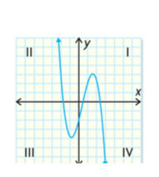
- Turning Points – Any point where the graph of a function changes from increasing to decreasing or from decreasing to increasing, for example, this curve has two turning points, since the y-values change from decreasing to increasing to decreasing:

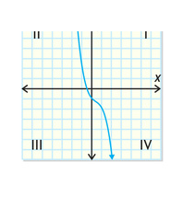

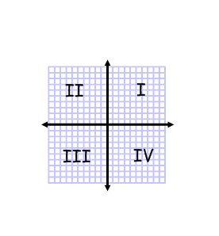

This curve does not have any turning points,
since the y-values are always decreasing:

- Cartesian grids are divided into four quadrants by the x-axis and y-axis.
Quadrants are identified using roman numerals, from I to IV, starting
from the top right and progressing counter clockwise around the origin.
- The degree of a polynomial function determines the shape of the function
- The graphs of polynomial functions of the same degree have common characteristics
- The chart below shows sample sketches of functions and displays all the possibilities for the x-intercepts, y-intercepts, end behaviour, range, and number of turning points for each type of function.

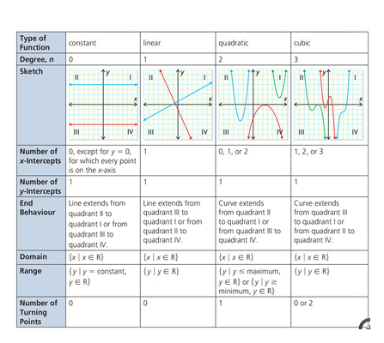

Outcome FM30-7A Practice #1
- Determine which graphs represent polynomial functions. Explain how you decided.
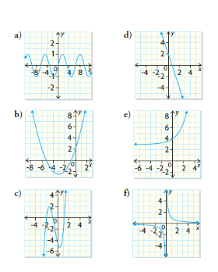
- Determine the following characteristics for each polynomial function in question #1.
- X-intercepts
- Y-intercept
- Domain
- Range
- End behavior
- Number of turning points

Graphing Polynomial Functions
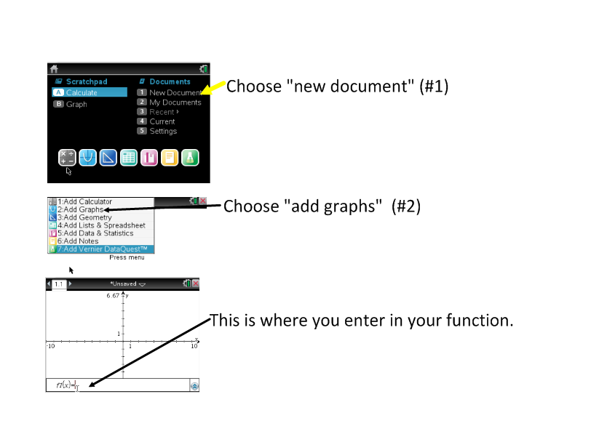
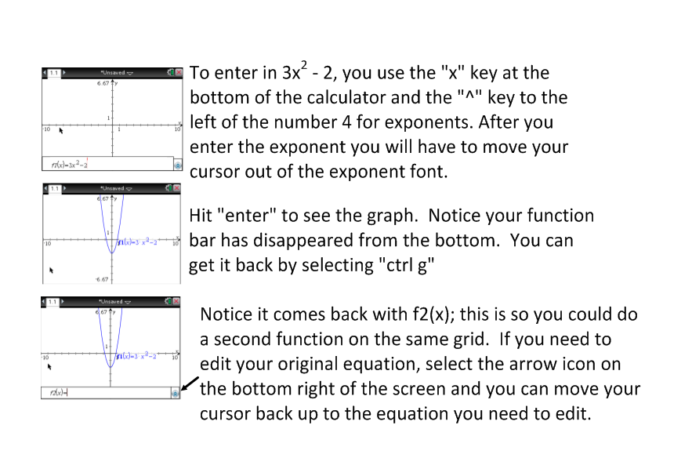
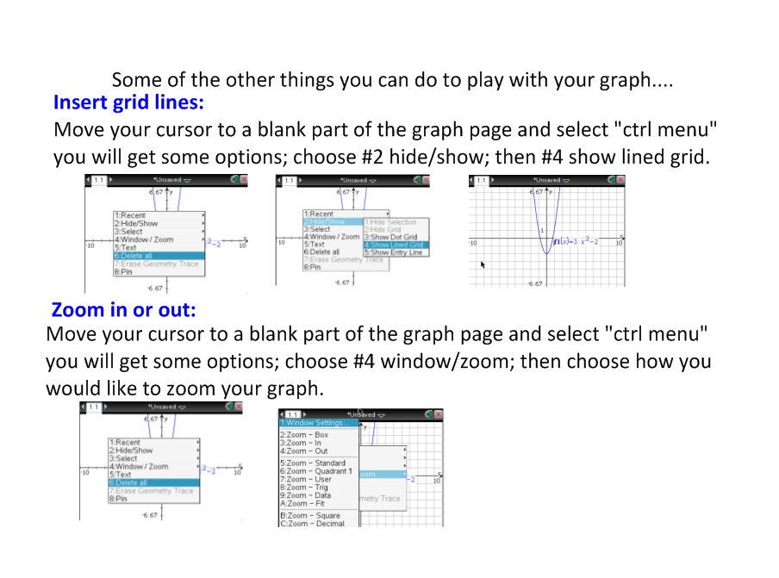
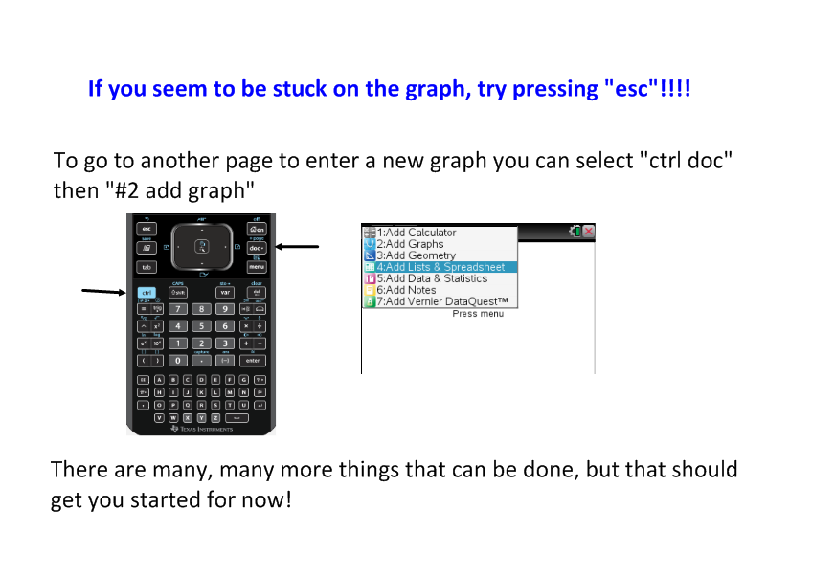
Outcome FM30-7A Practice #2
- Graph each polynomial function below. Determine the following characteristics of each function:
- Number of x-intercepts
- Y-intercept
- End behavior
- Domain
- Range
- Number of turning points
- f(x) = 3x – 1 b) f(x) = x² + 4
- f(x) = -2x³ – 5x + 3 d) f(x) = 5x³
- f(x) = -3 f) f(x) = -(x + 3)² + 2

- For each type of polynomial function below, sketch graphs to show all possible numbers of x-intercepts.
- Linear b) quadratic c) cubic

Characteristics of the Equations of Polynomial Functions
- Standard Form – The standard form for a linear function is F(x) = ax + b where a ≠ 0. The standard form for a quadratic function is f(x) = ax² + bx + c where a ≠ 0. The standard form for a cubic function is f(x) = ax³ + bx² + cx + d where a ≠ 0.
- Leading Coefficient – The coefficient of the term with the greatest degree in a polynomial function in standard form; for example, the leading coefficient in the function f(x) = 2x³ + 7x is 2.
- Constant Term – A term that does not change value; for example in f(x) = 3x + 2, 2 is the constant term
- When a polynomial function is in standard form:
- The maximum number of x-intercepts the graph may have is equal to the degree of the function
- The maximum number of turning points a graph may have is equall to one less than the degree of a function
- The degree and leading coefficient of the equation of a polynomial function indicate the end behavior of the graph of the function
- The constant term in the equation of a polynomial function is the y-intercept of its graph
- Linear and cubic polynomial functions with positive leading coefficients have similar end behavior. Linear and cubic polynomial functions with negative leading coefficients also have similar end behavior.
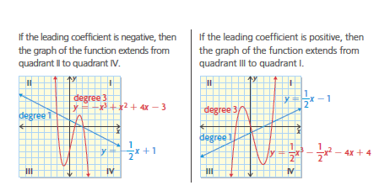
- Quadratic polynomial functions have unique end behavior.
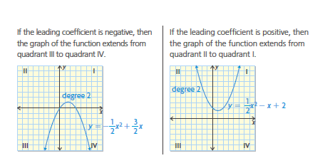

Outcome FM30-7A Practice #3
- Determine the following characteristics of each function:
- Degree
- Leading coefficient
- Constant term
- End behavior
- Number of possible x-intercepts
- Y-intercept
- Domain
- Range
- Number of possible turning points
- F(x) = -2x + 5
- V(x) = x² + 2x – 6
- U(x) = x³ – x² + 5x – 1
- W(x) = -2x³ + 4x
- G(x) = -x² + x + 5
- H(x) = x(x + 2)
- P(x) = 5x + 6 – x³
- Q(x) = -x – 1
- R(x) = $\frac{3}{2}$x³ – 2x²

- Match each graph with the correct polynomial functions. Justify your reasoning.
$i) y=-x^{3}+x+4$ ii) y = 2x² + 6x + 4 iii) y = (x + 1)(x + 2)
$iv) y=x^{3}-2x^{2}+6x+4$ v) y = 3 – x vi) y = -2x + 3
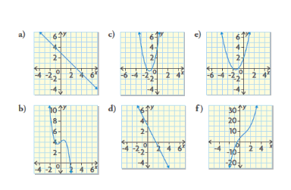

- Match each graph with the correct polynomial function. Justify your reasoning.
$i) f\left(x\right)= -x^{3}+6x^{2}-4x$ $ii) g\left(x\right)=2x^{3}-x^{2}-x+3$
$iii) h\left(x\right)= -x^{3}+2x^{2}-x+3$ $iv) j\left(x\right)= x^{3}-4x^{2}$
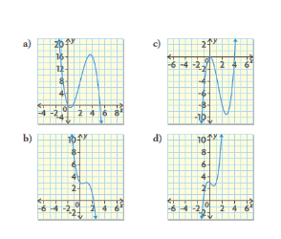

- Explain why cubic functions may have one, two, or three x-intercepts. Use sketches to support your explanation.
- Explain why quadratic polynomial functions have maximum or minimum values, but cubic polynomial functions have only turning points.
- The average retail price of gas in Canada from 1979 to 2008, can be modelled by the polynomial function P(y) = 0.008y³ – 0.307y² + 4.830y + 25.720 where P is the price of gas in cents per litre and y is the number of years after 1979.
- Describe the characteristics of the graph of the polynomial function
- Explain what the constant term means in the context of this problem.

- Suppose that you wanted to describe the graph or equation of a polynomial function and were allowed to ask only three questions about the function. What questions would you ask? Why?
- How can you tell whether a given equation represents a polynomial function?
- How can you describe the characteristics of the graph of a polynomial function by looking at the equation of the function?
- For each type of polynomial function below, write an equation that has a y-intercept of 5.
- Constant b) linear c) quadratic d) cubic

Modelling Data with a Line of Best Fit
- The independent variable is the variable that is being manipulated. The dependent variable is the variable that is being observed. The independent variable is always placed on the horizontal axis of a graph
- Line of Best Fit – A straight line that best approximates the trend in a scatterplot
- Regression Function – A line or curve of best fit, developed through a statistical analysis of data
- Interpolation – The process used to estimate a value within the domain of a set of data, based on a trend
- Extrapolation – The process used to estimate a value outside the domain of a set of data, based on a trend
- A scatterplot is useful when looking for trends in a given set of data
- If the points on a scatterplot seem to follow a linear trend, then there may be a linear relationship between the independent variable and the dependent variable. Technology can be used to determine and graph the equation of the line of best fit.
- Technology uses linear regression to determine the line of best fit. Linear regression results in an equation that balances the points in the scatterplot on both sides of the line
- A line of best fit can be used to predict values that are not recorded or plotted. Predictions can be made by reading values from the line of best fit on a scatterplot or by using the equation of the line of best fit.
- Using technology to create a scatterplot and find line of best fit:
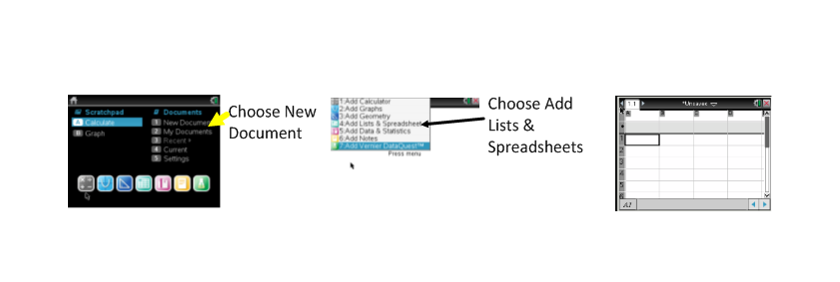
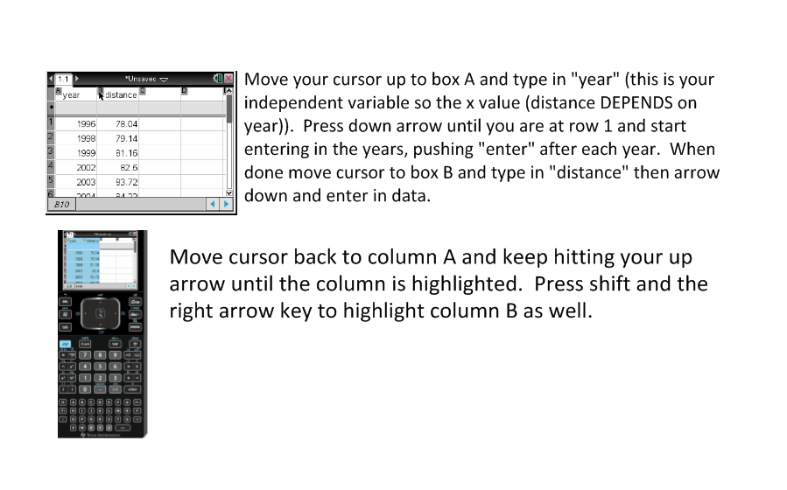
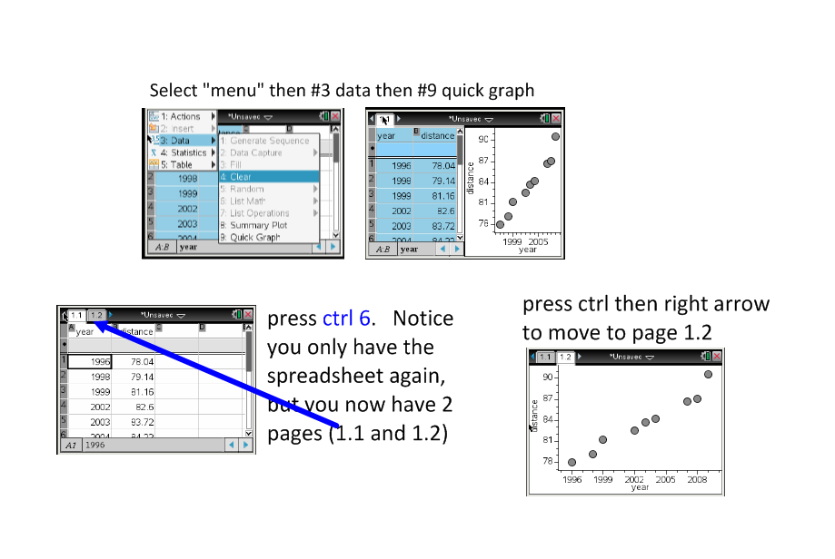
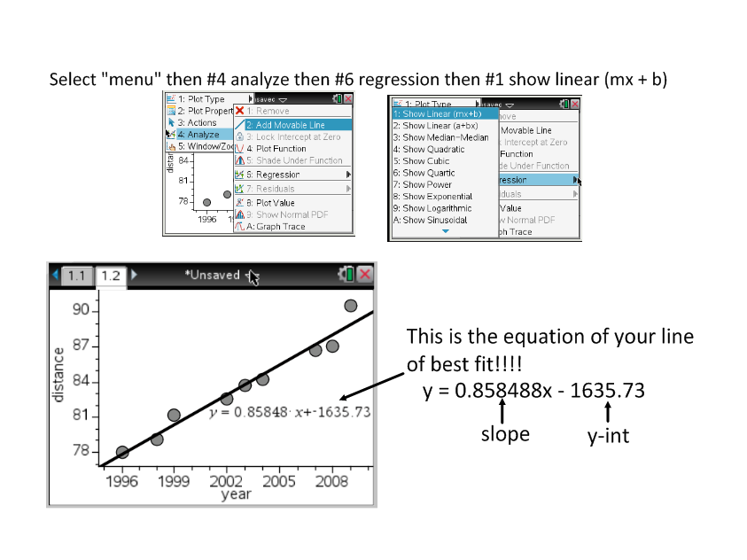

- Using the trace feature on your calculator:

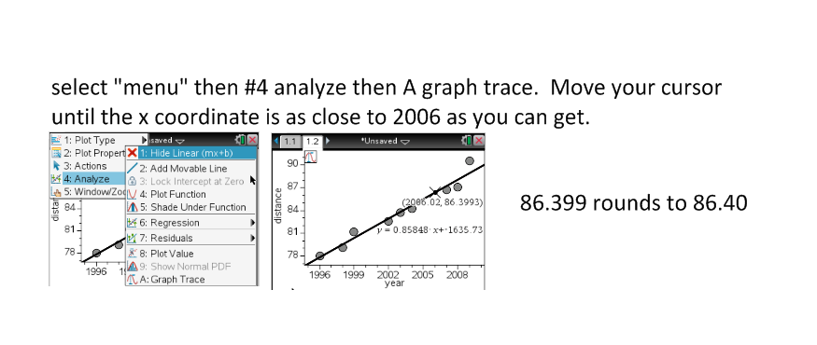
- Sometimes you have to zoom when you are tracing the graph:
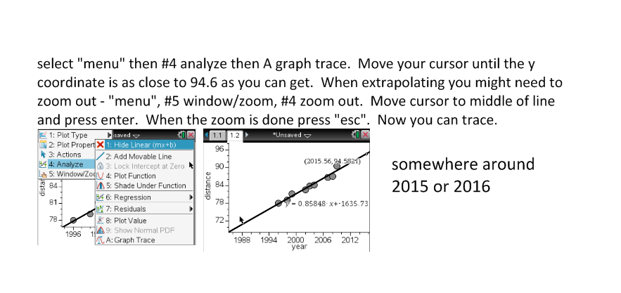
- Sometimes when you are interpolating or extrapolating, you may need to round to the nearest whole number, if your data is discrete. For example, if you want to find out how many t-shirts need to be sold, you would round to the next highest whole number - if your estimate gave 4.25, you would say you needed 5 t-shirts.

Outcome FM30-7A Practice #4
- The world record time for the men’s 100 m sprint was 10.00s in 1960. The table below shows the world record times since 1960.
Years after 1960 | 0 | 8 | 23 | 31 | 36 | 39 | 45 | 48 | 49
Time (s) | 10.00 | 9.95 | 9.93 | 9.86 | 9.84 | 9.79 | 9.77 | 9.72 | 9.58
- Create a scatterplot to display the data
- Describe the characteristics to the trend in the data
- Determine the equation of the linear regression function that models the data. What do the slope and y-intercept of the equation represent in this context?
- Interpolate a possible world record time for 2007.
- Asafa Powell, from Jamaica, accomplished a world record time on September 9, 2007. Research his time, and determine the difference between this actual time and your estimate.

- Devin is on a budget. He is trying to decide how many graduation events he can afford to attend this year. He interviewed 15 of his older brother’s friends to see how much money they spent, compared to the number of events they attended. The data he collected is recorded in the table below.
Number of Events | 1 | 3 | 4 | 2 | 1 | 3 | 3
Money Spent ($) | 200 | 1300 | 1500 | 400 | 150 | 1100 | 900
Number of Events | 5 | 4 | 3 | 2 | 4 | 3 | 2 | 2
Money Spent ($) | 1500 | 1450 | 1100 | 100 | 1100 | 800 | 300 | 600
Devin estimates that he has about $750 to spend on graduation events. Use linear regression to estimate how many events Devin should attend.

- According to Statistics Canada, the life expecancy for Canadians has been increasing over the past few decades.
 | Life Expectancy (years)
Years | Male | Female
1920 to 1922 | 59 | 61
1930 to 1932 | 60 | 62
1940 to 1942 | 63 | 66
1950 to 1952 | 66 | 71
1960 to 1962 | 68 | 74
1970 to 1972 | 69 | 76
1980 to 1982 | 72 | 79
1990 to 1992 | 75 | 81
2000 to 2002 | 77 | 82
- Create two scatter plots: one for the male data and one for the female data.
- Determine the equation of a linear regression function that models each set of data.
- Use your equations to estimate the life expectancy of males and females in 2010.
- The table below shows the normal high temperatures (in degrees Celsius) during the first fifteen days of April in Saskatoon.
Day | 1 | 2 | 3 | 4 | 5 | 6 | 7 | 8 | 9 | 10 | 11 | 12 | 13 | 14 | 15
High | 3.4 | 3.8 | 4.2 | 4.7 | 5.2 | 5.7 | 6.1 | 6.6 | 7.1 | 7.5 | 8.0 | 8.4 | 8.9 | 9.4 | 9.8
- Draw a scatterplot of the data.
- Determine the equation of a linear regression function that models the set of data
- Use your equation to predict the normal high temperature from April 20.
Modelling Data with a Curve of Best Fit
- Curve of Best Fit – A curve that best approximates the trend on a scatter plot.
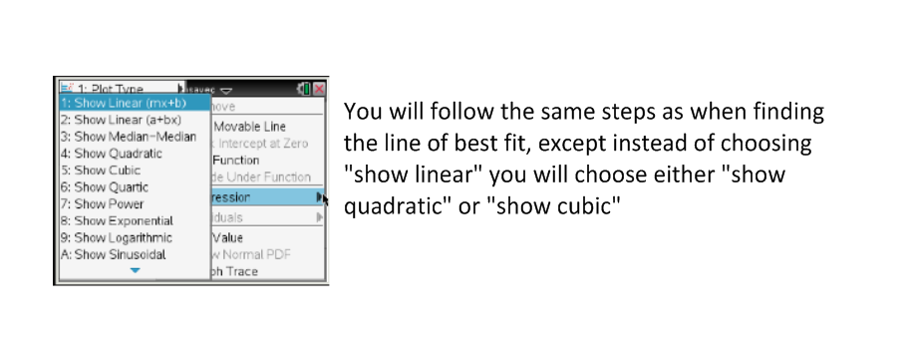
Outcome FM30-7A Practice #5
- A dolphin jumped out of the water in a tank and then dove back in. The dolphin’s height, in metres, above the wateris given in the table below.
Height (m) | 0.59 | 1.22 | 1.39 | 0.73 | -1.45
Time (s) | 0.5 | 1 | 1.5 | 2.5 | 3.5
- Use technology to plot the data as a scatter plot.
- Use quadratic regression to create a curve of best fit.
- Estimate the maximum height of the dolphin during the jump.
- A spherical balloon is being inflated. The volume, V, in cubic centimetres is related to the time, t, in seconds.
Volume, V(cm³) | 33.51 | 113.10 | 268.08 | 523.60 | 904.78
Time, t (s) | 0 | 1 | 2 | 3 | 4
- Use technology to plot the data as a scatter plot. Describe the trend you see.
- Use cubic regression to create a curve of best fit.
- Determine the volume of the balloon at 10.5s.
- A 225 L hot water tank sprung a leak at t = 0 min. The remaining volume was measured every 5 min for the first 40 min.
Volume V(L) | 225 | 188 | 155 | 124 | 100 | 72 | 55 | 36 | 23
Time, t(min) | 0 | 5 | 10 | 15 | 20 | 25 | 30 | 35 | 40
- Plot the data as a scatter plot. Describe the trend.
- Determine the equation of the quadratic regression function that models the data.
- Determine when the tank was half full
- Determine when the tank was empty.

- In an experiement, the volume, V, of 1 kg of water is measured as its temperature, T, is increased.
Volume, V(cm³) | 999.87 | 999.75 | 1000.01 | 1000.59 | 1001.44 | 1002.52 | 1003.76
Temp, T (C) | 0 | 5 | 10 | 15 | 20 | 25 | 30
- Plot the data as a scatter plot.
- Determine the equation of the cubic regression function that models the data.
- Interpolate the temperature at which the water has the minimum volume.
- Extrapolate the volume of water at a temperature of 40 C.
- Why is it better to use the regression function when interpolating from a set of data, rather than just using the data?
- How can you solve a problem involving a data set that can be modelled using a polynomial function?

Answers
Matching Activity
Scatterplot – f; polynomial function – h; end behavior – n; constant function – a; linear function – j; quadratic function – c; cubic function – q; turning point – L; domain – b; range – o; x-intercepts – d; y-intercepts – p; standard form of linear function – r; standard form of quadratic function – m; standard form of cubic function – k; constant term – g; leading coefficient – e; degree – i

Practice #1
- B, c, d are polynomial functions; a is a trig function, e is an exponential function and f is a rational funtion
- B) x-intercept at -1 and -5; y-intercept at 2; domain is x $∈$ R or (-$∞,∞$); range is [-2.2,$∞$ ) or $\{\left.y\right|y≥-2.2,y∈R\}$; end behavior – begins in quad II and ends in quad I; number of turning points – 1
2C) x-intecept at -2, -1, and 1; y-intercept at -4.5; domain is x $∈$ R or $(-∞,∞)$; range is y$∈$R or $(-∞,∞)$; end behavior is begins is quad III and ends in quad I; number of turning points is 2
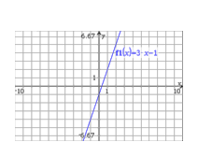
2D) x-intercept is 0.5; y-intercept is 2; domain is x $∈$ R or $(-∞,∞)$; range is y$∈$R or $(-∞,∞)$; end behavior is begins in Quad II and ends in Quad IV; number of turning points is 0.

Practice #2
1a) number of x-int is 1
y-int is -1
end behavior is begins is QIII and ends in QI
domain is $(-∞,∞)$ or $x∈R$
range is $(-∞,∞)$ or $y∈R$
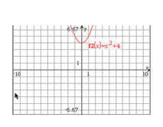
# of turning points is 0
- Number of x-intercepts is 0
y-int is 4
end behavior is begins in QII and ends in QI
domain is $\left(-∞,∞\right)$ or $x∈R$
range is $[4, ∞)$ or $\{\left.y\right|y≥4,y∈R\}$
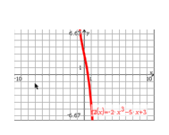
# of turning points is 1
- Number of x-int is 1
y-int is 3
end behavior is begins in QII and ends in QIV
domain is $(-∞,∞)$ or $x∈R$
range is $(-∞,∞)$ or $y∈R$
# of turning points is 0

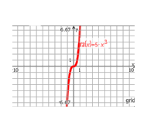
- Number of x-int is 1
y-int is 0
end behavior is begins is QIII and ends in QI
domain is $(-∞,∞)$ or $x∈R$
range is $(-∞,∞)$ or $y∈R$
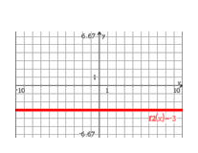
# of turning points is 0
- number of x-int is 0
y-int is -3
end behavior begins in QIII and ends in QIV
domain is $(-∞,∞)$ or $x∈R$
range is $\{\left.y\right|y=-3,y∈R\}$
# of turning points is 0

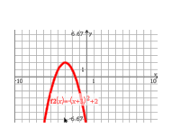
- Number of x-int is 2
y-int is -7
end behavior begins is QIII and ends in QIV
domain is $(-∞,∞)$ or $x∈R$
range is $\{\left.y\right|y≤2,y∈R\}$
# of turning points is 1
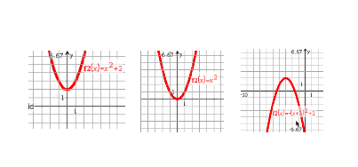
2a) 1 x-intercept b) 0, 1 or 2 x-interepts

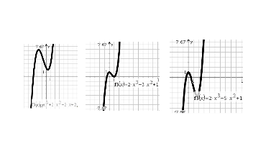

c)1, 2 or 3 x-intercepts

Practice #3
1.
Q# | degree | Leading  coefficient | Constant  Term | End  behavior | #x-int | y-int | domain | range | # turn  points
A | 1 | -2 | 5 | QII to QIV | 1 | 5 | $\left(-∞,∞\right)$ or $x∈R$ | $(-∞,∞)$ or $y∈R$ | 0
B | 2 | 1 | -6 | QII to QI | 2 | -6 | $(-∞,∞)$ or $x∈R$ | $$\{\left.y\right|y≥ min,y∈R\}$$ | 1
C | 3 | 1 | -1 | QIII to QI | 1, 2 or 3 | -1 | $(-∞,∞)$ or $x∈R$ | $(-∞,∞)$ or $y∈R$ | 0 or 2
D | 3 | -2 | 0 | QII to QIV | 1, 2, or 3 | 0 | $(-∞,∞)$ or $x∈R$ | $(-∞,∞)$ or $y∈R$ | 0 or 2
E | 2 | -1 | 5 | QIII to QIV | 2 | 5 | $(-∞,∞)$ or $x∈R$ | $$\{\left.y\right|y≥ max,y∈R\}$$ | 1
F | 2 | 1 | 0 | QII to QI | 1 | 0 | $(-∞,∞)$ or $x∈R$ | $$\{\left.y\right|y≥ min,y∈R\}$$ | 1
g | 3 | -1 | 6 | QII to QIV | 1, 2, or 3 | 6 | $(-∞,∞)$ or $x∈R$ | $(-∞,∞)$ or $y∈R$ | 0 or 2
H | 1 | -1 | -1 | QII to QIV | 1 | -1 | $(-∞,∞)$ or $x∈R$ | $(-∞,∞)$ or $y∈R$ | 0
I | 3 | $$\frac{3}{2}$$ | 0 | QIII to QI | 1, 2 or 3 | 0 | $(-∞,∞)$ or $x∈R$ | $(-∞,∞)$ or $y∈R$ | 0 or 2

2)i matches with b; ii matches with c; iii matches with e; iv matches with f; v matches with a;
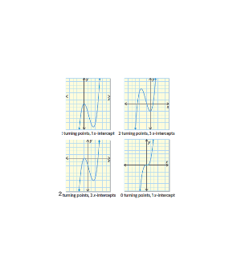
vi matches with d

3)i matches with a; ii matches with d; iii matches with b; iv matches with c
4) ie. A cubic function may have zero or two turning points. IF there are no turning points, the function has only one x-intercept. IF there are two turning points, the function may have one, two or three x-intercepts, depending on the values of a, b, c and d in the function
y = a³ + b² + c + d

- Ie. Cubic functions may have turning points, but they do not have any maximum or minimums. Quadratic functions have one turning point. The point at which they turn (the vertex) defines the functions maximum or minimum.
- A) The degree is 3, so it is a cubic function. The leading coefficient is positive, so the function is increasing from left to right. The graph extends from quadrant III to quadrant I. It has a y-intercept of 25.720 and may have 1, 2 or 3 x-intercepts.
b)The price of gas in 1979
7) ie. Ask for the degree of the function to determine the end behavior. Ask for the value of the leading coefficient to determine which quadrants the end behavior extends to and whether the function is increasing or decreasing from left to right. Ask for the number of x-intercepts to determine how many times the function crosses the x-axis. These questions will enable you to draw a rough sketch of the graph and determine a plausible equation.

8) A polynomial function is a function in which the coefficients are real numbers and the exponents of the varibales are whole numbers. It involves only multiplication and/or addition of real numbers and variables. For example, consider the following functions:
$a) y={3x}^{2}-5x^{3}+\frac{1}{2}x$ $b) y=\sqrt{x}+4x^{2}-3$
$c) y=\frac{x+3}{2x-5}$ $d) y=\sqrt{5}x^{2}+8x-10$
Only a and d are polynomial functions

9) The degree of the function, the sign of the leading coefficient, and the constant term can be used to describe the characteristics of the graph.
* The maximum number of x-intercepts of a polynomial function is equal to its degree
* The constant term is always the y-intercept of the graph
* If the function is linear or cubic and the leading coefficient is
- negative, then the function extends from quadrant II to quadrant IV
- positive, then the function extends from quadrant III to quadrant I
* If the function is quadratic and the leading coefficient is
- negative, then the graph extends from quadrant III to quadrant IV
- positive, then the graph extends from quadrant II to quadrant I
* All polynomial functions have the domain $\left(-∞,∞\right)$ or $x∈R$
* Linear and cubic functions have range $\left(-∞,∞\right)$ or $y∈R$
* Quadratic functions have the range restriced by their maximum or minimum value: $\left\{\left.y\right|y≥minimum,y∈R\right\}or\{\left.y\right|y≤maximim, y∈R\}$
* IF the function is
- cubic then there are no turning points or two turning points
- quadratic, then there is one turning point
- linear, then there is no turning point, the function is a line

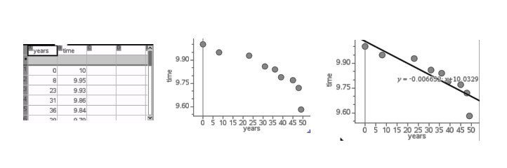
10a) ie. Y = 5 b) ie. Y = 3x + 5 c) ie. Y = 4x² + 3x + 5 d) ie. Y = -5x³ + x² – x + 5

Practice #4
1)

- See middle picture above for scatterplot
- As the years increase, the world record time decreases
- Y = -0.006….x + 10.032…; the slope represents the rate at which the world record time in seconds decreases each year; the y-intercept represents the world record time in 1960(year 0)
- Approx 9.75s

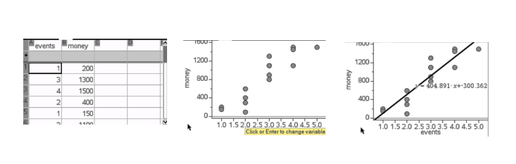
- 9.74s. My estimate was very close

2 events to ensure he doesn’t go over budget

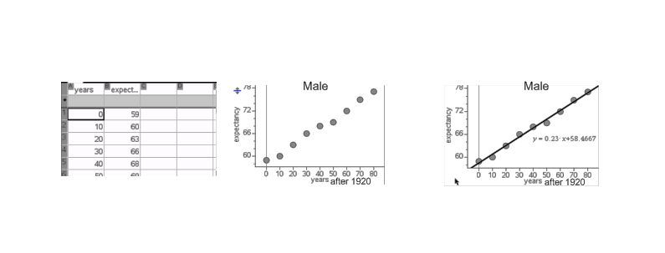
3)

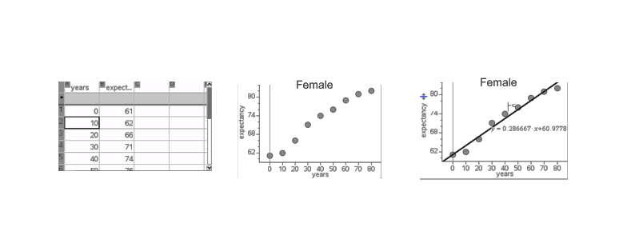

b)males: y = 0.23x + 58.466; female: y = 0.286x + 60.977
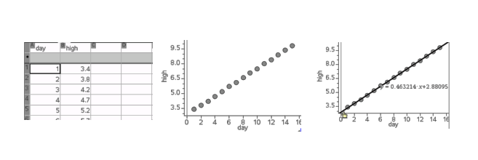
c)males: 79 years; females: 87 years

4)

b)y = 0.463214x + 2.88095
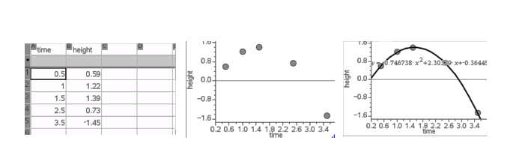
c) 12.1 C

Practice #5
- A)

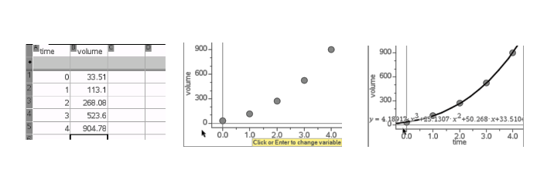
b)y=-0.746738x² + 2.30339x – 0.36445
c) 1.41m

2)

Ie. As time increases, volume increases at a faster rate.
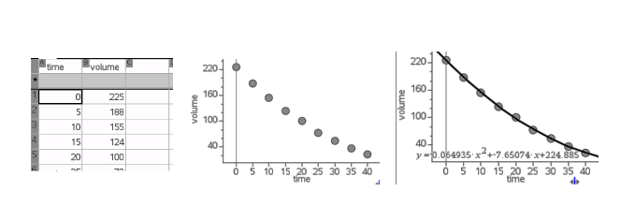
b)y = 4.189x³ + 25.130x² + 50.267x + 33.510
c) 8181.47 cm³

3)

- As time increases, the volume decreases
- V = 0.064t² – 7.650t + 224.885
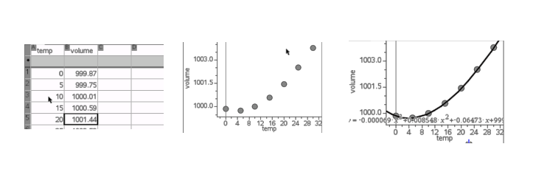
- 17.2 min
- 56.2 min

4)

b)y=-0.000069x³ + 0.008548x² – 0.06473x + 999.87
c) 40 C
d) 1006.55 cm³

5) Sometimes, just using the data to interpolate may provide a reasonable accurate estimate. It depends on the data. If the data does not have much scatter, then just reading the points may provide an accurate estimate. However, most real-life data has some scatter. To interpolate from data with scatter, you should use regression, which is a statistical analysis. Regression will produce an equation that will minimize the error in your estimate. With technology, you can perform regression easily. You can use the regression equation or line/curve of best fit to interpolate or extrapolate data values.

6)Using your graphing calculator you can perform linear, quadratic or cubic regression to determine the line or curve of best fit and the equation of the regression function that represents the relationship between the given data. You can interpolate or extrapolate values by tracing along the graph or by substituting values into the equation of the regression function.

Outcome FM30-7B

OUTCOMES | ASSESSMENT RUBRICS
FM30.7 Demonstrate understanding of the representation and analysis of data using:
- polynomial functions of degree ≤ 3
- logarithmic functions
- exponential functions
*sinusoidal functions
Level  Criteria | Intervention 1  some extra time with the criteria and ask for help. | Instructional 2  Good start. You are beginning to make sense of this on your own. You are consistent with the basic learning goals for this outcome. | Independence 3  You did it and you did it on your own. You are able to complete the processes for this outcome. Your work is thorough and consistently accurate. | Mastery 4  Great work! This is going extra well for you. You have understood the outcome, are able to explain your strategies and apply these to situations. Your work is always accurate.
FM30-7B Represent data, using exponential and logarithmic  functions, to solve problems. | I need more help with becoming consistent with the criteria | I can match equations of exponential and logarithmic functions to their corresponding graphs  I can graph and determine (with technology) the exponential or logarithmic function that best approximates the data. | I can determine the characteristics of exponential and logarithmic functions from their equations or graphs  I can interpolate and extrapolate data from exponential and logarithmic situations. | I can demonstrate my understanding of exponential and logarithmic functions. This may be done through interpreting graphs of exponential and logarithmic functions to describe the situations that each function models and explain the reasoning or solve situational questions that involve data that is best represented by graphs of exponential and logarithmic functions and explain the reasoning.
Exploring The Characteristics Of Exponential Functions
- Exponential Functions – A function of the form y = a(b)^{x} where a ≠ 0, b > 0, and b ≠ 1
- All exponential functions of the form f(x) = a(b)^{x}, where a > 0, b > 0, and b ≠ 1, have the following characteristics:
Number of x – intercepts | 0
y-intercept | a
End behavior | Curve extends from quadrant II to quadrant I
Domain | $$\left\{\left.x\right|x∈R\right\}or (-∞,∞)$$
Range | $$\left\{\left.y\right|y>0,y∈R\right\}or (0, ∞)$$

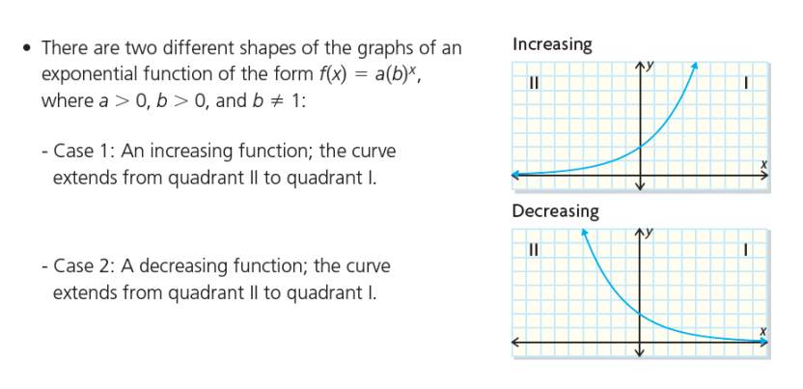

Outcome FM30-7B Practice #1
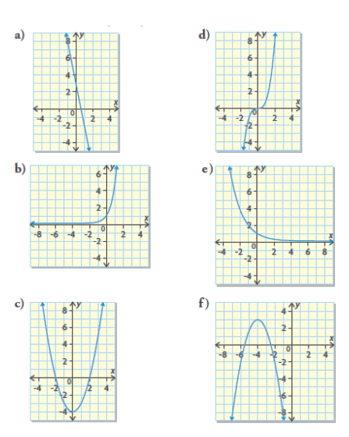
- Determine whether each graph represents an exponential function. If possible, identify the type of function.

- For each of the exponential functions you identified in question 1:
- State the number of x-intercepts
- State the y-intercept
- State the end behavior
- State the domain
- State the range

- Graph each exponential function. Determine the number of x-intercepts, the y-intercept, the end behavior, the domain and the range.
- $y=10{(2)}^{x}$ b) $y=4{\left(\frac{1}{2}\right)}^{x}$

Relating the Characteristics of an Exponential Function to Its Equation
- In a table of values for an exponential function, there is a constant ratio between consecutive y-values when the x-values increase by the same amount. The value of this ratio is equal to the parameter b in the function y = a(b)^{x}, where b ≠ 1.
- In an exponential function of the form y = a(b)^{x}, a is a non-zero multiplier and b is the base (where b > 0 and b ≠ 1) . The value of a is the y-intercept of the graph of the function
- An exponential function is an increasing function if a > 0 and b > 1.
- An exponential function is a decreasing function if a > 0 and 0 < b < 1
- The symbol e is a constant know as Euler’s number. It is an irrational number that equals 2.718… This number occurs naturally in some situations where a quantity increases continuously, such as increasing populations.
- Changing the parameters a and b in exponential functions of the form y = a(b)^{x}, where a > 0, b > 0, and b ≠ 1, does not change the number of x-intercepts, the end behavior, the domain or the range of the function. These characteristics are identical in all exponential functions of this form.
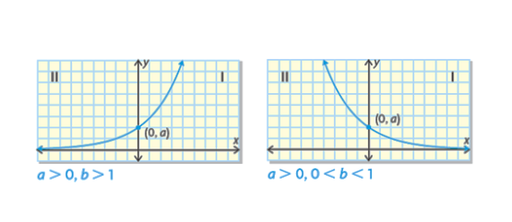

Outcome FM30-7B Practice #2
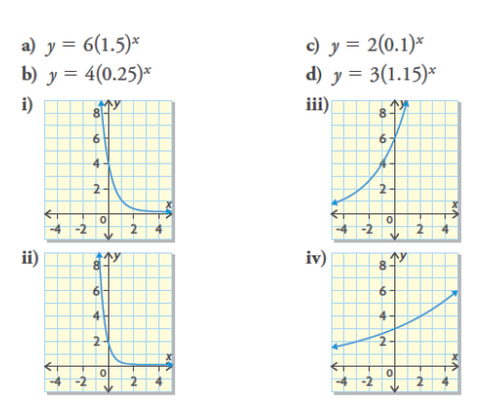
- Examine each function to determine if it increases or decreases. Then match each function with the corresponding graph below.

- Examine each function to determine if it increases or decreases. Then match each function with the corresponding graph.
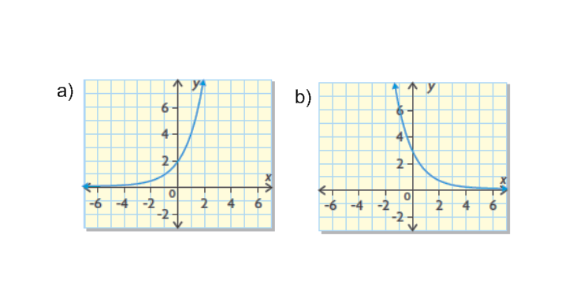
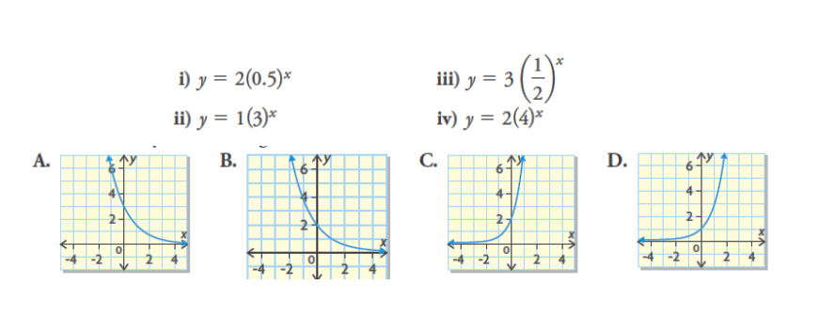
- For each of the following graphs, determine the following characteristics:
- The number of x-intercepts
- The y-intercept
- End behavior
- Domain
- Range

- Copy and complete this table. Verify your answers by graphing
 | Function | y-intercept | base | domain | range | Increasing or decreasing
a | y = 9(7)^{x}
B | y = 7(4)^{x}
C | $$y=6{\left(\frac{1}{7}\right)}^{x}$$
D | y = 2(0.35)^{x}
E | y = 2(e)^{x}
F | y = 4(0.3)^{x}
g | $$y=3.5{\left(\frac{1}{8}\right)}^{x}$$

- Explain how you could use the base of each function to determine if the function increases or decreases.
- $y=\frac{1}{3}(8)^{x}$ b) $y=4{\left(\frac{3}{5}\right)}^{x}$ c) y = 0.5(e)^{x}

6a)Write the equations of an increasing exponential function and a decreasing exponential function that each have a y-intercept of 5.
- Which characteristics of the functions would be the same? Which characteristics would be different?

7.Natasha claims that if she is given the equation of a polynomial function and the equation of an exponential function she can identify which is which. Do you agree or disagree? Justify your decision.

8.You are given an exponential function of the form y = a(b)^{x}, where a > 0, b > 0, b ≠1, and are asked to identify the number of x-intercepts, the y-intercept, end behavior, domain, range, and whether the function increases or decreases. Which of these characteristics are unique to the function you have been given, and which of these characteristics are common to all exponential functions of this form?

- How can you recognize when a graph or an equation represents an exponential function?
- How are the characteristics of exponential functions of the form y = a(b)^{x}, where a > 0 , b > 0, and b ≠ 1, different from the characteristics of polynomial functions of degree 3 or less?

Modelling Data Using Exponential Functions
- Exponential Growth Function – An exponential function whose y-values increase as you move from left to right along the x-axis; for an exponential function of the form
y = a(b)^{x}, exponential growth occurs when a > 0 and b > 1.
- Exponential decay function – An exponential function whose y-values decrease as you move left to right along the x-axis; for an exponential function of the form y = a(b)^{x}, exponential decay occurs when a > 0 and 0 < b < 1
- Use the exponential regression on your graphing calculator to determine an algebraic model for the data.
- An exponential function models growth when a > 0 and b > 1. The y-values of an exponential growth function increase as you move from left to right along the x-axis
- An exponential function models decay when a > 0 and 0 < b < 1. The y-values of an exponential decay function decrease as you move from left to right along the x-axis.
- The exponential regression model is f(x) = a(b)^{x} where a represents the initial value, and b represents the growth factor if b > 1 or the decay factor if 0 < b < 1
- An exponential curve of best fit can be used to predict values that are not recorded or plotted. Predictions can be made by reading values from the curve of best fit on a scatter plot or by using the equation of the exponential regression function.

Outcome FM30-7B Practice #3
- Samuel and his grandfather recorded the length and mass of every rainbow trout they caught in the Red Deer River during the summer. Samuel plans to use the data for an upcoming science fair project.
Length (mm) | 270 | 392 | 360 | 335 | 259 | 324 | 317 | 351 | 309 | 414 | 388 | 440 | 266 | 338
Mass (g) | 210 | 622 | 480 | 474 | 203 | 357 | 338 | 504 | 392 | 750 | 661 | 843 | 225 | 459
- Construct a scatterplot to display the data
- Determine the equation of the exponential regression function for the data. Graph the data function on the same grid that you plotted the points.
- Samuel caught a fish that measured 400 mm. Use your graph to estimate the mass of the fish, to the nearest gram.
- Samuel’s grandfather would like to catch a fish with a mass of 1000 g. How long, to the nearest millimeter, would you expect this fish to be?

- The height of a sunflower was recorded every seven days as it grew.
Day | 7 | 14 | 21 | 28 | 35 | 42
Height (cm) | 17.9 | 36.4 | 67.8 | 98.0 | 131.1 | 169.7
- Construct a scatterplot to display the data
- Use exponential regression to model the growth of the sunflower.
- Estimate the height of the sunflower, to the nearest tenth of a centimeter, on day 10
- Estimate the height of the sunflower, to the nearest tenth of a centimeter, on day 30. Does you answer make sense, based on the data? Explain.
- ON what day would you expect the sunflower to reach a height of 50 cm?

- Air pressure on a plane decreases as the plane’s altitude increases. The data below shows the pressure, in millibars, that is exerted by the atmosphere on an object at different altitudes, in kilometers.
Altitude (km) | 1 | 2 | 3 | 4 | 5 | 6 | 7 | 8 | 9 | 10
Air Pressure (mb) | 898.7 | 795.0 | 701.2 | 616.0 | 540.5 | 472.2 | 411.1 | 356.5 | 307.0 | 264.9
- Create a scatter plot to display the data
- Determine the equation of the exponential regression function that models the data. Graph the function on the same grid as your scatterplot.
- Estimate the pressure at 15 km, to the nearest tenth of a millibar
- Estimate the altitude, to the nearest kilometer, where the pressure reaches 500.0mb and 50.0mb.

- A sample of bacteria was taken from a patient. A lab technician then recorded the growth of the bacterial population at fixed time intervals. The first five observations are given below:
Observation | 1 | 2 | 3 | 4 | 5
Number of Bacteria | 6180 | 9270 | 13905 | 20857 | 31285
- Determine the equation of the exponential regression function that models the data.
- If this growth rate continues, how many bacteria will there be when the lab technician makes the 10th observation?
- A drug has been developed that affects the growth rate of the bacterial population. When studying a second identical sample that has been treated with the drug, the lab technician notices that the population now grows at a rate of 20% per hour. What function models the growth of the population in the second sample?

- The Mauna Loa observatory in Hawaii has been collected monthly data on the proportion of carbon dioxide (CO₂) in the atmosphere, in parts per million, since 1959. The data that was collected at the end of the year, every five years from 1960 to 2005, is shown in the table below.
Year | Atmospheric CO₂ (ppm)
1960 | 319
1965 | 322
1970 | 328
1975 | 333
1980 | 341
1985 | 348
1990 | 356
1995 | 364
2000 | 372
2005 | 381
- Could a linear function model the data? Justify your answer.
- Determine the equation of the exponential regression function that models the data.
- According to your model, what is the predicted proportion of atmospheric CO₂ in 2010 and 2020, rounded to the nearest part per million?

- How can you determine the best exponential function of the form y = a(b)^{x} to model data?

Characteristics of Logarithmic Functions with Base 10 and Base e
- Logarithmic Function – A function of the form y = a log_{b} x where b > 0, b ≠ 1, and
a ≠ 0, and a and b are real numbers
- The expression log₁₀x is known as the common logarithm or a logarithm with a base of 10. The expression is often written without the 10, so the two functions y = log₁₀x and y = log x are equivalent.
- The function y = log₁₀ x is equivalent to x = 10^{y} so a logarithm is an exponent. The meaning of log ₁₀ x is “the exponent that must be applied to base 10 to get the value of x” For example, log ₁₀ 100 = 2 because 10² = 100
- A logarithm with base e is called the natural logarithm and is written as ln x. The functions y = log_{e} x, y = ln x, and x = e^{y} are equivalent.
- A logarithmic function has the form f(x) = a log_{b} x, where b> 0, b ≠ 1, and a ≠ 0, and a and b are real numbers.
- All logarithmic functions of the form f(x) = a log x and f(x) = a ln x have these characteristics:
x-intercept | 1
Number of y-intercepts | 0
End behavior | The curve extends from quadrant IV to quadrant 1 or quadrant I to quadrant IV
Domain | $$\left\{\left.x\right|x>0,x∈R\right\}or (0,∞)$$
range | $$\left\{\left.y\right|y∈R\right\}or (-∞, ∞)$$
- All logarithmic functions of the form f(x) = a log x and f(x) = a ln x have these unique characteristics:
- If a > 0 the function increases
- If a < 0 the function decreases

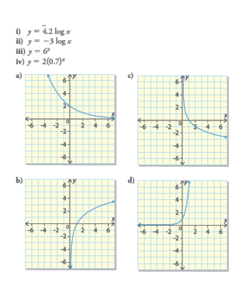
Outcome FM30-7B Practice #4
- Match each function with its corresponding graph.

- Predict the x-intercept, the number of y-intercepts, the end behavior, the domain, the range, and whether each logarithmic function is increasing or decreasing based on its equation. Verify your predictions using graphing technology
- f(x) = 3 log x b) f(x) = -9 log x c) f(x) = 12 ln x
d)f(x) = 0.5 ln x e) f(x) = -0.2 log x f) f(x) = 100 ln x
- State three reasons why you know that the following graph represents a logarithmic function of the form y = a log x.
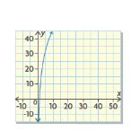
- Sketch the graph of the logarithmic function with each set of characteristics:
- X-intercept: 1
Number of y-intercepts: 0
End behavior: the curve extends from quadrant IV to quadrant I
Domain: $\left\{\left.x\right|x>0,x∈R\right\}$ or $\left(0,∞\right)$
Range: $\left\{\left.y\right|y∈R\right\}or (-∞, ∞)$
- X-intercept: 1
Number of y-intercepts: 0
End behavior: the curve extends from quadrant I to quadrant IV
Domain: $\left\{\left.x\right|x>0,x∈R\right\}$ or $\left(0,∞\right)$
Range: $\left\{\left.y\right|y∈R\right\}or (-∞, ∞)$

- Holly claims that she can distinguish between the graph of an exponential function of the form y = a(b)^{x} where a > 0, b > 0, and b ≠ 1, and the graph of a logarithmic function of the form y = a log x, where a ≠ 0, based entirely on the number of x-intercepts shown. DO you agree or disagree? Explain.
- The pH of a solution, p(x), can be determined using the function p(x) = -log x where x represents the concentration of hydrogen ions in the solution in moles per litre. Use the equation of the function to predict what happens to the pH of a solution as the concentration of hydrogen ions increases. Verify your prediction using graphing technology.
- Consider the following functions: y = a log x and y = a ln x
- For what values of a is each function decreasing?
- Do these functions have an unrestricted domain? Explain.
- Do these functions have an unrestricted range? Explain.

- How are the functions y = log x and y = ln x similar and how do they differ?
- How can you predict the characteristics of a logarithmic functions from its equation?

Modelling Data Using Logarithmic Functions
- The equation of the logarithmic regression function can be written as
y = (constant) + (multiplier) ln x
Most graphing calculators and spreadsheets provide the equation of the logarithmic regression function in the form y = a + b ln x
- A logarithmic function may be a good model for a set of data if the points on a scatterplot form an increasing or decreasing curve, where the domain is restricted to the set of positive real numbers.
- The general form of the logarithmic regression model is
y = (constant) + (multiplier) ln x
- A logarithmic curve of best fit can be used to predict values that are not recorded or plotted. Predictions can be made by reading values from the curve of best fit on a scatterplot or by using the equation of the logarithmic regression function.

Outcome FM30-7B Practice #5
- Altitude above sea level is a logarithmic function of atmospheric pressure. Michael just purchased an altimeter watch, which measures the current altitude in meters above sea level. The watch also measures the current atmospheric pressure in kilopascals (kPa). Michael recorded the atmospheric pressure at six different altitudes, as shown in the table below.
Pressure (kPa) | 101.30 | 95.40 | 87.14 | 64.50 | 74.90 | 39.90
Altitude (m) | 0 | 400 | 1000 | 3000 | 2000 | 6187
- Identify independent and dependent variables
- Use Michael’s data to determine the equation of the logarithmic regression function for the altitude, h, as a function of the pressure, P.
- Describe the following characteristics of the function:
- The intercepts
- The end behavior
- The domain and range
- Whether the function is increasing or decreasing.
- Michael lives at an altitude of 139 m. Determine the pressure setting that he needs to use to calibrate his watch. Round your answer to the nearest tenth.
- Determine the atmospheric pressure at the summit of Mt. Everest, which is 8848m above sea level, to the nearest tenth of a kilopascal.

- In February 2004, Mark Zuckerberg launched Facebook from his Harvard dorm room. Facebook had 1 000 000 registered users by December of that year, and it has been growing rapidly every since.
Number of months since Feb 2004 | Number of registered users (millions), n | Number of months since Feb 2004 | Number of registered users (millions), n
10 | 1.0 | 62 | 200.0
22 | 5.5 | 65 | 250.0
34 | 12.0 | 67 | 300.0
38 | 20.0 | 70 | 350.0
44 | 50.0 | 72 | 450.0
54 | 100.0 | 77 | 500.0
59 | 150.0 | 79 | 550.0
60 | 175.0
- Create a scatterplot that relates the date, in number of months, to the number of registered users of Facebook.
- Use the data to determine the equation of the logarithmic regression function for time, t, in months, as a function of the number of registered users, n.
- Interpolate to determine when Facebook first surpassed 275 million registered users.

- Describe the process you would use to interpolate a value for a set of data that can be modeled by a logarithmic function.
- To perform a logarithmic regression on a data set, how do you decide which variable is the independent variable?

Answers
Practice #1
1a) no. linear b) yes c) no; quadratic d) no, cubic e) yes, f) no, quadratic
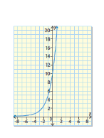
2b) no x-intercepts, y-int is 1, QII to QI; domain: $\left\{\left.x\right|x∈R\right\}or (-∞,∞)$, range: $\left\{\left.y\right|y>0, y∈R\right\}or (0, ∞)$
2f) no x-intercepts; y-int is 1, QII to QI; domain: $\left\{\left.x\right|x∈R\right\}or (-∞,∞)$, range: $\left\{\left.y\right|y>0, y∈R\right\}or (0, ∞)$
3a)
Number of x-intercepts is 0
y-intercept is 10
end behavior is QII to QI
domain is : $\left\{\left.x\right|x∈R\right\}or (-∞,∞)$,
range is : $\left\{\left.y\right|y>0, y∈R\right\}or (0, ∞)$

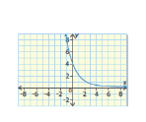
3b) number of x-intecepts is 0
y-intercept is 4
end behavior is QII to QI
domain is : $\left\{\left.x\right|x∈R\right\}or (-∞,∞)$,
range is : $\left\{\left.y\right|y>0, y∈R\right\}or (0, ∞)$

Practice #2
1a) matches with graph iii; is increasing b) matches with graph i; is decreasing
1c) matches with graph ii; is decreasing d) matches with graph iv; is increasing
2i) matches with graph b; is decreasing ii) matches with graph d; is increasing
2iii) matches with graph a; is decreasing iv) matches with graph c; is increasing
3a) number of x-intercepts is 0; y-intercept is 2; end behavior is QII to QI; domain is : $\left\{\left.x\right|x∈R\right\}or (-∞,∞)$,range is : $\left\{\left.y\right|y>0, y∈R\right\}or (0, ∞)$
3b) number of x-intercepts is 0; y-intercept is 3; end behavior is QII to QI; domain is : $\left\{\left.x\right|x∈R\right\}or (-∞,∞)$,range is : $\left\{\left.y\right|y>0, y∈R\right\}or (0, ∞)$
4.
 | Function | y-intercept | base | domain | range | Increasing or decreasing
a | y = 9(7)^{x} | 9 | 7 | $$\left\{\left.x\right|x∈R\right\}$$  $or (-∞,∞)$, | $$\left\{\left.y\right|y>0, y∈R\right\}or (0, ∞)$$ | increasing
B | y = 7(4)^{x} | 7 | 4 | $$\left\{\left.x\right|x∈R\right\}$$  $or (-∞,∞)$, | $$\left\{\left.y\right|y>0, y∈R\right\}or (0, ∞)$$ | Increasing
C | $$y=6{\left(\frac{1}{7}\right)}^{x}$$ | 6 | $$\frac{1}{7}$$ | $$\left\{\left.x\right|x∈R\right\}$$  $or (-∞,∞)$, | $$\left\{\left.y\right|y>0, y∈R\right\}or (0, ∞)$$ | Decreasing
D | y = 2(0.35)^{x} | 2 | 0.35 | $$\left\{\left.x\right|x∈R\right\}$$  $or (-∞,∞)$, | $$\left\{\left.y\right|y>0, y∈R\right\}or (0, ∞)$$ | Decreasing
E | y = 2(e)^{x} | 2 | e | $$\left\{\left.x\right|x∈R\right\}$$  $or (-∞,∞)$, | $$\left\{\left.y\right|y>0, y∈R\right\}or (0, ∞)$$ | Increasing
F | y = 4(0.3)^{x} | 4 | 0.3 | $$\left\{\left.x\right|x∈R\right\}$$  $or (-∞,∞)$, | $$\left\{\left.y\right|y>0, y∈R\right\}or (0, ∞)$$ | Decreasing
g | $$y=3.5{\left(\frac{1}{8}\right)}^{x}$$ | 3.5 | $$\frac{1}{8}$$ | $$\left\{\left.x\right|x∈R\right\}$$  $or (-∞,∞)$, | $$\left\{\left.y\right|y>0, y∈R\right\}or (0, ∞)$$ | Decreasing
5a) since the base is greater than 1, the function is increasing
5b) since the base is between 0 and 1, the function is decreasing
5c) since the base is greater than 1, the function is increasing
6a) increasing: y = 5(2)^{x}, decreasing: $y=5{\left(\frac{1}{4}\right)}^{x}$
6b) same: number of x-intercepts, y-intercept, end behavior, domain and range
Different: rate of change (increasing vs decreasing function)
- Yes, all exponential functions are of the form f(x) = a(b)^{x}
- The number of x-intercepts, the end behavior, the domain, and the range are common to all exponential functions. The y-intercept and whether the function increases or decreases is unique to the function
- Graph – if you are given a graph you can tell if the function is exponential by the shape of the graph. All exponential functions we have studied are one of these cases: Case 1: an increasing curve that extends from quadrant II to quadrant I. Case 2: a decreasing curve that extends from quadrant II to quadrant I
Equation – If you are given an equation, look at the form of the equation. All the exponential functions we have studied are of the form y = a(b)^{x}, where the independent variable, x, is the exponent in the equation.
- Number of x-intercepts: Exponential functions of this form have no x-intercepts. Polynomial functions of degree 3 or less may have 0, 1, 2 or 3 x-intercepts
End Behavior – exponential functions of this form extend from quadrant II to quadrant I. Polynomial functions of degree 3 or less can extend from quadrant III to quadrant I, quadrant II to quadrant IV, quadrant II to quadrant I or quadrant III to quadrant IV
Range: exponential functions of this form have a restricted range: $\left\{\left.y\right|y>0,y∈R\right\}or (0,∞)$. Only polynomial functions of degree 2 have a restricted range.
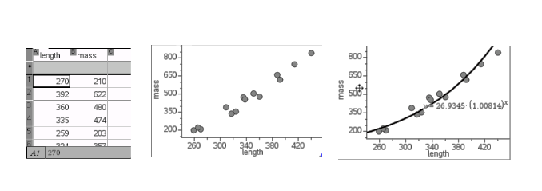
Practice #3
1a)

b)y=26.9345(1.00814)^{x}
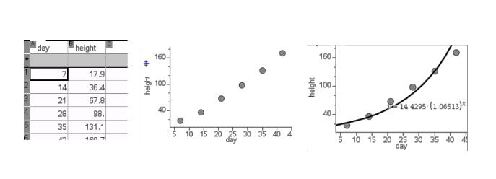
c) 690g; I identified the point on the curve that had an x-value of 400
d) 446 mm; I identified the point on the curve that had a y-value of 1000

2a)

b)y=14.4295(1.06513)^{x}
c) 27.1 cm
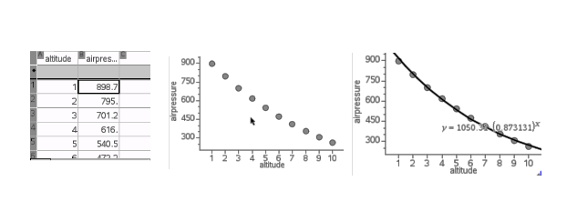
d) 95.8 cm; no, since it was 98.0cm on day 28
e) day 20

3a)

b)y=1050.31(0.873131)^{x}
c) 137.3 mb
d) 5km, 22km
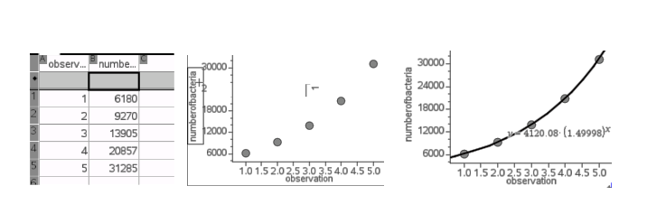
4a)

y = 4120.08(1.49998)^{x}
b)237553
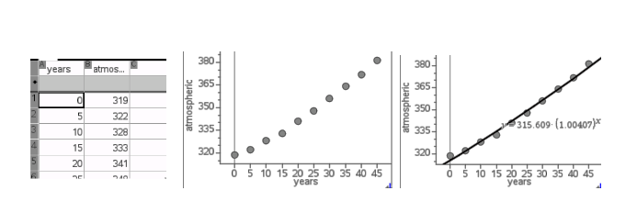
c) y = 4120.08(1.2)^{x}

5a) No, the rate of change of atmospheric CO₂ is increasing
b)

Y=315.609(1.00407)^{x}
c)387 ppm, 403 ppm

6) Enter the given data into a graphing calculator and do an exponential regression. The exponential regression function will represent the curve of best fit for the data. You can check how well the regression function fits the data by graphing the function and the points on the same axes.

Practice #4
1i) matches b because I know b is a logarithmic function because it has an x-intercept, does not have a y-intercept and extends from QIv to QI.
ii)matches c because I know it is a logarithmic function because it has an x-intercept, does not have a y-intercept and extends from QI to QIV
iii)Matches d because I know it is an exponential function because it does not have an x-intercept, it does have a y-intercept and it is an increasing functions
iv)matches a because I know it is an exponential function because it does not have an x-intercept, it does have a y-intercept and it is a decreasing function.
2)
 | x-int | # of y-int | End behavior | domain | Range
a | 1 | 0 | QIV to QI | $$\left\{\left.x\right|x>0,x∈R\right\}or (0, ∞)$$ | $$\left\{\left.y\right|y∈R\right\}or (-∞,∞)$$
B | 1 | 0 | Q1 to QIV | $$\left\{\left.x\right|x>0,x∈R\right\}or (0, ∞)$$ | $$\left\{\left.y\right|y∈R\right\}or (-∞,∞)$$
C | 1 | 0 | QIV to QI | $$\left\{\left.x\right|x>0,x∈R\right\}or (0, ∞)$$ | $$\left\{\left.y\right|y∈R\right\}or (-∞,∞)$$
D | 1 | 0 | QIV to QI | $$\left\{\left.x\right|x>0,x∈R\right\}or (0, ∞)$$ | $$\left\{\left.y\right|y∈R\right\}or (-∞,∞)$$
E | 1 | 0 | QI to QIV | $$\left\{\left.x\right|x>0,x∈R\right\}or (0, ∞)$$ | $$\left\{\left.y\right|y∈R\right\}or (-∞,∞)$$
f | 1 | 0 | QIV to QI | $$\left\{\left.x\right|x>0,x∈R\right\}or (0, ∞)$$ | $$\left\{\left.y\right|y∈R\right\}or (-∞,∞)$$
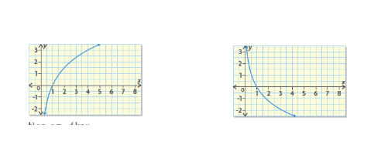
3)ie. One x-intercept, no y-intecepts, domain: $\left\{\left.x\right|x>0,x∈R\right\}or (0, ∞)$
4a) ie. Y =5 log x b) y = -4 log x

5) Yes; An exponential function has no x-intercepts, and a logarithmic function has 1 x-intercept
6) As hydrogen ion concentration increases, pH decreases
7a) a < 0
7b) the domain is restricted, x > 0 as the functions are logarithmic
7c) The range is unrestricted as all values of y are possible
8) Both are logarithmic functions, but they have different bases. The base of y = log x is 10. This is called the common logarithm. The base of y = ln x or y = log_{e}x is e. This is called the natural logarithm. Both functions share the same characteristics: one x-intercepts at x = 1; no y-intercept; the graph extends from QIV to QI; the domain is restricted, $\left\{\left.x\right|x>0,x∈R\right\}or (0, ∞)$; and the range is not restricted $\left\{\left.y\right|y∈R\right\}or (-∞,∞)$

9) A logarithmic function of the form y = a log x or y = a ln x has the following characteristics:
* there is one x-intercept at x = 1
* there is no y-intercept
* the value of a indicates whether the graph of the function is increasing or decreasing and determines the function’s end behavior
* the graph is increasing when a > 0. The graph extends from QIV to QI
* the graph is decreasing when a < 0. The graph extends from QI to QIV

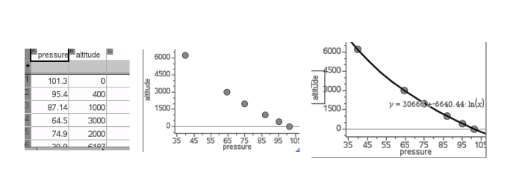
Practice #5
1a) independent is pressure; dependent is altitude
b)

Y = 30666 – 6640.44 ln x
c)x-intercept – 101.3 (use trace to find where y = 0); y-intercept – none; end behavior: QI to QIV; domain $\left\{\left.x\right|x>0, x∈R\right\}or (0, ∞)$; range: $\left\{\left.y\right|y∈R\right\}or (-∞,∞)$, function is decreasing
d) 99.2 kPa
e) 26.7 kPa

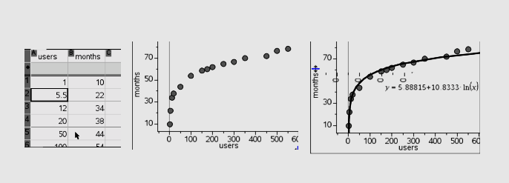
- **** This is one of the rare occurences where the x and y values are switched around in the table of values. The number of users is the independent (x) variable and the number of months is the dependent (y) variable

b)y=5.88815 + 10.8333 ln x
c) August 2009

- Enter the data in my calculator, perform a logarithmic regression, graph the data points in a scatter plot and the logarithmic function on the same axes, and identify the point with the known x-value and the unknown y-value
- Start by considering the context in which the data set is presented. Use the quantities in the context to help you decide which quantity depends on the other. This quantity is the dependent variable, while the other quantity is the independent variable. IF you can’t decide from the context, create a scatter plot of the data. If you have chosen the independent variable correctly, you should see either an increasing or decreasing trend, with many points scattered near the y-axis. These are characteristics of a logarithmic function. If many points are scattered near the x-axis, then you have incorrectly chosen the independent variable. Switch the variables and try again.

Outcome FM30-7C

OUTCOMES | ASSESSMENT RUBRICS
FM30.7 Demonstrate understanding of the representation and analysis of data using:
- polynomial functions of degree ≤ 3
- logarithmic functions
- exponential functions
*sinusoidal functions
Level  Criteria | Intervention 1  Spend some extra time with the criteria and ask for help. | Instructional 2  Good start. You are beginning to make sense of this on your own. You are consistent with the basic learning goals for this outcome. | Independence 3  You did it and you did it on your own. You are able to complete the processes for this outcome. Your work is thorough and consistently accurate. | Mastery 4  Great work! This is going extra well for you. You have understood the outcome, are able to explain your strategies and apply these to situations. Your work is always accurate.
Represent data, using sinusoidal functions, to solve  problems. | I need more help with becoming consistent with the criteria | I can match equations of sinusoidal functions to their corresponding graphs  I can graph and determine (with technology) the sinusoidal function that best approximate s the data. | I can determine the  characteristics of sinusoidal functions from their equations or graphs | I can demonstrate my understanding of sinusoidal functions. This may be done through interpreting graphs of sinusoidal functions to describe the situations that each function models and explain the reasoning or solve situational questions that involve data that is best represented by graphs of sinusoidal functions and explain the reasoning.

The Graphs of Sinusoidal Functions
- Radian – The measure of the central angle of a circle subtended by an arc that is the same length as the radius of the circle.
- Angles can be measured using different units. These include degrees, radians, gradients, and minutes and seconds.
- Any angle measures presented as real numbers without units are considered to be in radians
- Periodic Function – a function whose graph repeats in regular intervals or cycles
- Sinusoidal Function – any periodic function whose graph has the same shape as that of y = sin x
- Sinusoidal functions can be used as models to solve problems that involve repeating or periodic behavior.
- Functions whose graphs have the same shape and characteristics as the sine function are called sinusoidal functions
- Frequency – the number of times that a cycle occurs in a given time period. For example, the fourth A note on a piano has a frequency of 440 Hz or 440 cycles per second.
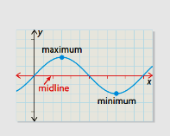
- Midline – The horizontal line halfway between the maximum and minimum values of a periodic function

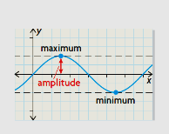
- Amplitude – The distance from the midline to either the maximum or minimum value of a periodic function; the amplitude is always expressed as a positive number

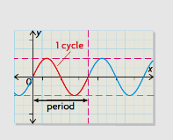

- Period – the length of the interval of the domain to
complete one cycle

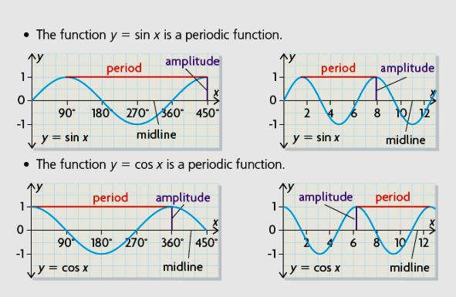

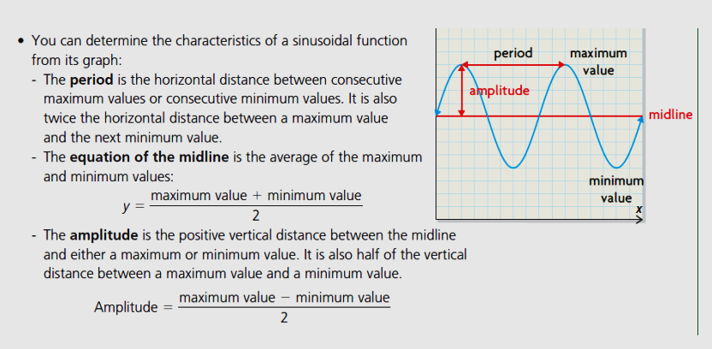

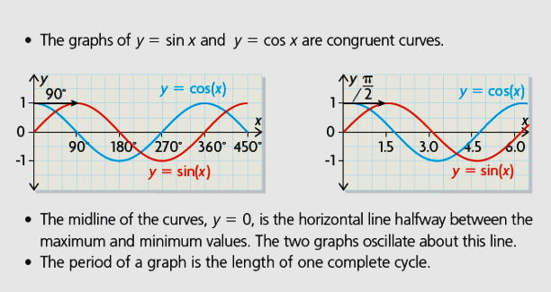
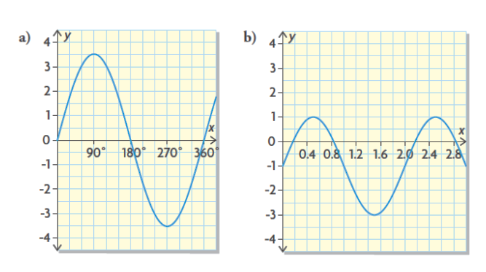
Outcome FM30-7C Practice #1
- Determine the range and amplitude of each graph

- Determine the equation of the midline and the amplitude of each graph.
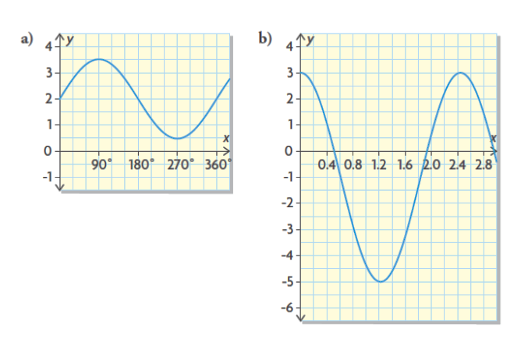
- Determine the period of each graph
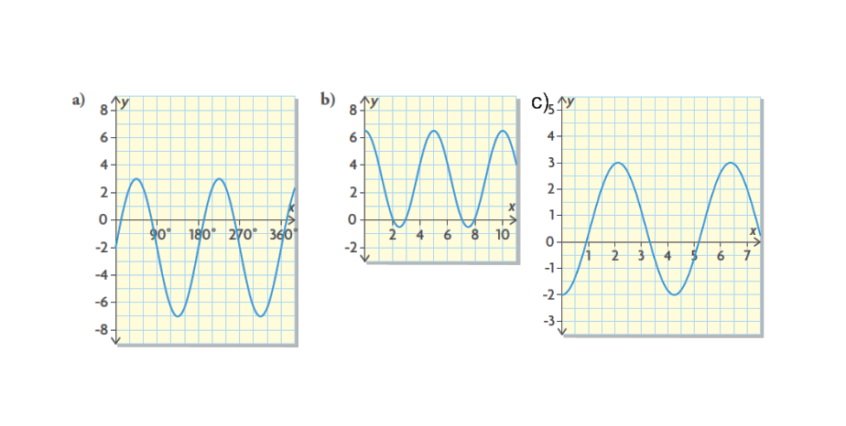
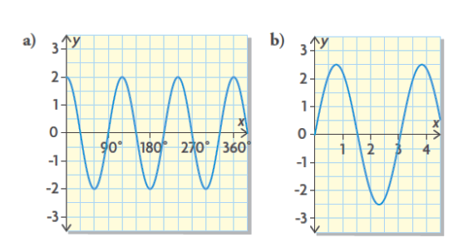
- Determine the range, amplitude, equation of the midline, and period of each graph.

- Sketch a possible graph of a sinusoidal function with the set of characteristics
Domain: $\left\{\left.x\right|0≤x≤16,x∈R\right\}$
Minimum value: 3
Maximum Value: -3
Period: 8
y-intercept -3

- How can you determine the amplitude, range, and equation of the midline of a given sinusoidal graph?
Outcome FM30-7C Practice #2

- Megan is sitting in an inner tube in the wave pool at West Edmonton Mall. The depth of the water below her, in terms of time, during a series of waves can be represented by the graph shown.
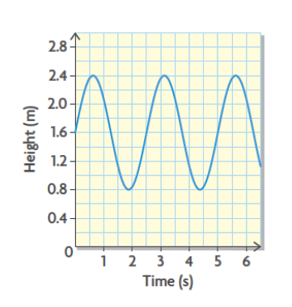
- What is the depth of the water below Megan when no waves are being generated?
- How high is each wave?
- How long does it take for one complete wave to pass?
- What is the approximate depth of the water below Megan after 4 s? What is the depth of the water below Megan at 7.5s? Assume that the waves continue at the same rate.
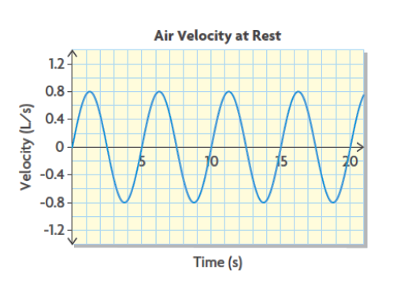
- When you breathe, the air entering your lungs
has a positive velocity and the air exiting your
lungs has a negative velocity. The relationship
between velocity, in litres of air per second (L/s),
and time, in seconds, for an adult at rest, can be
modeled by the graph shown.

- What is the equation of the midline? What does it represent in this situation?
- What is the amplitude of the function?
- What is the period of the function? What does it represent in this situation?

- When you exercise, the velocity of the air entering and exiting your lungs, measured in litres per second, changes in terms of time, measured in seconds. The following graph models the relationship between velocity and time for an adult who is exercising.
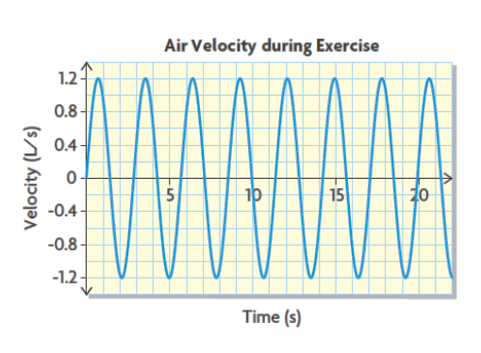
- According to this model, does an adult take more breathes per minute when exercising, or just deeper breathes, than an adult at rest (modeled in question 2)? How do you know?
- What characteristics (period, equation of midline, or amplitude) of this graph has changed, compared with the graph in question 2?
- What is the maximum velocity of the air entering the lungs? Include appropriate units of measure.

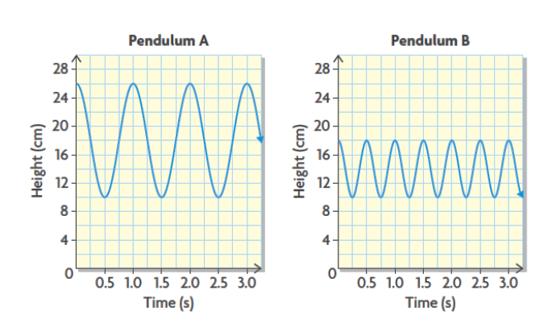
- Caitlin and Arland conducted an experiment in physics class. They swung two different pendulums above a table and recorded the motion of the pendulums in graphs.

- Compare the periods, minimum values, maximum values, and amplitudes of the two pendulums.
- Which pendulum is longer? Explain.
- Kelly and his sister Charmaine are hoop dancers. In part of a dance, they spin hoops about their arms. Each of the following graphs indicates the height of a point on a hoop, measured from the ground, that Kelly or Charmaine is spinning vertically.
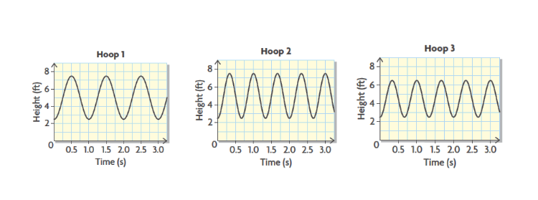
- What does the amplitude represent?
- Which hoop is the smallest?
- Which hoop is being spun at the slowest rate? Which is being spun at the fastest rate?
- Which hoop do you think the shorter person is spinning? Explain.

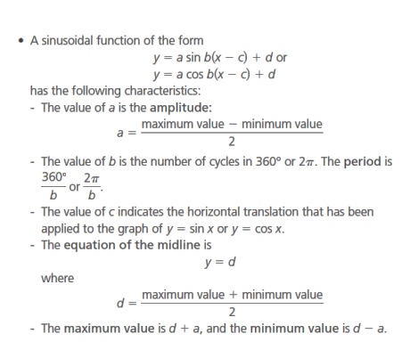
The Equations of Sinusoidal Functions
- Any sinusoidal function can be expressed as either a cosine function or a sine function

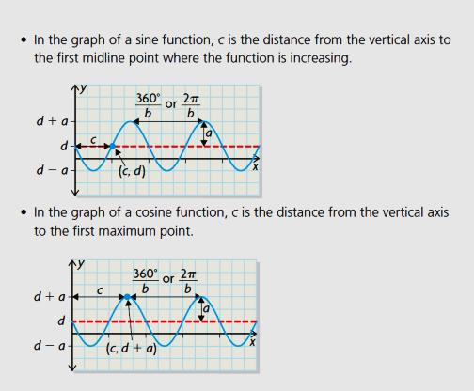
Outcome FM30-7C Practice #3
- Determine the amplitude and range of each function
- y = 7 sin 2(x – 5) b) y = 13 cos 0.5(x + 26)

- Determine the equation of the midline and the maximum and minimum values of each function
- y = 5 sin 2(x – 2.5) + 2 b) y = 3 cos (x + 1) – 3

- Determine the distance in degrees or radians by which y = sin x or y = cos x would be horizontally translated to create the graph of each function.
- Y = 2.5 sin 3(x – 30⁰) + 5 b) y = 2 sin 8(x – 4.5) – 3
c)y = 11 cos (x + 100⁰) – 2 d) y = 4 cos (x + 3) – 1

- Determine the period of each function, the number of cycles in 360⁰ or 2π and the distance by which its graph has been horizontally translated.
- Y = 3 sin 4(x – 45⁰) – 1 b) y = 2 sin 0.5 (x – 1) + 4

- Determine the range, amplitude, period, horizontal translation of y = sin x, and equation of the midline for each function
- Y = 4 sin 3(x – 20⁰) + 3 b) y = 2 sin 2(x – 60⁰) – 4

Outcome FM30-7C Practice #4
- Consider the following function: y = 3 cos 5(x + 30⁰) – 1. Describe the graph of the function, including the amplitude, the equation of its midline, the range, the period, and the distance of horizontal translation from y = cos x.
- Describe each function by stating the amplitude, the equation of the midline, the range, the period, and the horizontal translation of y = sin x.
- Y = 3 sin 2(x – 60⁰) + 4
- Y = 3 sin 2(x – 240⁰) + 4
- Y = 3 cox 2(x – 105⁰) + 4

- Match each graph with the corresponding equation below
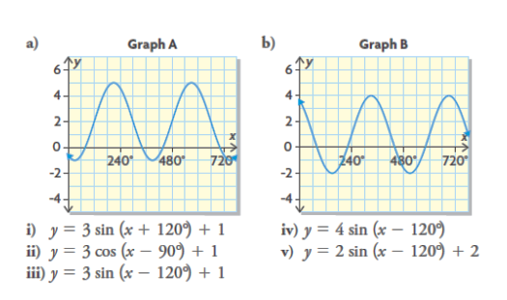
- Match each graph with the corresponding equation below
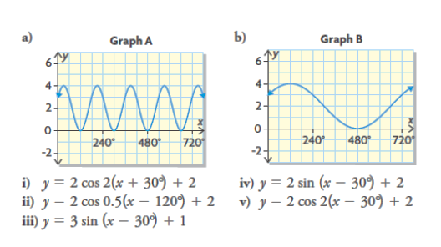

- Ashley boards the Ferris wheel at the Pacific National Exhibition. When the ride begins, her position can be modeled by the function y = 43 sin 3.5(x – 0.9) + 47, where y represents the height in feet and x represents the time in minutes.
- Determine the diameter of the Ferris wheel.
- How long does it take for the Ferris wheel to complete one revolution?
- How high above the ground is Ashley at the lowest point?

- An apple is attached to a spring. The height of the apple as it oscillates up and down can be modeled by the equation h(t) = 4 sin (8πt) + 6.5 where h(t) represents the height of the apple in centimetres and t represents the time in seconds.
- What are the highest and lowest points that the apple reaches?
- What is the period of the function? What does the period tell you about the apple in this context?

- A person’s blood pressure, P(t), in millimetres of mercury (mm Hg), can be modeled by the function P(t) = -20 cos (8.4t) + 100 where t is the time in seconds.
- What is the period of the function?
- What does the value of the period mean in this situation?

- How can you determine the characteristics of a sinusoidal function from its equation?

Modelling Data with Sinusoidal Functions
- If the data points on a scatter plot seem to follow a regular periodic pattern of increasing and decreasing curves, then there may be a sinusoidal relationship between the independent and dependent variables.
- If the points on a scatter plot show a sinusoidal trend, then graphing technology can be used to determine the equation of the sinusoidal regression function that models the data. Use radian mode when performing sinusoidal regression.
- Interpolated or extrapolated values can be predicted by reading values from a graph or by using the equation of the sinusoidal regression function.
- When the data in a set repeats in a regular, periodic pattern, interpolation or extrapolation can be used to make predictions.

Outcome FM30-7C Practice #5
- The Bay of Fundy, in the Maritimes, has the highest tides in the world. The height of the water, in metres above the seabed, is shown for one point over 36 h.
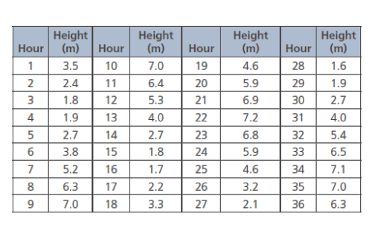
- Determine the equation of a sinusoidal regression function that models the height of the water.
- Does the regression equation match the data closely?
- How high is the water at high tide, to the nearest tenth of a metre? How high is the water at low tide?
- How long, to the nearest minute, does it take for the tide to cycle from high tide to low tide and back again?
- Simon plans to go fishing at hour 50. How high, to the nearest tenth of a meter, will the tide be when he begins fishing?

- The following table gives the hours of daylight in Regina, which is at a latitude of 50⁰. The hours of daylight are calculated as the time between sunrise and sunset each day.
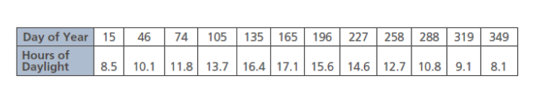 a) Determine the equation of a sinusoidal regression function that models the data.
b) Determine the range between the maximum and minimum hours of daylight in Regina. Round to the nearest minute.
c) Which day has the most hours of daylight?
d) Determine the hours of daylight in Regina on day 30. Round to the nearest minute.
e) Determine which days of the year have about 15.0 hours of daylight.

Answers
Practice #1
1a) $\left\{\left.y\right|-3.5≤y≤3.5,y∈R\right\}or[-3.5,3.5]$; 3.5
1b) $\left\{\left.y\right|-3≤y≤1,y∈R\right\}or[-3,1]$; 2
2a) y= 2; 1.5
2b) y = -1; 4
3a) 120⁰ b) 3
4a) $\left\{\left.y\right|-7≤y≤3,y∈R\right\}or[-7,3]$; 5; y = -2; 180⁰
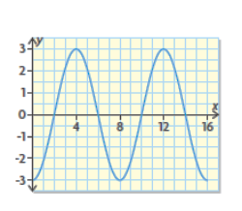
4b) $\left\{\left.y\right|-0.5≤y≤6.5,y∈R\right\}or[-0.5,6.5]$; 3.5; y = 3; 5
4c) $\left\{\left.y\right|-2≤y≤3,y∈R\right\}or[-2,3]$; 2.5; y = 0.5; 4.25

- The range is the difference of the maximum and minimum y-values. The amplitude is half the difference of the maximum and minimum values. The equation of the midline is y = average of the minimum and maximum values.

Practice #2
1a) 1.6 m b) 0.8 m c) 2.5 s d) about 1 m, 1.6 m
2a) y = 0; velocity of the air between breaths
2b) 0.8 L/s
2c) 5 s; time to breathe in and out completely
3a) both; the increased amplitude means that the breaths are deeper and the decreased period means more breaths per minutes
3b) amplitude and period have changed
3c) 1.2 L/s
4a) A: period = 1 s; minimum = 10cm; maximum = 26 cm; amplitude = 8 cm;
B: period = 0.5 s; minimum = 10 cm; maximum = 18 cm; amplitude = 4 cm
4b) A because it’s amplitude is greatere
5a) hoop’s radius
5b) hoop 3
5c) hoop 1; hoop 3 or hoop 2
5d) hoop 3 because the midline of the graph is lower

Practice #3
1a) 7; $\left\{\left.y\right|-7≤y≤7,y∈R\right\}or[-7,7]$
1b) 13; $\{\left.y\right|-13≤y≤13,y∈R\}∈or[-13,13]$
2a) y = 2; 7; -3 b) y = -3; 0; -6
3a) 30⁰ right b) 4.5 right c) 100⁰ left d) 3 left
4a) 90⁰; 45⁰ right b) 4π; 1 right
5a) $\left\{\left.y\right|-1≤y≤7,y∈R\right\}or[-1,7]$; 4; 120⁰; 20⁰ to the right; y = 3
5b) $\left\{\left.y\right|-6≤y≤-2,y∈R\right\}or[-6,-2]$; 2; 180⁰; 60⁰ to the right; y = -4

Practice #4
- Amplitude 3; midline y = -1; range $\{\left.y\right|-4≤y≤2,y∈R\}$; period 72⁰; horizontal translation from y= cos x is 30⁰ left.
2a) 3; y = 4; [1, 7]; 180⁰; 60⁰ to the right
2b) 2; y = 4; [1, 7]; 180⁰; 240⁰ to the right
2c) 3; y = 4; [1, 7]; 180⁰; 105⁰ to the right
3a) iii b⁾ i
4a) v b) ii
5a) 86 feet b) about 1.8 min or 1 min 48 seconds c) 4 feet
6a) 10.5 cm, 2.5 cm b) 0.25 s; the apple completes 4 bounces per seconds
7a) 0.75 s b) A person’s blood pressure makes a complete low to high cycle about every 0.75 seconds
8)Sinusoidal equations can be written in the following form:
Y = a sin b(x – c) + d
The amplitude of the function is a
The equation of the midline is y = d
The max value is the sum of the value of the midline and the amplitude or d + a
The min value is the difference between the value of the midline and the amplitude or d – a
The range is [(d-a),(d+a)]
The horizontal translation from y = sin x is c
The period is 360/b

Practice #5
1a) y = 2.726…sin(0.505…x + 3.016…)+ 4.426…
1b) yes
1c) 7.2 m, 1.7 m
1d) 12 h 25 min
1e) 4.3 min
2a) y = 4.207…sin(0.017…x – 1.398…) + 12.411…
2b) 8 h 12 min to 16 h 37 min
2c) day 171
2d) 9 h 10 min
2e) days 119 and 224

